

Annual Impact Report 2025/26

Contents
Table of Contents
Foreword by Sue Hunter 3
2025/26 at a glance 4
Our teams – Consulting, Digital Productivity and Partnerships 8
Who we are, and the impact of each team 8
Consulting 9
Digital Productivity 10
Partnerships 10
Strategy, business change and transformation 11
NCL Weight Management Programme 12
London Adult ADHD Transformation Programme 13
Redesigning support for children affected by sexual abuse in south west London 14
Data and analytics 15
National tools to reduce and prevent violence against NHS staff 16
Strengthening blood cancer diagnostic pathways at Royal Free London 17
Digital Productivity 18
Scaling automation across the NHS 19
Freeing up capacity: automating CKD referrals across North Central London 20
Automating shared services: saving 21 WTE and £450,000 a year 21
Learning and organisational development 23
Empowered Leadership: developing line management capability across the NHS 24
Building management resilience: Cambridge University Hospitals' response to NHS Staff Survey findings 25
After Action Review Training: building learning capability across the NHS 27
Pan-London partnership programmes 29
Thrive LDN: A system leadership response to mental health across London 29
London Co-Occurring Conditions Programme: integrating support for people experiencing homelessness 31
Fast-Track Cities – London HIV GP champions pilot 32
Curious to see how we can make a difference? 34

Foreword by Sue Hunter
I am pleased to introduce our third Annual Impact Report for Transformation Partners in Health and Care (TPHC).
This has been a year of real uncertainty for the NHS. The 10-Year Health Plan, published in summer 2025, set a clear direction through its three shifts: from sickness to prevention, analogue to digital, and acute to community. But it arrived alongside some of the most difficult financial conditions the system has faced. Integrated care boards were asked to cut running costs by around half, providers continued to manage significant deficits, and the abolition of NHS England added further structural change for our clients to absorb, often while delivering the transformation the plan demands.
For a consultancy hosted within the NHS, this was not an abstract backdrop. It shaped every conversation we had with clients about where to focus limited resources. What this report shows is that our teams did not just weather that uncertainty; they delivered measurable impact through it: from releasing 21 whole-time equivalents of capacity through automation, to opening equitable access to weight management medication for patients priced out of treatment, to helping establish a mental health urgent care centre now cited nationally as a model for crisis care.
That impact is possible because of what an internal NHS consultancy is. As one of the first of its kind, we understand NHS finance, governance, and operational pressure from the inside, because we work within them too. Our consultants hold NHS values; striving to deliver productivity and efficiencies, and the knowledge we build is kept in the system rather than sold back to it. But what brings clients back is delivery: work they can rely on, quality they can trust, and a team that anticipates problems rather than waiting to be asked.

My thanks go to our Consulting, Digital Productivity, and Partnerships teams. The work in these pages is theirs. If you are facing your own version of these challenges, we would welcome the chance to work alongside you.

Sue Hunter
Managing Director
Transformation Partners in Health and Care

2025/26 at a glance
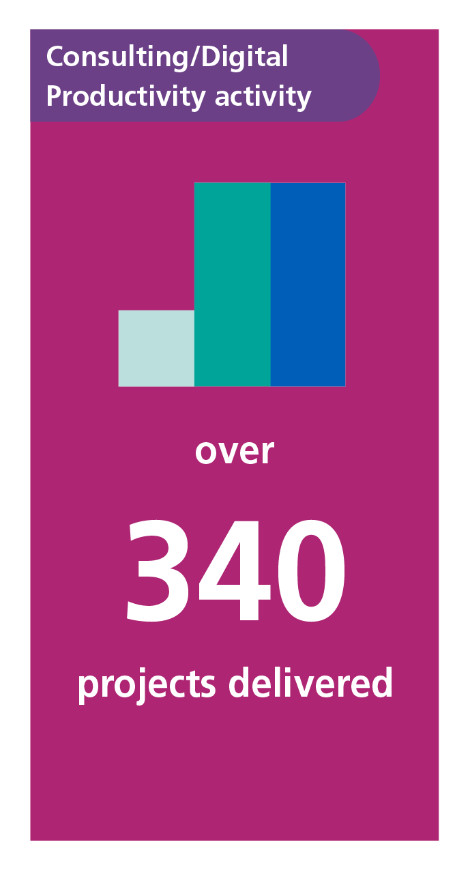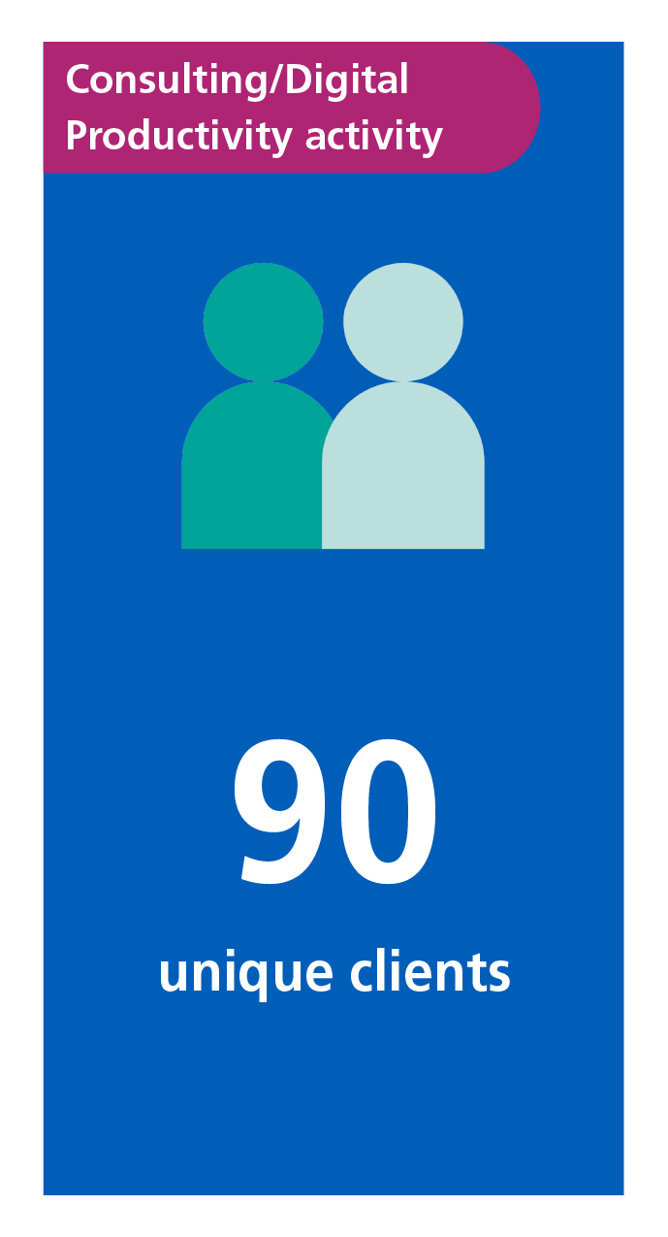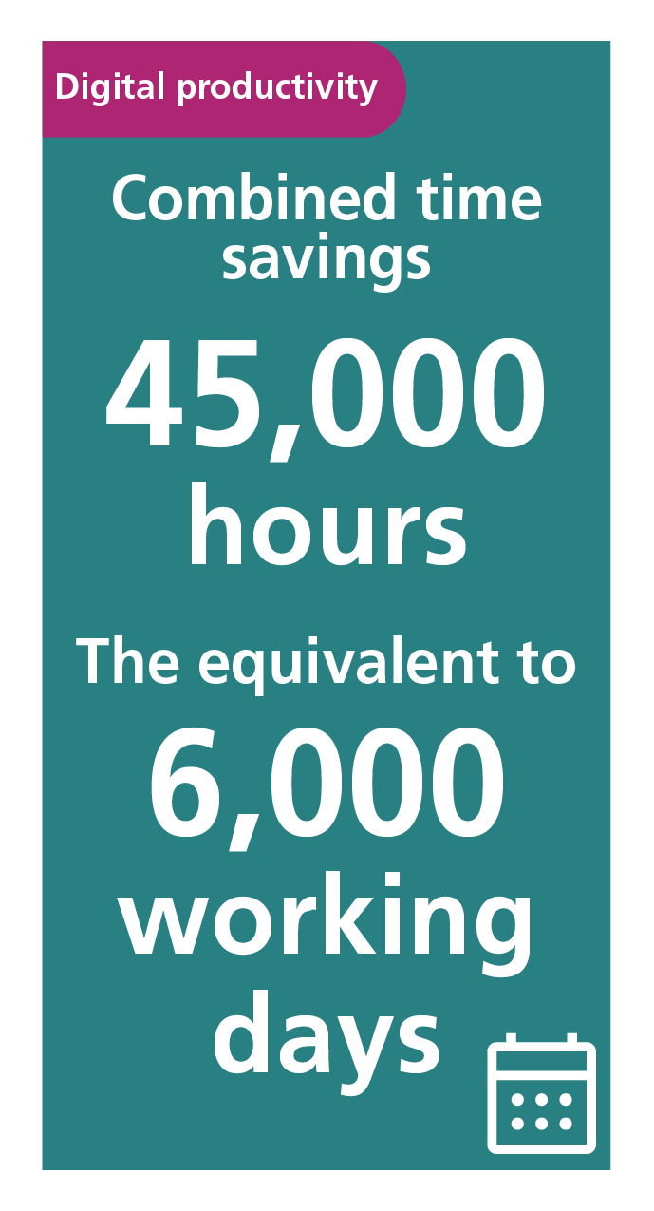

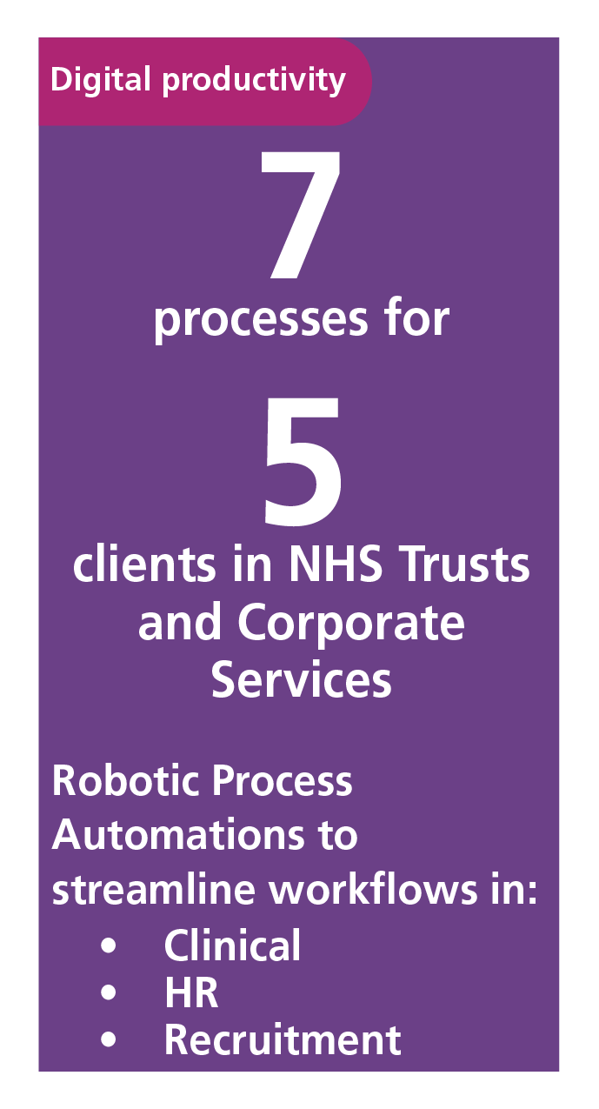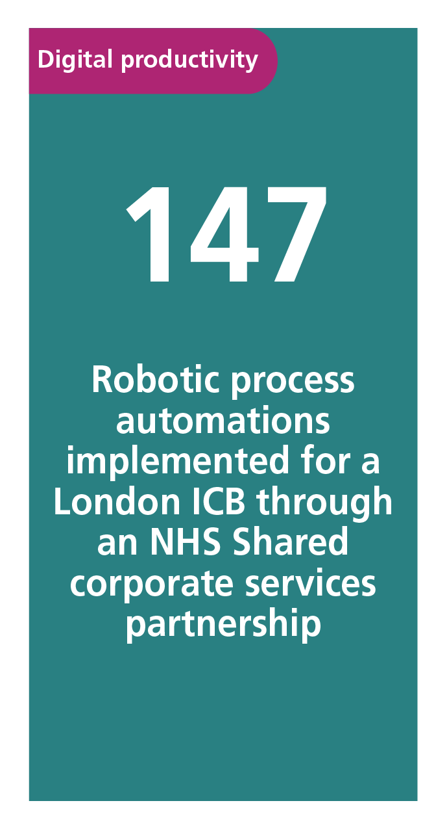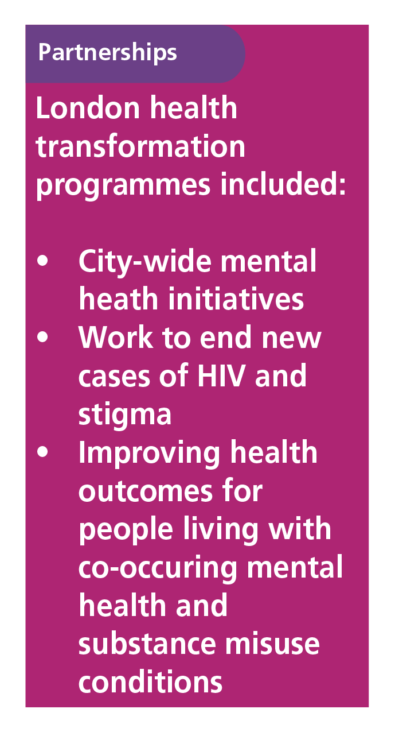

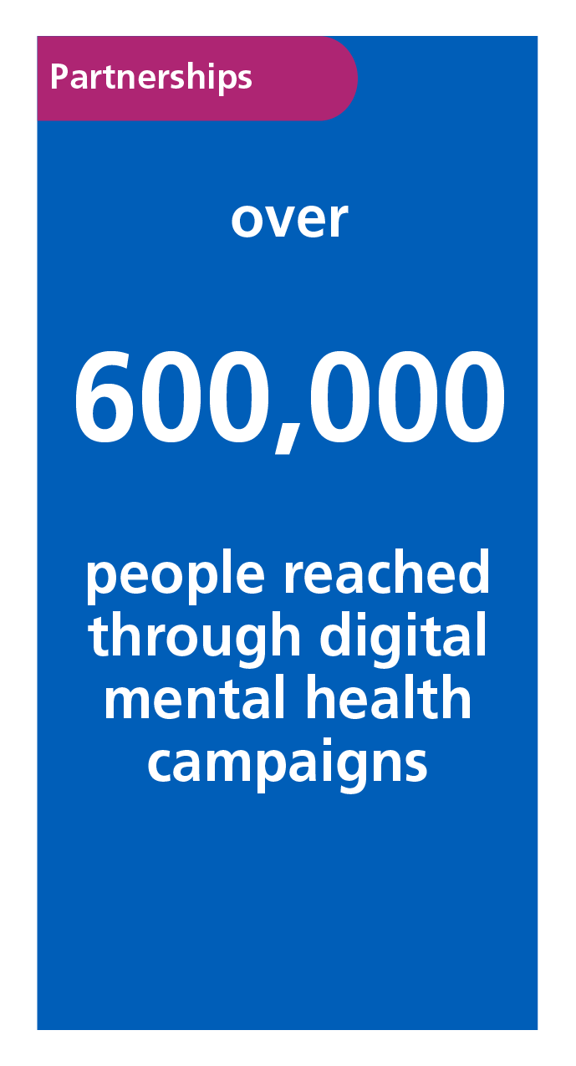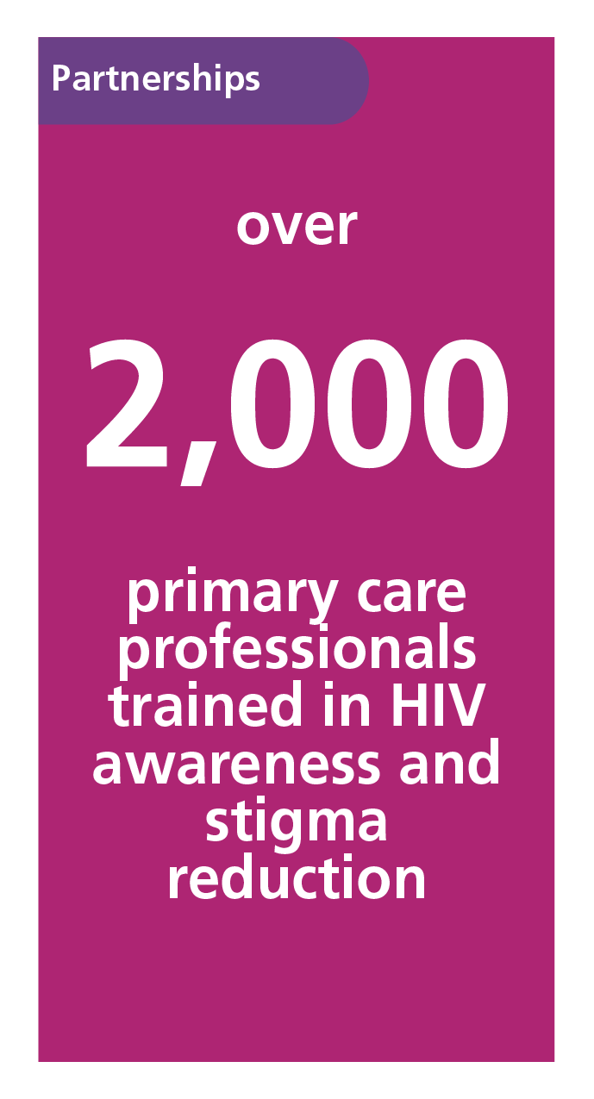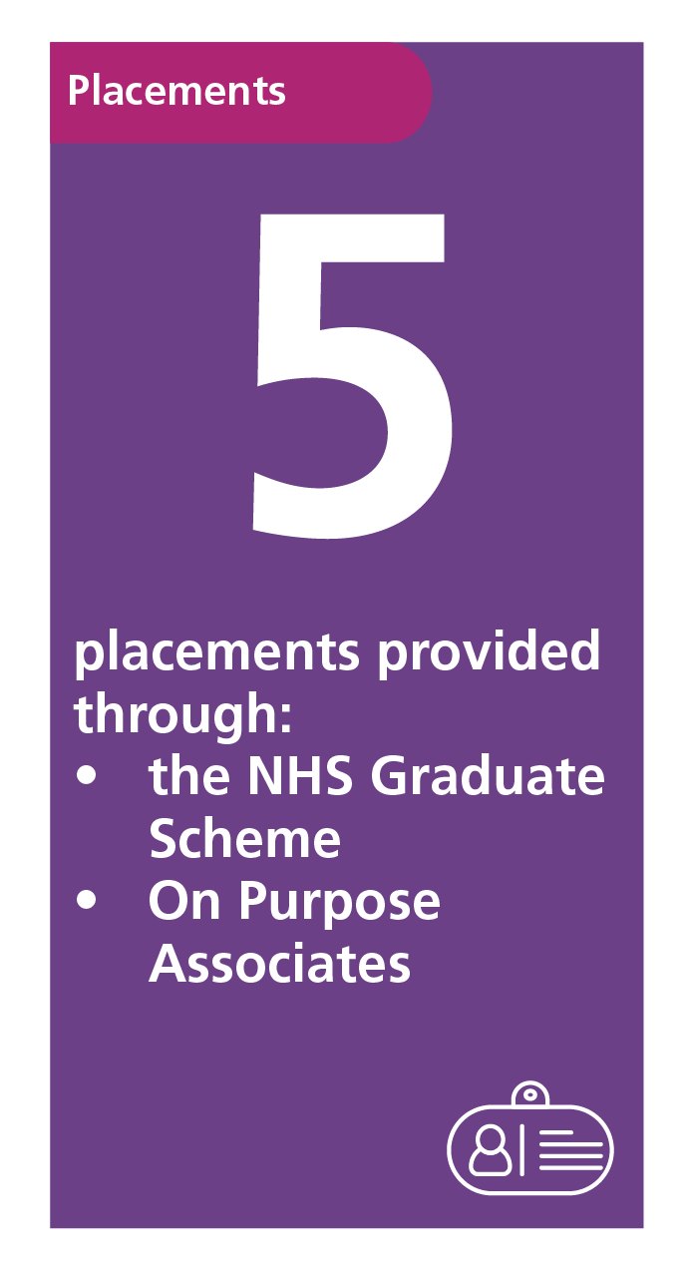
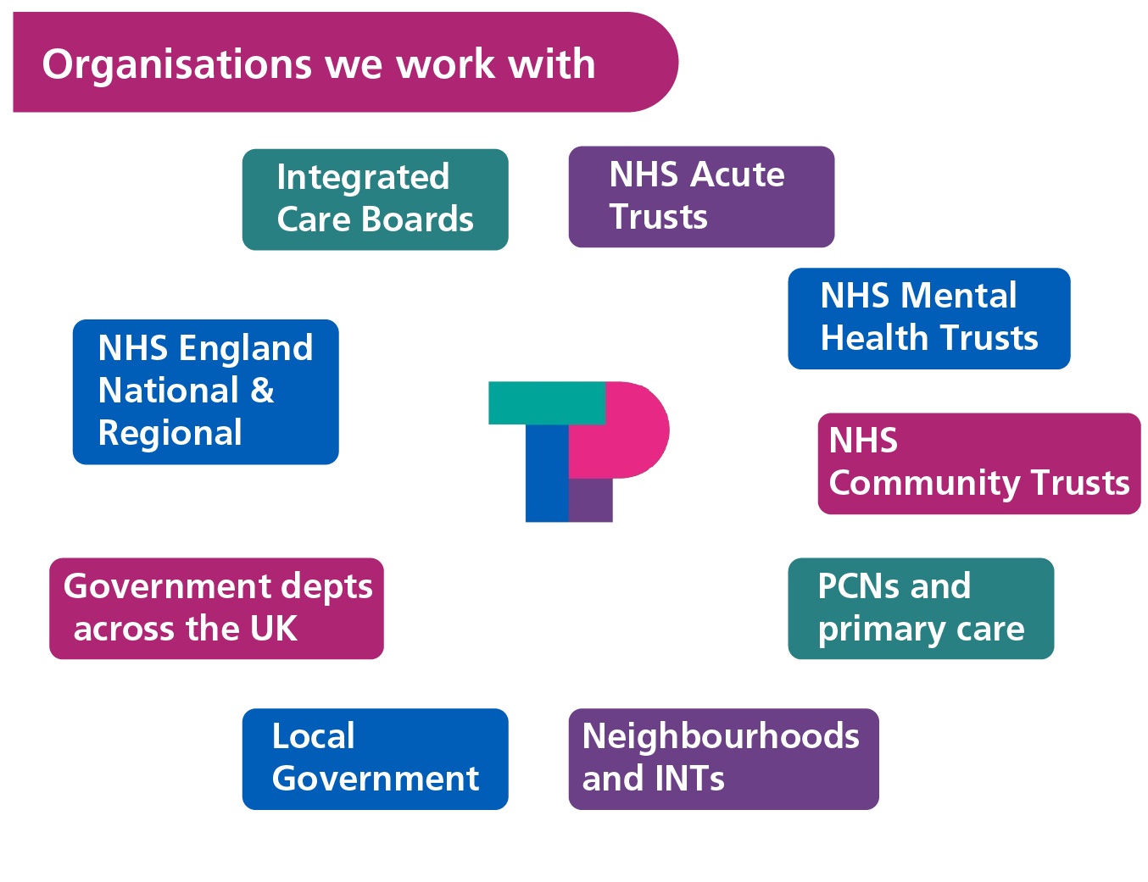

Healthcare awards recognition
At the HSJ Awards 2025 in November 2025, which attracted more than 1,250 entries from across the health sector, we were recognised twice:

Shortlisted among eight other entries, we won the 'Reducing Inequalities and Improving Outcomes for Children and Young People' award in partnership with North Central London Integrated Care Board (NCL ICB) and Whittington Health, for the North Central London Dental Transformation Programme.

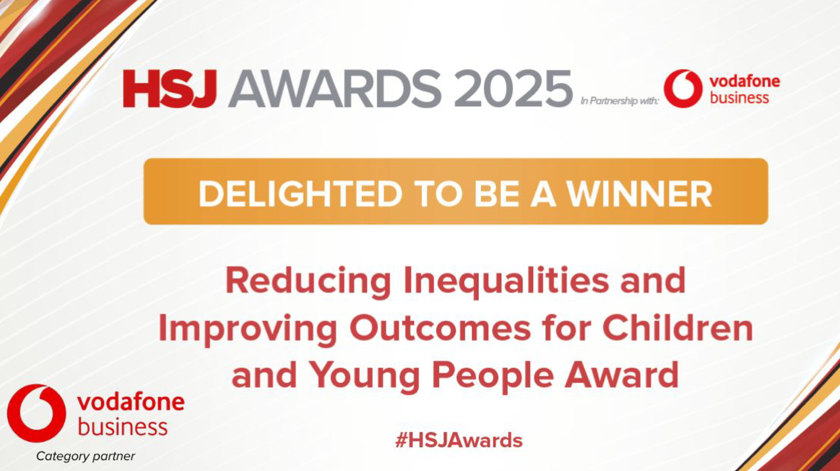

"Your innovative, co-designed approach has not only addressed these disparities head on but has set a new standard for what community-centred healthcare transformation can achieve."
Sir Sadiq Khan, Mayor of London — writing to congratulate the team, January 2026

We were named a finalist among eight other entries for the 'NHS Communications Initiative of the Year' award, for our communications and engagement work supporting NHS England's reconfiguration of very specialist children's cancer services.

Through our work with our clients and partners, we are helping to improve health and care outcomes for patients and communities.

Results from our work this year include:
- Combined time savings of 45,000 hours delivered through the Digital Productivity programme
- Releasing 21 whole-time equivalents of capacity annually and saving approximately £450,000 a year through automation of NHS shared services, with processing costs reduced by around 50%
- Over 1,200 people supported through a mental health urgent care centre, with 72% of admissions discharged within 12 hours, a service now cited nationally as a model for crisis care
- 111 hours of clinical capacity released weekly at Royal Free London, mitigating around £183,000 a year in financial risk to the Elective Recovery Fund
- 600,000+ people reached through digital mental health campaigns across 10 London boroughs, with 5,000+ practitioners equipped with trauma-informed skills
- £754,000 recurrent funding secured for the Homeless Health Outreach Service, supporting over 100 people in its first six months who would otherwise have struggled to access mental health care
- HIV testing increased by 29% in south London following a pilot launch, with over 2,000 primary care professionals trained in HIV awareness and stigma reduction

Case studies set out in this report will tell you more about our teams’ combined expertise and how we achieved these results through multi-disciplinary approaches.

Our teams – Consulting, Digital Productivity and Partnerships

Who we are, and the impact of each team
We understand that organisations are being asked to deliver more than ever before across health and social care, with increasingly stretched resources.

We have three distinct teams: ‘Consulting’, ‘Digital Productivity’ and ‘Partnerships’. All teams work together to co-support programmes, share expertise and devolve learning.
As committed public sector professionals, we understand each client’s needs and share their mission of improving patient outcomes and delivering essential transformation and improvement services while demonstrating value for money.

Consulting


TPHC Consulting is an NHS-hosted management consultancy. Our consultants work alongside NHS leaders, integrated care boards and local authorities across London, bringing direct experience of NHS finance, governance and operations to every engagement.

We are members of the Management Consultancies Association (MCA) and publish an annual commitment to consulting excellence. All members of our Senior Management Team, and a significant number of our senior consultants, hold or are working towards Chartered Management Consultant status (MCMI ChMC), the highest professional accreditation for management consultants in the UK.

In 2025-26, our work with north London NHS partners on shared services reform delivered the equivalent of 21 full-time posts' worth of workforce savings.
"I see TPHC as an essential and high-value resource for our health and care system. The expertise and return on investment it provides are significant and not something we would want to lose in London — the contribution of two TPHC consultants delivers impact that exceeds what we might expect from a larger number of non-specialist roles."
Professor Kevin Fenton, Regional Public Health Director, London, Office for Health Improvement and Disparities

Our consultancy covers three core service areas:
Strategy, Business Change and Transformation — Designing and delivering complex, large-scale change across London's health and care system.
Data and Analytics — Building analytical capability and connecting data across organisational boundaries.
Learning and Organisational Development — Developing the leadership, skills and organisational culture that lasting change requires.

Digital Productivity


TPHC's Digital Productivity team helps NHS organisations cut administrative burden and free up clinical time. In 2025-26, our tools and automation solutions saved health and care staff over 45,000 hours, time returned directly to patient care.
The team delivers a portfolio of digital products and services, from robotic process automation to system interoperability solutions, developed around the practical realities of NHS IT environments.

"The TPHC Digital Productivity team worked closely with us to design and deliver this innovative solution to support interoperability between two clinical systems, facilitating a comprehensive triage process at scale across north central London. Simultaneously, it has reduced the manual burden on administrative teams, freeing them up to deliver essential workload. It has been a pleasure to work with the TPHC team, who have been collaborative and responsive throughout the project."
Sarah Milne, Clinical Lead for Chronic Kidney Disease, Royal Free London NHS Foundation Trust

Partnerships


TPHC leads a focused portfolio of pan-London partnership programmes on behalf of NHS and local authority funders. In 2025-26, that portfolio comprised three programmes: Thrive LDN, London's citywide movement for good mental health and wellbeing; Fast-Track Cities London, the international network working to end the HIV epidemic; and the London Co-occurring Conditions Programme, supporting people living with both a mental health condition and a substance use problem.

Thrive LDN reached over 600,000 Londoners through digital campaigns in 2025-26. Through Fast-Track Cities London, a GP Champions programme placing 16 HIV-specialist GPs across London's integrated care systems drove a 29% increase in HIV testing in south London, with the model's findings now informing the National HIV Action Plan.

Across all three, TPHC provides the coordination, programme management and communications infrastructure that enables partners, drawn from the statutory, voluntary and community sectors, to work effectively at scale.

"The GP Champions model was designed to empower primary care professionals to lead this change: reducing stigma, normalising HIV conversations, and improving earlier diagnosis and access to care across our communities. This pilot has laid a strong foundation for expanding the role of general practice in achieving the goals of the Fast-Track Cities initiative."
Dr Aneesha Noonan, GP and Regional Medical Director for Commissioning, NHS England London

Explore how each of our teams delivered impact in 2025-26 below.

Strategy, business change and transformation
TPHC's Strategy, Business Change and Transformation (SBCT) directorate works at the strategic and system level, supporting NHS commissioners, integrated care boards and national bodies to tackle some of the most complex challenges in London's health and care system.
Where other parts of the business have a defined primary focus in digital automation, data and analytics capability or workforce development, SBCT works across several concurrent transformation areas simultaneously. In 2025-26, that included mental health transformation, weight management, maternity, ADHD, children and young people's mental health services, Health and Justice, and helping NHS organisations scale shared services to release capacity and reduce costs.
What connects them is less the clinical topic than the nature of the work: multi-stakeholder, often politically complex, and requiring both the strategic thinking to set direction and the practical delivery capability to see it through.

NCL Weight Management Programme
Around 64% of adults in the UK are overweight or living with obesity. Integrated care boards are required to make new treatments for weight loss, including tirzepatide (Mounjaro), available for a defined group of their population. However, rollout has been slow, and the medication is unavailable in many areas. More than nine in ten people currently on these treatments are paying privately. This two-tier system risks making health inequalities worse.

What we did
TPHC supported North Central London (NCL) Integrated Care Board to design and commission new equitable weight management pathways.

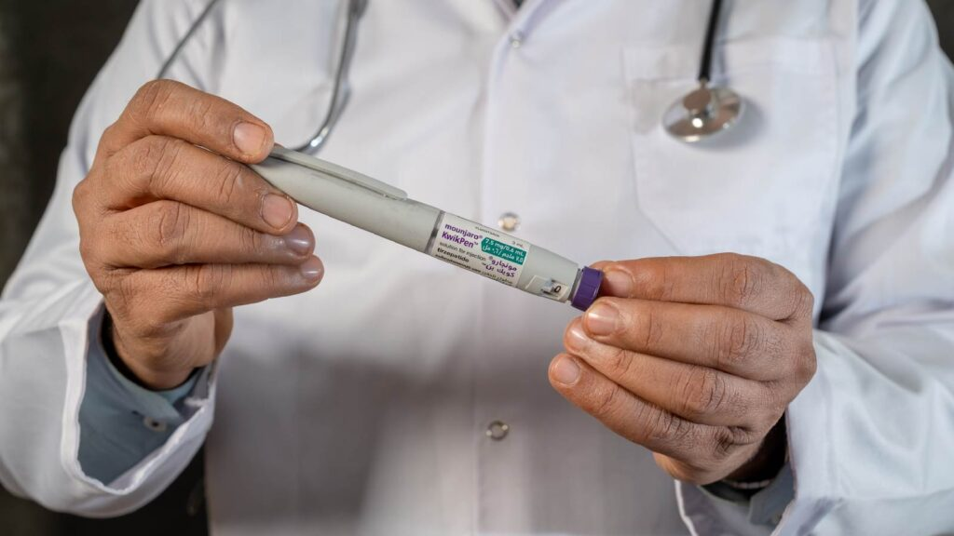
Access to weight management medication
NCL patients with the greatest clinical need for tirzepatide now have access to the medication for the first time. Pathways have been deliberately designed to reach people with learning disabilities, people from diverse communities, those with lower levels of health literacy and others facing health inequalities, in order to address inequities in access to care and improve outcomes across the population.

This has also brought NCL ICB into compliance with its statutory responsibilities, including local commissioning pathways, phased rollout, access to lifestyle and behavioural support programmes and clinical eligibility guidelines.

Potential future impact
Three-year results from the SURMOUNT-1 study showed that continued use of tirzepatide in pre-diabetic patients with obesity resulted in a sustained weight loss of up to 19.7% and a markedly lower risk of progressing to Type 2 diabetes.

Client feedback
'I would strongly recommend TPHC to any colleagues across the NHS. They have been invaluable in supporting our programme of work and we would use them again for any additional support that is needed.'
Hannah Logan, Public Health Consultant, NCL ICB


London Adult ADHD Transformation Programme
NICE estimates that approximately 3.5% of UK adults have ADHD, around 1.6 million people in England. In London, just 16% of that population currently receive treatment, rising to 23% for those with moderate or severe ADHD. Insufficient service capacity, and differences in how services are organised locally mean that adults with suspected or diagnosed ADHD are facing delays and unequal access to diagnosis and treatment.

What we did
TPHC partnered with NHS England London to develop a clear, evidence-based approach to transforming the adult ADHD pathway across the capital. By engaging a wide range of clinical, commissioning, and operational leaders, and drawing on expert oversight, we built a more consistent and effective model of care for London. We also coordinated a once-for-London response to national policy developments, establishing a robust baseline and practical mechanisms to support implementation.

Reducing waiting times and addressing health inequalities
Implementation will focus on strengthening primary care capability, improving consistency in service standards, tariffs and market management, and improving transitions of care. The aim is to reduce waiting times, address health inequalities—including for under-recognised groups such as girls and women—and bring ADHD mental health care closer to parity with the treatment of physical health conditions.
Wider benefits
This work gave NHS England London, ICBs and providers a shared understanding of adult ADHD services across the capital. It will lay the foundation for a once-for-London service specification with more seamless pathways and reduced health inequalities.

Client feedback
“TPHC's expertise in strategic transformation and service improvement will enable meaningful, sustained improvements across the adult ADHD pathway in London, ensuring people receive the right interventions and care to help them thrive in every aspect of life.”
Maria O'Brien, Chief Executive of West London NHS Trust and Senior Responsible Officer for the NHSE London ADHD Programme.

Redesigning support for children affected by sexual abuse in south west London
It is estimated that around 500,000 children are sexually abused every year in England and Wales. Children who have experienced sexual abuse can suffer a range of psychological and behavioural issues from mild to severe in both the short and long term. The effects depend on the circumstances of abuse, the child's developmental stage, and how the adults around the child respond.

Services for children and young people affected by child sexual abuse in south west London were fragmented across six boroughs and had critical gaps. South West London Integrated Care Board commissioned TPHC to evaluate the impact of a pilot scheme and develop a clear plan for sustainable, equitable care.

Listening to users
Our evaluation ensured the lived experiences of young people and families were central, capturing complex outcomes that had previously gone unmeasured such as psychological distress and parental isolation. It also identified groups who were less likely to access sexual abuse services: boys, neurodivergent young people, and young people with learning difficulties.

Creating sustainable, long-term provision
We created a clear action plan for an evidence-based pathway. This enabled system leaders to move beyond fragmented, short-term pilot funding towards a stable, long-term service model. This includes providing embodied, non-verbal, and creative therapies, meeting a wider range of needs.

The service was accessed by 335 children and young people over 22 months, a fourfold increase in reach of the previous provision. Of those who completed therapy outcomes surveys, 78% recorded a positive change in scores. The evaluation was designed to capture outcomes that previous provision had left untracked, including changes in psychological distress and parental isolation. Commissioners are using the findings and consortium modelling to develop a multi-partner business case and inform recommissioning of the service, working towards more consistent, equitable provision across south west London.

Client feedback
“I recommend TPHC as a suitable provider for independent evaluations. They have demonstrated strong experience in working across health and community projects, using robust and ethical evaluation methods, and worked well with diverse stakeholders. Their report on the evaluation of our child sexual abuse commissioned work across SWL has been of high quality, and provided clear, actionable insights.” — SWL ICB Mental Health Transformation Project Manager

Data and analytics
TPHC's Data and Analytics directorate helps NHS organisations make better use of their data, build analytical capability, and navigate the technical and governance challenges that make data-driven decision-making difficult in health and care.
The team spans two complementary areas. Analytical consultants and data specialists work directly with NHS clients to improve how data is collected, managed and used: building local capacity, designing reporting infrastructure, and translating information into insight that decision-makers can act on. Digital and innovation consultants support NHS organisations from initial scoping through to implementation and evaluation, drawing on expertise in product management, information governance, clinical risk and Agile delivery.
Both draw on deep familiarity with NHS data environments and clinical priorities. In practice, that means analytical findings that clinicians trust enough to act on, and digital solutions that are designed around how NHS organisations actually work.

National tools to reduce and prevent violence against NHS staff
Violence against NHS staff is widespread. In the 2025 NHS Staff Survey, 14.47% of staff reported physical violence from patients or the public, and 25.25% reported harassment, bullying or abuse. The estimated cost of violence, harassment and abuse against NHS staff is £1.36bn in England (2021/22). This affects retention, increases sickness absence, and reduces productivity. Yet NHS-funded organisations across England had no standardised approach to preventing or reporting violence and abuse against their staff.

What we did
NHS England commissioned TPHC to create a standardised data reporting framework and guidance for organisations and staff on safe working practices. We worked with experts – violence prevention and reduction clinical and managerial leads, frontline staff with lived experience, equality leads, unions, and national bodies – to co-design these tools.

Enabling consistent data and better action
The new data reporting framework supports more consistent and reliable collection of information on violence and abuse across England, including experiences linked to protected characteristics. This will enable stronger national oversight, meaningful benchmarking, and sharing of learning between organisations, helping the NHS identify risks earlier and take more effective, targeted action.

Improving staff experience and wellbeing
The safe working practices guidance takes a trauma-informed, public health approach to preventing and reducing violence and abuse. It identifies priority actions for organisations, leaders and frontline staff, including implementation of a culture where staff feel safe to report incidents and organisations visibly act on learning. Training for staff in how to respond to stressed or frustrated patients is part of this wider compassionate culture.

Delivering nationally aligned, locally usable solutions
The guidance and framework have enough flexibility to be usable by organisations in different circumstances (for example, GP practices and acute trusts) and with different levels of data maturity. This work will create a more consistent approach to staff safety, with clearer guidance and better reporting. It will help organisations learn from each other, spot patterns and inequalities, and take earlier action to prevent harm.

Client feedback
"This is a comprehensive, high-quality piece of work. Both sets of guidance look excellent and go well beyond what we originally envisaged."
Wazir Muhammad, National Staff Violence Prevention and Reduction Programme Lead, NHS England

Strengthening blood cancer diagnostic pathways at Royal Free London
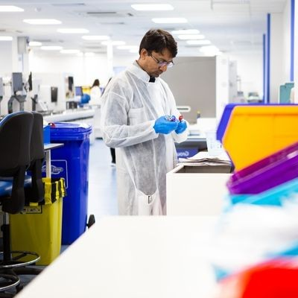
The 28-day Faster Diagnosis Standard (FDS) is an NHS target guaranteeing that patients urgently referred by their GP for suspected cancer receive a diagnosis or have cancer ruled out within 28 days. Royal Free London's (RFL) haematological malignancy service, England's highest-volume FDS provider, had seen performance against this standard fall below the required level. The principal constraint was not initial referral, but the complex diagnostic phase, which requires timely investigation, clinical review, MDT coordination and communication across a multi-site service.
What we did
TPHC carried out the first detailed demand and capacity analysis of the service, mapping 148 clinical and administrative activities across 11 pathways. Clinicians saw their own data drive the findings, which built genuine ownership of the evidence base. The analysis made visible variation in patient access, experience and coordination between sites serving markedly different demographic profiles and identified substantial hidden administrative and coordination work absorbed by the multidisciplinary team alongside their core clinical roles.
With active input from clinical, administrative and operational colleagues, who drew on their detailed understanding of day-to-day delivery to prioritise and shape practical solutions, some of it building on work already underway, we developed a clear action plan to improve diagnostic timelines, pathway coordination and patient experience. Recommendations included geriatric-oncology pathway considerations and providing more care closer to home, including local treatment and medication collection, particularly reducing the travel burden for frail older patients who currently need to travel to central London.
Releasing time for clinical care
We identified five tactical interventions that could remove around 111 hours of avoidable administrative and coordination time each week, roughly 3 whole-time equivalents of unpaid extra hours currently absorbed by the multidisciplinary team. Releasing this time would allow staff to focus more consistently on clinical decision-making, patient communication and progression through the diagnostic pathway.
Protecting patient access
Up to 70 clinic slots each week were identified as dependent on consistent consultant cover, adding pressure to the FDS pathway through its effect on capacity for urgent referrals, diagnostic follow-up and treatment decisions. Substantiating the case for consistent medical cover would protect both patient access and diagnostic throughput, while mitigating around £183,000 a year of risk to Elective Recovery Fund income.
Driving service efficiency through evidence and collaboration
Our methodology, triangulating quantitative capacity modelling with qualitative discovery, is directly transferable to other complex, multi-site clinical reviews. While TPHC identified the opportunities for improvement, the clinical, administrative and operational team has been central to finding solutions that are credible, deliverable and sustainable in day-to-day practice.

Digital Productivity
TPHC's Digital Productivity team helps NHS organisations shift the burden of repetitive, high-volume administrative work from people to automated digital processes, freeing clinical and operational staff to focus on the work that matters most.
The team operates across two complementary models. The Digital Productivity Platform (DPP) offers NHS organisations access to a growing library of ready-to-deploy automation processes on a consumption-based model, a first for the NHS that removes the need for significant upfront investment and makes automation viable for organisations of any size or digital maturity. Alongside the platform, a professional services offer supports bespoke digital delivery, from design and governance through to implementation and evaluation, for organisations with more complex or tailored requirements.
Both are built around the realities of NHS environments: governance-compliant, clinically safe, and designed to work within existing systems rather than around them.


Scaling automation across the NHS

Automation in the NHS struggles to scale due to high upfront investment required and short-term budgets. Legacy systems, fragmented procurement, and hidden workflow redesign costs all hinder adoption.

TPHC’s Digital Productivity Platform (DPP) addresses this by offering a pay-as-you-go model for digital tools such as intelligent automation. This is a first for the NHS, enabling organisations of any size, financial status, or digital maturity to access automation without significant upfront investment.

What we did
TPHC designed, built, and scaled a multi-organisation automation platform, establishing governance pathways, onboarding frameworks, and a flexible commercial model aligned to NHS requirements.

Savings for NHS organisations
Lewisham and Greenwich NHS Trust (LGT) became the first NHS organisation to go live on the DPP in April 2025, redeploying six existing HR automations. During 2025/26, the platform delivered 69,000 minutes (1,150 hours) of automated HR activity across recruitment, rostering, compliance, and employee lifecycle processes, releasing 0.8 WTE.
Expansion at LGT was rapid in 2025/26 as the DPP’s value was demonstrated. Having started in HR, it was being used in outpatients, finance, cancer services, information systems and data, electronic patient record migration, and pharmacy by the end of the year.
Improving staff experience
Automation at LGT removed repetitive manual activity, freeing up staff to focus on higher-value activities.
Opportunities for the future
The DPP has replicable frameworks that simplify and accelerate adoption, supporting the analogue to digital shift for NHS organisations. It can work with multiple platforms, and the team is expert in assisting organisations to implement effectively.
Client feedback
"The trust has grown significantly whilst our ESR and recruitment teams have remained relatively lean but have ensured we continue to deliver excellent services with minimal errors or complaints thanks to the automation and time saved through the DPP." LGT's Deputy Chief People Officer.
"Automating repetitive tasks has improved efficiency and consistency, reduced manual error, and freed up capacity to focus on higher-priority recruitment activity. We've been able to be more responsive with hiring managers, which has improved engagement and reduced delays in communication." LGT's Head of Recruitment.

Freeing up capacity: automating CKD referrals across North Central London
Chronic kidney disease (CKD) is a long-term condition affecting around one in ten people. There is no cure for CKD, but early diagnosis and treatment can help to relieve symptoms and prevent further deterioration. Left untreated, advanced CKD (stage 5) can require dialysis or a kidney transplant.

North Central London's CKD service receives between 50 and 70 referrals each week. Before automation, each required around 30 minutes of manual processing: registration onto the EMIS clinical system, triage preparation, and outcome letter creation. Beyond the resource cost, the manual process carried clinical risk: transcription errors, registration delays, and reduced clinician access to records at the point of triage.

What we did
TPHC's Digital Productivity team worked with the service to design and deploy an automated referral workflow, integrating NHS e-Referral Service with EMIS to manage the full CKD referral pathway, from referral collection and registration, through to triage, outcome letters, and discharge. The automation also enables clinical teams to access patients' primary care records securely via EMIS during triage. The team led the governance work required to operate safely at scale: a Data Protection Impact Assessment and compliance with the DCB0160 clinical safety standard were both completed before go-live. The automation has run continuously since April 2024.

Better for patients
Automating registration and enabling EMIS access to primary care records during triage supports more accurate, evidence-based clinical decisions. Patients receive a faster, more consistent referral pathway with less risk of delays or errors from manual handling.

Better for staff
Between go-live in April 2024 and the end of March 2026, the automation has processed 4,289 CKD referrals end-to-end, at 30 minutes saved per referral. This represents 2,144 hours (286 working days) returned to the CKD team over two years. Administrative staff are freed from manual processing, creating capacity for work that requires clinical judgement.

Better for the system
Having met the DCB0160 standard and completed a full DPIA, the model demonstrates that clinically safe, governance-approved automation can operate reliably at scale. Well-documented and transferable, it offers a way forward for other specialities considering comparable automation.

Client feedback
"The TPHC Digital Productivity team worked closely with us to design and deliver this innovative solution to support interoperability between two clinical systems, facilitating a comprehensive triage process at scale across north central London. Simultaneously, it has reduced the manual burden on administrative teams, freeing them up to deliver essential workload. It has been a pleasure to work with the TPHC team, who have been collaborative and responsive throughout the project."
Sarah Milne, Clinical Lead for Chronic Kidney Disease, Royal Free London NHS Foundation Trust.


Automating shared services: saving 21 WTE and £450,000 a year
North London Partners Shared Services (NLPSS) is a partnership of seven NHS Trusts delivering NHS corporate services at scale. NLPSS faced a growing imbalance between demand and capacity in shared workforce services, where high-volume, manual processes in recruitment, employment services and medical workforce teams were becoming increasingly difficult to sustain. These pressures drove higher operational costs, increased reliance on staff, and caused delays to critical workforce activities.

What we did
We worked in partnership with NLPSS to design, build and scale a managed Robotic Process Automation (RPA) and digital productivity service embedded in live workforce operations. This evolved into a scaled productivity service, combining automation with process standardisation, governance, and user-centred tools.

We rolled out 147 live automations across three services with digital workflow and dashboard reporting tools, service desk support (over 300 tickets addressed annually), and performance management against agreed service level agreements and key performance indicators.

Better for the system
Automation reduced processing costs by around 50% compared to manual activity, with up to 90% cost reductions achieved in the most optimised processes. Unit costs were reduced from £31 per hour to £17 per hour, delivering a £14 per hour saving. Annual savings reached approximately £450,000 while enabling services to absorb increasing demand without additional workforce growth.

The programme released 21 whole-time equivalents of capacity annually. Performance and quality improved alongside financial savings: technical processing errors fell by 49.5%, well below the industry benchmark of 5% for mature automation platforms, and cases requiring manual escalation due to business rules fell by 15%.

Better for staff
Operational users experienced a positive impact on their day-to-day working, including reduced complexity, improved usability and better frontline experience. Automation has removed a significant proportion of repetitive, manual administrative activity, releasing capacity for staff to focus on higher-value activities such as data quality, training and service improvement.

Staff feedback highlights the practical impact:
"It is fantastic to see technology used to make our work easier."
"I extended a fixed-term contract today, and the process couldn't have been easier."

Better for inclusion
By removing repetitive manual processing, much of which sits with lower-banded roles, the programme has released capacity for those staff to focus on higher-value work and eased workload pressures that fall unevenly across teams. Standardised automated workflows also mean recruitment and employment cases are handled consistently regardless of which team processes them, reducing variation in outcomes and increasing transparency, supporting fairer outcomes.

Learning and organisational development
TPHC's Learning and Organisational Development (L&OD) directorate builds the capability and culture that health and care organisations need to sustain change. Working with NHS trusts, integrated care boards and national bodies, the team delivers learning programmes, leadership training and organisational development support from team level through to board.
Two products sit at the core of the CPD-certified L&OD offer. Empowered Leadership: Creating Inclusive and Effective Workplaces is a four-day line management course grounded in the NHS People Promise and the Expectations of Line Managers framework, equipping existing and new managers with the skills to lead inclusively, manage performance, and have difficult conversations with confidence. The After Action Review (AAR) Conductor Development programme trains staff to facilitate structured learning reviews within their own organisations, building a self-sustaining culture of reflection. CPD-certified and endorsed within the NHS Patient Safety Incident Response Framework, it has supported teams across multiple NHS trusts since 2021.
The team’s wider offer covers board and clinical leadership development, governance review, and organisational and partnership development, supporting the structural and cultural changes that lasting transformation requires.

Empowered Leadership: developing line management capability across the NHS
Nationally, 82% of NHS managers have never received formal management training. Yet line management is a critical driver of staff experience, retention, and organisational performance, with poor line management strongly linked to low morale, avoidable turnover, and underperformance.

What we did
TPHC developed the Empowered Leadership programme, a four-day CPD-accredited development initiative designed to address this gap. The programme equips line managers with the core skills, behaviours, and confidence required to lead compassionate, inclusive, high-performing teams.
The design was informed by national evidence, including the NHS Leadership Way, NHS People Promise, and NHS Long Term Workforce Plan, alongside insights from staff with lived experience of inclusion, exclusion, bias, neurodiversity, and health needs. We embedded policy and employment relations casework to ensure scenarios reflected the complexity of leading people in NHS settings.
Delivery combines face-to-face small-group sessions with experiential learning (role plays, fishbowl demonstrations, scenario-based practice), bite-sized learning videos on key policies, and a dedicated online platform with resources and guidance.
Increased confidence for managers
All NLPSS line managers completed the four-day programme over a 14-month period. 100% rated it as effective, relevant, and said they would recommend it to others. Managers reported significantly increased confidence in having difficult conversations, giving and receiving feedback, managing performance concerns early, supporting staff wellbeing, and understanding their responsibilities as line managers.
Delegates described the programme as "transformational", "engaging", "thought-provoking" and "extremely useful". One participant reflected:
"No words can quite describe the special learning journey that you are taken on over a 4-week period. The most inspiring and empowering course you could attend. The facilitators ooze passion for the course they lead, and this automatically encourages you to want to do better each and every day."
Creating a more inclusive, high-performing culture
Over a 12-month period, NLPSS observed a positive increase in appropriate escalations, reflecting greater confidence in addressing poor performance and behaviours rather than avoiding or delaying action. The cohort of trained managers now lead with greater clarity, compassion and confidence, use a shared language and consistent approach to people management, intervene earlier, and contribute to a more accountable, inclusive and high-performing culture.
The programme demonstrates that experiential learning is highly effective for adult learners, peer learning is a major strength, and creating space for lived experience and reflective discussion deepens understanding and empathy. NLPSS is now exploring action learning sets to sustain learning and developing communities of practice for line managers.

Building management resilience: Cambridge University Hospitals' response to NHS Staff Survey findings
The 2024/25 staff survey results for Cambridge University Hospitals revealed high levels of burnout and a perceived disconnect between senior leadership and frontline reality, including a sense that leaders lacked understanding of the reality staff faced on the ground.
In response, Cambridge University Hospitals launched a mandatory 18-month leadership development initiative for 3,500 leaders across two tailored programmes: one for new leaders and the other for existing leaders. The aim was to build trust and accountability among leaders and between leadership and staff, enable higher-quality conversations across the organisation, and encourage all to live the trust’s values at work.

What we did
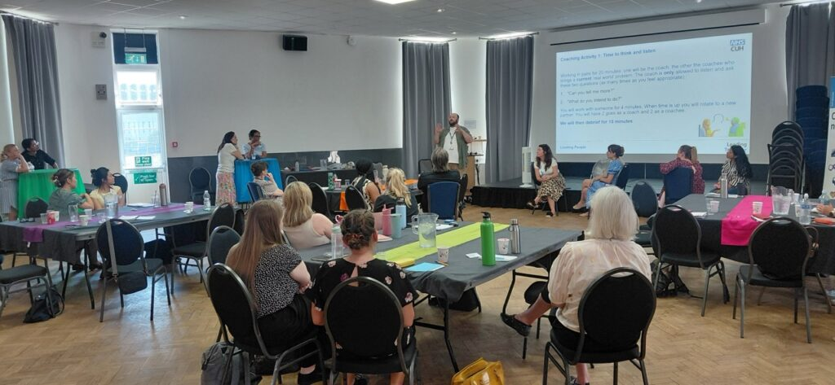
TPHC's expert training faculty supported the design and delivery of both programmes. We worked with the client to refine and recommend changes to programme content, drawing on our own experience of delivering leadership development. We delivered 82 training days and more than 11 action learning set days, with a further 42 delivery days scheduled for Q1 2026/27.
Our expert insight and real-life experiences of inclusion and exclusion strengthened both the leaders we worked with and the programme content itself. This ensured the programme was grounded in lived experience and reflected the reality of leading people in NHS settings.

Building trust and accountability in leadership practice
Participants reported significant increases in their ability to lead through change, lead more inclusively, have difficult and important conversations, and engage in distributed leadership while building greater accountability in their leadership practice. Over 99% of participants who gave feedback said they would recommend the training to colleagues.
Participants described the training as "reflective, supportive, insightful, informative". Specific feedback highlighted:
"This programme gave me the skills and, more importantly, the confidence to try new things back at work – I've been able to take things from the classroom and use them in my leadership practice."
"The programme has given me the space and time to think more purposefully about the people I lead, leading to insights as to how I can get the best out of each of them. My relationships with my team have strengthened as a result."
"Good opportunities to build my network and learn from the different perspectives of colleagues in the Trust."

After Action Review Training: building learning capability across the NHS
After Action Reviews (AARs) are structured debriefs that support learning and improvement following significant events. They are one of the learning tools identified in the Patient Safety Incident Response Framework (PSIRF), which sets out how NHS organisations should respond to and learn from patient safety incidents.

What we did
TPHC delivered AAR training and direct AAR facilitation across the NHS and wider public sector in 2025/26, training over 150 professionals to lead AARs effectively.
By extending our reach into new organisations and sectors, and facilitating a growing community of practice, we supported the development of more reflective, learning-oriented cultures.
Alongside training, our in-house expertise delivered targeted AARs and Before Action Reviews across a range of contexts, from recruitment and process improvement to incident and programme review, helping organisations close the gap between expected and actual outcomes while embedding continuous learning.

Equipping participants with the tools to support effective team performance
Post-training evaluation consistently shows over 95% of delegates leave the training with high confidence scores to conduct AARs, introduce AAR to colleagues, and support effective team performance through learning collectively. Our introduction in 2025/26 of mixed-cohort training, enabling participants to learn alongside colleagues from outside their own organisations for the first time, enriched discussions and broadened perspectives.
Building learning capability within teams
Ongoing support through action learning sets and a community of practice is helping newly trained conductors build confidence in facilitation, embed AARs into everyday practice, and develop their skills over time. Over 150 NHS and public sector colleagues received accredited CPD hours in 2025/26, enabling them to undertake AARs in their own organisations and build learning capability within their teams.

Strengthening learning across the NHS
TPHC's full-day AAR Conductor Development course holds CPD certification, recognising the quality and professional value of the training as a dedicated conductor development programme. Our in-house conductors have delivered AARs and Before Action Reviews across a range of focus areas, demonstrating our expertise in conducting reviews and training others to do so. This dual capability, training others while delivering high-quality AARs directly, strengthens system learning and supports the embedding of PSIRF principles across the NHS.

Pan-London partnership programmes
TPHC's Partnerships team convenes and hosts a portfolio of pan-London programmes on behalf of NHS and local authority funders, bringing together the NHS, local government, voluntary sector organisations, clinicians, and communities around health challenges too complex and cross-cutting for any single organisation to lead alone.
In 2025-26, three active programmes made up this portfolio. Thrive LDN reached over 600,000 Londoners through anti-stigma campaigns and equipped more than 5,000 practitioners with trauma-informed skills. Fast-Track Cities London expanded its HIV GP Champions model across all five London Integrated Care Systems, driving a 29% increase in HIV testing in south London and training over 2,000 primary care professionals, with the model now cited in the new National HIV Action Plan. The London Co-occurring Conditions Programme secured £754,000 in recurrent funding for a new Homeless Health Outreach Service and contributed to the 2025 national Co-occurring Mental Health and Substance Use Delivery Framework.
2025 also marked the close of two long-standing programmes: Good Thinking, which reached over 900,000 Londoners across eight years as the first city-wide digital mental wellbeing service in any global city, and the Mental Health Transformation Programme, which drove system-wide improvement across London from 2015 to 2025. Full accounts of both legacies are available in their respective legacy pages.

Thrive LDN: A system leadership response to mental health across London

Common mental health conditions and psychological distress have increased consistently across London and the rest of the country over the past two decades. Thrive LDN was established as a coordinated system leadership response to the complex social, economic, and environmental factors in London, such as the rising cost of living, that shape resident wellbeing. The programme provides a system leadership framework that delivers a once-for-London approach and regional economies of scale across public mental health activity, existing to promote mental wellbeing among all Londoners and their communities, and help prevent mental ill-health.

What we did

The Thrive Partnership, hosted by TPHC, worked with people with lived experience and academic collaborators to advance research and practice in prevention and anti-racist approaches to mental health. Through influential publications and citywide initiatives, we helped shape the agenda for population-level change while embedding trauma-informed approaches across systems.

Alongside research and training, we delivered targeted interventions to reduce stigma, improve wellbeing, and strengthen community resilience, particularly for underserved groups. This included digital campaigns, frontline workforce development, grassroots funding, and the launch of innovative tools and programmes. We also maintained critical system infrastructure, such as real-time suicide surveillance and multi-agency prevention networks, ensuring a coordinated and responsive approach across the capital.

The Thrive LDN partnership delivered:
Reach and engagement: 600,000+ people reached through digital campaigns across 10 boroughs, 5,500+ partner organisations engaged through Great Mental Health Day, 67 community activities across 28 London boroughs, 5,000+ practitioners equipped with trauma-informed skills

Confidence and capability gains: 90% of participants in our in-depth trauma-informed practice (TIP) workshops reported increased confidence applying these skills in their professional roles. 70% of financial wellbeing project participants reported a measurable increase in their confidence managing personal finances.

Campaign outcomes: A digital advertising campaign promoting Zero Suicide Alliance training drove over 4,300 click-throughs to the platform. Close to 38,000 Londoners completed ZSA suicide awareness training during 2025/26, contributing to nearly 500,000 who have completed it since the #ZeroSuicideLDN campaign launched in 2019.

Better for communities
Thrive LDN delivers targeted activities for underserved populations and publishes research on population-level anti-racist interventions to address health inequities. Feedback from community and grassroots organisations highlights support at familiar community or religious locations is more effective for communities at greater risk of poor mental health. Robust Equity Impact Assessments are undertaken for all activities to ensure work directly addresses health inequalities.

What we learned for scaling
Great Mental Health Day shows the value of a once-for-London, partnership-led model. Pairing a single citywide moment with local activity, over 650 people joined two online sessions from 16 boroughs, and 67 borough events were recorded across 28 of London's 32 boroughs, meant reach did not depend on local resource levels. Separately, Thrive LDN continues to explore the intersection of climate change, mental health, and systemic inequalities through a three-year partnership project.

Learn more about Great Mental Health Day in this video: https://youtu.be/KHbgpPctpvw?si=-_XjfBV9Q-Gas_nx

London Co-Occurring Conditions Programme: integrating support for people experiencing homelessness
People experiencing homelessness frequently face co-occurring mental health conditions, substance use issues, and complex health needs. Guidance on meeting their needs was published in the 2025 Co-Occurring Mental Health and Substance Use Delivery Framework and is reflected in existing NICE guidance, and Public Health England recommendations. However, many people still experience services as inconsistent, inaccessible, and fragmented. TPHC manages the London Co-Occurring Conditions Programme to ensure there is no "wrong door" to support and treatment.
What we did
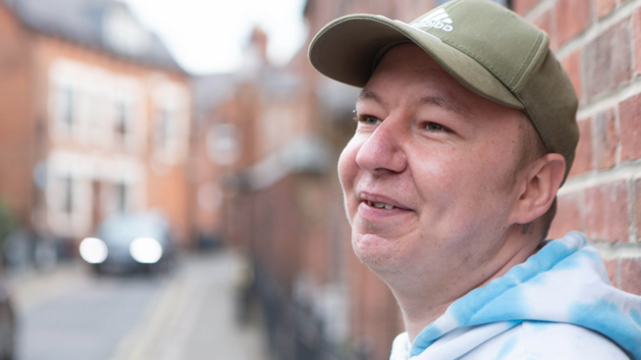
TPHC played a leading role in shaping and delivering system-wide improvements for people with co-occurring needs, contributing expert insight at both national and regional levels. By working in partnerships spanning mental health, substance use, homelessness, autism, and end-of-life care, we helped design and implement more integrated, responsive models of support.
This included establishing a new mental health outreach service in North Central London, piloting an expedited autism assessment process for people rough sleeping in Newham, and enabling multi-sector collaboration in research and service redesign.
Alongside this, we refined our own operating model to align with a more place-based, public health-led approach for the future.
Improving access for people experiencing homelessness
Our programme was part of the National DHSC COMHAD Expert Reference Group. We advocated for the national Co-Occurring Mental Health and Substance Use Delivery Framework to reference the disproportionate impact of co-occurring mental health and substance use on people experiencing homelessness (and vice-versa). This has been referenced in the new Framework. The London Co-Occurring Conditions Task and Finish Group has developed a set of co-produced London principles, a consensus statement, and a quality checklist for London stakeholders. The Mayor's Rough Sleeping Plan of Action has recognised inclusion health and co-occurring conditions as a key priority, and our programme is working in partnership with the Greater London Authority.
The programme secured £754,000 recurrent funding via North London NHS Foundation Trust to establish the Homeless Health Outreach Service, which opened in north central London in September 2025. It has seen over 100 people in its first six months who would otherwise have struggled to access mental health support.
In Newham, an expedited assessment process for autistic people rough sleeping is now being trialled and evaluated. A shared training programme has been delivered between Newham autism service and local homelessness services, increasing workforce knowledge and skills. In north east London and south west London, Communities of Practice and a learning programme have been established to support staff when working with people experiencing homelessness at end of life.
Strengthening pan-London coordination and national influence
The programme achieves critical strategic and operational impact through national influencing and pan-London coordination. It supports a London system that is extremely stretched which has little capacity for the consistent, collaborative, improvement activity needed to address co-occurring conditions. This dual role, working at both strategic and operational levels, supports a shift towards more integrated, coordinated, and effective pathways, services, and systems for people experiencing co-occurring conditions and homelessness.

Fast-Track Cities – London HIV GP champions pilot
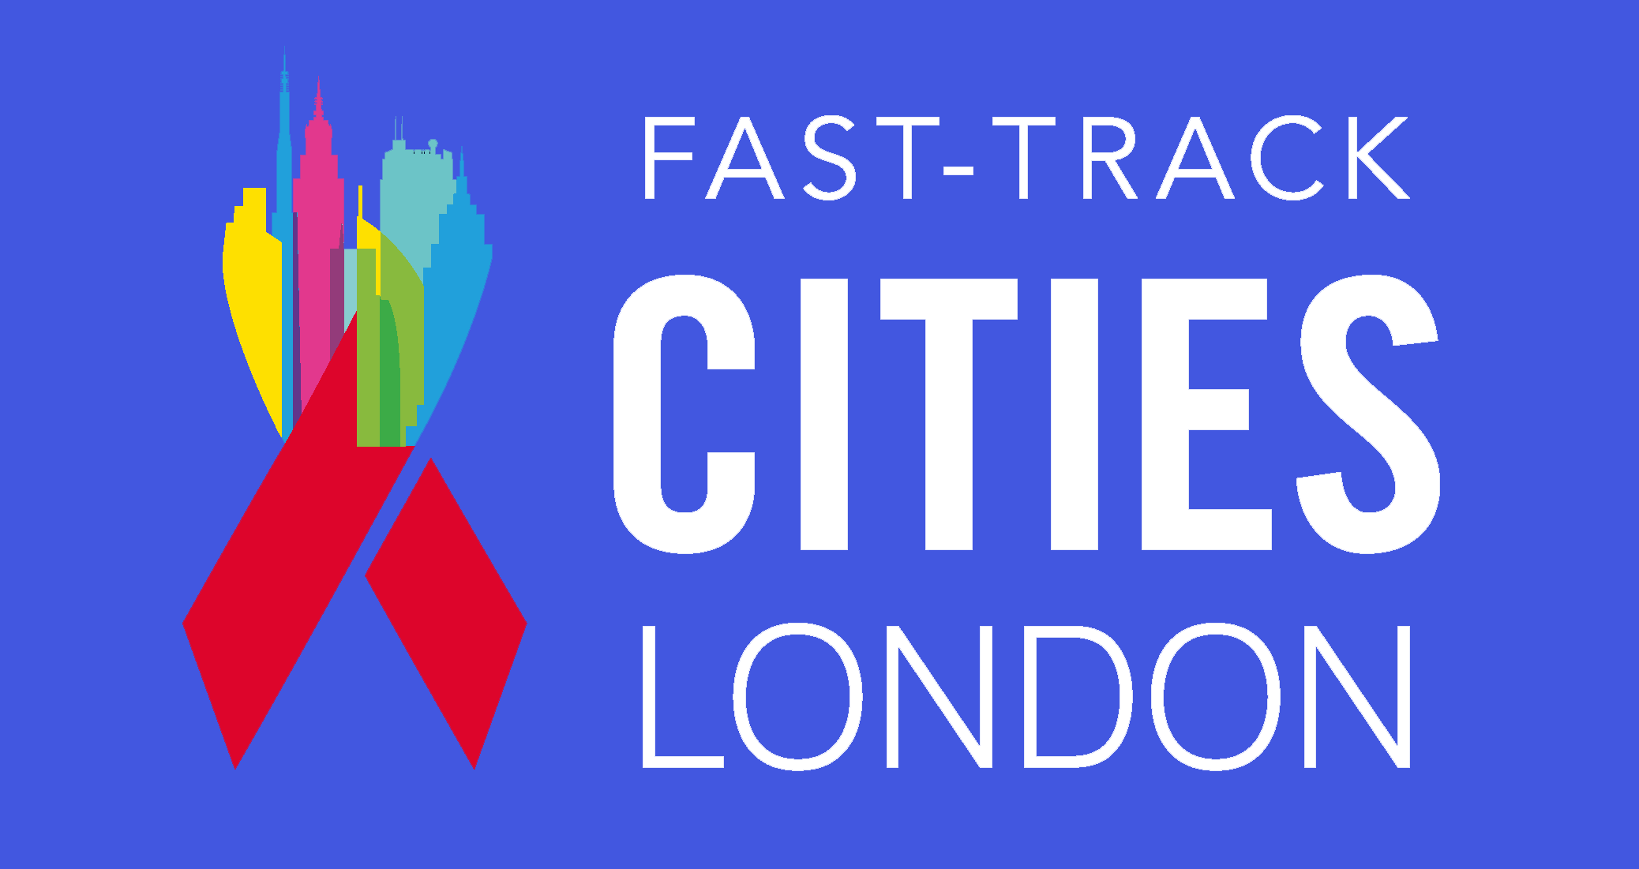
HIV care remains fragmented across services in London. People with HIV miss testing opportunities and face ongoing stigma and inconsistent support in healthcare settings. Primary care plays a crucial role in early diagnosis, prevention, and long-term management of HIV. Without better integration, people living with HIV receive disjointed, reactive care rather than the preventive, coordinated support they need.
London is part of Fast-Track Cities, a global initiative to achieve zero new HIV transmissions, zero AIDS-related deaths, and zero HIV-related stigma by 2030.

What we did
We developed a GP Champions model, designating 16 existing GP Champions across London's five integrated care systems to lead locally tailored initiatives improving HIV testing, prevention, and long-term care in primary care. We worked with people with lived experience and community organisations to ensure services addressed stigma, improved engagement, and were responsive to the needs of people living with HIV.
Learn more about the GP Champions model in this video: https://youtu.be/SvYQqwWq2pk?si=hHZ8lb4Higx7LD7T

Improving HIV testing and diagnosis
HIV testing increased by 29% in south London following the pilot launch in 2025. Over 2,000 primary care professionals were trained across London in HIV awareness and stigma reduction. The data showed increased statin prescribing (over 50% in some areas) and improved uptake of preventative care. This means more people are being diagnosed earlier, stigma is being reduced within healthcare settings, and people living with HIV are receiving more coordinated, holistic care closer to home.
Clients, stakeholders and clinicians reported that the programme improved relationships between primary and secondary care and removed barriers to delivering good HIV care.

Strengthening the system and driving policy change
The GP Champion programme is a key case study in the National HIV Action Plan released on 1 December 2025, informing primary care actions at national level.
Our evaluation identified five critical recommendations for scaling the model:
- sustain and scale the GP Champions model beyond the pilot
- fund HIV consultant involvement to reflect their essential role
- develop shared pan-London performance metrics
- provide local incentives to support GP practice engagement
- reframe HIV as a long-term condition to support integration into primary care.
The programme demonstrates that GP-led flexibility and local leadership drive innovation, and that strong collaboration between GPs, HIV consultants, and community organisations is essential for integrated care.

Curious to see how we can make a difference?
Interested in hearing more about how we have helped tackle health inequalities? Contact us for an informal chat.

Email us at:rf-tr.tphc-communication@nhs.net.

