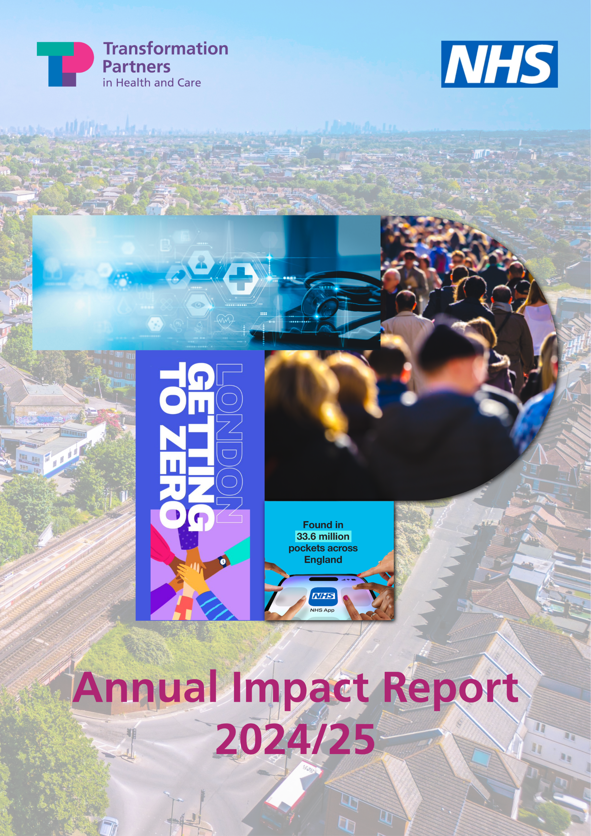

Settings

Contents

Contents 2
Introduction 4
Foreword 4
At a glance 5
Our teams 8
Analogue to digital 12
Digital and technology 12
Transforming adult social care through digital innovation in north west London 12
Streamlining contract management in north central London 13
Automating chronic kidney disease referrals in north central London 14
Digital communications 15
Promoting the NHS App in London 15
Data and analytics 16
Enabling secure access for NHS staff to vital data 16
Appraising the National Amyloidosis Centre’s data estate 17
Enabling data-driven healthcare in London’s prisons 18
Supporting better decision-making by the NHS 19
Hospital to community 20
Reducing dental inequalities and improving oral health outcomes for children and young people in north central London 20
Hepatitis C pilot successfully reaches and supports the health needs of east London’s homeless community 22
Engaging on a Neighbourhood Health strategy with staff at CLCH 24
Improving respiratory care in north central London 25
Improving care for people with long-term conditions in north central London 25
From treating to preventing sickness 28
Evaluation of London Covid Vaccination Outreach Programme 28
Integrating physical activity into NHS Talking Therapies with Sport England 29
Championing better mental health support for young Londoners 30
Championing a citywide mental health response with Thrive LDN 31
Supporting Londoners’ mental wellbeing with Good Thinking 33
Fast-Track Cities London mission for ending HIV epidemic 35
Convening community-led prevention in London 36
The London Homeless Health Partnership 38
Driving improvements through the Pan-London Co-occurring Conditions Programme 39
Organisation development and improvement 42
People 42
Develop your people, transform your impact: learning and development across the NHS and public sector 42
Transforming occupational health and wellbeing services for the NHS workforce in North Central London 44
Inclusion Improving accessibility of information for Moorfields patients 45
Sustainability 46
Taking a greener by design approach to digital in north central London 46

Introduction
This is the second edition of Transformation Partners in Health and Care’s Annual Impact report and provides a snapshot of our activity and impact in 2024/25.
We are proud to have worked alongside our partners and clients to navigate much change in the heath and care system and support them to take important steps to achieving their transformation and improvement goals.

Foreword
I am delighted to introduce our second Annual Impact Report for Transformation Partners in Health and Care (TPHC).
Over the past year, our outstanding Consulting, Partnerships, and Digital Productivity teams have continued to impress our clients with their exceptional talent, resilience, and ability to deliver meaningful change. Their commitment to NHS values has remained steadfast and, despite one of the most challenging years the NHS has faced, we are proud to have made a significant difference for both our clients and the people who rely on health and care services.
2024/25 was a time of considerable change and anticipation, with a new Labour government, a new Secretary of State for Health and Care, and the publication of the Darzi report, which was followed up in July 2025 by the publication of the 10 Year Health Plan for England. The NHS is embarking on a period of radical transformation, including three key shifts that will shape where our skills and support are most needed in the years to come:
- sickness to prevention
- analogue to digital
- acute to community
This report demonstrates how TPHC is already contributing to these shifts, with real-world examples of the impact we’re delivering for our partners and clients. It also showcases the breadth of knowledge and expertise across our teams — spanning data and technology, productivity, patient safety, mental health, primary care, large-scale change, and tackling health inequalities.

As with last year, uncertainty and pressure remain constant across the health and care system. TPHC is here to navigate these complexities with you, working in partnership to address challenges and deliver sustainable solutions that improve outcomes for all.
Sue Hunter
Managing Director
Transformation Partners in Health and Care

At a glance

In 2024/25 we delivered:

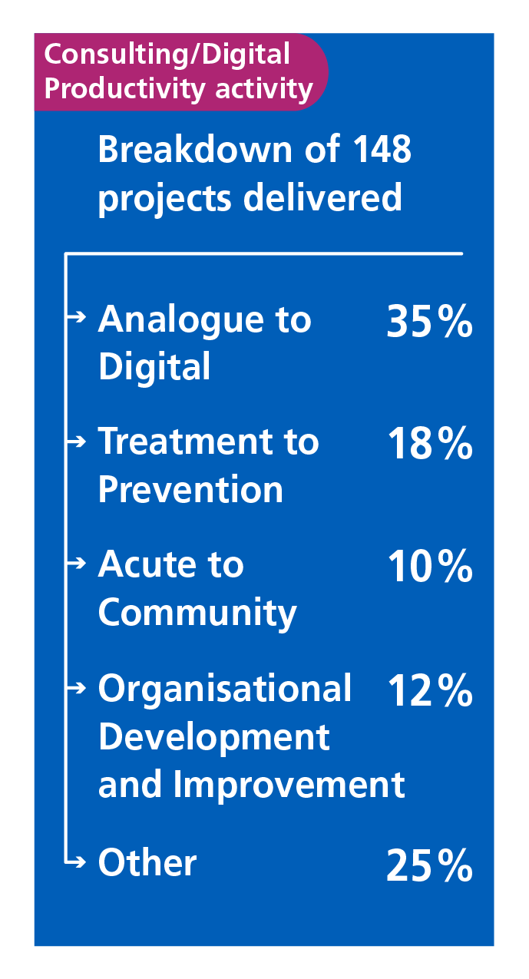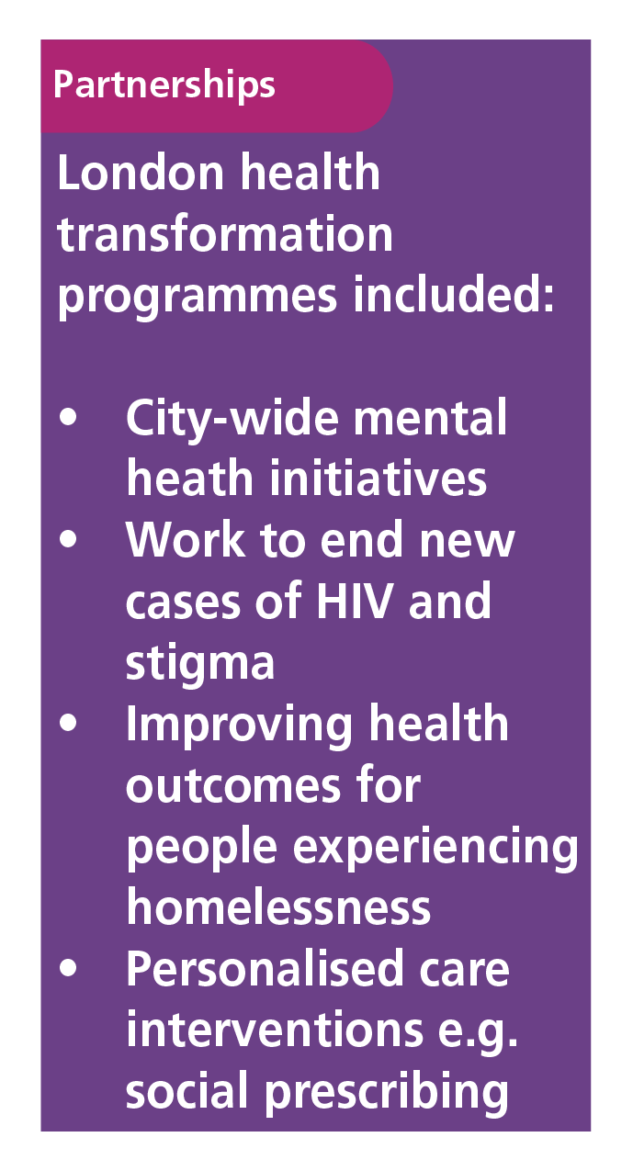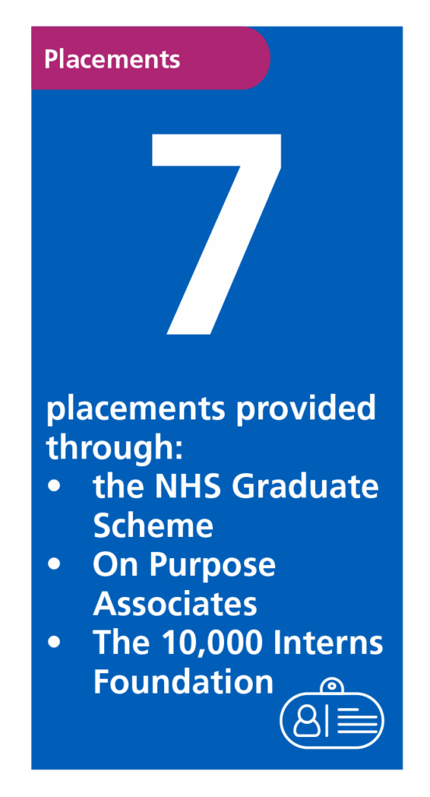
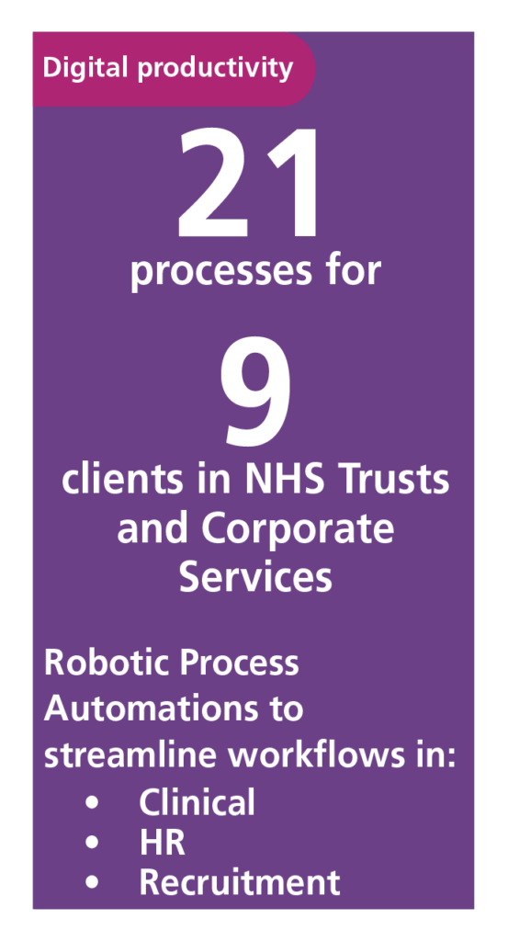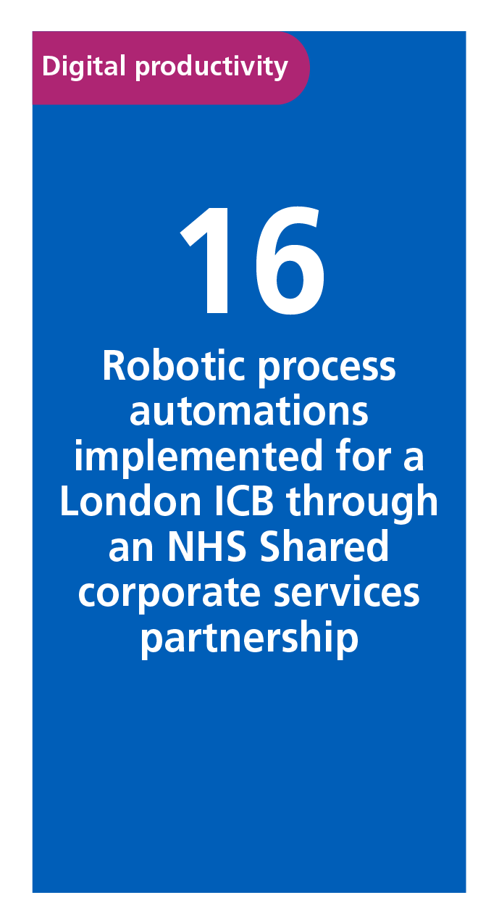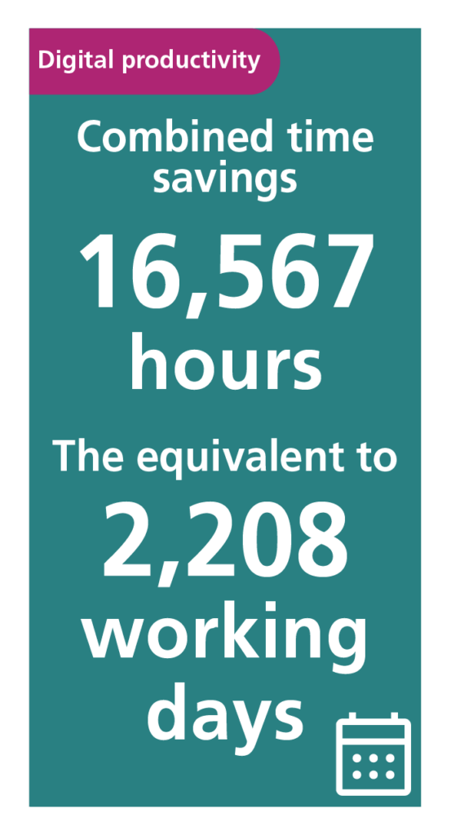

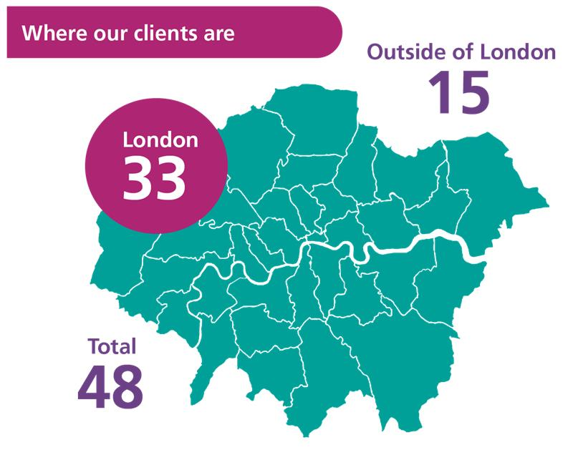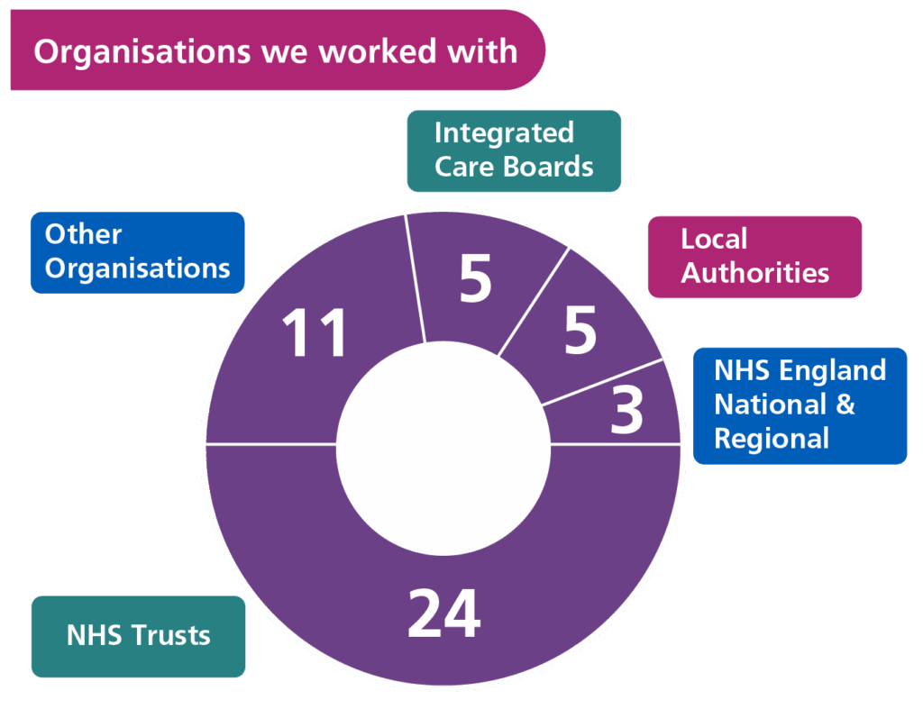

Healthcare awards recognition

We were shortlisted among 8 other entries from across the UK and went on to win the ''Connecting Health and Social Care through Digital'' award in the HSJ Digital Awards 2025 with North Central London Integrated Care Board. Two of our entries have been shortlisted in the HSJ Awards 2025, which attracted more than 1,250 entries from across the health sector:
- Our communications and engagement team are shortlisted for the “NHS Communications Initiative of the Year” award.
- TPHC, working in partnership with North Central London Integrated Care Board (NCL ICB) and Whittington Health, are shortlisted for the “Reducing Inequalities and Improving Outcomes for Children and Young People” award.


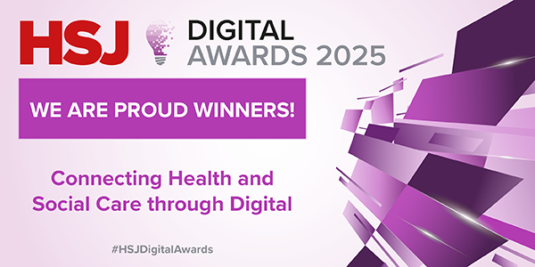

Our impact

Through our work with our clients and partners we are helping to improve health and care outcomes for patients and communities.
The Digital Productivity team delivered:
  - 21 robotic process automations (RPA) for 9 clients in NHS trusts and corporate services
  - Processes and solutions to streamline workflows in:
    - Clinical
    - HR
    - Recruitment
  - Combined time savings for clients of 16,567 hours, equivalent to 2,208 working days
  - Saving over 1,244 hours – equivalent to 155 working days – for the north central London kidney disease referrals team
  - Onboarding and connecting a London ICB to 16 robotic processes automations through an NHS shared corporate services partnership.

Results from our Consulting and Partnerships work in 2024/25 include:

- Growing and empowering London’s social prescribing link worker workforce to support half a million Londoners
- 'Tackling dental inequalities with North Central London Integrated Care Board by creating 71,650 additional dentist appointments across 41 local dental practices
- Hepatitis C, HIV and Hepatitis B pilot reaching 100+ people in one of London’s most deprived areas
Enabling 91% of care homes and 60% of home care providers in north west London to be digitally safe and secure
- Launching the first nationwide Population Mental Health Consortium and securing £7million funding for population-based improvements in mental health through a Kings College London and Thrive LDN partnership.

You can read more about these projects and other work later in this report.

Our teams

Consulting
As an MCA member, Transformation Partners in Health and Care (TPHC) Consultancy is committed to Consulting Excellence. We uphold the highest standards and demonstrate best practice for consultancy in the UK.

Currently, 9 members of TPHC Consultancy hold Chartered Management Consultant status (MCMI ChMC), the highest professional accreditation for management consultants in the UK, awarded by the Chartered Management Institute (CMI) in partnership with the Management Consultancies Association (MCA).

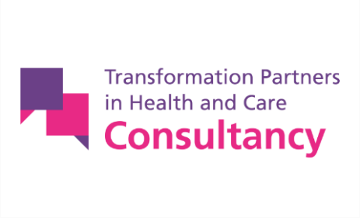
TPHC’s Consultancy team provided a wide range of services in 2024/25. We were pleased to work with new organisations in and out of the NHS, providing rapid, flexible and targeted support. We continued to take forward longer-term transformation work, alongside clients with whom we have formed partnerships, such as Sport England.
As part of our programme close-down process, we make sure that our clients are equipped with a shared vision, a clear implementation plan and an array of practical tools to take forward and mobilise their workforce. We keep in touch and enjoy seeing the real-time results and impact they are making on their people, patients and communities, and we are proud of the role we play in helping them to make change happen.

A few examples to highlight:
- In 2021/22, our team designed the Greener NHS programme and helped launch the world’s first net-zero ambulance. Fast forward to 2024/25, and the London Ambulance Service has launched its first electric ambulances as part of its ambition to drive towards a net-zero fleet. It’s fantastic to see work that we started helping to improve air quality for Londoners and reduce fuel costs for London’s ambulances
- In February 2025, the Mayor announced the launch of the London-wide Appropriate Adult service, which ensures children and vulnerable adults are supported during police interviews or while in police custody. The £5.4million pan-London service fills a historic gap in provision and ends variation across boroughs. It is based on recommendations from our work, which were fully adopted by The Mayor’s Office for Policing and Crime (MOPAC) and regional co-funders.
- In February 2025, the Secretary of State for Health and Social Care informed stakeholders he had decided not to “call in” for review NHS England’s decision on the future location of very specialist cancer services for children with cancer living in south London and much of south east England. We provided expert communications and consultation support for this complex reconfiguration, enabling a decision which HSJ quoted the Secretary of State for Health and Social Care as saying was the “best decision” for young cancer patients.
- The Framework for Integrated Care (Community), which we co-developed with NHS England’s Health and Justice Children’s programme, has been the foundation for a vanguard programme by Healthier Together, the Bristol, North Somerset and South Gloucestershire (BNSSG) integrated care system. The Framework was created as part of the 2019 NHS Long Term Plan commitment to provide additional support for the most vulnerable children experiencing complex trauma. It sets out guiding principles and practices that act as a template for genuine co-production and development of integrated services for children and young people with ‘high risk’ behaviours that may lead to contact with the criminal justice system. We worked with NHS England to shape and launch the Framework in consultation with clinical specialists and multiple agencies.
BNSSG’s pioneering work has been shortlisted for two HSJ Awards in 2025.
This recognition highlights its innovative approach to integrated and multi-agency working within a trauma-informed system, improving outcomes for children and young people with complex needs, by reducing high-risk behaviours and supporting their overall wellbeing.

You can find out more about a selection of work we delivered in 2024/25 later in this report.

Digital productivity

TPHC’s Digital Productivity team is a collective of NHS digital professionals with over 60 years of combined experience in the field of intelligent automation.

The team’s catalogue offers over 100 clinical, HR and recruitment robotic process automations (RPAs) which are being used to support organisations across the NHS. Collectively, these RPAs are saving over 16,567 hours for our clients, equivalent to 2,202 working days and a crucial timesaving for our NHS colleagues.

Powering efficiencies in shared corporate services
In 20242/25, robotic process automations continued to power North London Partners Shared Services’ (NLPSS) award-winning recruitment robotic process automations, which are designed and deployed by the Digital Productivity team. NLPSS provide shared corporate services to eight NHS trusts and the North Central London Integrated Care Board. Automations save the partners’ time and money while also improving the recruitment experience for recruiters, applicants and new hires.

Benefits include:
- an annual £500k saving for the recruitment team, by reducing the need for agency support
- average time to hire new staff is reduced from 35-50 to 16 days
- consistent high score of 90% candidate satisfaction score with the employment check process.

Innovating by the NHS, for the NHS
The team has also been busy behind the scenes, working to deliver a first for the NHS. The Digital Productivity Platform (DPP) builds on our vision of bringing different digital technologies, such as Intelligent Automation, to the NHS, offering value for money through a pay-as-you-go model.

This is a first for the NHS and enables organisations of any size, financial status, and digital maturity to access digital productivity tools as a service. More will be shared about the results for our early adopter organisations in 2025/26.

Partnerships
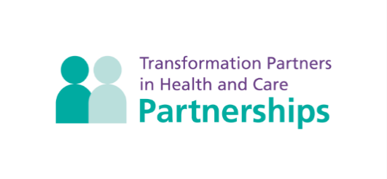
2025 marks 10 years since the formation of the Healthy London Partnership (HLP). HLP was established by London’s NHS, London Councils, the Mayor of London, the London Association of Directors of Public Health, the Office of Health, and other local organisations and individuals to address the health and care challenges facing London.

HLP’s work continues today through our Partnerships team, who in 2024/25 led eight transformation programmes on behalf of 47 funders across London. The teams delivered work to:
- improve Londoners’ mental health and emotional wellbeing with city-wide initiatives led by Thrive LDN and free digital mental health and wellbeing support through Good Thinking
- put an end to HIV in London as part of the Fast Track Cities Initiative
- improve health outcomes for people experiencing homelessness
- deliver personalised care interventions, such as social prescribing and the community chest model
- transform urgent and emergency care, and cancer services
- we also delivered the London Vision with The Office of the London Partnership.

The Partnerships team are experts in convening multi-agency programme boards and delivery teams to agree city-wide priorities and co-create targeted, once-for-London solutions to address them. We are proud of our role as transformation instigators, who create and sustain momentum to make lasting change happen.

With much progress and change now embedded in the system, London leaders agreed that work in urgent and emergency care, transforming cancer services, homeless health and community prevention was ready to transition back into the system for local teams to take forward business as usual. This creates space for new priorities to be taken forward at a regional level.

You can read highlights from these programmes and the impact we have made with our partners.

Part 1

Analogue to digital
TPHC’s specialist digital and analytics consultants and Digital Productivity team support organisations and teams across the NHS and social care to transition safely and sustainably from analogue to digital systems and pathways.

In 2024/25, we provided expertise and resource to support digital transformation at the trust, system, regional and national levels. We built and deployed process automations to achieve crucial time savings for teams and services, delivered digital transformation programmes for integrated care systems, and developed and improved multiple statistical and visualisation tools, including dashboards for the national Federated Data Platform.

Digital and technology

Transforming adult social care through digital innovation in north west London
TPHC has partnered with North West London Integrated Care Board since 2023 to deliver two key national programmes under NHS England’s Digitising Social Care initiative: the Data Security and Protection Toolkit and Digital Social Care Records.

With our support, 91% of care homes and 60% of home care providers in north west London are now digitally safe and secure, and 86% of all care providers use digital shared care records for all those they support.

With over 700 CQC-registered providers in north west London and no local delivery support available, TPHC stepped in as Local Support Organisation for the digitisation, leading engagement, delivery and reporting across the system. We built strong relationships with the eight local authorities and, via their networks, engaged providers through forums, webinars and tailored outreach.

Client feedback stated: “We could not have delivered the key outcomes for residents without the expertise and approach from the TPHC team. This has real meaning for patients and care homes.” Jane Wheeler (Programme Director Local Care, NWL ICB).

Better for residents with care needs
- Digital social care records allow real-time updates and shared access to care plans for care homes staff, improving patient care.
- When care providers implement the Data Security and Protection Toolkit, the data of people who receive care from them is protected.

Better for the NHS and care services
- Better information sharing improves efficiency.
- This programme has helped north west London’s health and care system to work more closely together. Next steps could include integration and shared digital infrastructure.

Streamlining contract management in north central London
TPHC worked with North Central London Integrated Care Board to enhance their contract and procurement management by implementing Atamis, the Department of Health and Social Care’s cloud-based platform, replacing previously spreadsheet-driven processes.

We undertook an in-depth review with ICB commissioners, which found inefficiencies that adopting Atamis would address. We designed and piloted a target operating model for contracting teams in the ICB that restructured workflows, clarified responsibilities, and embedded Atamis’ full functionality.

The target operating model enables real-time visibility of contract lifecycles, automates workflows for compliance, and centralises key performance indicator monitoring, enabling Atamis to become the single source of truth across the system for contracting and procurement.


Our work included:
- establishing an Atamis Working Group to lead implementation and change
- developing supporting material, including user guides and stakeholder FAQs
- delivering dashboards and user stories to demonstrate impact and track progress.

Better for patients
- More efficient back-office processes (such as automated renewal notifications, invoice matching and contract storage) can unlock 10 to 20% cost savings, which can be reinvested in frontline services such as staffing, diagnostics, and equipment, ultimately enhancing patient care.
- Proactive contract performance management provides better visibility of provider delivery and service reviews, enabling faster resolution of underperformance and ensuring patients receive high-quality, reliable care.
- Improved visibility and control over service contracts helps identify gaps in access or inequalities in provision, supporting fairer distribution of resources and helping all patients to receive timely, consistent care regardless of location or background.

Better for the NHS
The pilot scheme resulted in the ICB:
- improving contract data completeness from 55.2% to 98.3%
- empowering commissioners to proactively manage their contracts
- reconciling 364 contracts with 99.8% match accuracy to previous spreadsheet-based contract registers.

Full rollout of the target operating model is planned for 2025, pending funding approval.

Atamis also:
- enables visibility of suppliers’ environmental, social and governance performance
- reduces paper waste and the administrative burden of analogue working.

Client impact:
We received positive feedback from the client: “Our high-quality, technically complex support transformed operations and laid the groundwork for smarter, more sustainable procurement.”

Automating chronic kidney disease referrals in north central London
TPHC’s Digital Productivity team worked with Royal Free London NHS Foundation Trust to streamline the referral process for chronic kidney disease across north central London, improving efficiency and reducing the risk of manual errors.

The Royal Free’s chronic kidney disease team receives up to 70 referrals a week.
Previously, each required around 30 minutes of manual work to register, triage, and respond to, placing strain on resources and increasing the risk of human error.

To tackle this, we developed an automated referral workflow, integrated with the NHS e-Referral Service and clinical system EMIS, which automated the full referral process.


The project’s success was built on close collaboration with clinical, digital and information governance teams. The automation passed a robust DPIA and met the DCB0160 clinical safety standard, ensuring secure handling of patient data and safe interoperability between systems.

Better for patients and the NHS:
The automation went live on 15 April 2024. As of February 2025:
- 2,489 chronic kidney disease referrals processed end-to-end via automation
- over 1,244 hours saved – equivalent to 155 working days
- reduced admin burden and faster, more reliable triage
- won the Quality Improvement and Efficiency award at the RFL staff awards 2024.

“It has been a pleasure to work with the TPHC team... Their innovative solution supports interoperability between clinical systems and eases the burden on administrative teams.”
Sarah Milne, clinical lead for chronic kidney disease

This successful automation demonstrates how targeted digital solutions can deliver measurable productivity gains while improving patient safety and clinician efficiency.

Digital communications

Promoting the NHS App in London
TPHC’s communications team supported the NHS in London to promote awareness and drive usage of the redesigned NHS App through a coordinated campaign which reached both broad and hyperlocal audiences.

Alongside a three-month London-wide campaign, for which we developed assets and messages which were shared with communities and stakeholders by the NHS and other partners, we ran a four-week targeted social media campaign in north west London. This was supplemented by a leaflet door drop to households in the two north west London primary care networks with the lowest NHS App uptake.

The campaign, which was co-designed with NHS and community partners, performed above benchmark and increased NHS App engagement at every level, with the greatest gains in the areas where usage had been lowest:
- London region: 7.4% increase in logins (an increase of 638,531 logins), 12.3% increase in GP medical record views (an increase of 475,218 medical record views).
- North west London: 3.5% increase in logins, 8.3% increase in record views.
- Targeted primary care networks: 6.5% increase in logins, 9.2% increase in medical record views.

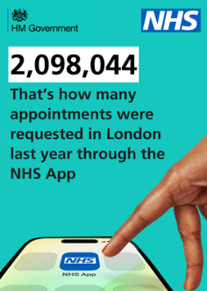
Better for patients
- More people are benefiting from the convenience of the NHS App.
- Greater use of technology for patients who want it, and frees up face-to-face appointments for those who don’t.

Better for the NHS
- People who have their notifications turned on get automatic messages through the NHS App, saving the cost and time of sending texts and letters.
- Staff are benefitting from reduced admin workload, with more time to focus on complex patient needs.

Data and analytics

Enabling secure access for NHS staff to vital data
The NHS Federated Data Platform (FDP) allows NHS trusts and other organisations to share information in a safe and secure environment. Staff with the need to see specific information – for direct patient care or planning, for instance – can access it safely and securely without having to log into different systems.
Our team has played a key role in supporting the FDP and the migration of national datasets, laying the foundation for more connected, data-driven healthcare in the future. Our team is currently working with NHS England to provide delivery support to pilots of the FDP products, including patient-led validation of waiting lists for acute NHS providers in London and Cumbria, which will enable trusts to maximise use of clinics.

Better for patients
- Simplifying complex systems means more patients can be seen faster, and those who have the most urgent needs can be prioritised.
- Access for planners to near real-time data (with identifying information removed) improves the NHS’s ability to maximise uptake of available appointments, helping cut waiting times.
- The FDP has several products which improve care for patients, and more will be added.

Better for the NHS
- Simplifying complex systems means the NHS saves time and money, which can be used to support patient care.

Appraising the National Amyloidosis Centre’s data estate
The National Amyloidosis Centre (NAC), based at the Royal Free Hospital in London, supports the diagnosis and care of patients with amyloidosis across England.

To meet growing demands, NAC wanted to explore ways to modernise how it stores and uses patient data. A key goal was to improve how information is shared with other hospitals involved in amyloidosis patient care.

At present, NAC uses an older system to manage patient records and appointments. Although this system has been adapted over time, it now faces many limitations. TPHC’s data and analytics team was commissioned to carry out a detailed review, engaging with key staff and stakeholders, and exploring future needs, privacy concerns, costs, and the practicality of upgrading the system.

The outcome was a proposal for a modern, integrated data system that could be hosted either within the NHS or by an external provider and would include advanced tools for reporting and data analysis. We are now working with NAC to develop a business case to support these improvements.

Better for patients
Currently, patients across England need to travel to the amyloidosis centre in London for advanced treatments. Patients will benefit from better ongoing and improved care that is closer to home, with more virtual diagnostic activities made possible by the modernised data estate.

Better for the NHS
This project delivered significant value, including a clear and actionable roadmap to move from legacy systems to a modern, resilient data environment. Amyloidosis clinicians will benefit from better decision-making with access to new and centralised data sources and data exchange between providers. This will also support clinicians running clinical trials.

Enabling data-driven healthcare in London’s prisons
NHS England – London’s Health and Justice team commissions healthcare services for those held in the capital’s prisons. A critical challenge in monitoring service delivery and improving care pathways was the lack of consistent, high-quality data.

To address this, TPHC partnered with the Health and Justice team to develop a comprehensive data strategy for adult prisons across London.

Working closely with commissioners, clinicians and providers, we developed an automated data architecture and designed a new London Prisons Healthcare dashboard.

The dashboard provides a shared, system-wide view of the healthcare needs of the adult prison population. It supports consistent data collection across sites and provides clear insights into how care is being delivered and where improvements are needed.

Through regular engagement, workshops and focus groups, we ensured the dashboard met real-world needs and priorities, helping to:
- standardise data collection and reporting across London prisons
- establish additional data collections to address identified gaps in knowledge
- enhance regional teams’ understanding of the healthcare needs of the secure and detained population
- identify efficiency opportunities through a new "Escorts and Bedwatches" data collection and dashboard, which tracks high-cost, high-risk escorts and bedwatches activity (where prisoners need to receive care outside of the secure estate)
- deliver a framework for identifying inequalities and promoting equitable care.
Better for patients
The dashboard is providing an evidence base to inform the recommissioning of services. This includes a prison’s inequalities analysis report that created an analytical framework based on Core20PLUS5 and identified areas of potential inequality across several clinical areas. This is being taken forward by a pan-London expert reference group as a key component of a wider inequalities strategy.
Better for the NHS
Our work enables NHS England and partner organisations to make evidence-based decisions, supporting service redesign, informing the recommissioning of care, and shaping strategy to address health inequalities.

The data is also used in high-level briefings, including for the National Chief Medical Officer and World Health Organisation forums, and is central to London’s emerging prison health inequalities strategy.

Supporting better decision-making by the NHS
NHS England uses national dashboards to track performance and progress across key health priorities, improving transparency. TPHC’s experienced technical and business analysts worked closely with NHS England’s Data Services team to ensure these dashboards meet users’ needs and deliver high-quality insights. We helped design, plan, and deliver dashboards that support better decision-making at both local and national levels.



Better for patients
Dashboards we’ve supported, such as for health inequalities, primary care networks, and urgent and emergency care, enable NHS teams to target interventions and resources where they're needed most.

Better for the NHS
By bridging the gap between technical delivery and user needs, our work has contributed to better use of NHS data and more efficient services.

Better for the NHS workforce
We led on the design and development of the dashboards, ensuring they are relevant, usable, and align with clinical and operational goals. This freed up NHS development and engineering teams to focus on technical delivery and improved collaboration and clarity across programme teams.

Part 2

Hospital to community
In 2024/25, our teams supported clients to evolve how they deliver the best care for patients and populations in their communities and closer to home. This work will continue and expand as the “left shift” from hospital to community becomes the new, better way of doing things for the NHS, improving patients’ outcomes and wellbeing.

“The best bed is your own bed”: Patients recover faster and retain more independence if they are in the place they call home.

Reducing dental inequalities and improving oral health outcomes for children and young people in north central London
North Central London’s Dental Transformation Programme shows what’s possible when dental care is prioritised and shaped locally. The Integrated Care Board has co-developed targeted workstreams to transform dental outcomes for children and young people. We played a key role in coordinating and delivering this programme, with engagement with local authorities, NHS England, dental public health consultants and local dentists to identify shared priorities and inequalities.

Addressing oral health inequalities
A deep-dive exercise into dental health inequalities in NCL identified a clear link between deprivation and poor oral health outcomes in children, including hospital admissions for tooth decay. Children from the most deprived wards experience more severe tooth decay and often face associated anxiety, school absence, and long-term health risks. The ICB made a strategic decision to reinvest underspend into dentistry to improve access and outcomes. Targeted initiatives were co-produced with local communities and organisations to increase engagement and uptake.

Preventative interventions for children and young people
A Supervised Toothbrushing Programme was co-designed with local dental practices and boroughs, targeting over 1,000 3 to 4-year-olds in over 70 early years settings in the most deprived wards to promote good oral health. The programme is reinforced by educational materials for parents and policies promoting healthier food and drink choices.

A staff member shared: “Children enjoy it and...even prompt each other to brush the back teeth themselves.”

The ICB also invested in Giving Up Loving Pop (GULP), delivered by Tottenham Hotspur Foundation to children aged seven to 11 in 20 schools in high-deprivation areas, focusing on sugar reduction, hydration, oral hygiene, and physical activity.

GULP received royal recognition with a visit from His Royal Highness, The Duke of Edinburgh, at Tottenham Hotspur Stadium, pictured below.

Better for children
- Toothbrushing twice daily rose from 47.1% to 61.8%, and children demonstrated better recognition of high-sugar drinks such as smoothies and milkshakes.
- 75% of classes taking part in GULP were in the 20% most deprived areas.
- Preference for water over high-sugar drink alternatives in school increased from 51.1% to 79.2%, and during sports from 21.3% to 49.7%.

Better for the NHS
The programme is improving dental access and outcomes for children, helping to embed healthier habits at a young age. It will prevent more children from developing dental issues and other health-related issues later in life, particularly in areas of higher deprivation in north central London.

Better access to dentistry
71,650 additional Units of Dental Activity were allocated across 41 local dental practices, providing thousands more patients from deprived areas with access to dental care. Practices also introduced extended hours, including after-school slots for children to further cut waiting times.

Reduced treatment delays
To address the backlog of children needing dental work, including extractions under general anaesthetic, North Central London Integrated Care Board funded additional capacity, including weekend clinics at community dental practices.

Better for children
- Data from local dental practices shows waiting times for appointments fell from 20 to 17 weeks despite an increase in the number of referrals
- There was a 228% increase in paediatric general anaesthetic procedures within the community dental service. This reduced referrals to secondary care by 85%.

A community dentist shared feedback from a parent of a child who underwent an extraction, thanking the service for the availability of a weekend appointment, ‘‘as she knew...the treatment, which involved some stainless-steel crowns, could have ended up being secondary care-based extractions under general anaesthetic had she waited too long”.

The programme was underpinned by robust governance, reporting, and assurance frameworks. The success of the Dental Transformation Programme is a testament to the strength of system-wide teamwork in delivering meaningful, sustainable change.

Hepatitis C pilot successfully reaches and supports the health needs of east London’s homeless community
People experiencing homelessness and those who inject drugs face significant barriers to accessing healthcare. This leads to poor health outcomes, including high rates of Hepatitis C and other blood-borne viruses. Nationally, NHS England has made real progress in reducing new infections and increasing treatment uptake for Hepatitis C and blood-borne viruses, but reaching underserved population groups, like people experiencing homelessness, remains a challenge.

The Homeless Health London Partnerships Programme at TPHC was commissioned by the NHS England National Hepatitis C Elimination Programme to deliver a pilot project, aiming to improve access to Hepatitis C care pathways and support NHSE England’s objectives of Hepatitis C virus (HCV) elimination by 2025 and to improve health outcomes.

The pilot in north east London was co-designed in partnership with both primary and secondary care healthcare professionals, experts by/with lived experience, local substance misuse service, advocacy organisations and peer outreach services, through a series of focus group sessions.

The TPHC team worked with Health E1 Homeless Medical Centre, a specialist practice serving people experiencing homelessness in Tower Hamlets, one of London’s most deprived areas. The team ran training and education sessions with all practice staff, covering each blood-borne virus, stigma awareness and trauma-informed care. The innovative pilot model offered integrated rapid blood-borne virus testing (Hepatitis C, HIV and Hepatitis B), peer outreach support, harm minimisation, wound care, liver health screening, tuberculosis screening, vaccinations, and access to a holistic primary care clinic through a drop-in model.

A service user told us: "This was the first time I felt I was being treated like a human being by a health service."

Also that:
"I wouldn’t have come in if I had to make an appointment or speak to a receptionist. I’ve been turned away too many times before.

"It helps when someone has lived your life and can explain things in your language."

Pictured below (seventh from left), Dr Chris Streather, Regional Medical Director at NHS England – London, visited Health E1 following World Hepatitis Day to learn more about the drop-in clinic.

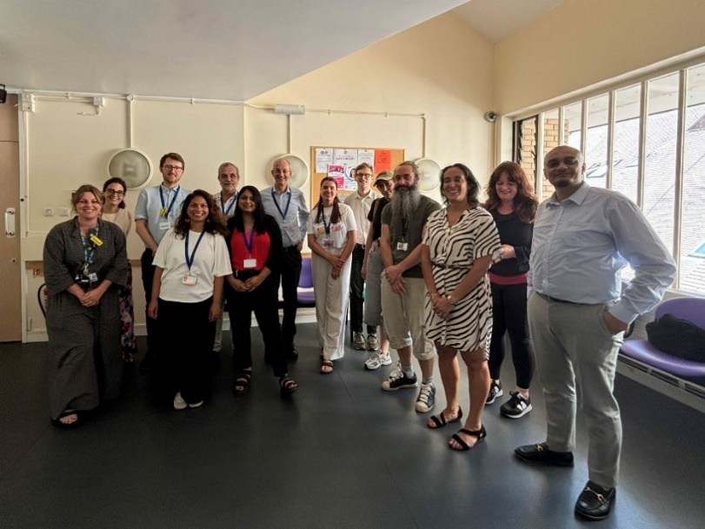

Better for Londoners from minoritised backgrounds
The pilot reached 104 people, many of whom were injecting and/or smoking drugs, sharing equipment and were rough sleeping at the time. The clinic saw more women and people from ethnic minority and migrant backgrounds than typically seen by homeless and drug treatment services.

Key clinical outcomes from the six-month pilot:
- Three people were newly diagnosed with Hepatitis C infection and referred to the specialist team at Barts Hospital for follow up. Two have completed their treatment.
- One person living with HIV who had previously disengaged from HIV care has re-engaged after attending a drop-in clinic. They are supported by a peer support worker from Positive East.
- Integrated support and other health interventions offered on site, such as needle exchange and wound care, enabled nine people to avoid hospital admission.
- The project also supported broader health and social needs, making nine referrals to the local substance misuse service, carrying out 98 fibroscans to measure liver stiffness, and registering 10 patients with Health E1 Homeless Medical Centre.

Better for Londoners
The Hepatitis C pilot at Health E1 shows that a holistic primary care service offering a welcoming environment for people can successfully engage with underserved individuals in London, identifying critical health needs and successfully linking individuals to life-saving treatment and support.

"The partnership worked well to help bring people in – it was a good setup...We caught infections early and got people into care who would never have come to the hospital." Member of the pilot team

“I don’t see why this wouldn’t work in other areas; rough sleeping isn’t unique to Tower Hamlets.” Member of the pilot team

By facilitating new GP registrations and making referrals to other services, including housing, mental health, drug and alcohol, or specialist hepatology clinics, depending on need, people’s health outcomes are improved.

Better for the NHS
This pilot demonstrates the power of integrated models of care with peer outreach support, co-designed with experts by experience. Proactive care has the potential to reduce emergency hospital attendance and the high costs it incurs.
The evaluation report from the Health E1 pilot is due to be published in 2025, and a second pilot is scheduled for 2025 at a non-specialist practice in Croydon, building on the learning to date.

Engaging on a Neighbourhood Health strategy with staff at CLCH
In 2024/25, Central London Community Healthcare NHS Trust (CLCH) developed a powerful new corporate strategy to underpin integrated, innovative working with its partners and communities as part of a Neighbourhood Health Service.


The Trust asked TPHC’s specialist communications and engagement team to engage with CLCH staff, building their understanding of how the strategy will empower them to work differently and gathering information on the opportunities and challenges they see.

We developed simple messaging and held events with over 130 clinical, non-clinical and corporate staff, mainly in-person in each of the Trust’s five divisions, and also online.

Staff who engaged were interested and positive about the strategy and appreciated having a safe space to raise concerns, including potential challenges with implementation.

Our report for the Trust’s leadership summarised the key themes from staff engagement and recommendations for action to inform how they implement the five-year strategy, launching in 2025/26. We also developed a toolkit and resources for senior staff and team leads to undertake further engagement.

Better for patients
Staff had good ideas about how CLCH’s new corporate strategy will help them transform the health and wellbeing of the communities they serve. These included spreading good practice and operationalising new initiatives more quickly, educating and working more closely with partners, supporting patients to take greater control of their own health, and making better use of technology to free up clinical time for patient care.

Better for the NHS
Staff ideas included ways to reduce duplication and bottlenecks in pathways, and to make better use of technology to free up clinical time for patient care. These will improve efficiency and make better use of staff time and effort.

Improving respiratory care in north central London
In 2024/25, TPHC supported North Central London Integrated Care Board (NCL ICB) on several critical projects to improve healthcare delivery and patient outcomes. These included respiratory diagnostic hubs, long-term conditions clinical networks, and the local maternity and neonatal system.

We supported NCL to set up respiratory diagnostic hubs to address a significant backlog in spirometry testing following the pandemic. The work with system stakeholders resulted in the creation of new clinical pathways, a new way to search cases that identified over 5,500 high-risk patients, the establishment of multidisciplinary teams (MDTs) with specialist expertise, and training for over 150 staff.

Better for patients
Thanks to enhanced training for GPs and faster testing, resulting in a quicker diagnosis, patients are being diagnosed at an earlier stage of their illness, helping them to stay well for longer. Patients now have access to the same, high-quality service, wherever they live in north central London.

Better for the NHS
The service has enhanced collaboration and improved efficiency, cutting down on delays and duplication so that it is more sustainable.

Improving care for people with long-term conditions in north central London
We supported the review and future strategy of North Central London’s Long-Term Conditions Clinical Networks, as they move from multiple, individual networks focusing on a single condition in isolation to a more holistic approach, looking at multiple long-term conditions in the round.

Our report set out principles, benefits and critical success factors to develop governance arrangements and structures and the successful creation of new Long- Term Conditions Clinical Network structures.

Better for patients
A holistic and integrated improvement approach by clinical networks to long-term conditions pathways will improve preventative and proactive care for patients, particularly older people, people from deprived communities and people from ethnic minority backgrounds, who are at greater risk of having multiple long-term conditions.

Better for the NHS
A holistic approach will enable more shared learning and innovation, which will improve NHS efficiency.

"TPHC has delivered excellent support for our work on development of the Long-Term Conditions Clinical Networks and the work on spirometry. They have been committed, professional, extremely thorough and determined to stick with both projects through all the challenges. It has felt like one team and that they were as passionate about project success as I was, which was really gratifying. Both projects also required working across organisation with a lot of ambiguity and both times they were equally effective and skilled at that. Big thanks."
Amy Bowen, Director of Proactive Care and Long-Term Conditions for NHS North Central London Integrated Care Board

Improving maternity care in north central London
We assisted North Central London Integrated Care Board’s Local Maternity and Neonatal System to reduce inequalities. The work included:
- testing ways to increase referrals of Black women and birthing people to perinatal mental health services
- enhancing Maternity and Neonatal Voices Partnerships
- streamlining Local Maternity and Neonatal System governance, communications and processes for sharing learning
- supporting the system’s Maternal Medicine Network
- improving language services.

Now there is a stronger focus on embedding anti-racist practice, a better understanding of perinatal mental health, increased collaboration between maternity and mental health teams, more support for Maternity and Neonatal Voices Partnerships, which are service user-led groups, and more feedback about neonatal services.
Four trusts in North Central London with maternity services have a Maternity and Neonatal Voice Partnership (MNVP) representing women and families who have used maternity and neonatal services, and including professionals who provide these services.

As a result of our work:
- MNVPs have received additional funding and resources, enabling them to hear from more women and families
- service user leads are now becoming involved in NCL-wide projects, ensuring user voices are heard at a system level
- We are helping service user-led groups to strengthen links with community groups to better understand the experiences and priorities of people who experience the worst health outcomes. This feedback will inform improvements to services.

Better for patients
The changes are addressing some of the most significant barriers to improved patient safety, outcomes and experience:
- Feedback from parents has identified a lack of communication and information about the neonatal repatriation process (where patients are moved between different hospitals according to their needs). This is being fed into an NCL review of antenatal education and a review of the NHS’s Operational Delivery Network service specification.
- We worked with NCL trusts to develop a standard operating procedure for on-demand interpreting and are supporting a pilot of the CardMedic interpreting and translation tool for medical staff. We are also working with the language service provider to improve its performance and support effective contract monitoring. Key performance indicators, pilot results, and feedback will inform system-level work to remove language barriers so staff across north central London trusts can communicate with service users from all backgrounds.

Better for the NHS
These improvements for patients will help make the most of NHS resources in north central London.

"TPHC's programme management skills, ability to engage stakeholders and work flexibility has given momentum to the Equity and Equality Action Plan. Their experience and network connections have been incredibly valuable in helping us learn from others and work more productively. They are an absolute joy to work with and have added huge value to the team, we are very grateful for your support and expertise."​ Sumayyah Bilal, Assistant Director of Maternity & Neonates Quality, Service Development & Commissioning for NHS North Central London Integrated Care Board

Part 3

From treating to preventing sickness
The shift from treating to preventing sickness requires tackling the underlying causes of ill health and promoting healthier lifestyles. TPHC has been working with clients and partners across London and other regions to deliver preventative programmes and initiatives. This includes the work of our pan-London Partnerships programmes, which are run on behalf of regional organisations, and bespoke work delivered by our Consultancy team for our clients.

Across the board, this work supports the health and care needs of diverse populations and communities, helping them to live longer, healthier lives. Learning and insights from our teams are regularly shared regionally and beyond to support the delivery of best practice on effective preventative approaches.

Evaluation of London Covid Vaccination Outreach Programme
NHS England – London commissioned TPHC to evaluate its autumn/winter 2024/25 outreach programme. This programme looked to address persistent disparities in COVID-19 vaccine uptake and improve equity. The evaluation focused on Black African, Black Caribbean, and Bangladeshi communities in six key London boroughs, supported by a pan-London overview.

Our comprehensive assessment measured how effective the programme was at increasing vaccine uptake and trust in the vaccine. We provided data-driven insights and recommendations to inform future vaccination efforts.

Key outcomes included:
- shifting vaccine perceptions: the programme demonstrated a strong impact, with 86% of previously hesitant people shifting to a ‘very likely’ stance post-engagement. Key drivers included empathetic peer champions and offering vaccines in familiar, accessible settings
- strategic recommendations: we emphasised the value of trusted, community-led initiatives such as breakfast club pop-ups and improved access through mobile clinics, which collectively delivered over 18,000 vaccinations through access and inequalities-funded initiatives
- rich community insights: results from over 1,000 public surveys and engagement with 24 organisations highlighted mistrust, often linked to local misinformation, as a major barrier to vaccine uptake and underscored the importance of culturally tailored messaging through trusted community figures.

Better for Londoners
NHS England London and ICBs are currently developing action plans for how to implement the recommendations. Our evaluation findings provide the NHS in London with critical insights to shape future vaccination outreach and build greater trust within London's diverse communities, improving equity and protecting Londoners.

Integrating physical activity into NHS Talking Therapies with Sport England
We are supporting Sport England to explore how physical activity can best be integrated into NHS Talking Therapies. The initiative is a key element of Sport England's ten-year plan, “Uniting the Movement”, which links health services more closely with sport and physical activity.

First, we worked with Sport England on a study involving input from nearly 400 people, including Talking Therapies staff, commissioners, and people using services. Over 90% said physical activity is important for people with common mental health conditions, like anxiety and depression, and most of them strongly supported NHS Talking Therapies doing more to increase physical activity levels.

This led to a recommendation to better embed physical activity into these services in the report: How can physical activity be better utilised within NHS Talking Therapies?

As a result, a national strategy and shared plan were developed by Sport England. A key recommendation in the report was to establish multiple Trailblazer sites across England to explore what works best for service users and services and demonstrate cost-effectiveness.

Better for patients
We have supported Sport England to recruit three Trailblazer sites, each with differing geographies and populations. Each site provides a direct link into local communities, with physical activity in NHS Talking Therapies supporting the engagement and outcomes of underserved communities.

As part of our support to Sport England, we are now developing detailed plans for recruiting, monitoring, and evaluating these sites. The goal is to ensure that physical activity, with its many benefits for prevention, plays a meaningful and sustainable role in mental health support within the NHS nationwide.

Nationally, the NHS recognises that embedding physical activity into lifelong healthcare will benefit patients, NHS staff and the wider population, in line with Sport England’s findings.

Championing better mental health support for young Londoners
TPHC’s Partnerships team leads the Mental Health Transformation Programme to drive forward impactful change across London’s mental health system for children and young people in 2024/25.

Addressing waiting times for children and young people’s mental health services
The Children and Young People Mental Health Waiting Times project analysed waiting times through a comprehensive baseline analysis and meaningful youth engagement.
- Findings revealed the urgent need for whole-pathway transformation, improved demand and capacity planning, and a sharper focus on inequalities — especially for young people from globalised majority communities and those waiting for neurodevelopmental support.
- We established a Youth Advisory Board of over 20 young Londoners aged 16 to 25, in partnership with Partnership for Young London, to shape recommendations for change. This included youth-led interviews with senior leaders across the health and care space.
- We created a resource hub to share the learning from the evidence review, data diagnostics, and input from young people. It also has case studies and webinars on good practice in reducing waiting lists, making changes to pathways to improve flow within services, and applying productivity and process measures to improve waits. This work aligns with the NHS waiting times guidance, providing practice examples to transform services.

Meaningful engagement with young people
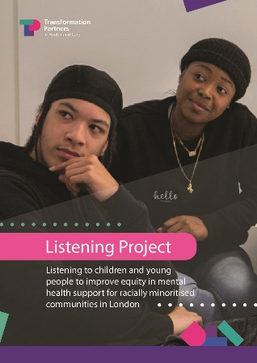
We supported work to implement the learning from the Listening Project, which asked 114 young people from Black, Asian and Latin American communities about their mental health, what affects it and their experience of mental health support in London. Delivered in collaboration with partners including Black Thrive and Taraki, the project uncovered structural inequalities and stigma that impact access to care, as well as recommendations for how to do things better.

Better for the NHS
Integrated care board leaders and mental health services have engaged directly with the Listening Project and have used it to inform their service transformation planning in their localities.

Championing a citywide mental health response with Thrive LDN
Thrive LDN is a citywide public mental health partnership to ensure all Londoners have an equal opportunity for good mental health and wellbeing. TPHC hosts the core programme team, who work with a coalition of partners towards the shared mission of ensuring everyone living or working in London is treated fairly and can live a happy and healthy life.

Promoting individual and community wellbeing
Working with regional partners, including Good Thinking, the team coordinated the fourth Great Mental Health Day (GMHD), a London-wide initiative to get Londoners talking about their mental health and wellbeing.

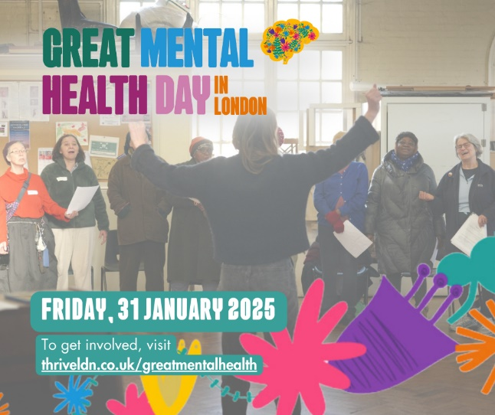
For 2025, the theme of small actions for others was chosen for Great Mental Health Day for Londoners to celebrate and learn from organisations and community leaders who are devoting energy and compassion to others. Around 150 organisations across London boroughs took part and held free events to bring people together to share stories, experiences and explore ways to support individual and community wellbeing. The team produced content, resources and toolkits to help individuals and organisations to get involved.

Activity on the day included:
- 45+ in-person events in 17 London boroughs
- 12,000+ visits to the Thrive LDN Great Mental Health Day online resources
- a BBC Radio London interview with Lynette Charles (CEO, Mind in Haringey).
Great Mental Health Day 2025 received a strong endorsement and message from the Mayor of London, Sir Sadiq Khan:
“I am proud to support Thrive LDN’s Great Mental Health Day. It’s vital that we continue breaking down the stigma surrounding mental health, and this range of free events offers a great opportunity to bring people together and find out more about the support and services that are available across the capital.’’

Mental wellbeing support for Hongkongers living in London
In 2024/25, Thrive LDN worked with a small number of Hong Kong community organisations and partners to co-develop a series of policy recommendations to support the mental health and wellbeing of Hongkongers living in London.

This work was commissioned by the Greater London Authority’s Hong Kong Welcome Programme, supported by the Ministry of Housing, Communities and Local Government. It focused on the challenges Hongkongers were facing and what policymakers and those in a position to create changes in the healthcare system could do to unblock these issues.

The report, Supporting the mental health and wellbeing of Hongkongers in London, was published on the Thrive LDN website to share learning and solutions.

Better for migrant communities in London
The report noted the importance of, among other things, addressing historical and ongoing trauma, isolation, transition, identity and the importance of cultural awareness and humility.

Understanding these is of significance not just for Hongkongers but also for other displaced communities and those facing shock or crisis, where their experience mirrors that of the newly arrived Hongkongers.

These findings have supported Thrive LDN’s community resilience and crisis response work as a whole.

The UK’s first Population Mental Health Consortium
Through a partnership between King’s College London and Thrive LDN, the first nationwide Population Mental Health Consortium launched in September 2024. The consortium aims to connect stakeholders across academia, public health, local government and voluntary organisations, to create new opportunities for population-based improvements in mental health across the UK.

The Consortium has received over £7million of funding from UK Research and Innovation, and includes Thrive LDN, King’s College London, University College London, Middlesex University, Swansea University, Ulster University, University of Manchester, Birmingham Women’s and Children’s NHS, and Applied Research Collaboration West Midlands.

Better for Londoners
The consortium has secured significant investment in London’s mental health landscape, providing funding and commitment from multi-sector agencies and stakeholders. Focus areas include children and young people, suicide and self-harm prevention and multiple long-term conditions. An interdisciplinary approach is being taken through the consortium to enable identification, prioritisation and evaluation of public health policy interventions locally, regionally, and nationally. This is underpinned by novel, rigorous research methods, capacity building, and close involvement with the public and communities.

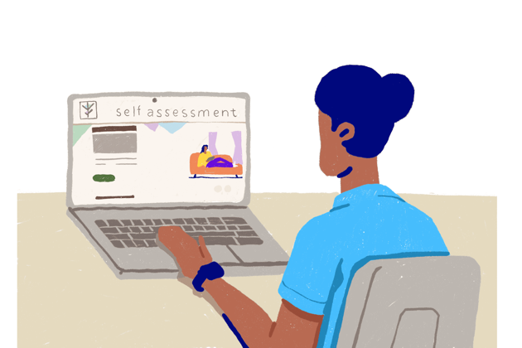
Supporting Londoners’ mental wellbeing with Good Thinking
TPHC hosts and supports the Good Thinking platform, which provides free, 24/7 access to a wide range of NHS-approved mental health and wellbeing resources for anyone living, working or studying in London. These include workbooks, how-to guides, toolkits, apps, podcasts, webinars, and training around four key mental health concerns: stress, anxiety, low mood, and sleep problems. In 2024/25, the programme team led several initiatives to raise awareness of the Good Thinking platform and boost engagement with external audiences.

Engagement with specific communities to co-produce tailored mental health content included:
- working with LGBT+ organisations across London to develop content around the LGBT+ community and mental health challenges. This included a collaboration with the Speakers Collective for Pride Month 2024 to share personal stories and practical tips on looking after your mental health, from members of the LGBTQ+ community
- working with Digital Health Ambassadors through Partnership for Young London to develop a podcast for Children’s Mental Health Week (3-9 February) on the theme of self-awareness
- developing content on student mental health, and signposting to support, including Good Thinking’s bespoke digital student hub, in collaboration with Brunel, Greenwich and Middlesex Universities, to support University Mental Health Day on 13 March

Activity also marked regional and national mental health awareness events:
- a Good Thinking webinar was attended by 100+ stakeholders in support of Great Mental Health Day on 31 January 2025. It focused on resources produced by Good Thinking and how they can support mental health and wellbeing in London.

Targeted London campaign to raise awareness of mental health resources
In July 2024, Good Thinking ran a targeted online search campaign to reach key audiences across London. The objectives were to:
- raise awareness of Good Thinking and the mental health support resources available across London;
- drive increased traffic towards the Good Thinking website
- evaluate content efficacy to identify areas for development.

The first phase of the campaign ran from July 2024 to March 2025; key outcomes were:
- nearly 80,000 new users accessed the Good Thinking website during the period, generating 2.2 million impressions
- both the average click through rate (CTR) and session duration time were above our average benchmarking rates, with CTR more than double our benchmark
- average engagement rate was 58%, just above the top end of our 55-58% benchmark, demonstrating strong user engagement with the content
- the four pillars of Good Thinking (anxiety, stress, low mood and sleep) were the top four performing webpages through the campaign – with anxiety accounting for 43% of traffic. This indicates that Londoners are seeking information on common mental health conditions, and the content and resources provided by Good Thinking are both relevant and engaging.
In 12 months (1 April 2024-31 March 2025), the campaign generated almost 75% of Good Thinking’s new users. Following the campaign, the number of returning users has started to increase, indicating that Londoners are finding the range of resources provided through the Good Thinking platform beneficial.

Making health and wellbeing apps accessible to Londoners
The Good Thinking service also makes health and wellbeing apps available for free to Londoners. In January 2025, a new app, Pathway through pain, was launched, signifying a new direction in terms of drawing a link between the impact of chronic musculoskeletal pain with mental health and wellbeing.
Better for Londoners with chronic pain
- To date, 86% of licenses have been allocated to users in London
- Pathway through Pain is providing users with a structured pain management programme delivered by experts to help reduce the impact of pain and support them to develop skills and knowledge to effectively manage their pain in the long term

Feedback from a Pathway through Pain App user:
‘‘I am so glad to have been able to do this programme. It has helped me to really consider what I can do to manage my pain. I am also a lot more aware of pain itself and the impact it has... This program is thorough and deals with different aspects of pain. It was very useful to me. I now want to be able to continue with the tools with the hope it will continue to benefit me and also my relationships and work.’’

Fast-Track Cities London mission for ending HIV epidemic
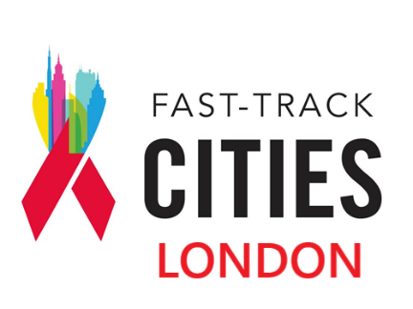
Fast-Track Cities is a global initiative to end the HIV epidemic by 2030. London joined the global Fast-Track Cities Initiative in January 2018. The central programme team is based in TPHC’s Partnerships team. In 2024/25, Fast-Track Cities London made significant strides toward its goal of ending new HIV transmissions, preventing avoidable deaths, and eliminating stigma by 2030. Through a combination of community-driven programmes, healthcare innovations, and policy leadership, the initiative demonstrated measurable impact across the capital.

Expanded HIV testing and care through primary care
We convene the GP Champions Group through a community of practice, connecting members to the wider HIV clinical forum and providers in the voluntary, community, faith and social enterprise sector. We funded GP champions in north east London who are working to establish proactive management in primary care for people living with HIV. Their work saw:
- a 31% increase in HIV testing across north east London, up from 24,289 tests in 2023 to 31,858 in 2024
- an offer of HIV testing to all patients registering with a GP practice.

Integrated peer support in every London HIV clinic
Peer-led social prescribers are being integrated within the patient pathway in HIV clinics and multidisciplinary teams across London to improve patient engagement and retention in care. They provided personalised care, support and signposting to improve the quality of life of 482 people living with HIV.

Empowering people living with HIV
"Learning to Live Well with HIV" courses, commissioned by Fast-Track Cities London, supported 35 people who were newly diagnosed with HIV. Surveys indicated improvements across all 10 quality-of-life indicators. These types of initiatives are also known to increase engagement in treatment and care.

Addressing the social determinants of health
Programmes implemented as part of the Getting to Zero collaborative are providing immigration, housing, welfare benefits advice, mental health and chemsex support, acknowledging the broader social factors affecting health outcomes.

Tackling stigma and discrimination in the capital
On World AIDS Day, the Mayor of London became a founding member of the HIV Confident charter, a workplace anti-stigma initiative led by the National AIDS Trust and Positively UK, developed in partnership with Fast-Track Cities partners and funded by the London leadership group for the first three years.

Global engagement in HIV
Fast-Track Cities London is committed to ending HIV. The team attended the Fast Track Cities 2024 conference in Paris and has been involved in several initiatives to support global efforts. This includes working in collaboration with Amsterdam, being a part of the European team working on a network response to HIV and hosting the UK and Ireland network.

Better for Londoners with HIV
Fast-Track Cities is preventing avoidable deaths. Our work on reducing stigma and improving support for people with HIV means people are more likely to come forward for treatment and keep taking it, improving their health and wellbeing and reducing the risk of transmission. Offering HIV testing as a routine part of healthcare enables HIV infections to be identified early, leading to faster treatment and better outcomes.

Better for all Londoners
Fast-Track Cities is reducing the risk of onward HIV transmission by ensuring people living with HIV are supported to better engage in treatment and care, and that PrEP is more easily accessible to those who need it.

Better for the NHS
Fast-Track Cities is reducing HIV transmission and illness in London, reducing the pressure on HIV services and team members.

Convening community-led prevention in London
The London Personalised Care programme, established in 2017, evolved last year into the Community-led Prevention programme. Its aims throughout have included supporting Londoners with practical, social and emotional needs which are impacting their health to access local activities, groups, and services which can help them feel better.

Between 2017 and 2024, the team supported the growth London’s social prescribing workforce to more than 500 social prescribing link workers, health and wellbeing coaches and care coordinators in London’s primary care networks.

The team also worked with voluntary and community organisations and other partners in boroughs to co-design a shared investment Community Chest fund. This allocated £500,000+ of funding to small local voluntary, community, faith and social enterprise organisations to deliver activities to improve residents' wellbeing, targeting unmet needs identified through social prescribing services.

In 2024/25, the focus moved to supporting London’s health and care systems to develop more proactive, preventative and community-centred approaches to improve the health and wellbeing of those most impacted by health inequity.

We supported:
- NHS trusts and integrated care boards to embed personalised interventions and community-led approaches into specialist pathways, largely in cardiac care and services for children and young people
- integrated care boards to make social welfare legal advice available in healthcare settings such as hospitals. Many more patients can now easily access support for issues such as housing, debt, and unemployment, which can have a big impact on people’s health
- integrated care boards to embed key enablers of prevention – such as co-producing their plans with communities, workforce development, and building community partnerships – in their day-to-day ways of working.

We drew on our extensive knowledge and experience to publish numerous toolkits and guidance to help organisations create change. These were:
- a Community Chest Toolkit to help local partners create community funding mechanisms that offer grants to approved grassroots initiatives to meet local needs
- a Community-centred Approaches Guide with practical insights for neighbourhood teams on making prevention and community voice a core part of service design and delivery
- a Secondary Care Prevention Toolkit for trust and system leaders. This helps them explore how community-led models, such as social prescribing, can be part of secondary and acute care pathways, contributing to whole-system transformation
- a Social Prescribing Evaluation Toolkit that gives local teams the tools to measure and demonstrate the impact of prevention work, further supporting informed decision-making and long-term investment in community-led approaches.

Better for Londoners
These approaches support action by communities to identify and remedy health and wellbeing issues for local people, using their in-depth knowledge and understanding of what local people need.

Preventing sickness and giving people the knowledge and support they need to take more control of their health will improve health and wellbeing for individuals and communities.

Better for the NHS
We have passed on our knowledge from many years of running the personalised care programme to enable health and other organisations in London to carry on the good work. From September 2024, we initiated a transition phase to embed our work into the system, for NHS England and integrated care boards to take forward and continue delivering sustainably.

The London Homeless Health Partnership
The London Homeless Health Partnership was established in 2021 to improve healthcare access, service coordination, and health outcomes for people experiencing homelessness. It was grounded in participation, integration, and innovation, and it drove significant improvements to healthcare for people experiencing homelessness.

Improving healthcare access and experience for people experiencing homelessness
In 2024/25, the London Homeless Health and Primary Care Steering Group published Transforming Primary Care for Homeless and Inclusion Health. This report, shaped by regional workshops with partners from the NHS, local authorities, and the voluntary sector, outlined ten priority areas for improving primary care for people experiencing homelessness. It has been shared with all of London’s integrated care systems. It has resulted in:
- a dedicated workforce task and finish group, convened and managed by NCL Integrated Care System (ICS) and our programme team, produced a comprehensive report on the workforce working with inclusion health groups. It identified challenges and made system-wide recommendations for enhancing training, support, and collaboration across sectors
- extensive engagement led by our team with multidisciplinary teams and service users to gather insights and principles for a homeless health section of the Universal Care Plan, a digital tool for Londoners to share their care and support wishes with all professionals providing their care. Design of the homeless health template is being taken forward by a 50-member working group and a dedicated focus group of experts from frontline services and people with lived experience of homelessness.

The programme also played a key role in supporting the national evaluation of out of hospital care models for people experiencing homelessness, delivered by King’s Health Partners. The London Homeless Health Partnership delivered the out of hospital programme in London between 2022 and 2024, when across the country, different care models were invested in and tested with national funding. The evaluation report can be accessed here.

Embedding lived experience into programme delivery
Lived experience was central to all homeless health activities in London in 2024/25, led by homelessness charity, Groundswell, who were commissioned to deliver this function. Our team hosted and promoted masterclasses and workshops on safeguarding people experiencing homelessness and implementing NICE guidelines with meaningful involvement of experts by experience. Groundswell also developed a toolkit to embed lived experience in service design, training, and participation across London. Funding was secured for experts by experience so they can continue to shape homeless health priorities, including safeguarding, workforce development, and the Universal Care Plan.

Integrated care systems, particularly North East London and South East London, worked together to develop their homeless health strategies. Training in co-production was co-developed with experts by experience and Groundswell and delivered with volunteers.

We made recommendations to integrated care boards to increase the visibility of homelessness in existing datasets, collaborate across regions, and train frontline staff. These recommendations were taken forward by the London School of Economics, University College London, and the London integrated care boards.

Better for people experiencing homelessness in London
Recommendations for improving primary care, better training and support for the inclusion health workforce, improved data, the development of system-wide homeless health strategies, and a homeless health template for the Universal Care Plan will all improve healthcare delivery and play a part in some of London’s most vulnerable residents receiving more equitable healthcare.

The regional programme concluded in March 2025 when its functions transitioned to London’s integrated care systems and NHS England – London.
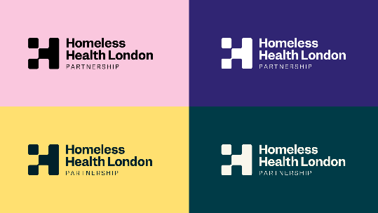
The programme team is continuing to deliver a pilot to improve access to Hepatitis C testing and treatment on behalf of NHS England. Read more about this work on page 24 of this report.

Driving improvements through the Pan-London Co-occurring Conditions Programme
TPHC hosts and runs the pan-London Co-occurring Conditions Programme, overseen by the Office for Health Improvement and Disparities – London’s Alcohol, Drugs, and Tobacco programme. The project focuses on improving coordination between substance use and mental health services for people experiencing homelessness in London.

Raising the profile and visibility of the issues across London
In 2024/25, we continued to engage with organisations across London on behalf of the programme to raise awareness and inspire action. More than 80 strategic leaders from substance use, mental health, homelessness and primary care attended the London Co-occurring Conditions Summit at City Hall in February 2025. The summit identified priority areas focusing on leadership, workforce, stigma and integrated commissioning, which have been taken to the London Task and Finish Group for Co-occurring Conditions. A set of key principles will be published in 2025/26.

Addressing inequity in mental health and homelessness outreach services in London boroughs
Working with members of the London Mental Health and Homelessness Advisory Group, we mapped access to mental health and homelessness outreach services in London. This research enabled the programme to analyse gaps and provide targeted support to boroughs with no provision. We:

- developed a new service model in North Central London, creating consistent access to mental health outreach for people experiencing rough sleeping
- secured funding for the continuation of the STEP project (mental health outreach for people experiencing multiple disadvantages) and for the continuation of the Lewisham Dual Diagnosis Health Outreach Practitioner role
- led work with the London borough of Lambeth to develop and evaluate a new Dual Diagnosis Health Outreach role, which has now been funded for another year.

Better for Londoners with co-occurring conditions
Londoners with co-occurring conditions are some of the most marginalised people in the capital. Our work helped to focus attention on their needs and to support improvements to their care, including targeted support and provision by London boroughs.

Sharing learning and resources
Building on our work in 2023 with North Central London integrated care system to establish a community of practice, in 2024/25 we replicated this model for the four other integrated care systems in London, reaching over 400 participants. This is enabling the sharing of knowledge, resources and contacts across London.

To date, nearly 2,600 people have completed a trauma informed practitioner e-learning course, which we developed in partnership with the Office for Health Improvement and Disparities (OHID). The course supports cross-sector professionals to better meet the needs of people facing homelessness who have co-occurring needs.

The team also shared learning as guests on a podcast on co-occurring conditions by the National Expert Citizens Group.

Research and communications
We worked with 186 frontline practitioners to gather views about working with autistic people who are experiencing homelessness. The findings were compiled into a report, “Neurodiversity is an afterthought at the moment”. Key insights included:
- 95% of participants felt that better training and resources are needed for services working with autistic people experiencing homelessness
- 81% of participants were not aware of any specialist services in their area that would work with autistic people experiencing homelessness
- only 14% of all participants felt that mainstream services in their area meet the needs of autistic people experiencing homelessness.

We have convened an advisory group to develop a bespoke training programme on working with people experiencing homelessness and autism to address the findings.

Better for Londoners and the NHS
Treating Londoners with co-occurring conditions effectively is likely to reduce their burden of ill-health, improving their quality of life and, potentially, their life expectancy and reducing pressures on health and care services.

Part 4

Organisation development and improvement
Our expert team is highly skilled at implementing transformation, change and improvement programmes. We help our clients in health and care, and other sectors, to articulate their drivers for change, identify opportunities for improvement, and design and implement comprehensive change programmes using best-in-class methodologies.

In 2024/25, we delivered a range of bespoke coaching and highly-rated learning and development courses, including Effective Line Management, accessibility and inclusion, and After Action Review training, to upskill teams and individuals across the system.

We also designed a number of programmes and strategic initiatives to help NHS organisations adopt new ways of working to deliver more inclusively, efficiently and sustainably.

People

Develop your people, transform your impact: learning and development across the NHS and public sector
TPHC’s Learning and Development faculty upskills and empowers people working both inside and outside the NHS. We are proud to deliver bespoke and tried-and-tested courses and coaching that provide people with effective tools and actionable strategies that help them to work more inclusively, efficiently, with purpose, and in line with best practice.

In 2024/25, we trained staff, including those from our host organisation, The Royal Free London Group, and external clients from a range of NHS and non-NHS organisations.

We provided:
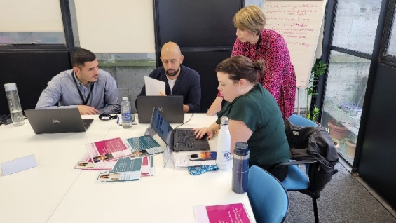
- project and programme management training
- line management training
- leadership support
- bespoke training, developed to meet clients’ specific needs and strategic priorities
- training in consultancy skills by our in-house Consulting Academy
- training on accessible communication and reasonable adjustments
- tailored coaching, empowering people to meet their personal and professional objectives and boost their job satisfaction and experience.

Better for the NHS
- 120 health and care staff in a London borough undertook our accessibility training on improving communications and engagement with underserved communities. 97% of them rated it as excellent or good.

Feedback on our accessibility training:
‘‘Great training, the pace was just right. I really liked that it was interactive with lots of different tools to keep us engaged. The content was really good. Found it really useful. Thank you.’’

Better for NHS managers and leadership
- Leaders at an NHS trust took part in our pilot leadership training to equip them to be as effective as possible. 100% rated the course as excellent.
- 44 participants took part in our first cohort of Effective Line Management training, to maximise managers’ and staff performance. 100% agreed or strongly agreed that course objectives were met, and that the content was meaningful and relevant.

Feedback on our Line Management Training:
‘‘I really enjoyed the course. content was very relevant and leaders were very friendly and made you feel comfortable to speak openly. Best management training I have received.’’

Building a culture of continuous improvement with After Action Review
An After Action Review (AAR) is a structured evaluation to analyse actions or events where there has been an unexpected outcome. After Action Reviews, run by a facilitator, create a psychologically safe environment where everyone has an equal opportunity to input, enabling lessons to be learned for future improvement.

We delivered AARs for a range of clients, also delivering our CPD-certified training on how to use this approach. We supported organisations to set up their AAR community of practice to embed the AAR approach, as part of their strategies for improving patient safety or building a culture of continuous improvement.

Better for patients
- We undertook many after action reviews, enabling teams to understand and share learning from completed work, benefiting patient care and NHS efficiency.
- We delivered 10 After Action Review facilitator training sessions to over 180 NHS and non-NHS participants, equipping organisations to undertake the After Action Review process themselves.

Transforming occupational health and wellbeing services for the NHS workforce in North Central London
North London Partnership Shared Services is a corporate services partnership for eight north central London NHS trusts whose purpose is to deliver high quality and better value shared NHS corporate services at scale.
It helps staff across its network to access the information, systems and processes they need quickly and seamlessly, which frees up time to focus on direct patient care. It is committed to excellent patient care through an outstanding employee experience.

Its occupational health and wellbeing service (OHWB) was formally established in early 2022, when five partner organisations transitioned their teams to the central shared service. This provided business as usual continuity in the short term.

In 2024/25, TPHC undertook a strategic review focused on developing the future shared service delivery model and offer by OHWB services to improve the health and wellbeing of the workforce.

The methodology adopted was robust and structured, with extensive stakeholder engagement; desktop research to identify models in the NHS, education and commercial sectors; and analysis of qualitative data.

This informed the development of a shared vision and ambitions; short, medium and long-term priorities; and workstreams to take forward with a high-level roadmap. Our findings and recommendations helped senior leaders build a shared understanding and vision of the future among the wider leadership team and stakeholders, a case for change, and actionable steps to achieve it. We also ensured the work aligned with key national policy and strategies. These included the Growing Occupational Health and Wellbeing Together strategy and Lord Darzi's 2024 review of the NHS in England.
Better for NHS staff
Our recommendations to transform the service focused on transitioning to proactive prevention. OHWB is developing a holistic, tiered offer that's sustainable, scalable and supports mental health, musculoskeletal health, and health through menopause. This will better meet the needs of individual team members, managers, and partner organisations, improving staff health and wellbeing and ultimately benefiting patients.

Better for the NHS
This work has generated national interest. The team has shared its learning widely to benefit other organisations looking to review and scale their occupational health and wellbeing offer.

Mike Tresise, Service Development Director, NLPSS, shared:
‘‘[TPHC’s] specialist NHS knowledge combined with a robust approach has delivered an excellent and practical strategic plan for NLPSS including clear priorities that is also recognised nationally as a valuable asset to help shape occupational health and wellbeing services in the future.”

Inclusion
Improving accessibility of information for Moorfields patients
TPHC worked with Moorfields Eye Hospital NHS Foundation Trust to support a project to embed the Accessible Information Standard across the organisation. The Standard sets out a specific, consistent approach to identifying, recording, flagging, sharing and meeting the information and communication support needs of patients, service users, carers and parents with a disability, impairment or sensory loss.

This is a national requirement; health and care providers across the country have been challenged by funding and staff training gaps to fully implement the Accessible Information Standard. As a specialist eye hospital, Moorfields is committed to implementing the standard to best meet the needs of many of its users who have temporary or permanent visual impairment.

We delivered the project by running stakeholder workshops to understand the key steps for implementation, including the many interdependencies and provided programme support and advice.

Better for disabled patients
Patients will be able to communicate with staff more effectively, which will improve their experience and their health outcomes.

Better for the NHS
Improving communication with patients and those supporting them will also improve staff satisfaction and NHS efficiency.

The client shared:
“Alex was fantastic at helping to get our project going, implementing a project structure, engaging teams and bringing people into the project to help bring it to life. She and Zoe got to grips with some complex challenges in order to create the road map for the subsequent phases of work.”

Sustainability

Taking a greener by design approach to digital in north central London
NHS England’s Greener Digital team is working to embed a sustainable 'Greener by design' approach into the development and lifecycle of all digital projects and programmes. As one of four system partners in this initiative, North Central London Integrated Care System brought in TPHC to pilot embedding a greener by design approach in ongoing digital projects.
We convened a multi-skilled digital sustainability team with a shared vision and passion for adopting more sustainable practices in the digital space. They mobilised rapidly and used an Agile approach to structuring and delivering this work.

The ambitious plan looked to:
- test emerging “greener by design” principles against live digital projects in north central London trusts
- work with the Green Web Foundation to co-design a Digital Assurance Framework
- undertake stakeholder engagement with north central London trusts, ICT teams and senior leadership to understand the requirements and challenges for adopting greener, more sustainable practices
- engage with digital, clinical and sustainability leads from across trusts and other organisations, partnering with the NHS England Greener Digital Team.
- produce content for both the north central London Green Plan submission and emerging digital strategy.

We:
- co-produced a “greener by design” testing protocol, producing a number of pilot case studies to document outcomes and learning
- co-created with NHS England, a Digital Sustainability Lifecycle Model and a Digital Sustainability Assurance Framework in partnership with the Green Web Foundation
- collated project learnings and insights, articulating digital sustainability opportunities in an end of project report that was drawn on by both the green plan submission for North Central London Integrated Care System and the Integrated Care Board’s Digital Strategy.

Our team handed over this work to North Central London Integrated Care Board with an implementation plan to support ongoing collaboration with NHS England.

Better for patients
Digital healthcare benefits patients by streamlining their access to care, reducing delays, and enhancing their ability to manage their appointments and their own health. Working greener in digital contributes to healthier environments and lowers health risks linked to air pollution and climate change which can exacerbate health inequalities. Reducing NHS carbon emissions will benefit patients with respiratory conditions and other vulnerable populations, particularly very young and very old people.

Better for the NHS
The success of our work created momentum among the system’s digital sustainability leads to do more “greener by design” work.

Greener digital design will enable the NHS to operate more sustainably, lower the carbon footprint of services, streamline appointment management, and reduce reliance on physical infrastructure and paper-based systems. This will be better for people, the planet and the NHS.

We are Transformation Partners in Health and Care

We understand the challenges health and care organisations face as they strive to make lasting improvements for large and diverse populations.
Our experienced and talented people deliver high-quality bespoke consultancy and transformation services from neighbourhood to national level, with an outstanding track record in achieving positive and tangible results.

You can also view a digital version of this report on the Transformation Partners in Health and Care (TPHC) website.

Contact us on: rf-tr.tphc-communication@nhs.net to discuss any of the work featured in this report, or how we can help you achieve your transformation and improvement goals.

To calculate the increase in the number of logins/medical record views and the percentage increase, an 8-week average date range was selected before and after the campaign launch. This date range was 5 March to 11 April (before the campaign) and 12 April to 18 May (after the campaign). These date ranges were selected to include an equal number of weekdays and weekends in both periods, ensuring a fair and balanced comparison. The percentage change represents the difference in each metric from before to after the campaign.

