Supporting children and young people’s mental health

Resource pack for London

Background
For children and young people in London facing many challenges such as social and academic pressures and cost of living worries, can be challenging on their mental health. The Children and Young People’s Mental Health Transformation team and Transformation Partners in Health and Care (TPHC) has put together this resource pack to help partners and local organisations support London’s children and young people.
Support for children and young people awaiting support from mental health services in London
TPHC is committed to supporting children and young people and their families to be able to access mental health support when they need it. London has made good progress in increasing access to community mental health services, but we know many children and young people are still having to wait too long. TPHC has delivered a programme of work to respond to this.
Visit our website to learn more about this programme, including new resources, updates from events and best practice learning.
Interim and preventative mental health support
We have collated information and resources produced by TPHC and key partners in London for local authorities, schools/colleges, and community/third-sector organisations on different mental health services and support which is available for children and young people, and their parents and carers.
We hope these resources help you to direct children and young people, and their parents/carers to the appropriate support for their mental wellbeing, whether they are looking for tips to help cope through different situations, are awaiting treatments or interventions for a specific condition, or need urgent crisis support.
Contents:
- Key messages about mental health for children and young people, and their parents/carers
- What to do in a mental health emergency?
- Resources to share mental health information with children and young people
- Support and resources on mental wellbeing for children and young people
- Resources on eating disorders and disordered eating
- Further information and support

1. Key messages on children and young people’s mental health
For older children and young people:
- You may need urgent help for many reasons. The important thing to know is you will not be wasting anyone's time.
- If you are experiencing something that makes you feel unsafe, distressed, or worried about your mental health, but it's not an emergency, get help from NHS 111 online or call 111.
- If you can, also let a parent, carer, friend, teacher or someone else you trust know how you’re feeling.
Key messages for parents/carers and other non-health professionals:
- If someone is in danger, call 999 or go to A&E right away.
- If you are concerned that someone you care for is experiencing something that makes them feel unsafe, distressed, or worried about their mental health, but it's not an emergency, get help from NHS 111 online or call 111.
- If you are concerned that a child or young person is extremely distressed and might not be able to keep themselves safe, call your local NHS mental health helpline which is open 24 hours a day, seven days a week for immediate support and advice.

2. What to do in a mental health emergency?
A mental health emergency or crisis can be triggered at any time and by events, such as bereavement, stress and social isolation, which may require an immediate response. There will be periods throughout the year like over the summer while waiting for the exam’s results, back to school or the winter months that can be particularly difficult if someone is struggling.
NHS urgent mental health support
NHS urgent mental health support is available for people of all ages in England. Your mental health is as important as your physical health: you will not be wasting anyone's time if you think you need help.
In an emergency
- If you or someone else is in danger, call 999 or go to A&E now
- If you need help urgently for your mental health, but it's not an emergency, get help from NHS 111 online or call 111.

Contacting 111
If you’re deaf or have hearing loss, please use the following link to be connected to local crisis service – NHS 111 – SignVideo.

If you aren't able to make the call yourself, then anyone can call on your behalf –
For example, a friend, carer, loved one or even your GP. You can also access NHS111 online via 111.nhs.uk.

Support is there for anyone in England facing a mental health crisis, which could include:
- Changes to your mood
- Withdrawing from people (close family, friends, or work colleagues)
- Not taking care of yourself like you usually would
- Having increased thoughts about your life not being worth living
- Excessive worry
- Feeling out of control or unable to cope
- Feeling anxious about leaving the house
- Hearing voices or seeing things that others can’t
- Thinking about harming yourself.

By calling 111 for mental health help, the NHS can help to get you the urgent support you need.
For advice and support if you are struggling with your mental health
Find a local NHS urgent mental health helpline in England
NHS urgent mental health helplines are for people of all ages in England, including children and young people, and those with neurodevelopmental needs.
You can call for:
- 24-hour advice and support for you, your child, your parent or someone you care for
- help speaking to a mental health professional
- an assessment to find the right care for you

To find a local telephone number for the London borough you live in, visit the NHS urgent mental health service finder: https://www.nhs.uk/nhs-services/mental-health-services/
If you or a young person cannot access the online service finder, call 111.

What happens when I call?
The phone will be answered by a trained mental health professional who will be able to listen to your concerns and help you get the support you need. With your permission, they can also access your electronic patient records to better meet your needs and to avoid you repeatedly having to tell us your situation.
They can offer advice over the phone, put you in contact with crisis services, or where appropriate, refer you to a relevant service.

3. Resources to share mental health information with children and young people
Resources and messaging in this toolkit can help to signpost children, young people and their parents/carers to helpful information that can help support their overall mental wellbeing, as well as what to do in a mental health crisis/emergency.

- TPHC’s short animation explaining how NHS mental health crisis support telephone lines work, available to:
  - share or embed using the URL: https://youtu.be/CF40VZEB_MY
  - Download for social media sharing in vertical or horizontal format
- An assembly plan for education settings to share information about mental health and wellbeing, aimed at young people in key stage 3-5.
- Copy to share on websites or newsletters:
Title: Supporting young people’s mental health
Young people and their families in need of urgent help with their mental health can get free urgent support from trained NHS professionals by telephone.
The NHS provides free telephone support across London (and elsewhere in England) which are open all day, every day, and staffed by trained mental health professionals. They can provide immediate support, or refer young people, or those caring for someone, to other sources of help if needed. Visit:
https://www.nhs.uk/nhs-services/mental-health-services/ to find a local NHS urgent mental health helpline in England.
If you, or someone you know needs mental health help but it's not an emergency, get help from NHS 111 online or call 111.
Reaching young people through social media – suggested messaging and downloadable graphics
111 for mental health support
To use or adapt for social media platforms including:  - X (Twitter),  - Facebook  - Instagram  - LinkedIn | If you are experiencing something that makes you feel unsafe, distressed, or worried about your mental health, you are not alone.  If you need help but it’s not an emergency go to 111.nhs.uk or call 111. | Visit our Google Drive to download full-sized image:  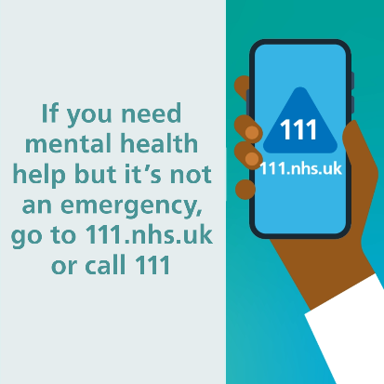

Helping children and young people to stay mentally well when back to school or while waiting for exam’s results
X/Twitter  Facebook  LinkedIn  WhatsApp | Children and young people might feel anxious about the start of the school year.  Call or search 111 if you’re worried about your #mentalhealth.  You can also find support and information on staying mentally well at: https://www.transformationpartners.nhs.uk/urgentsupportlines/ | Visit our Google Drive to download full-sized images:  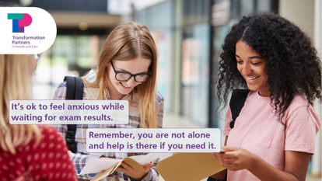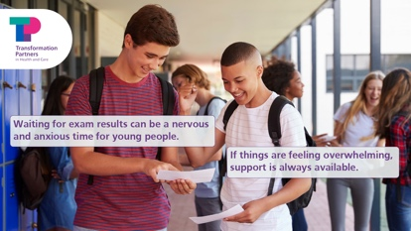
Instagram posts | Children and young people might feel anxious about the start of the school year.  Call or search 111 if you’re worried about your #mentalhealth.  You can also find support and information on staying mentally well at: https://www.transformationpartners.nhs.uk/urgentsupportlines/ | 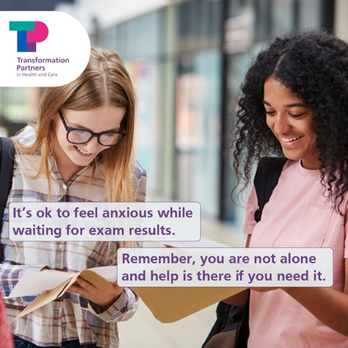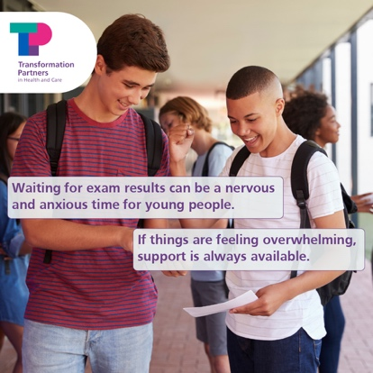
Instagram Stories | Link to: https://www.transformationpartners.nhs.uk/urgentsupportlines/

Helping children and young people to stay mentally well this winter
X/Twitter  Facebook  LinkedIn  WhatsApp | Winter can be a hard time for children and young Londoners.  Call or search 111 if you’re worried about your #mentalhealth.  You can also find support and information on staying mentally well at: https://www.transformationpartners.nhs.uk/urgentsupportlines/ | Visit our Google Drive to download full-sized images:  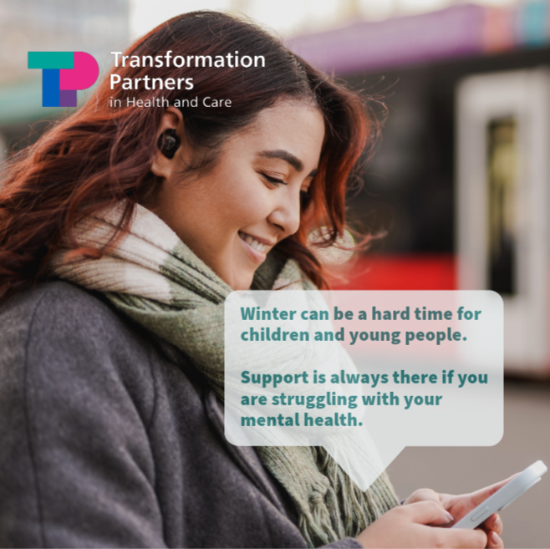
Instagram posts | Winter can be a hard time for children and young Londoners.  Call or search 111 if you’re worried about your #mentalhealth.  You can also find support and information on staying mentally well at: https://www.transformationpartners.nhs.uk/urgentsupportlines/
Instagram Stories | Link to: https://www.transformationpartners.nhs.uk/urgentsupportlines/ | 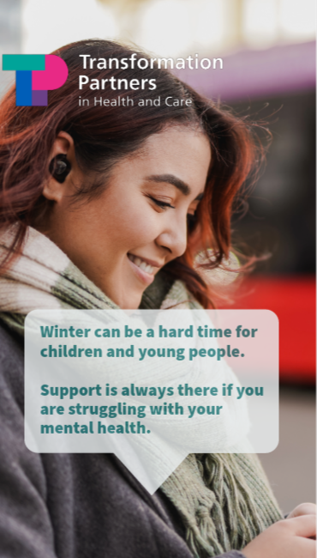

4. Support and resources on mental wellbeing for children and young people
Good Thinking
On Good Thinking you'll find lots of helpful digital resources, including free NHS-approved apps and top tips to help you get through the tough times. Working closely with organisations like Partnership for Young London, we invite young people to guide and review our content so you can be sure we’ll help with the issues that really matter to you.
See Good Thinking’s hub for young people for free tips, resources and content on looking after your mental health.
Good Thinking has also developed a student hub with bespoke mental wellbeing advice, guidance and resources for young people at school, college or university.
See Good Thinking resources for support on ‘How to deal with anxiety, stress and imposter syndrome' ahead of results day.
See Good Thinking resources for support on ‘How to stay positive and move forward' during and after results day.
See Good Thinking resources on ‘Wellbeing tips for going back to school’ as the start of the school year approaches.
Services in London supporting children and young people can signpost to Good Thinking throughout the school year.
See suggested messaging below which points to resources for:
- children and young people,
- parents and carers, and,
- Good Thinking’s winter wellbeing toolkit.

Good Thinking support and resources for children and young people
Copy for X | Graphic
Feeling stressed, anxious or overwhelmed?  @GoodThinkingUK are here to help boost your mood with free NHS-approved advice, tips and tools created specifically for young Londoners:  👉 https://www.good-thinking.uk/youngpeople | Visit our Google Drive to download full-sized images:  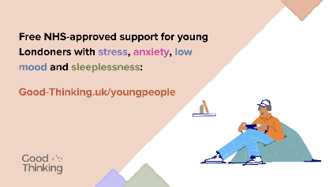
Copy for Instagram/WhatsApp | Graphic
Feeling stressed, anxious or overwhelmed?  @goodthinkinguk are here to help boost your mood with free NHS-approved advice, tips and tools created specifically for young Londoners:  👉 https://www.good-thinking.uk/youngpeople | 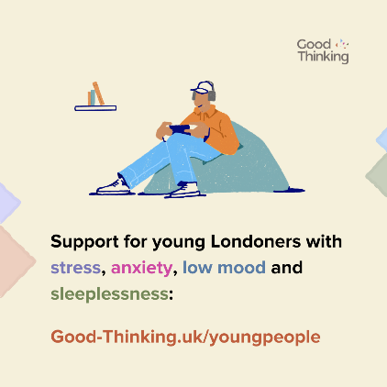
Copy for Facebook/LinkedIn | Graphic
Feeling stressed, anxious or overwhelmed?

@goodthinkinguk are here to help boost your mood with free NHS-approved advice, tips and tools created specifically for young Londoners:
👉 https://www.good-thinking.uk/youngpeople

Good Thinking support and resources for parents and carers
Copy for X | Graphic
Looking to support your child’s mental wellbeing?  @GoodThinkingUK has a range of dedicated resources for parents and carers.  If your child is stressed, anxious or feeling down, help is available - including free NHS-approved wellbeing apps:  👉https://www.good-thinking.uk/parents-and-carers | Visit our Google Drive to download full-sized images:  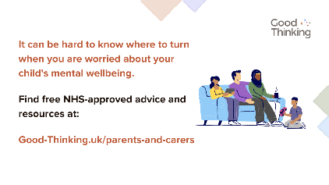
Copy for Instagram/WhatsApp | Graphic
Looking to support your child’s mental wellbeing?  @goodthinkinguk has a range of dedicated resources for parents and carers.  If your child is stressed, anxious or feeling down, help is available - including free NHS-approved wellbeing apps:  👉https://www.good-thinking.uk/parents-and-carers | 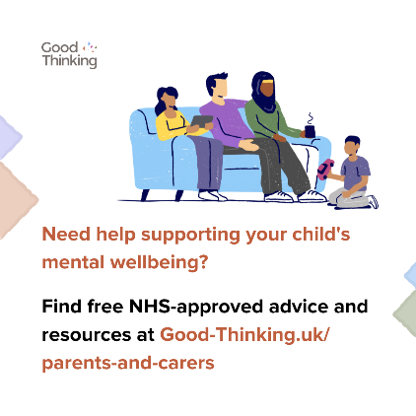
Copy for Facebook/LinkedIn | Graphic
Looking to support your child’s mental wellbeing?

@goodthinkinguk has a range of dedicated resources for parents and carers.

If your child is stressed, anxious or feeling down, help is available - including free NHS-approved wellbeing apps:

👉https://www.good-thinking.uk/parents-and-carers

Good Thinking’s guide to winter wellbeing
Copy for X | Graphic
This time of year can be tough, and many are finding it harder as the cost of living continues to rise.  @GoodThinkingUK has put together practical tips and resources to help if you’re feeling stressed, anxious or lonely.  👉 https://www.good-thinking.uk/advice/winter-wellbeing-guide | Visit our Google Drive to download full-sized images:  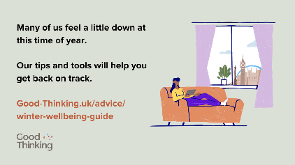
Copy for Instagram/WhatsApp | Graphic
This time of year can be tough, and many are finding it harder as the cost of living continues to rise.  @GoodThinkingUK has put together practical tips and resources to help if you’re feeling stressed, anxious or lonely.  👉 https://www.good-thinking.uk/advice/winter-wellbeing-guide | 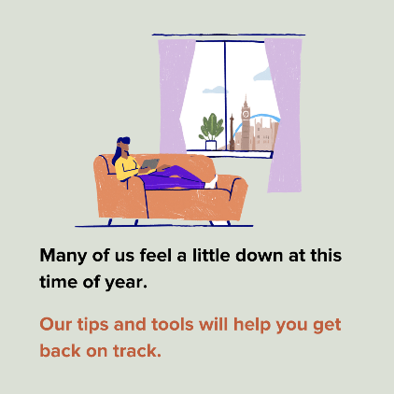
Copy for Facebook/LinkedIn | Graphic
This time of year can be tough, and many are finding it harder as the cost of living continues to rise.

@GoodThinkingUK has put together practical tips and resources to help if you’re feeling stressed, anxious or lonely.

👉 https://www.good-thinking.uk/advice/winter-wellbeing-guide

5. Resources on eating disorders and disordered eating
TPHC has worked with a number of partners to produce practical guidelines to help loved ones and professionals working with children and young people to recognise the signs of an eating disorder or disordered eating.
Changes in behaviour and eating patterns may or may not be linked to a person’s weight or appearance so it’s important not to make any assumptions. Getting help early can help prevent a condition from worsening, please speak to a GP for advice if you are concerned about any changes.
Changes or restrictions in eating patterns should be taken seriously, but try not to focus solely on eating – have you noticed any other changes in behaviour?
Further support can also be found on the Beat website, the UK’s eating disorder charity.

Find resources and links to further support and advice on eating disorders and disordered eating here.
See suggested copy and graphics to help raise awareness on social media below.
Copy for X | Graphic
Changes in eating patterns can be caused by many factors. If you spot changes in someone’s eating, try not to assume it’s an eating disorder and encourage them to speak to a GP for support.  Find #eatingdisorders resources from @_TPHC:  www.transformationpartnersinhealthandcare.nhs.uk/eating-disorders-resources/ | Visit our Google Drive to download full-sized images:  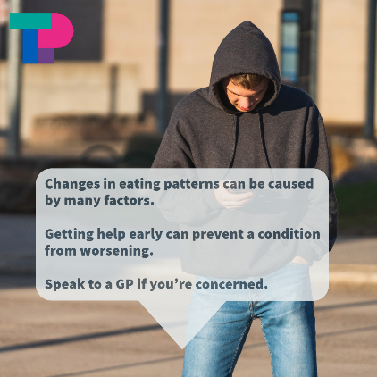
There are 6 signs that someone may be developing an eating disorder.  Getting help early can help prevent a condition from worsening. Find more information and resources on eating disorders from @_TPHC at:  www.transformationpartnersinhealthandcare.nhs.uk/eating-disorders-resources/ | Link to video: https://youtu.be/AiThbk7CYHI  Or download Reel/TikTok here
Copy for Instagram | Graphic
Post:
Changes in eating patterns can be caused by many factors. If you spot changes in someone’s eating, try not to assume it’s an eating disorder and encourage them to speak to a GP for support.
Find more information and resources on #eatingdisorders from @beatedsupport
Reel:  There are 6 signs that someone may be developing an eating disorder.  Getting help early can help prevent a condition from worsening.  Find more information and resources on #eatingdisorders from @beatedsupport | Link to full video: https://youtu.be/AiThbk7CYHI  Or download Reel/TikTok here
Copy for Facebook / LinkedIn | Graphic
Post:  Changes in eating patterns can be caused by many factors. If you spot changes in someone’s eating, try not to assume it’s an eating disorder and encourage them to speak to a GP for support.  See Transformation Partners in Health and Care’s resources on children and young people’s #eatingdisorders for more information:  www.transformationpartnersinhealthandcare.nhs.uk/eating-disorders-resources/  Further support and information can be found by visiting: /www.beateatingdisorders.org.uk/ | 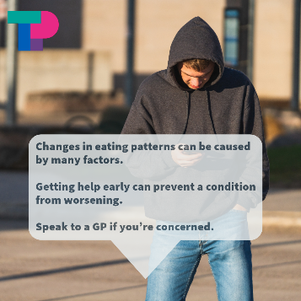
There are 6 signs that someone may be developing an eating disorder.  Getting help early can help prevent a condition from worsening.  See Transformation Partners in Health and Care’s resources on children and young people’s #eatingdisorders for more information:  www.transformationpartnersinhealthandcare.nhs.uk/eating-disorders-resources/  Further support and information can be found by visiting: /www.beateatingdisorders.org.uk/ | Link to video: https://youtu.be/AiThbk7CYHI  Or download Reel/TikTok here

Further information and support:
- Thrive LDN is the regional lead for suicide prevention in London on behalf of NHS England. We’ve partnered with the Zero Suicide Alliance, who have created a training program to help people to be able to identify warning signs and to feel comfortable having conversations about suicide. Click here to learn more and to take the training.
- TPHC Schools Mental Health toolkit: an online directory of content and resources relating to children and young people’s mental health.
- The Mix: providing essential support for under 25s.
- Kooth: a free safe any anonymous place for young people to find support.
- Young Minds: a mental health charity for children, young people and their parents.

