Listening Project communications toolkit
The Listening Project report complements several policy frameworks and requirements related to reducing mental health inequalities among racialised populations.
NHS England published its first Advancing Mental Health Equalities Strategy in 2020. The strategy outlined the core actions needed to bridge the gaps for communities faring the worst outcomes in mental health services. In 2021, NHS England published the Core20PLUS5 approach for adults and children and young people, which explicitly re-states the need to reduce inequalities faced by racialised and ethnic groups across all parts of the health service.

Our aims and goals
Our overarching aim is to socialise the Listening Project report across London partners, conveying how it can shape their implementation of mental health strategy and support them in meeting their reporting requirements.
In launching and socialising the report, we hope to:
- Communicate that the Listening Project report provides a unique opportunity to hear directly from children and young people from racialised communities about their experiences
- Make explicit how the report aligns with, and is distinct from, much of the other strategic work and programmes currently at play around mental health equalities, children and young people, and race
- Providing a meaningful rationale to enable and support organisations’ anti-racist and equalities work
- Sharing findings, recommendations and examples of positive practice to explore what can be done differently.
In our efforts to maximise the impact of the report’s findings throughout the system, we ask you to:
- Share the full report with your networks, including: children and young people, service providers, those advancing engagement of lived experience, and others dedicated to improving mental health for children and young people from racialised backgrounds in London.
- Share about the report on your social media channels
- Use the report to inform and shape ongoing work to improve mental heath equity in children and young people

Tailored resources for your use
Article copy for use in your newsletters, bulletins, intranets
Short copy
In 2023, a partnership of London youth and mental health organisations came together to create The Listening Project, a project dedicated to understanding the mental health experiences of minoritised young people in London.

The Children and Young People’s Mental Health team at Transformation Partners in Health and Care worked with Black Thrive Lambeth; Hammersmith, Fulham, Ealing, and Hounslow Mind; Partnership for Young London; Taraki; and Thrive LDN to understand the experiences of young Londoners aged 12 to 25 who identify as Asian, Black, or Latin American.

The Listening Project explored a number of areas, including how health inequalities are experienced by young people in London and the factors that contribute to this group being under-represented in community mental health settings. It also explores he beliefs, attitudes, and experiences of young people in mental health service provision.

The report centres the voices young people exploring their experiences with mental health services and their wider communities. This report includes the Project’s key findings, recommendations for change, and examples of positive practice to explore what can be done differently.

Addressing the long-overdue inequities experienced by children and young people from racially” minoritised communities is a key focus of the NHS Long Term Plan. The report focuses on supporting the NHS and the wider health and care system to act upon what young Londoners are telling us about what they want from their mental health services.
The full report can be found here.
(190 words)

Long copy
In 2023, a partnership of London youth and mental health organisations came together to create The Listening Project, a project dedicated to understanding the mental health experiences of minoritised young people in London.

The Children and Young People’s Mental Health team at Transformation Partners in Health and Care worked with Black Thrive Lambeth; Hammersmith, Fulham, Ealing, and Hounslow Mind; Partnership for Young London; Taraki; and Thrive LDN to understand the experiences of young Londoners aged 12 to 25 who identify as Asian, Black, or Latin American.

The Listening Project explored a number of areas, including how health inequalities are experienced by young people in London and the factors that contribute to this group being under-represented in community mental health settings. It also explores he beliefs, attitudes, and experiences of young people in mental health service provision.

Addressing the long-overdue inequities experienced by racially minoritised children and young people is a key focus of the NHS Long Term Plan. This report shares the Project’s key findings, recommendations and examples of positive practice to explore what can be done differently. In particular, the report explores the social, community, and structural factors that impact the mental health of young people from Black, Asian and Latin American communities. It highlights why ICS’s should prioritise preventive approaches to tackle the root causes of systemic racism, and holistic approaches to improve access, experience, and outcomes for young people from racially minoritised backgrounds.

Findings also point towards the need for provider organisations and mental health trusts to nurture their workforce’s cultural capability and awareness in anti-racism, while diversifying their workforce at all levels as well as the crucial necessity for a co-produced pan-London Action Plan that addresses mental health services, education, health and social care, and the police.
The full report can be found here.
(318 words)

Social media assets and accompanying messaging

Below are our social media assets and suggested narrative for you to share on your channels
Click here to download the full-sized images of the assets below

Caption:  Listen to the voices of young people from racialised groups with lived experience of mental health to help shape policy and strategy at the highest levels  Read the full report at https://www.transformationpartners.nhs.uk/listening-project-report | 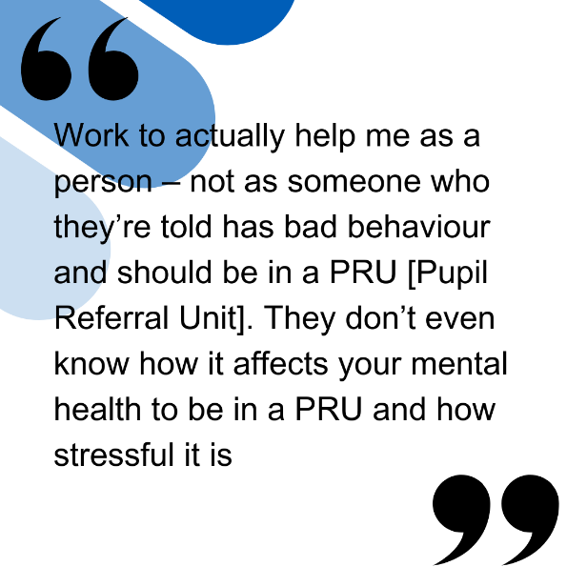
Caption:  The Listening Project, which listened to children and young people from Black, Asian and Latin American communities talk about their mental health, demonstrates best practice on how to engage effectively and creatively with children and young people. This model can benefit the development of your organisation’s engagement practices.  Read the full report at https://www.transformationpartners.nhs.uk/listening-project-report | 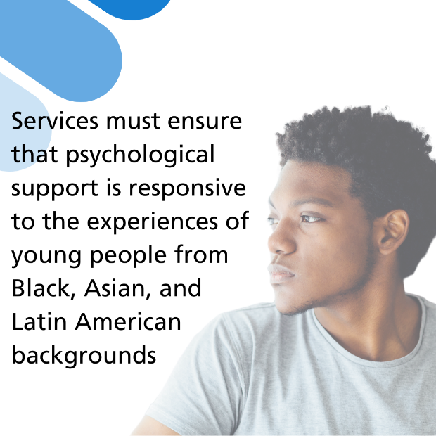
Caption:  In 2023, a partnership of London youth and mental health organisations came together to create The Listening Project, a project dedicated to understanding the mental health experiences of minoritised young people in London. How do we apply the insights from this report to service improvement to better respond to needs of racialised children and young people?  Read the full report at https://www.transformationpartners.nhs.uk/listening-project-report | 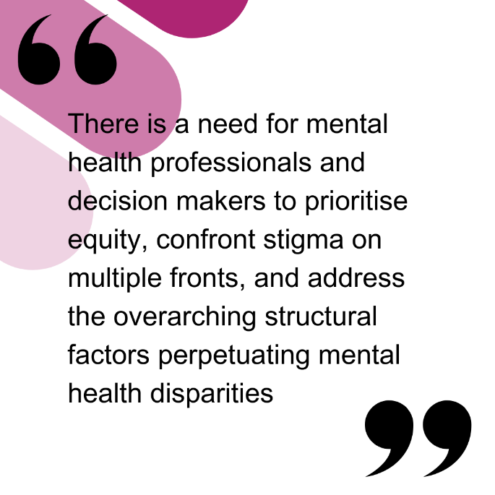
Caption:  The Patient and carer race equality framework (PCREF) identifies critical competencies for organisations to develop, against which they will be assessed. The Listening Project’s recommendations provide guidance on how to progress in multiple of these competencies, including workforce, partnership working, and co-production.  Read the full report at https://www.transformationpartners.nhs.uk/listening-project-report | 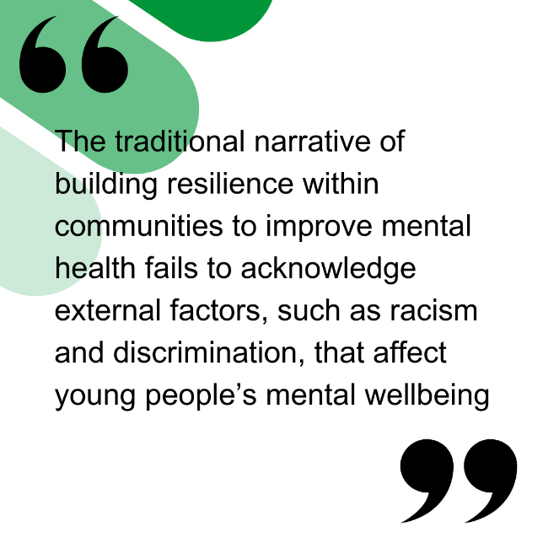

Downloadable one page infographic

Click here for a one page infographic on the report to cascade to internal teams

