# My Asthma Triggers

List the things that make your asthma worse:

Pollen Dust Animal fur Weather Exercise

Mould/damp Fumes Tobacco smoke

House dust mite

Vaping Environmental pollution

Other fumes/ sprays Respiratory infections (cold/flu) Medicines Stress/emotions Food *

REMEMBER

Good asthma control means having NO symptoms at all

If you have any symptoms you should speak to your doctor or asthma specialist as soon as

* Always refer to your Allergy Plan as well

Any Other Triggers:

possible

Extra Advice from my Asthma Professional:

# Contact Details

GP:

Asthma Specialist/Team:

Young People Asthma Plan

Ages 12 - 18

This plan was approved by

London Asthma Leadership and Implementation Group (LALIG) Approval Date: May 2024

Name: Date:

Click here

Produced by

To Be Revised: May 2026 London Babies, Children and Young People’s Team



Additional Resources:

[Asthma and Lung UK](https://www.asthmaandlung.org.uk/conditions/asthma) [Check you’re using](https://www.asthmaandlung.org.uk/living-with/inhaler-videos) [Asthma Toolkit](https://www.asthmaandlung.org.uk/conditions/asthma)  [your inhaler properly:](https://www.asthmaandlung.org.uk/living-with/inhaler-videos)

I need to take my preventer inhaler every day

It is called:

Click here

* needs a spacer

Click here

and its colour is:

I wheeze, cough, my chest hurts, or it's hard to breathe or

I regularly need my rescue inhaler one or more times a week or

If my asthma is stopping me doing sport or other activity or

My symptoms aren’t COMPLETELY better after 6 puffs of my rescue inhaler or

I need my rescue inhaler again in less than four hours or

My peakflow measure falls below 60%:

l/min

 l/min

My best peakflow measure is:

l/min

I'm waking up at night because of my asthma (this is an important sign and I will book a next day appointment with my GP or nurse) or

I also need to take up to 10 puffs of my rescue inhaler, one puff at a

I take puff/s of my preventer inhaler in the morning and puff/s at night. I do this every day even if my asthma's OK

_

_

Other asthma medicines I take every day:

My peakflow measure falls below 80%:

l/min

time.

Take 2 puffs of my rescue inhaler, one puff at a time.

If my symptoms aren’t completely better after 10 puffs

After 5-10 minutes, if I still have symptoms repeat this until I have had up to 6 puffs.

My rescue inhaler helps when I am wheezy or coughing, finding it harder to breathe, or my chest hurts. I should not need it regularly.

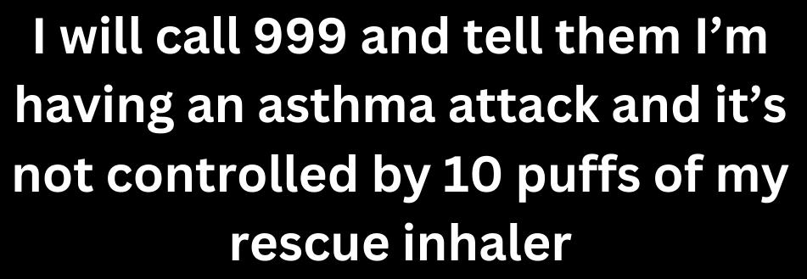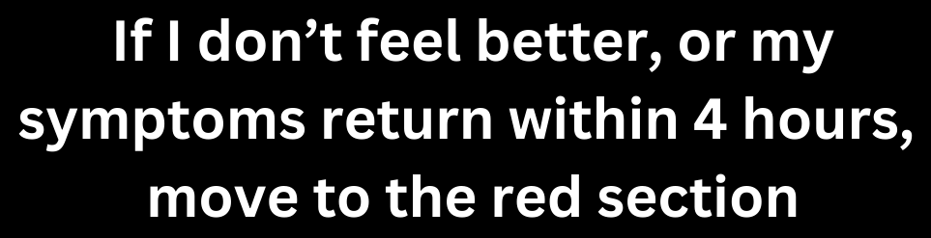

Click here

It is called:

* needs a spacer

Click here

and its colour is:

_

I take puff/s when needed

This should last at least 4 hours.

I will call my GP to arrange an appointment today or tomorrow

Sit up - don't lie down. Try to keep calm.

Take one puff of my rescue inhaler. Then repeat every 60 seconds.

If the ambulance has not arrived after 10 minutes, contact 999 again immediately.