# 

# Annual Impact Report 2023/24

# June 2024

## Contents

* Forewords
* About this report
  + Our three teams
  + 2023/24 in figures
* Digital, data and analytics
* Tackling Health inequalities
* Maternity
* Children and young people
* Mental health
* Cancer
* Primary care
* Integrated Urgent Care
* Workforce
* Equality, diversity and inclusion
* About us

## A consultant talking to a client

## Forewords

### Sue Hunter

I am thrilled to introduce the first ever Annual Impact Report for Transformation Partners in Health and Care (TPHC).

At the time of writing, it is 18 months since Healthy London Partnership and Healthcare Consulting came together as TPHC, later joined by the Digital Productivity team in 2023. Collectively, however, we have hundreds of years of health and care experience, and NHS values at our heart.

This report showcases recent examples of our work as NHS improvement and transformation experts. It demonstrates our track record in designing and delivering complex NHS transformation projects and programmes across health and care systems. Importantly, it captures the deliverables, outcomes and the impact of our work for our partners and customers, and the patients and communities they serve.

It also provides a snapshot of the rich knowledge and skills our three teams have, including in digital, data and technology; mental health; primary care; and tackling health inequalities.

Whilst there are many uncertainties and pressures within the health and care system, TPHC is here to guide your organisations through the challenges, overcome them, and become even stronger together.

**Sue Hunter**

**Managing Director, TPHC**

### Robert Prince

​TPHC is a valued part of the Royal Free London NHS Foundation Trust family, where it sits within the Group Corporate Services division which I lead. With its NHS values, experience and expertise, TPHC is trusted by dozens of partners and customers every year to guide them through complex improvement and transformation challenges.

As well as helping customers achieve their goals, TPHC staff add social value and embed sustainable change. What’s more, working with TPHC also means resources are invested back into Royal Free London, our people, and the communities we serve.

**Robert Prince**

**Managing Director,**

**Group Corporate Shared Services**

**Royal Free London NHS Foundation Trust**

## About this report

Examples of work and case studies included in this report are not exhaustive. We have focused on projects and programmes delivered by TPHC teams in 2023/24, however some may precede this date.

The report reflects the priorities of our customers, and how we have helped them to achieve them.

### At a glance

### What we do and how we do it

Health and care organisations are being asked to deliver more than ever before, with increasingly stretched resources. As committed public sector professionals, we understand each client’s needs and share their mission of improving patient outcomes, and delivering essential transformation and improvement services, while demonstrating value for money.

#### **Consultancy**

Our diverse and expert consultancy team provides high-quality bespoke programme management and advisory services to organisations across health and social care and, increasingly, other sectors.

Specialisms include digital, data and analytics, project and programme management, service/process improvement design, and strategic communications and engagement.

#### **Partnerships**

Our partnerships team is an integral part of London’s health and care system, supporting the NHS in London to tackle health inequalities and work towards making London the world’s healthiest global city, and the best global city in which to receive health and care services.

We deliver work to improve Londoners’ mental health and emotional wellbeing, put an end to HIV in London, improve homeless health, deliver personalised care, and much more, working closely with partners including The Office of London Partnership.

#### **Digital Productivity**

Our Digital Productivity team combines technology and automation solutions with process and business redesign. With over seven years of experience in this field, we have been at the forefront of driving efficiency, reducing costs, and ultimately improving patient care.

### 

### 2023/24 in figures

A graphic showing 2023/24 figures for TPHC's teams:
9 pan-London Partnerships programmes, 43 funders.

Organisations we worked with:
42 NHS trusts
5 NHS ICBs
2 NHS England
10 NHS commissioning support units
10 Non-NHS organisations
62 total

223 projects delivered and 62 customers for Consulting and Digital Productivity

28 customers in London, 34 outside of London. 


Figure Organisations we worked with through our partnerships, consulting and digital productivity teams

**Through our work with our customers and partners we are helping to improve health and care outcomes for patients and communities.**

#### **Results this year include:**

* Feedback from children and families is shaping the future Children’s Cancer Centre in south London
* Updated healthcare standards will ensure children in secure settings in England get improved access to healthcare
* An extra 224,657 primary care appointments have been made available each year in north east London in the evenings, at weekends and over bank holidays
* 100% of 18 London trust staff surveyed about the CapitalMidwife Anti-Racism Framework said it was having a positive impact in their workplace.
* 85% of NCL care home providers are using remote monitoring tools to detect early signs of deterioration and illness
* Raising awareness of childhood asthma through the London led NHS #AskAboutAsthma campaign reaching over 3.5 million people on social media
* Nearly 5,000 Londoners celebrated Great Mental Health Day 2024, almost 3,000 taking part in person at 60+ events in 15 London boroughs
* Tackling stigma and discrimination in frontline public services by launching London’s first [HIV Confident Charter](https://fasttrackcities.london/new-charity-partnership-for-hiv-anti-stigma-charter/).

Case studies set out in this report will tell you more about our teams’ combined expertise and how we achieved these results through multi-disciplinary approaches.



## Digital, data and analytics

We help the NHS harness the potential of digital solutions and data at every level from the most local to national, improving experience for patients, carers, and health and social care staff.

Children and young people’s data dashboardA national dashboard our digital, data and analytics team developed to give commissioners and providers a clear picture of children and young people’s care and outcomes went live in April 2023.

It means that children and young people’s programme leads can now easily see regularly updated data on asthma, diabetes, epilepsy, Complications from Excess Weight clinics, and urgent and emergency care. This helps them benchmark their services and make informed decisions on where to focus their efforts and resource.

The dashboard complements other ongoing work our digital, data and analytics experts are doing for NHS England’s Children and Young People Transformation Programme.

For example, they create and update bespoke data packs for programme leads for key areas of focus including asthma, epilepsy, diabetes, urgent and emergency care, elective recovery and waiting lists, and cerebral palsy.

#### **Better for children**

* The numbers and demographics of clinically extremely vulnerable children and young people are now visible, guiding national policy, particularly on vaccination.
* Areas of unwarranted variation and inequalities are clearly visible, prompting action.
* Comparisons between areas are possible, stimulating sharing of learning and best practice.

### Award-winning automation speeds up recruitment

The NHS in north central London has slashed its time for bringing in new staff from 30 to 18 days, largely thanks to smart technology.

The initiative, by our Digital Productivity team and North London Partners Shared Services (NLPSS) who support 10 north central London NHS trusts:

* enables successful applicants to complete new starter forms online
* uses robotic process automations (RPA) created by our team to securely transfer that data to other NHS databases
* won the [HPMA Award for Smarter Working in 2023](https://www.transformationpartners.nhs.uk/innovations-to-speed-up-nhs-recruitment-win-award/).

#### **Better for applicants**

* Faster, smoother processes.

#### **Better for NHS teams**

* Time saved on processing forms is freed up for other tasks.
* Vacancies in clinical and non-clinical teams are filled faster.

#### **Better for patients**

* More staff where they’re needed, faster.

## Supporting social care to go digital

### Boosting digital safety in north west London

In just four months, we supported over 250 care homes and 500 care providers in north west London to be digitally safe and secure.

After being commissioned by North West London Integrated Care Board in 2023 to tackle low levels of compliance with national standards by care homes and providers, we:

* built relationships with NHS and local authority social care leads, and care providers
* demonstrated how to comply with the national Data Security and Protection Toolkit and the benefits for services
* communicated regularly on progress and shared resources
* offered one-to-one email and phone support to care providers.

Almost 90% of care homes are now compliant (88%, up from 67% at the start) beating the national target of 80%*.*

Half ofdomiciliary care providers are compliant, up from a starting point of 10%.

#### **Better for care home residents**

* Their data is protected from the risk of a data breach or cyber-attack.
* Compliant care services can use NHSMail and Digital Social Care Records to support joined-up working by health and social care.

We continue to support this work.

**“Thank you for your work supporting improvements which, whilst techy, have a direct impact on care for our residents.”**

Jane Wheeler, Director of Local Care, NWL ICB

## Enabling happier, healthier lives in north central London

Our consultancy team worked with North Central London Integrated Care Board (NCL ICB) and five local boroughs between 2021 and 2023 to support care homes to improve their level of digital care.

Specifically, this project supported care home providers to:

* comply with the national Data Security and Protection Toolkit
* use innovative digital tools like remote and acoustic monitoring.

We set up the project for success, and NCL ICB and local partners continue to deliver it.

#### **Better for care home residents**

* In 2023/24, the proportion of care home providers using digital care records increased to 58%, enabling more joined-up, coordinated care for residents, including by GP practices and community services.
* Remote monitoring tools (now used by 90% of care home providers) detect early signs of deterioration and illness, reducing time spent in hospital.
* Acoustic monitoring tools alert staff when residents need assistance, helping to reduce falls.

#### **Better for staff**

* Easier to deliver high quality care.

#### Better for patients

* Less pressure on hospital beds.
* Increased collaboration across the whole of the North Central London health and care system is benefiting other areas of work.

### Supporting GP practices to go digital

We have also supported GP practices in north central London to provide digital access to services, transforming how they work, while making sure that people who can’t use technology aren’t excluded.

Our team used a range of different project management techniques to deliver the Digital First programme, which has been recognised by NHS England as ‘best-of-breed.’

We managed the programme across the whole of North Central London Integrated Care System, working in partnership with the Integrated Care Board, boroughs, primary care networks, third sector, and commercial vendors.

The five-year programme, which ended in 2024, used a flexible planning and contracting model with a yearly cycle. Our Agile approach and wealth of inhouse expertise enabled us to provide the right support whenever it was needed, including TPHC expertise in business analysis, finance, and data and digital.

#### **Better for patients**

* All north central London GP practices now provide online consultations, as part of their offer to patients.
* 52.5% of practices now use the NHS App, making it easy for patients to contact them.
* Greater use of technology for patients who want it frees up face to face appointments for those who don’t.

#### **Better for GP practices**

* Improved efficiency.

## 

## Tackling health inequalities

Tackling health inequalities is a key priority in the NHS Long Term Plan. Our partnerships programmes and consulting teams work with customers to tackle stigma and address service gaps for diverse and marginalised communities in London.

### 

### Leading London’s Great Mental Health Day

In January 2024, [Thrive LDN](https://thriveldn.co.uk/), which works to ensure all Londoners have an equal opportunity for good mental health and wellbeing, led the third annual Great Mental Health Day (GMHD).

This awareness event saw thousands of Londoners come together to talk about mental health, destigmatise asking for help, and shout about the great local support available to them.

Thrive LDN, a citywide mental health partnership hosted by our partnerships team, laid on in-person and online events. We produced content, resources and toolkits to help individuals and organisations to get involved.

GMHD 2024 offered Londoners:

* the chance to connect with local services and groups
* safe spaces to talk about their mental health and wellbeing
* signposting to support beyond the day
* the opportunity to celebrate the people and communities who have got them through tough times.

The Mayor of London was among those who championed it.

#### **Better for people with mental health and wellbeing needs**

* Nearly 5,000 Londoners celebrated GMHD 2024, with almost 3,000 taking part in person at 60+ events in 15 London boroughs.
* There were more than 80,000 views on social media, and more than 13,000 views of the GMHD web pages on the Thrive LDN website.

**Speaking about the impact of Great Mental Health Day, Londoners said:**

***“It highlights how important everyone’s wellbeing is.”***

***“It has opened up a safe space for people to speak freely about their mental health.”***

***“It gives people a great understanding of mental health issues.”***

#### Appropriate Adult service for vulnerable adults in London All vulnerable adults who are suspected of an offence should have access to an Appropriate Adult (AA) as per the Police and Criminal Evidence (PACE) Act Code C. However, no organisation has the statutory duty to commission and fund these services for adults.

A new service delivery model for vulnerable adults in London was needed by March 2024 and we were commissioned to carry out an options appraisal to outline and analyse possible models.

We undertook:

* desktop research
* detailed analysis of the current service, jointly funded by London bodies
* comprehensive stakeholder engagement including with local authority representatives (both users of the funded service and of alternatives), independent custody visitors, custody officers, and people with lived experience.

Our Design Group included representation from local authorities, the National Appropriate Adults Network, Metropolitan Police, Mayor’s Office for Policing and Crime, NHS England, and lived experience representatives, coordinated by third-sector organisation, Revolving Doors.

In the group, we listened to and addressed their suggestions and concerns.

This robust process resulted in a way forward being agreed by all stakeholders, solving a longstanding issue.

#### **Better for vulnerable adults**

* There will be a consistent, comprehensive Appropriate Adult service for vulnerable adults in London.

### Championing homeless and inclusion health in London

People experiencing homelessness face significant barriers to health services, and often have unmet health and care needs. Even if able to access services, they may experience discrimination or stigma which puts them off coming back.

The [Homeless Health London Partnership](https://www.transformationpartners.nhs.uk/programmes/homeless-health/health-housing-and-social-care-integration-for-people-experiencing-homelessness-needs-identified-in-an-inpatient-audit/) (HHLP) is a pan-London programme led by TPHC that works with the five NHS Integrated Care Boards (ICBs), statutory health bodies, local government, third-sector organisations, and people with lived experience to address challenges that impact the health of people experiencing homelessness.

#### **Insights**

In 2023/24, our team provided valuable research and insights for this population:

* a [hostel survey](https://www.transformationpartnersinhealthandcare.nhs.uk/homeless-hostels-a-london-survey-of-health-and-care-needs/), published in April 2023, quantified the level of health and care needs of residents
* [one article](https://www.rcpjournals.org/content/clinmedicine/23/4/387) on the [hostel survey](https://www.transformationpartnersinhealthandcare.nhs.uk/homeless-hostels-a-london-survey-of-health-and-care-needs/) and [another](https://www.rcpjournals.org/content/clinmedicine/23/4/395) on a [snapshot inpatient audit](https://www.transformationpartnersinhealthandcare.nhs.uk/programmes/homeless-health/health-housing-and-social-care-integration-for-people-experiencing-homelessness-needs-identified-in-an-inpatient-audit/), were published in the Clinical Journal of Medicine
* a [report](https://www.transformationpartners.nhs.uk/programmes/homeless-health/transforming-primary-care-for-homeless-and-inclusion-health/#key-issues-and-proposed-recommendations) of the outcomes and recommendations from three workshops with the London Homeless Health Primary Care Working Groupwas published in March 2024. This addresses priority areas including training on GP registration, and improving access to care for people experiencing multiple disadvantages.

#### **Tackling Hepatitis C**

We are also delivering a **pilot** project to improve local testing and treatment in primary care for Hepatitis C virus (HCV), for people experiencing homelessness, in a collaborative and sustainable way.

To do this, we have:

* engaged with experts by experience from the start, centring their voices
* identified two pilot sites (one specialist homeless practice and one mainstream) to carry out the six month pilot
* trained clinical and non-clinical practice staff so they have the tools and skills required for the pilot
* organised for a researcher from an acute trust to carry out the evaluation at the end of the pilot.

NHS England’s goal is to eliminate Hepatitis C by 2025.

#### **No wrong door**

We also host the Pan-London Co-Occurring Conditions programme. This aims to improve access to services and quality of support for people who are homeless and also have substance use issues, mental health challenges and/or neurodiversity. We want to ensure that that there is 'no wrong door' to people when they seek support and treatment.

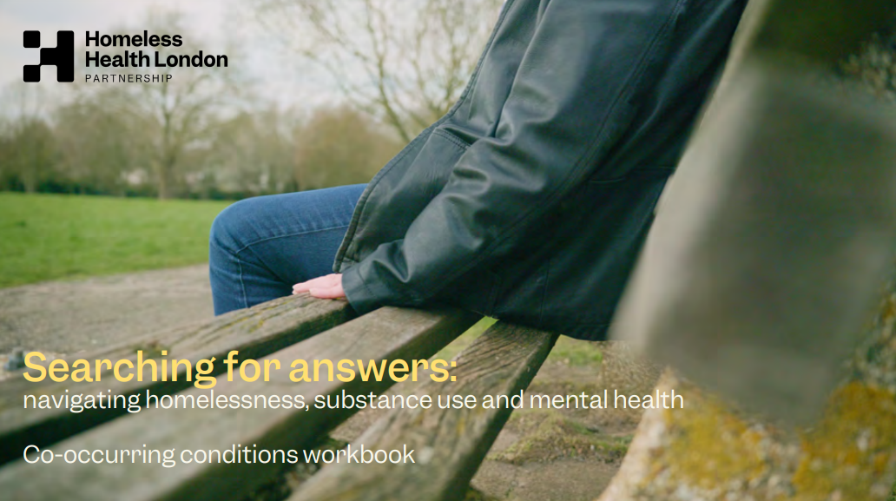

#### **Better for people experiencing homelessness**

* **Influencing strategy**: Addressing co-occurring conditions is now embedded into North Central London and North East London inclusion health workplans.
* **Training:** Over 1500 people have completed our co-occurring conditions e-learning course. Hackney Council has made the training course mandatory for all customer-facing staff in its benefits and housing needs service.
* **Raising awareness:** The programme created a short film ['Searching for answers'](https://www.transformationpartners.nhs.uk/searching-for-answers-film/#:~:text=Searching%20for%20Answers%20is%20a,conditions%20with%20kindness%20and%20compassion.) which highlights the lived experience of people with co-occurring conditions when trying to get help (played over 390 times since launch).
* **Influencing practice and service design**: There are now service standards for substance use services, co-created with people with lived experience.
* **Building the evidence base:**  Our Market Position Statement and data mapping report (March 2023) identifies the issues and makes recommendations for change. These recommendations are informing the programme's influencing work at pan-London level which will create more integrated, consistent, service provision and commissioning.

### Championing social prescribing adoption across London

Many people face financial, emotional and other issues and concerns which impact their health and wellbeing but can’t be solved by traditional healthcare. By connecting people to services and activities that meet their needs, social prescribing can have a huge impact on lives. But there is limited public awareness of social prescribing and little public involvement in services. There is also limited funding for services that people need.

#### **Supporting people to share their stories**

Our [Personalised Care team](https://www.transformationpartners.nhs.uk/programmes/personalised_care/projects/community-chests-for-social-prescribing/more-about-community-chest/) ran a Patient Voices Programme in London to support those who wished to share their experiences of social prescribing. It was developed with experts by experience including NHS and mental health peer leaders, lived experience practitioners, trusts’ patient voices groups, social prescribing managers and link workers across London.

Participants were trained in storytelling, communication and presentation, which helped build their confidence and deliver their stories with impact.

*“I’m shocked that I learnt so much. It was such a positive experience to meet so many wonderful people and hear their stories. I’ve come away inspired.”*

*–* **Spencer Cole, 2023 Patient Voices participant**

#### **Community chests**

Community chests for social prescribing are a way for communities to provide targeted support for the specific needs of their residents, such as loneliness and the cost of living.

Working with North East London Integrated Care Board, we supported each of the seven boroughs in north east London to pilot community chests.

Our personalised care team worked with each borough separately. Local people and groups came together to decide how they wanted their community chest to work and agree what the key needs were. They focused particularly on people in underserved communities. The funding was additional to that usually available.

The pilot took a “needs-led” approach to commissioning, responding to both the unmet needs of residents and the strengths of local groups and initiatives to address them. Each of the community chests successfully assigned its funding to services and activities to meet the needs of residents.

#### **Better for residents who took part in community chest funded activities**

* In Redbridge, 70% of those who responded to a survey rated their life satisfaction at over 80% compared to under 40% before
* In Havering, 20% of those who responded said they wouldn’t have known where to turn if the extra support hadn’t been there.

#### **Better for community organisations**

* Many of those who took part developed new skills and stronger relationships with NHS and borough colleagues.

#### **Better for the integrated care system**

* The pilot raised awareness of social prescribing, including by community organisations.
* Fewer residents sought medical help for non-medical problems. In Havering, over 25% of people said they would have attended the GP surgery if they hadn’t accessed the activities.

Tackling HIV stigma in London  
Fast-Track Cities is a global initiative to end the HIV epidemic by 2030. London joined the global Fast-Track Cities Initiative in January 2018. At TPHC, we host transformation support and programme management for the Fast-Track Cities London leadership.

Despite major advances in clinical care, quality of life for people living with HIV suffers because of stigma.

In April 2023, we supported the launch of London’s first [HIV Confident Charter](https://fasttrackcities.london/new-charity-partnership-for-hiv-anti-stigma-charter/) to tackle stigma and discrimination in frontline public services, and in society.

Organisations sign up to the charter to access training, support with HIV policies, tools to report stigma, and a staff survey. Once this is successfully completed, they are awarded an HIV Confident Charter mark. The charter was developed by the National AIDS Trust, NAM aidsmap and Positively UK, working with the HIV sector.

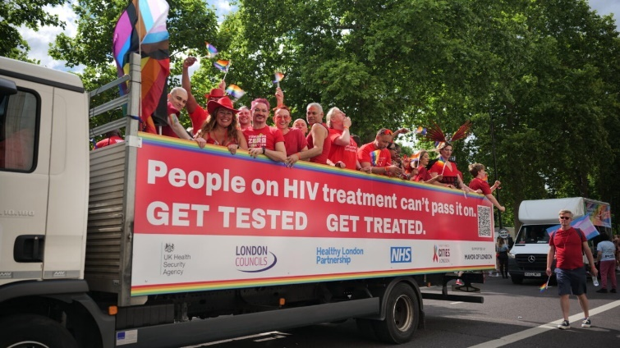We also supported the launch of a three-year HIV Ambassadors programme in partnership with Terrence Higgins Trust. This recruits and trains people living with HIV to act as ambassadors, educating people to tackle stigma in society.

And as usual we supported Pride month, highlighting the work of LGBTQ+ and HIV community groups. We secured attendance at the London Pride parade with some of London’s most senior leaders.

#### **Better for people living with HIV**

* There are 15 founding members of the charter, from the Greater London Authority to NHS Trusts, boroughs, GP practices and businesses
* 18 ambassadors have been recruited and trained and are already delivering sessions
* London’s anti-stigma programme empowers people living with HIV to take charge of their health and wellbeing and to advocate for and support others.

The HIV Confident Charter and Ambassadors programme are integral to the efforts to get to zero new cases of HIV, zero preventable deaths, zero stigma and 100 per cent of people living well with HIV in London.

## Maternity and maternal mental health

The [NHS Long Term Plan](https://www.longtermplan.nhs.uk/publication/nhs-long-term-plan/) renewed the NHS’s commitment to transformation in specialist perinatal mental health services, to ensure that all women who can benefit are able to access care. Our experts in mental health played an integral role in London’s response and commitment to enhancing and improving mental health support for new mums.

### Universal access to perinatal mental health services

In 2024, we concluded a seven-year programme in London to achieve all the ambitions for perinatal mental healthcare set out in the NHS Long Term Plan.

Working in partnership with the NHS in London, we have collectively ensured there is universal access to specialist perinatal mental healthcare, supported by Provider Collaboratives across the capital.

Perinatal mental health services are for women/birthing people who are planning a pregnancy, pregnant, or who have a baby up to one year old, and who experience mental health problems.

The programme we supported, which started in 2017, succeeded by creating a responsive network of professionals, peer support and experts by experience who were all determined to improve the care and experiences of women, birthing people and families.

To facilitate this work, our team:

* set up clinical leads support and networks
* created the first Lived Experience Practitioner programme team post to support the roll out of maternal mental health services and encourage the development of peer support for perinatal mental health
* developed and updated a training and education plan for London to address gaps in training and education. There are now hundreds of perinatal mental health champions in the capital
* created a dedicated [webpage](https://www.transformationpartners.nhs.uk/programmes/mental-health-transformation/perinatal-mental-health/), podcast series, clinical guidance and newsletter
* supported the creation of Provider Collaboratives in London.

#### **Better for patients, babies and families**

* Every postcode in London is covered by community perinatal mental health teams.
* Women, birthing people and families have access to a wider range of psychological interventions
* As of April 2024, all three London Provider Collaboratives have gone live.

# **Children and young people**

The work we do that impacts on children, young people and their families stands out because of its breadth, variety, and sensitivity of approach.

### **Children’s Cancer Centre consultation**

We led communications and engagement for a high-profile consultation on changes to very specialist cancer treatment services for children who live in south London and much of south east England.

It was very important the programme heard from children with experience of cancer as well as their families, staff, councillors, and others.

To do this, we:

* spoke to children and young people about what would help them to take part
* created clear, simple materials, as they advised, including an animation, and an easy read summary of the consultation document and questionnaire
* arranged for letters to be sent to current patients and their families about the consultation, asking them to share their views
* spoke directly to children and young people in the waiting room at The Royal Marsden, and at cancer units in other hospitals across the catchment area
* went to meetings of parents of children with disabilities, and from minoritised communities to ensure their specific needs were considered
* brought in a specialist organisation to speak to parents and children in more deprived communities
* brought in a play specialist organisation to work with children having cancer treatment.

The play specialist team:

* created a play hospital for younger children to help them understand the proposal, share their responses, and have fun while doing it. It could be taken to the bedsides of very sick children
* encouraged older children to tell the story in their own words, using cards on a bulletin board, comic strip images, or writing a ‘letter to the big boss’ using a template.

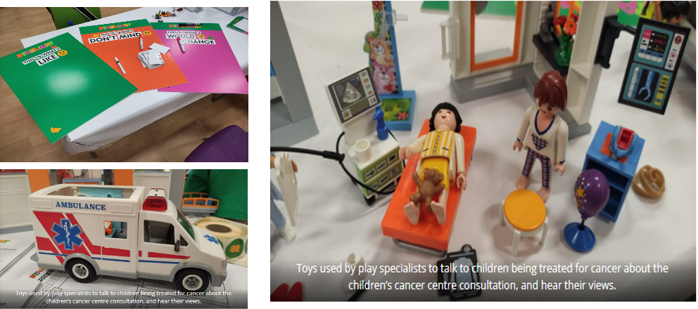

There were more than 2,600 responses to the consultation. The decision in March 2024 took account of the consultation feedback including the different concerns raised.

**Feedback on behalf of the London Mayor mentioned** “the seriousness and effectiveness” of engagement with the public and stakeholders and added: “…there has been a creative approach taken to consultation, using a variety of media and access options and multiple delivery partners, and strengthened by using an independent organisation to report on consultation activities. That report found that those engaged were broadly representative of the patient cohort.”

#### **Better for children**

* Plans for the new centre are being shaped by what children, young people and parents said they would most value.

### **Healthcare for children in secure settings**

We were commissioned in 2023 by NHS England Health and Justice Children Programme to refresh the standards for healthcare for children in secure settings in England. Secure settings include young offender institutions, secure schools and training centres.

About 1,000 children aged 10 to 17 are in secure settings at any time. They are more likely to have:

* mental health difficulties
* neurodevelopmental conditions
* speech, language and communications needs
* physical health needs
* experience of serious maltreatment
* experience of crime and/or abuse (as victims or perpetrators).

We worked with a specialist organisation to hear from 20+ children with experience of secure settings, visiting four settings. What they said played a key part in the final standards.

#### **Better for children with complex needs**

* The updated standards are now being rolled out across England.
* They stipulate better feedback mechanisms, more focus on trauma-informed care, and clarity on restraint and supervision procedures.
* Secure settings must also provide more dental care, and better support for neurodevelopmental conditions, learning difficulties, and girls’ health and wellbeing.
* This will ensure this vulnerable group gets the same access to healthcare as other children and young people.

### Making the case for funding secure children’s homes

We were commissioned to look at provision in London for children who need to be in a secure children’s home for welfare reasons, or because they have been sentenced or had bail refused.

Our research found, with no such homes in London, around 33 London children at any time are in one of 15 other homes across England – on average 192 miles from home. As well as the personal cost, we identified serious impacts on planning for their futures, issues with the availability of placements, and the financial cost.

We undertook an analysis of demand and needs for which we:

* spoke to children at several secure children’s homes
* engaged with many other stakeholders and experts
* co-developed a set of options
* undertook a full options appraisal
* undertook financial modelling
* developed a business plan for a Pan London Vehicle to create two secure children’s homes for London, with step-down facilities for those moving on.

The plan was endorsed by NHS England, London Councils, the Association of London Directors of Children’s Services, and the Mayor’s Office for Policing and Crime. It was successfully submitted to the Department for Education for funding.

#### **Better for children**

* Children in London who need the tailored support provided by a secure children’s home will have access to it.
* Children who are ready to leave a secure children’s care home will have access to transitional support.

### Supporting care leavers into work

We worked with more than 50 young people as part of North Central London Integrated Care System’s drive to support care leavers into meaningful education, employment, and training in the health and care sector.

Working closely with system partners, we coordinated access to opportunities and held recruitment and careers events.

Key activities included:

* creating opportunities for care leavers to learn about health and care careers
* offering them the chance to participate in simulated healthcare work activities
* supporting them with their applications
* offering them guaranteed and same day interviews
* giving them priority access to a variety of roles.

#### **Better for care leavers**

* Ten of them found jobs, education or training as a result.
* Care leavers in north central London have ongoing access to employability support.
* Learning from this work was celebrated at a national event, via regional workforce colleagues, helping other systems to follow suit.

### Childhood asthma campaign

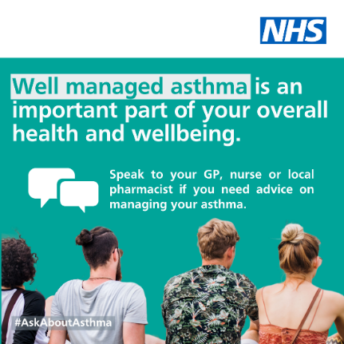We lead the communications for NHS England – London’s annual #Askaboutasthma campaign. Coinciding with the new school year in September, the campaign highlights simple changes that will make a big difference to children and young people with asthma.

2023 was the seventh year of the campaign and to keep it relevant and maintain growing support from the wider system, the focus was widened to include the impact of housing, mould and vaping.

We collaborated and co-produced content with children, parents and professionals, ensuring it addressed stigma, and encouraged people to share their own experiences.

We supported the team to run a weeklong schedule of virtual events with:

* webinars and conferences for professionals
* blogs, videos and podcasts
* a live educational broadcast to primary schools
* traditional and social media.

#### Better for children

* The 2023 campaign reached over 3.5 million people on social media, raising awareness of issues impacting on asthma, and tips for care.
* It also achieved national coverage in traditional print media.

Support from partners including the Mayor for London, Asthma + Lung UK, Mums for Lungs, and parents of children with asthma was key to getting this reach.

## Mental health

#### Good mental health is important at every stage of life, and having access to timely, appropriate support can be life changing. The NHS is committed to improving access to mental health services so that more people of all ages receive the treatment they need.

### Understanding the mental health and wellbeing needs of children and young people with SEND in London

We carried out a stocktake for the London Leaders Group on the scale and range of mental health and emotional wellbeing needs of children and young people with special educational needs and disabilities (SEND) in London.

Through in-depth data analysis, we:

* outlined the current levels of need in children who come forward
* analysed trends over the previous five years
* estimated the current number and prevalence
* considered wider risk and protective factors.

#### **Better for children with SEND**

* Our work identified the areas of London where children and young people with SEND have the highest level of mental health and emotional wellbeing needs.
* It also identified the backgrounds and circumstances of those most likely to develop such needs.
* Our analysis is helping to inform London leaders on where preventative intervention or support is most needed in London.

### Leading suicide prevention in London

[Thrive LDN](https://thriveldn.co.uk/) leads suicide prevention in London on behalf of NHS England. In September 2019, Thrive LDN launched the Real Time Surveillance System (RTSS), co-hosted by the Metropolitan Police.

This is a platform for multiple agencies that securely collects and shares real-time data on suspected suicides.

A similar model was launched nationally in November 2023 and Thrive LDN was among 15 national experts consulted on it.

#### **Better for people at risk of suicide**

* Recording of key demographic information, including contextual and geographic links, enables preventative initiatives.
* Capturing emerging means of suicide allows coordinated action.

#### **Better for people bereaved by suicide**

* The system makes real-time referrals to specialist bereavement support in London, enabling services to proactively contact people bereaved by suicide.

### Supporting free digital mental health and wellbeing for Londoners

[Good Thinking](https://www.good-thinking.uk/), a free, NHS-approved, online mental health and wellbeing service for Londoners, is one of the mental health programmes we support.

It offers Londoners the tools and guidance to find their own path to improve their wellbeing, is available 24/7 on any device and is completely anonymous.

We work with different organisations, communities, charities, and others to create impactful content.

#### **Better for children and young people**

* Good Thinking now has information on dealing with exam stress and bullying, created with Partnership for Young London.

#### **Better for adults**

* This year Good Thinking will be launching training to support workplace wellbeing.
* We’re also supporting a ‘train the trainer’ pilot in Newham with community organisations to raise awareness of Good Thinking by making every contact count. This will support more people to better understand and manage their mental wellbeing.

## Cancer

We are supporting the NHS in London to transform cancer services in line with the NHS Long Term Plan, supported by the expert insights of patients and professionals.

### Transforming cancer services in London

#### **Analysis** Analysis plays a key role in understanding the current position. As part of their work on this, our Transforming Cancer Services Team undertook demand and capacity modelling for endoscopy services at Epsom and St Helier, and chemotherapy services at St George's.

#### **Training** We delivered Cancer Waits and Best Practice Timed Pathways training to cancer clinicians and service support staff in February 2024. Out of 40 evaluations received:

#### 100% agreed the session was helpful for their work

#### 95% said the delivery was clear and well presented

#### 87% said they would attend a further session if offered.

#### **Patient engagement** We have enhanced the diversity of the Transforming Cancer Services Patient Advisory Group, recruiting several new members in 2023/24 so it better reflects the London population. We also arranged expert training in equality, diversity and inclusion for members of the group.

**Conversation, collaboration and innovation**We set up the London Cancer Community of Practice (CoP) in early 2023 in collaboration with NHS England Workforce, Training and Education, and Central London Community Healthcare Academy. It enables community nurses, general practice nurses and allied health professionals to come together, learn, and work together on cancer service development.

We organised well-attended webinars on the CoP in 2023/24, with a wide range of NHS speakers. Topics included cancer screening for LGBTQI+ communities; frailty, cancer and old age; and quality improvement in cancer services.

The Community of Practice was selected by the 2023 Oncology Nursing Society (ONS) Conference as an example of good practice. We presented a poster and conference abstract.

#### **Better for people with cancer**

* All this work supports more effective cancer services for Londoners, making best use of resources and keeping waiting times as low as possible.

## Primary care

We provide expert support for integrated care boards and primary care networks to help them deliver primary care that meets the increasingly complex needs of their residents.

### Working towards integrated primary care in north east London

We provided North East London Integrated Care Board with the evidence it needed to invest multi-year funding in a same-day urgent primary care service for north east London that meets the requirements of the Fuller stocktake report.

In six months from April to October 2023, our team:

* developed the full business case for investment in same-day primary care access including service design principles
* developed the service specification and undertook a compliant procurement approach
* achieved widespread clinical consensus and support, and the backing of the ICB’s assurance processes
* helped secure Board agreement to allocate around £22million over three years to increase urgent primary care capacity in the evenings and at weekends
* supported the system and enabled the ambitious go-live date of 1 October 2023, ensuring service delivery and continuity of care.

#### **Better for patients**

An extra 224,657 primary care appointments a year will be available in the evenings, at weekends and over bank holidays. This will help residents get convenient same-day care when they need it. It will also help reduce the pressure on key urgent services such as A&E, 111 and Urgent Treatment Centres.

The process strengthened the commitment of general practices in north east London to working together, which has benefits for patients.

### Brent liver cancer scanning pilot

We supported two primary care networks in Brent, north west London, to set up the infrastructure they needed for a 12-month NHS England liver cancer case-finding pilot.

We provided Harness North and Harness South Primary Care Networks with programme management office expertise, helped them to develop governance structures, and supported them to strengthen their partnership with secondary care and NHS England.

The first community fibroscan clinic – a service Harness Care has contracted from secondary care – took place on 21 February 2024. Twice weekly clinics will continue until September 2024. The aim is to test over 1,500 patients.

**Better for people at risk of liver cancer**

* This proactive approach is helping to make a real difference to the lives of people at higher risk of liver cancer in Brent.
* By reporting outcomes to the NHS England Liver Scanning pilot, it also paves the way for further strategies to combat liver cancer.

## Integrated Urgent Care

Integrated urgent care is key to ensuring that patients get the right care in the right place at the right time.

### Supporting London’s urgent and emergency care response

We have supported NHS England London’s urgent and emergency care programme to:

* set up urgent and emergency care networks to oversee the planning and delivery of care London-wide
* designate urgent and emergency care facilities to ensure London quality standards are met seven days a week
* improve and expand the NHS 111 system to help patient get the right care, first time.

As part of this, we have developed the MiDoS© search tool to enable healthcare professionals to find service information in a variety of settings and on the move.

MiDoS© has been piloted by London Ambulance Service and A&E staff, and GPs in urgent care settings.

We have also worked on technology to mitigate staffing issues in urgent and emergency care and NHS 111. This coincides with the integration of AI into NHS 111, with a product called Visiba. Visiba’s platform allows remote consultations between patients and healthcare professionals, freeing up the need for a non-clinical health adviser at the history taking stage.

#### **Better for patients**

* MiDoS© enables ambulance and A&E staff to contact GP practices via bypass numbers, and community services, helping patients get the right care in the right place.

### Workshop enables senior leaders to create real improvements in services and emergency care

In spring 2023 following a winter of pressures including industrial action, North Central London Integrated Care System commissioned us to run a workshop where senior figures in the system would come together, including acute and mental health trusts, ambulance service and local authorities.

The purpose of the event was to collectively:

* discuss system pressures, including the impact of NHS industrial action
* consider the issues and challenges facing the different parts of the system
* learn together and reflect as part of system planning for winter 2023/34
* discuss which interventions should become business as usual.

We co-designed and co-produced the workshop with the integrated care board and delivered the event. This gave the participants space to examine what could be adopted from measures taken during the industrial action. We challenged them to investigate the role of community and virtual care as part of their overall strategy for meeting demand.

#### **Better for patients**

* System leaders reflected and learned together and identified opportunities for improvement, including historical issues with discharge pathways.
* It was agreed to audit discharge pathways and share best practice as well as further work on urgent and emergency care (UEC).
* It was also agreed to do further work to understand capacity and demand in urgent and emergency care including looking at prevention, population health and public health measures to reduce demand, and to explore the impact of pressures on mental health services.

## Workforce

We partner with organisations to help them make the most of the rich diversity of skills and experience within their workforce.

We work on both small and large scale organisational issues, whether it’s tailored leadership development programmes or wider organisational training.

### Supporting north central London to retain and develop vital workforce

We supported the development and are supporting the implementation of a five-year People Strategy for North Central London Integrated Care System’s 88,000 strong health and care workforce.

Published in May 2023, the strategy focuses on achieving a sustainable workforce by:

* training, developing and retaining staff and reversing leaver rates
* transforming clinical and care delivery models
* transforming the skills and capabilities of the health and care workforce in north central London.

The NHS, local authorities and voluntary organisations in north central London’s five boroughs have worked together to make the first year of the strategy a success.

We have supported leaders to implement the strategy by:

* facilitating engagement, setting up governance and supporting collaboration
* developing a detailed implementation plan for year one delivery and a formal reporting process to bring rigour and structure to the programme
* setting up Workforce Delivery Boards, and developing workforce data dashboards with the Integrated Care Board data team
* finding funding opportunities such as a £3 million grant from the WorkWell Partnership Programme for employment support for young people with mental health issues or long-term conditions. We will help it mobilise
* working with system partners to find good practice and joint working to encourage collaboration and streamline activity
* raising awareness of the People Strategy.

The People Strategy recognises that staff working across health and care are a key asset and to support staff retention, a number of enablers have been put in place in NCL. These cover equality diversity and inclusion (EDI), health and wellbeing, and talent and leadership.

#### **Better for residents**

* Greater stability of staffing will benefit the 1.4 million residents of north central London when they need support from health and care services.

### Supporting improvement in the NHS

We have trained more than 500 people in the NHS and universities to carry out After Action Reviews – important structured debriefs. This includes more than 350 NHS staff, from consultants to admin support, in east of England trusts since 2021.

We offer support for newly trained facilitators (After Action Review conductors) to develop their practice, and advice on setting up a community of practice for their organisation.

Our in-house conductors have delivered over 100 After Action Reviews and Before Action Reviews since 2021 for NHS trusts, integrated care boards, NHS England, local authorities, the Youth Custody Service, and political parties.

**Better for patients**

* After Action Review training builds excellent problem solving, flexible thinking and capacity for continuous improvement in teams.
* After Action Reviews allow organisations to learn and improve from incidents, near misses, and successful events.
* The learning is used to avoid future failures and promote success, as well as build staff confidence to speak out.

### Improving care and supporting district nurses

North and East London NHS Foundation Trust asked us to help identify ways to reduce the growing pressures on its district nursing service.

Between September and December 2023, we facilitated engagement between all stakeholders and partners to look at what might help and how it could work in practice. This identified three priority areas for different ways of working: diabetes, documentation and end-of-life care. All align with the Trust’s existing demand and capacity programme.

**Better for patients**

* Plans for diabetes aim to manage patients’ care better, achieving a reduction in complications, and a decrease in the number who need insulin administration.
* Improved documentation aims to reduce repetitive visits, increasing access for other patients.
* Plans for enhanced end-of-life care in the community aim to decrease the number of patients requiring emergency interventions and/or hospital admissions.
* Reduced pressures on nurses will make it easier for them to maintain consistent, high quality care.

**Better for nurses**

* The plans aim to reduce pressures on district nurses, improving job satisfaction, retention and recruitment.

### Leadership programme equips mental health leaders with the skills to champion, influence and advocate

Before we came together as TPHC, our partnerships team led the development and delivery of a leadership programme for clinical and service leads in London’s children and young people’s mental health services.

It focused on equipping them with the skills, knowledge and expertise to tackle strategic workforce problems and develop creative solutions for the future.

The programme, which was commissioned by Cavendish Square Group and what was then Health Education England (now NHS England Workforce, Training and Education) consisted of six taught modules, directed learning, team coaching and team collaboration sessions. It focused on equality; diversity and inclusion; retention; supervision; fragmentation and awareness; and wider system service configuration.

#### **Better for children and young people with mental health needs**

* Over two years, the programme trained 50 mental health leads from the NHS, local authority children’s services, and voluntary and community sector organisations.
* It equipped them to champion and influence children and young people’s mental health, and advocate for change at a strategic and operational level.
* They also developed system-wide relationships, critical thinking, and creative problem-solving skills used to address challenges in the children and young people’s mental health workforce.

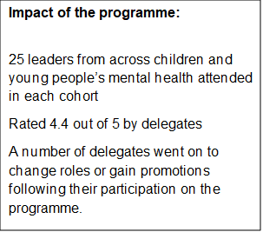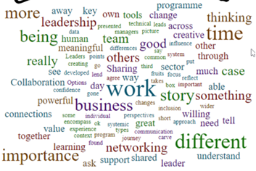

Figure Wordcloud of delegate feedback

''Really, really good to see people from all different organisations coming together across London''

''Excellent work, I truly want to be part of it'' – Cavendish Square Group

## 

## Equality, diversity, inclusion

‘Equality, diversity and inclusion is a key foundation for creating a caring, efficient, productive and safe NHS’ – NHS England

Our teams are trusted experts in working strategically and sensitively with our partners and customers to achieve improvements in equality, diversity and inclusion, contributing to improvements to staff experience and patient outcomes.

### Breakthrough insights on gathering workforce equality, diversity and inclusion data

In 2023, we were commissioned to work with several national and London bodies on equality, diversity and inclusion (EDI) and the workforce.

In partnership with the London Public Health Workforce Collaborative, we sought to investigate the characteristics and experiences of health protection practitioners working in the UK Health Security Agency (UKHSA).

To do this, we tested and developed a successful approach to gathering their EDI data, including surveys and focus groups.

This resulted in insights into what we did and how it worked – a new methodology. We also produced a case study on EDI within UKHSA and recommendations for how UKHSA could strengthen its EDI approach, and how the London Public Health Workforce Collaborative could gather data from other public health teams in London.​

#### **Better for patients**

* Having a diverse and inclusive workforce not only helps tackle health inequalities but also helps in creating a culture where everyone is valued and respected.
* Our learning has been shared at a national level and the methodology can be replicated by any team that wants to gather more EDI data.

### Supporting London’s maternity workforce

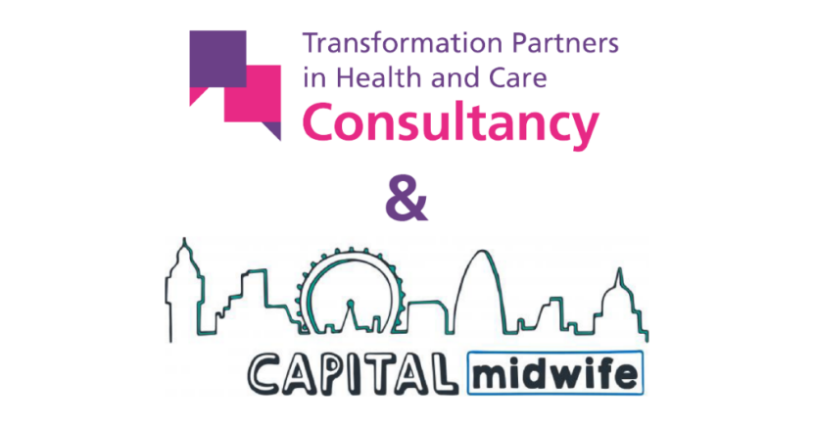We have run the CapitalMidwife programme on behalf of NHS England’s London Regional Maternity Team since 2018.

This brings together staff to design and champion work to make sure London maternity staff are valued, respected, listened to and supported to reach their full potential. This pre-emptively tackles issues that can lead to midwives leaving the workforce.

Working with midwives across London, we have designed and supported implementation of:

* the CapitalMidwife Preceptorship Framework which outlines expected standards for support by maternity trusts to newly qualified midwives. Quality marks are awarded to trusts that achieve the standards
* the CapitalMidwife Fellowship. This provides training in leadership, quality improvement and interview skills for selected band 6 and 7 ethnic minority midwives to support their career progression
* the CapitalMidwife Anti-Racism Framework which gives hospital maternity departments a roadmap for developing an anti-racist culture. It has nine key anti-racist initiatives with awards for achieving different stages of implementation.

We delivered all aspects of this successful work, including coordinating recruitment for and managing the fellowship, coordinating assessments for trusts, and monitoring and evaluating the products.

The work won the 2023 Royal College of Midwives Award for Equity and Equality and was shortlisted for two 2023 Health Service Journal Awards.

#### **Better for patients in London and nationally**

* Within two years of the Preceptorship Framework being launched, every trust in London had received a quality mark, and the framework was adapted by NHS England and rolled out nationally.
* 43% (13 out of 31) of the first CapitalMidwife Fellows moved into more senior roles and 100% were able to apply what they had learned to their work. As a result a second Fellowship was funded and completed. Discussions are being held with the national NHS maternity team about expanding the Fellowship beyond London.
* 100% of trust staff surveyed about the Anti-Racism Framework said it was having a positive impact in their workplace. Two of the 18 London trusts with maternity services have achieved an award for implementation and 16 are engaged or working towards implementation.

**“Our collaborative partnership with THPC has been remarkable, thanks to their expertise, seamless processes, and robust infrastructure. Their dedication to surpassing our needs has been evident, making them an invaluable part of our team and contributing significantly to our success”.**

Nina Chalazae - Interim Regional Chief Midwife for London

## Contact us

Transformation Partners in Health and Care (TPHC) delivers high-quality bespoke consultancy, programmes and projects from neighbourhoods to a national level, with an outstanding track record in achieving positive and tangible results for populations.

We have three distinct offers, ‘partnerships’, ‘consulting’ and ‘digital productivity’, with all teams working together to co-support programmes, share expertise and devolve learning. Our experience gives us a unique understanding of the needs of our partners and clients, along with the challenges they face.



Contact us at: [rf-tr.tphc-communication@nhs.net](mailto:rf-tr.tphc-communication@nhs.net) to discuss how we can meet your health and care challenges.

Visit our website to browse our latest news, reports and case studies: <https://www.transformationpartners.nhs.uk/>

