Primary Care and Homelessness: GP Registration, Access, and Provision of Care
Homeless Health and Primary Care Workshop
Wednesday 4 October 2023
Contents
EXECUTIVE SUMMARY 3
REPORT OUTLINE 5
CONTEXTUAL BACKGROUND 5
WORKSHOP OVERVIEW 6
Summary of presentations 7
Presentation 1: Scoping the systemic barriers which lead to unsuccessful general practitioner registration attempts amongst Londoners 7
Presentation 2: Remote General Practice and Inclusion Health 9
Presentation 3: Regional Primary Care Programme update – Homeless Health 10
Presentation 4: Addressing the blocks to GP registration and access experienced by those with multiple disadvantages 11
Workshop activity: Slido 11
KEY ISSUES AND PROSPOSED RECOMMENDATIONS 13
Summary of breakout sessions 13
Room 1: Mainstream practices: Implementing recommendations in the guidance around registration, accessibility, and appointments. 13
What are practices/PCNs/ICBs doing locally to support the Homeless health population? 22
Room 2: Specialist Practices: Which standards/recommendations should be considered within APMS contracts. 24
Room 3: Mainstream Practices: What an LCS should contain as a bare minimum (Appendix 5) 27
Room 4: Specialist and mainstream practices incorporating the electronic patient record (EPR) template for homelessness 30
Activity: Slido 32
CONCLUSION 32
Appendices 33
Appendix 1 : Scoping the systemic barriers which lead to unsuccessful general practitioner registration attempts amongst Londoners. 33
Appendix 2 : Remote General Practice and Inclusion Health: a qualitative study 35
Appendix 3: Primary Care Programme Overview and Summary of Fuller Stocktake Report, GP contract & the Access Recovery Plan 37
Appendix 4: BJGP Guidance on meeting the GP access needs of patients from Inclusion Health groups 43
Appendix 5: Comparison of ICB Homeless Health LCS/LES Service Specifications – Mainstream practices 55

EXECUTIVE SUMMARY
People experiencing homelessness frequently encounter multiple disadvantage and face severe health disparities, often due to challenges in accessing and engaging in health and care services. Health needs may include both physical and mental health concerns but is often also associated with substance use problems. Barriers to access and engagement with community based, preventative, primary care services can mean that problems remain untreated until they become sever and complex. Some of these barriers include stigma and discrimination as well as fragmented, siloed and rigid services. Despite there being no contractual duty for practices to seek evidence of identity, immigration status or proof of address, practices both across London and nationally, continue to refuse registration on the grounds that a patient is unable to produce such evidence. Tackling these barriers and working to break them down requires a multi-professional, trauma-informed partnership-based approach across the healthcare system.
On 4 October 2023, a third and final workshop of the London Homeless Health Primary Care Steering Group was held bringing together stakeholders from various backgrounds, including Integrated Care Board leads, frontline clinical and non-clinical teams, local authorities, outreach services, colleagues from NHS England London region and voluntary sector partners. The workshop focused on identifying barriers, showcasing effective practices, and proposing measures to improve registration, engagement and access to services for people experiencing homelessness or with multiple disadvantages. The workshop emphasised collaboration and inclusivity and the importance of centring people with lived experience in service design and delivery.
Four presentations featured during the workshop and highlighted key practices and approaches around London and the UK, informing workshop breakout discussions:
- Scoping the systemic barriers which lead to unsuccessful general practitioner registration attempts amongst Londoners: Ella Johnson provided an outline of the work which was commissioned in partnership by the GLA and NHS London region to look at the systemic barriers which lead to unsuccessful GP registration attempts amongst Londoners. Please note that the report was published in May 2022 and since then there have been advances made in this space.

- Remote general practice and inclusion health: Victoria Tzortziou Brown provided an overview of a research study caried out by Aaminah Verity and Victoria Tzortziou Brown in Northeast and Southeast London that looked at the perspectives of patients from inclusion health groups on access to primary care and identified opportunities for improvement.

- Regional Primary Care Programme Overview & Summary of Fuller Stocktake Report, GP contract & the Access Recovery Plan: Dr Agatha Nortley-Meshe provided an overview of the London region primary care programme by London region’s medical director, Dr Agatha Nortley-Meshe. The group heard a summary of the Fuller Stocktake report, GP contract and the Primary Care Access Recovery Plan, with consideration of inclusion health groups.

- Addressing the blocks to GP registration and access experienced by those with multiple disadvantage: Dr Jasmin Malik provided details on a proposal and potential approach of implementing a theory of change model when addressing ongoing blocks to GP registration and access to services encountered by people experiencing homelessness and from multiple inclusion health groups. This outlined the developing of a London region campaign/pledge/commitment towards changing the approach taken within primary care.
During the workshop, participants identified key issues and proposed recommendations in several priority areas, some recommendations included:
- Multi Professional and Multi Agency working: Develop local homeless health community of practices and coordinate care through MDTs.
- Co-production of referral pathways and Shared models of care: Person-centred care, develop shared approaches to risk and care, co-designing services and standardised templates. Develop a homeless template for the London Universal Care Plan (UCP) platform.
- Training: Awareness & education of Multiple disadvantages, trauma-informed care approaches and system coding.
- Barriers to engaging with patients: Address language barriers, offer flexibility in appointments and offer an alternate approach for accessing services where digital solutions cannot be adopted.
- Data collection: Consistent electronic patient record (EPR) coding from the point of registration of someone who is experiencing homelessness.

In summary, this workshop highlighted the value of partnership working and recommended collaborative actions to address the complex needs of people experiencing homelessness. While some solutions are more straightforward than others to implement, some require further exploration and discussion. Local community of practices for homeless and inclusion health can aid taking a tailored approach to local needs.
A summary of short-, medium- and long-term next steps has been included in the ‘Transforming Primary Care for Homeless and Inclusion Health’ report. This is a consolidated report of all three workshops of the London Homeless Health Primary Care Steering Group that took place in 2023. The proposed recommendations and next steps aim to improve access, coordination, and care for people experiencing homelessness with multiple disadvantages.

REPORT OUTLINE
This report is intended for system partners working across the following sectors:
- Primary care
- Mental health
- Substance use
- Acute & Intermediate care
- Primary Care Network
- Integrated Neighbourhood teams
- Training Hubs
- Local authority
- Social Care
- Voluntary Community Social Enterprise (VCSE)
- Health & Social Care Service commissioners
- NHS Digital
It provides a summary of key issues impacting access to services and barriers to engage for people experiencing multiple disadvantages and provides recommendations to address them at PCN/Neighbourhood, borough and ICS level.

CONTEXTUAL BACKGROUND
Inequalities and the health inequity gap between the most and least deprived in society are stark. When comparing those who are experiencing homelessness with all other population groups, they have by far the worse health outcomes. The mean age of death of someone who is sleeping rough or in emergency shelters is in their 40’s, and frequently people develop multiple long-term conditions at a young age. Standardised mortality ratios for inclusion health groups (homeless populations, sex workers, prisoners, and people with substance use disorder) are a staggering eight to 12 times higher than the general population.
People experiencing homelessness continually face barriers in registering with a GP. Those from other multiple disadvantage groups also come up against obstacles when engaging with their GP practice as well as other mainstream services. The format and service structure can often impact the person’s ability to access care. It is also understood that abuse and neglect experienced in childhood will impact the ability of an individual to form trust within relationships throughout their adult life. Consequently, because of childhood experiences as well as sometimes ongoing social challenges, many people experiencing homelessness find it difficult to develop trusting relationships with clinicians. Their care is also often uncoordinated, this combined with their vulnerability and complex multiple health needs, makes it particularly important that they experience continuity of care, facilitating the development of trusting therapeutic relationships.
Inclusion health GP practices are in place in some areas of London and as such, a more targeted approach can be taken by these specialist services. That said, a significant proportion of inclusion health populations continue to access mainstream services, therefore it is important to recognise the barriers and challenges that impact engagement for both mainstream and specialist services.

WORKSHOP OVERVIEW
This workshop was brought together through the collaborative working of sub-group one of the London Homeless Health and Primary Care Steering Group. This group’s focus was on GP registration, access, and quality of care.
Recent research and data highlight the ongoing concern around GP registration and provision of care for people experiencing homelessness as well as other inclusion health groups.
It was co-produced by colleagues from North Central London and South-East London integrated care board (Amanda Rimmington NCL ICB, Angela Ezimora-West from SEL ICB) and the Homeless Health team from the Homeless Health London Partnership, TPHC.
On 4 October this workshop was held to:
- Showcase recent research looking into the challenges & barriers around registration and access for people experiencing homelessness.
- Identify gaps and areas to strengthen to improve the quality of care provided for people experiencing homelessness.
- Outline an approach of addressing ongoing blocks to GP registration and access to services experienced by People Experiencing Homelessness and inclusion health groups, through a London region campaign/pledge/commitment towards changing the approach taken within primary care.
- To discuss the research and work undertaken by the Right to Care project (a collaboration between Doctors of the World (DoTW) UK, University College London Hospital Find and Treat, and University College London).
The workshop comprised of various stakeholders (42 attendees) including representation from ICBs, frontline clinicians, Local Authority, NHSE Regional Primary Care leads, homeless peer advocacy and the Voluntary Care Sector (VCS).
Four breakout sessions were held, focusing on:
- Implementing recommendations around registration, accessibility, and appointments.
- Which standards/recommendations should be considered within alternative provider medical services (APMS) contracts?
- What should a homeless health LCS contain as a bare minimum?
- Considering the content of the electronic patient record (EPR) template.
As the group comprised of multiple stakeholders from different clinical and non-clinical backgrounds, the use of the term “patient” and “client” have been used interchangeably throughout the report.

Summary of presentations

Presentation 1: Scoping the systemic barriers which lead to unsuccessful general practitioner registration attempts amongst Londoners
Presented by Ella Johnson, Implementation Programme Manager, London Legacy and Health Equity Partnership (LHEP) (Previously worked at the GLA)

About
Please note that the report was published in May 2022 and since then there have been advances made in this space. Please refer to presentation slides for further detail.
The work was commissioned in partnership by the GLA and NHS London region to look at the systemic failings that would potentially undermine the staff's ability to implement the Primary Care Policy and Guidance Manual (PGM) and NHS England new patient registration policy.
A desk review was undertaken looking at the policy & guidance manual, the GMS1 form and associated research and academic reports. 15 semi-structured interviews and nine key informant interviews were carried out. Semi-structured interviews were predominantly with practice managers and people working in patient assistance in reception settings. The key informant interviews were individuals working on the issue of access to healthcare and barriers in primary care. A focus group was established. There were three challenges and one innovation-based recommendation. The report made seven recommendations to the challenges.
Challenge 1: Systemic pressures on the health system and individual professionals impact GP frontline staff confidence and understanding in enacting registration policy in relation to requiring ID’s and proof of address.

Recommendations
- Develop and promote a prescriptive, universal, simplified, and standardised registration process toll for practice managers and receptionists to complement current guidance.
- Redevelop the GMS1 form to clarify what information is mandatory and what is optional and provide the form in various languages.
Challenge 2: Communication channels around registration policy and processes are dense and top-down with little support to ensure registration guidance is interpretated correctly, and effectively at all staff levels.

Recommendations
- Provide GP surgeries with clearer and more immediate communication channels for handling registration queries.
- Develop and strongly recommend a standardised online training for all GP receptionists on registration to ensure a shared interpretation of registration policies at all staffing levels.
Challenge 3: Accountability and policy buy-in to registration guidance among individual GP practices is limited, potentially undermining the prioritisation of registration policy compliance amongst competing concerns.

Recommendations
- Clarify or redevelop GP surgery contractual obligations to include accountability measures to ensure that staff register patients who are unable to provide ID or proof for address.
- In response to systemwide and multi-faceted pressures on primary care services, reassess current staffing levels and resources at GP surgery level.

Innovation: Digital registration platforms offer potential solutions to some challenges of registering without an ID or proof of address but should be closely monitored and not used effectively.

Recommendations
- Explore and monitor standardised online approach to registration that does not require ID or proof of address.
*A new online registration platform has been developed and is live in 28% of practices in London.

Presentation 2: Remote General Practice and Inclusion Health
Presented by Dr Victoria Tzortziou Brown, OBE, Queen Mary University of London.

About
This presentation provided an overview of a research study caried out by Victoria Brown and Aaminah Verity in Northeast and Southeast London. The aim of the project was to explore the real perspectives of patients from inclusion health groups on access and identify opportunities for improvement.
Three outputs were delivered.
- A qualitative study. 21 participants were interviewed who were from the Gypsy & Roman traveller communities, sex workers, vulnerable migrants, and those experiencing homelessness, with a thematic analysis produced at the end.
- A mystery shopper exercise aiming to understand the real experiences of those from inclusion health populations, attempting to access care. Shoppers were asked to perform two tasks, booking an appointment in person and a telephone request for a prescription.
- A series of workshops with wider stakeholders (including GP’s, LMC representatives, Primary care commissioners) who were brought together to reflect on the findings and to produce recommendations for change.

Recommendations
- Clearer communication with patients.
- Training for receptionists (care navigation skills and understanding the impact of what they communicate to patients).
- Similar care pathways (walk in pathway to mirror online registration).
- Digital inclusion initiatives.
- National support to practices.
- Flagging vulnerability.
- Staffing issues within practices.
- Primary care funding/contracting for inclusion health.
- Training and education for clinicians and other practice staff.
This research has since been published and is available online here:
- https://bjgpopen.org/content/7/2/BJGPO.2023.0023
- https://bjgpopen.org/content/early/2024/03/05/BJGPO.2024.0021
The guidance developed by them around meeting the GP access needs of patients from Inclusion Health groups can be found in Appendix 4.

Presentation 3: Regional Primary Care Programme update – Homeless Health
Presented by Dr Agatha Nortley-Meshe, Regional Medical Director for Primary Care.

About
This presentation provided an overview of the programme and the work currently being delivered across London in partnership with the regional primary care, ICBs and wider stakeholders.
Six areas were identified as priority areas of focus for the programme. Each area is integrated with one another and supported by alignment with enabling work undertaken by other regional teams such as estates, digital, urgent emergency care and care in the community.
- Pan-London strategic transformation
- Assurance, best practice & evaluation
- Data
- Access
- Workforce
- Patient experience & empowerment
The presentation included a brief overview of the fuller stocktake including enablers, integrated neighbourhood teams and the primary care access recovery plan, which was delivered after fuller in May 2023 (Appendix 3)

Presentation 4: Addressing the blocks to GP registration and access experienced by those with multiple disadvantages
Presented by Dr Jasmin Malik, Clinical Lead for the Homeless Health Programme, TPHC.

About
The presentation provided details on a proposal for a ‘pledge for change’ initiative. The initiative would build upon previous work that has been developed or delivered. Using a Theory For Change model and approach, the initiative would support the creation of a road map identifying what is needed to help GP practices better engage with the inclusion health population. The aim of this proposed initiative would be to increase GP registrations among inclusion health populations by x% by the end of 20XX.
The proposed goals of the initiative would be to:
- Increase GP registrations among people experiencing homelessness and other vulnerable health inclusion population groups.
- Increase the understanding among practice staff, of the barriers and challenges to GP registration for this population.
- Galvanise support among London-based GP practices to create more accessible services for people experiencing homelessness.
- Raise awareness of the rights of people without fixed address in accessing GP care.

Workshop activity: Slido
Attendees were asked to anonymously share their thoughts on ‘What are the main challenges that you see as being the issue with someone experiencing homelessness accessing GP services?’
There were 21 participants with 57 responses in total. The following were each of the responses/themes in ranking order from highest to lowest.
- Discrimination
- Compassion fatigue
- Misapplied registration policy and difficult registration process
- Lack of trauma-informed practice
- Lack of personalised care and care coordination
- Communication and common understanding of ‘jargon’
- Lack of knowledge/understanding/training gap
- Understanding that they may need to be referred to be a specialist team/secondary care
- Digital inclusion

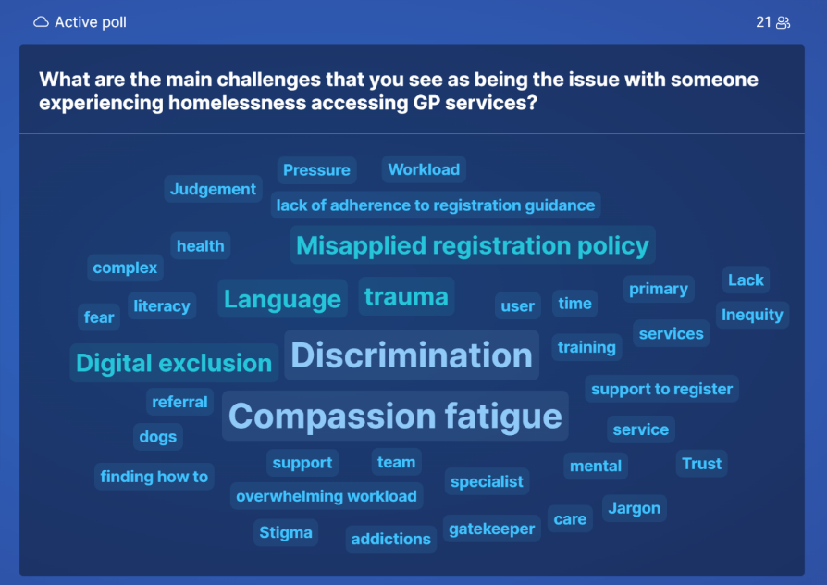

KEY ISSUES AND PROSPOSED RECOMMENDATIONS

Summary of breakout sessions

Room 1: Mainstream practices: Implementing recommendations in the guidance around registration, accessibility, and appointments.
Facilitators: Angela Ezimora-West & Charlotte Scott
The following areas were identified as the key operational functions affecting good practice in mainstream GP services.

The following table includes proposed recommendations for the following common areas affecting patient engagement with primary care: registration, access, and provision of care. The proposed recommendations below are grouped under the key operational areas identified by the workshop participants.
Priority issues | Proposed recommendations
Registration | Service delivery  - GP practices should register all patients unless their list is closed or there are reasonable grounds for refusal. These should not include a lack of ID, proof of address, immigration status or any protected characteristic.  - Practices should offer support to complete registration forms for those who require assistance.  - Whilst the full registration process is underway, practices should allow immediate and necessary clinical care and temporary registration should be suggested.  - If registration is refused by the practice, this should be recorded explaining the reasons. This should be communicated to the patient at the time of refusal.  - The reception team should have access to expert support within the practice/PCN to deal with registration queries (e.g., senior receptionist, practice manager or GP partner).  Training  - Practices to consider signing up to become safe surgeries and adopt the principles into daily practice  - Homeless and Inclusion health training for all practice staff, clinical and non-clinical. This will empower front-line staff to better support people experiencing homelessness.  Collaborative working  - Whole system collaboration – working across organisations within PCNs and local neighbourhoods. Practices to recognise that registration may be initiated by non-medical teams supporting a person in engaging with healthcare.  - Linking hostel staff to neighbourhoods.  - Collaborative approach with voluntary sector organisations, again linking them to PCN and neighbourhood approaches.  Digital inclusion  - Offer registration pathways that do not depend on digital access.  - Practices should use communication methods based on the person’s preferences and abilities (e.g., phone call, text message, email, letter, face to face).  - If hostel staff or key workers are assisting and supporting their clients to register online, provide support where required.  - Currently, there is some information available regarding GP registration on the London MECC (making every contact count) Link website.  The website to include a checklist for key workers – community, hostel and primary care be made available on the London MECC around GP registration?  - Examples of unhelpful text currently on some GP websites:  Website asks for an address you’re living at/intend to live at the address for six months.  - Practices to review their GP websites from an inclusion health user journey and ensure they provide adequate support for these individuals to join and engage with the practice.  Data collection  - Correctly identifying patients experiencing homelessness when registering them on the system so that they are coded appropriately. This can be at the point of registration or during the new patient health check  - During the new patient check, enquire about and identifying if someone maybe ‘hidden’ homeless (training should address questions to be considered, for example, if someone is exchanging sex for accommodation)  - Consistent electronic patient record (EPR) coding from the point of registration of someone who is experiencing homelessness  Communication & Advocacy - Scheduling first appointment/new patient check  - Recognise the barriers to engagement, and how delays in being seen can cause blocks. If an appointment is offered sometime in the future, enquire of any support or key workers who may be able to assist them with attending. Also consider referrals to peer advocacy services (e.g., Groundswell) to aid attendance to appointment.  - Manage expectations early in terms of delays between temporary registration and full registration (medical history is attached to the SPINE). Enquire of any recent hospital admissions or documentation that may support the clinician during the consultation.  Funding  - Some practices are in boroughs which have locally commissioned services (LCS) or locally enhanced services (LES) in place. Commissioners to consider the benefit of having an LCS/LES in places where the prevalence of homelessness may be high.
Access to primary care | Service delivery  - Adjustments to service delivery, allowing for co-development and design.  - Co-location of welfare, debt & legal advice with health care. Also consider co-location with social care colleagues and voluntary sector services.  - Develop health passports for patients and embed Annual Health Checks in hostels that align with those at the GP practice (due to be piloted in Camden).  - Services to adopt a MECC approach.  - Joining up community clinics and providing outreach that takes into consideration the population they are trying to engage.  - Embed care navigation into referrals so that people who are referred to other services have improved chances of engagement.  - Consider where services can be streamlined and where the individual can self-refer therefore bypassing the GP to receive care – this can then be outlined on the website. (Part of PCARP implementation is a self-referral pathway for various services including MSK, audiology etc.).  Training  - Embed the Safe Surgeries principles into daily practice.  - Training for mainstream practice on triaging patients who are homeless and recognising opportunities for engagement.  - Training on supporting the use of an advocate for the patient if one is available, while being alert to the possibility of exploitation or coercive control.  - Specialist homeless GP services to offer webinars to GPs, social prescribers, and others to raise awareness.  - Cancer alliances in London are working jointly with Groundswell to develop a London Wide resource for people experiencing homelessness to access bowel, breast, and cervical screening. This is supported by LA, ICB teams.  Collaborative working  - Support the assistance provided by key workers, care navigators and peer advocates when available.  - Working with the VCS and charities.  - Linking health services with appropriate local authority teams.  - Linking hostel staff to neighbourhoods.  - Collaborative approach with VCS organisations, again linking them to neighbourhood approaches.  - If the practice catchment area is close to hostels or other forms of temporary accommodation, practices to improve working relationships with these services to aid in engagement.  * GP practices to also recognise the limited time available from support teams, and that they may be supporting several clients at one time.  * Hostels to explore the role of a designated health champion who links in with the surgery to aid engagement.  Digital inclusion  - Include information for inclusion health groups about their rights to health and social care services on the practice website.  - Provide easy digital access for patients and their support network to access the service. If digital solutions can’t be adopted, then offering an alternate approach for accessing the service.  Data collection  - It is important to code correctly as a proactive measure in aiding the identification of individual health need, but also in demonstrating the scale of health need in a practice and PCN locality.  Communication & Advocacy - Scheduling follow up appointment  - Check with the patient how they would like to be reminded for their future appointment. If they do not have a phone, enquire if they have a key/support worker who can assist on their behalf, and if the patient is happy for them to be contacted.  - Check which day of the week and times work best for the patient.  Recognise that the appointment time could impact engagement, for example, if someone is bedded down in another part of London getting to a 9am appointment would be difficult. Another example is that free meals are offered in certain areas of London on certain days/times, or that an individual may require to find a sleep spot early in the day. These basic human needs understandably take priority.  Funding  - Some of the adjustments that would make the biggest impact e.g., longer appointments, outreach to street/hostel will need additional funding.  - Recognise limits within hostels and from hostel staff – further investment for “Health Champion” in hostels, and how they work with primary care teams to improve engagement.
Provision of care | Service delivery  - Enabling outreach/in-reach into hostels.  - Offer longer appointments.  - Offer continuity of care with the same healthcare practitioner (if available).  - Vaccination events that have evolved into health and wellbeing events alongside welfare, food e.g. Street Fest in Islington/Haringey.  - Services to adopt a making every contact count (MECC) approach.  - Joining up community clinics and providing outreach that takes into consideration the population they are trying to engage.  - Remove the costs incurred for medical support letters.  - Everyone who is homeless to be offered an Annual Health check.  Training  - Training hubs to hold sessions for practice staff.  - Specialist homeless services to provide local training.  - Training around coding and developing consistency on entering information on the electronic patient records.  - Training for staff and PCNs around care navigation.  Collaborative working  - Multi-professional working, taking a proactive care approach for those with multiple disadvantage and co-occurring conditions such as those on the T1000* list held by the GLA/LA.  - Co-development of a homeless template for the London UCP.  - Embed care navigation into referrals to so that people who are referred to other services have improved chances of engagement.  - Improve collaboration between health and social care.  - Create a community of practice in in each ICS to share local practices, improve communication between primary and secondary care, extend support and skills for inclusion health practitioners in both primary and secondary care and identify gaps and on the ground issues in local provision.  - At scale working across ICBs to support patients in specific inclusion groups and vulnerable populations.  - Joint community clinic (e.g., in Barking) with primary care, community, secondary care, Local authority, voluntary sector focused on supporting patients and each other.  - Gain consent to include hostel staff in key discussions.  Digital inclusion  - Creating a resource sheet for GPs of all local services, with select referral links embedded in electronic patient records EPR (e.g. System1/EMIS).  - Develop a Health Passports that incorporates the Annual Health Checks - embedding a dedicated member of staff at each hostel to ensure these take place for every service user (pilot to be done in Camden).  Data collection  - See recommendations from breakout room 4 further in this report.  - Consistent EPR coding for people experiencing homelessness to enable clinicians identify people who need a different approach (e.g., longer appointments).  - Aim to include cancer screening within EPR templates for specialist GP practices in NCL and across London via TPHC, Primary care teams.  Funding  - Increase the amount of peer advocacy and care navigation roles.  - Locally commissioned services (LCS) for people experiencing homelessness.  - Extra payment for health checks for homeless patients.  - Extra consultation time to make adopting a MECC approach more feasible.

*The T1000 (Target Thousand) project was launched in July 2020 with the intention of providing a focused and collaborative approach to ending rough sleeping for some of London’s most vulnerable people experiencing homelessness, particularly those most at risk of returning to the street and those who have been sleeping rough for a significant period. At the time of this report, there were 883 T1000s in London, with approximately 300 of those sleeping rough. The project is delivered sub-regionally with Westminster and the London Navigator Team treated as single sub-regions due to their cohort size.

What are practices/PCNs/ICBs doing locally to support the Homeless health population?
The following table captures good practice taking place across the five ICB London regions and shared during the workshop.
Region | Good practice
NWL | Locally enhanced services being commissioned in some of our NWL boroughs.  Created a community of practice in NWL to extend support and skills for primary care clinicians.
NEL | Putting together a bid to launch a GP outreach homeless service in Waltham Forest as no GP specialist service.  A Community care model has been effective in a local Community Clinic in Barking, bringing together relevant colleagues from various sectors (e.g. local authority, health, social care) and work in partnership to address patient/individual needs and enabled people to access the care they needed. An observation was that when this was available, people didn’t need to see their GP.
NCL | Specialised GP service for the homeless in each borough of NCL – each have their own approach tailored to their population needs.  Aim to include cancer screening within EPR templates for specialist GP practices in NCL and across London via TPHC, Primary care teams.  Cancer alliance - breast and bowel screening teams are developing a training package for key workers and people in frequent contact. This is supported by LA, ICB teams.  Vaccination events that have evolved into health and wellbeing events alongside welfare, food e.g., Street Fest in Islington/Haringey.  Outreach and multi-professional care e.g., HHIT (Haringey), CAPP (Camden), hostel outreach (Islington).  Haringey Health Inclusion Team made up of GP and MH practitioners, go into day centres and hostels so that services are more accessible, whilst thinking about a joined-up approach. Conversations are currently ongoing around integrating with primary care services.  Out of Hospital Care Model for people experiencing homelessness in NCL.
SWL | Encouraging uptake and implementation of 'safer surgeries' initiative through joint campaign between SWL & SEL.
SEL | Encouraging uptake and implementation of 'safer surgeries' initiative through joint campaign between SWL & SEL.  LES for the homeless population in place for some boroughs.
London region | Working with VCS and charities.  Offering webinars to GPs, social prescribers, and others to raise awareness.  Encouraging uptake and implementation of 'safer surgeries' initiative.  Cancer alliances in London are working jointly with Groundswell to develop a London Wide resource for people experiencing homelessness to access bowel, breast, and cervical screening.  Cancer Alliance have done some work around improving cancer screening for people experiencing homelessness. Aims are to identify barriers accessioning screening (e.g. GP registration) and to determine what reasonable adjustments can be made in the next 12 months (e.g. developing a London wide resource tailored for this population, e.g. inclusive language, trauma informed practice). They are also working with groundswell around MECC principles and offering opportunistic bowel screening within specialist practices.

Room 2: Specialist Practices: Which standards/recommendations should be considered within APMS contracts.
Facilitators: Amanda Rimington & Natalie Miller
Q: Which Standards / Recommendations should be considered within APMS contracts?
The breakout room heard examples from two specialist APMS practices in London that provide healthcare services to the homeless population.
Some considerations from the group included:
Key areas | Key issues identified | Proposed recommendations
Registration | - It is a common assumption that those registered at specialist practices are currently rough sleeping, yet specialist practices register and provide care for a spectrum of need and various forms of homelessness that people may experience.  - There are large variations of types of homelessness that someone may experience, and there is often flow seen between the different forms of homelessness (from rough sleeping to temporary accommodation then back and forth to residing on the streets). There are a multitude of factors that can lead to this yo-yo effect, and a system wide multi-agency approach is required to aid in breaking the cycles seen within those who are homeless. | - Standards and KPIs (key performance indicators) for APMS practices should expand focus beyond street homelessness and equally consider the complex and substantial spectrum of health needs seen within the population of people experiencing homelessness who are residing in hostels or other forms of temporary accommodation.
Access | - Aspects around registration and access are currently included in APMS contracts, but details around outreach are not consistently present. Different models of outreach exist within various areas of London, however, they may not be directly offered or provided by specialist services. An example was provided of how Camden approached centralising the outreach provision not with additional funding, but through a KPI embedded into the contract. | - APMS contracts to consider how they approach outreach to improve access to healthcare and engagement in their specification.
Provision of care | - Those working in a specialist service have a deeper understanding of the needs of those who are homeless, embedding training for other local primary care services will improve overall care for people experiencing homelessness. Education could be considered at place level, borough, ICS (Integrated Care System) or wider at region. | - APMS practices to provide education sessions for relevant local services
 | - Clinical staff could spend up to 75% of their weekly working hours doing non-patient facing work which included teaching sessions, case conferences, as well as both local and system wide work. Not all APMS contracts fully recognise or capture this as an integral. part of providing care for those experiencing homelessness.  - Future outcome measures should include capturing system improvement meetings as well as the part practices can play in collaboration and system leadership. It was also highlighted that although it is important to factor in non-patient focused work, a balance is required to avoid detracting from patient focus in surgeries.  - At present, APMS practices across London are not collecting the same data nor using the same templates or tools. The group heard that having consistency across London’s specialist homeless primary care practices would be helpful in benchmarking output as well as outcome measures.  - Also, to use KPIs not just as a measure of service performance, but as a measure to develop a more detailed picture in terms of true health needs and engagement. This in turn will aid building a more detailed picture of the needs of this population across London. | - Service specification to capture the importance of non-clinical/patient facing time in both service development and delivery as well as overall improvement for provision of health care for the population
 | - It was also heard that moving towards qualitative outcome measures rather than only quantitative ones would aid in exploring more in-depth understanding of efficiency and level of service provision offered by a practice. | - Develop a Universal set of standards and outcome measures around data collection and KPIs for APMS practices across London. This to include both qualitative and quantitative data capturing
Provision of care | - There are additional factors to be considered, such as an individual may have multiple disadvantages and health needs associated with other inclusion health groups (e.g., those seeking asylum, those sex working, or those in touch with the criminal justice system). Although many approaches and solutions can overlap, consideration is needed for the wide variation of presentations and needs. | - KPIs to measure outcomes that reflect the need of different inclusion health groups

Room 3: Mainstream Practices: What an LCS should contain as a bare minimum (Appendix 5)
Facilitators: Angela Ezimora-West & Charlotte Scott
Prior to the workshop, ICSs were requested to provide their homeless health focused locally commissioned services (LCS) and locally enhanced services (LES) in place throughout their boroughs. Several were received however not the full scope across London. The following comparison is therefore only from LCS/LESs that were received ahead of the workshop.
Each LCS/LES that was shared had a variation in approach, however, four main principles were consistently present - access, engagement, partnership, and training.
Appendix 5 captures a summary of what is included in some LCS/LESs across London. This was shared with breakout room attendees ahead of the workshop, to facilitate a discussion around future considerations for enhanced service specifications.
*SWL currently do not have any homeless health LCS/LES service specifications but have expressed they would be considering this and would like to co-develop their approach as part of future planning.

Future considerations for enhanced service specifications, stemming from the breakout discussion (LCSs/LES)
Recommendation 1: London-wide deep dive and review of all homeless LCS/LES in place across London.
Attendees of the workshop acknowledged the summary of London’s LCS/LES but recognised that it does not fully capture what is in place across the whole of London. They proposed that a more detailed London-wide review of existing LCSs, what they include, and which have been most impactful would be beneficial for future planning and implementation.
Recommendation 2: Requirement of practices to be registered as a Safe Surgery as part of future LCSs.
Discussions during the breakout session reviewed good practice examples. Attention was drawn to the LCS in Brent (not included in the LCS/LES table pre-workshop summary) that includes a requirement to be a safe surgery leading to 100% registered. It was recognised that some LCSs currently require practices to be a Safe Surgery as part of their LCS, however this requirement was not consistent across other LCSs. Suggestions for future locally commissioned services to become part of the foundation of the enhanced service, so to aid imbedding the principles and framework into daily practice.

Recommendation 3: LCS/LES to be co-produced by commissioners, clinical leads and with relevant service providers and users where appropriate.
Emphasis was also placed on creating services that adequately capture people’s need, not what we wish to commission, therefore services should also be co-produced with those who have lived experience. It was noted that sometimes there is a disconnect between commissioning teams and primary care teams, and that it would be valuable for the teams to work closer together. It would not only support a shared understanding of what is currently available within organisations, but also support co-produced pieces work and services.
Recommendation 4: Incorporate multi-professional and multi-agency approaches in the future LCS, and avenues for communication.
The importance of multi-professional and multi-agency working to improve engagement across all sectors was highlighted during discussion. The London Universal Care Plan intend to develop a homelessness template. Future enhanced service frameworks should consider how to include this into its structure so to incorporate and best utilise the relevant information required to be shared between services (e.g., crisis plan, mental health plan, care act assessment).
Recommendation 5: Regarding London’s specialist services, consider the use of sharable electronic patient records across the region (e.g. EMIS web community).
Recognising that someone who is homeless will frequently cross borough boundaries in their daily movements and may bed down at multiple different locations over a period, a suggestion of cross-GP relationships was proposed, and enabling patients to access care at different practices. This would allow delivery of healthcare that was more accessible to the population across a large geographical area and in turn increase engagement.
Recommendation 6: Inclusion of screening, management and onward referral tailored to the needs of the population.
Some areas included in the shared LCSs may appear to fall under the core contract, however, the advised reason for including these areas within an LCS is due to the increased risks associated with someone being homeless, and how additional screening and blood tests may be indicated to address the high prevalence of unmet health needs. Certain tests may be required to be done more frequently as part of screening (e.g. blood borne viruses screening), or disease monitoring with appropriate follow up or onward referrals required. Overlap may exist with services such as Find & Treat or Hepatology, and so improving communication between services is important to reduce the possibility of repeated testing.
Recommendation 7: Inclusion of recommendations around cancer screening for those who are homeless to be included in future enhanced service specifications.
Adaptations of approach are needed to improve engagement with cancer screening pathways, and thus additional time is required to improve uptake. The North Central London Cancer Alliance team are piloting approaches to be taken for people experiencing homelessness within the boroughs of NCL ICB. The aims are improving survival, focusing on early diagnosis, and in line with the 2028 NHS Long Term Plan ambition, to reduce inequalities across the whole cancer pathway until services are on par across our population. Incorporating the recommendations from this work in future enhanced service specifications would also be of benefit to those experiencing homelessness.
Recommendation 8: ICBs to consider adopting similar approaches taken with other areas of healthcare with high need patients when addressing the needs of people experiencing homelessness.
ICBs could consider adopting similar approaches that are taken towards long-term conditions, and PCNs could consider applying how they are tackling the Enhanced Health in Care Homes Directed Enhanced Service (EHCH DES) as well as their Personalised Care/Anticipatory Care DES, to the homeless population in general, as well as those living in hostels.

Room 4: Specialist and mainstream practices incorporating the electronic patient record (EPR) template for homelessness
Facilitators: Amanda Rimington & Natalie Miller
There are significant discrepancies in numbers of homeless and homeless health data captured by health services and that of the local authorities.
Participants agreed that the current Homeless template was comprehensive and a valuable tool. It was considered that perhaps the criticism toward the tool was around practitioners not using it in the intended way. It was suggested that we encourage practitioners to move away from the presumption that it is to be completed at each contact, but towards an understanding of gathering information and accurately coding data over time that will further support the health outcomes of local needs the homeless population overall.

About the EPR template for homelessness:
- In 2014, 14 Homeless Health Services including Pathway teams and GP Surgeries, came together to put a structure around the template.
- The EPR template is a library of codes to use to make sure patient activity is coded correctly e.g. new patient health check, housing status, etc.
- It isn’t designed to fill out every box every time clinician sees a patient; it’s designed to be used as a rich theme of data set, to support standardise patient records being described in a coded way.
- There is a full set of searches that people can download to extensive set of searches that are associated with the national template.
- National Homeless EPR template has been copied into EMIS1 and SystmOne in various areas and can be downloaded, edited, and adapted to the service’s needs.
- London specialist practices have adapted the EPR template according to the respective practices’ needs.

Advantages/ disadvantages of using the template:
- Advantages – it is comprehensive; has all the codes in; easy access to being able to code data which makes data available locally and nationally; can be used as library of codes that are standardised for this data set and Homeless population; has a wide search functionality.
- Disadvantages – it is a very long template; practitioners do not use it appropriately thinking they have to complete the whole template; there is no nutrition screening tool; codes are not linked to Urgent Care records (999/111).

How mainstream practices and non-specialist services can use this template and what can we use the information for:
- Locally commissioned services have smaller paired version of the template – it is suggested that the codes used in those versions are pulled from the main template to meet standardised data set. For example, Camden’s template is very similar to the Islington Outreach one – it has mandatory and non-mandatory fields.
- The template can be used to record consultations in the patient’s medical records – therefore encouraging writing patients’ information in a more consistent coded way rather than free text that may use various other codes which makes data collation difficult.
- Data is staying within the practice system, and although it helps the practice improve their provision of clinical care, limited amounts of data are going to any form of benchmarking. If practices within PCNs/boroughs/ICBs used the same coding and recording system imbedded in the homeless template, consistency with coding will significantly aid data extraction for demonstrating health need for this population across the local level. If consistency was achieved across all the ICSs in London, we would be able to develop an accurate representation of health requirement for this population.

Recommendations:
- Create a separate working group including users and IT experts to look at core bare minimum standards and how to make the template easier to navigate from a user’s perspective, rather than slim it down and detract from its meaning.
- Housing status should be included in all national health data sets - ongoing conversations are being had with NHS Digital Services.
- Enhance template to include cancer screening – Cervical, bowel and breast screening codes.
- Include nutrition screening tool.
- Usage of the template as a health passport to allow easy access for patient and move information easily between services to support the new practice with their coding. Health passport is already used across mental health and learning disabilities services.
- Future service contract to include sharing anonymised data to demonstrate needs across the patch and improve care at the practice, PCN, neighbourhood, borough and ICB level.

Activity: Slido
On drawing the workshop to a close, attendees were asked ‘what would you like to see prioritised first when addressing the issues discussed today?’
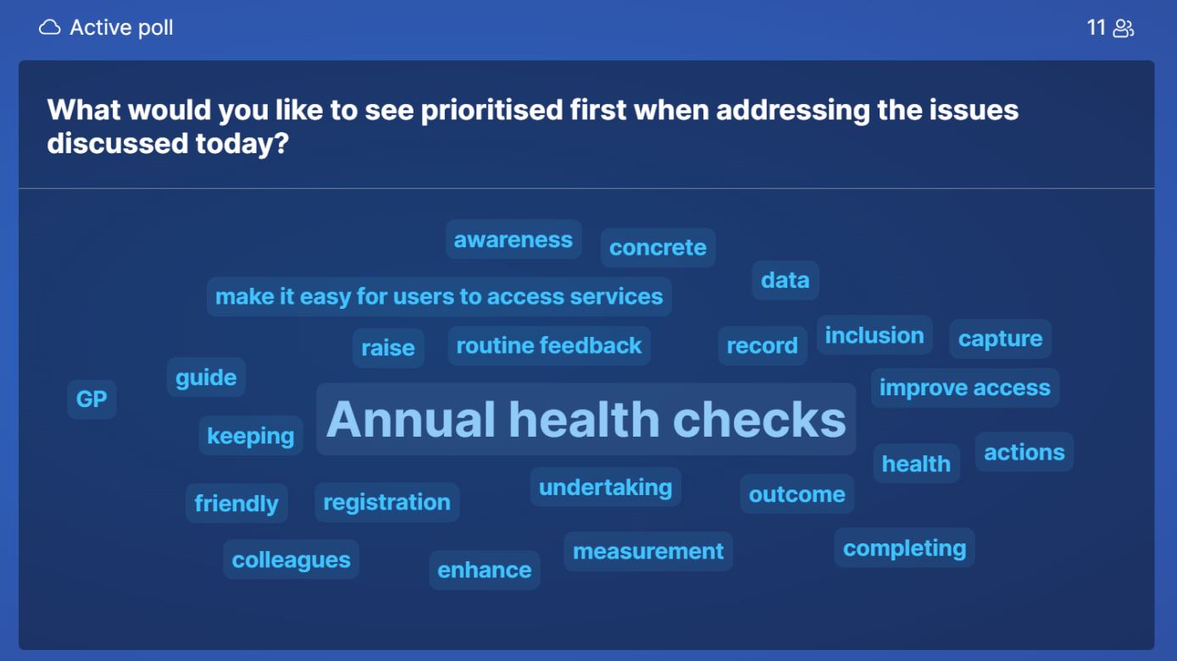

CONCLUSION
The workshop discussions highlighted the pressing need for tailored and coordinated healthcare services for people experiencing homelessness. Recommendations ranged from redefining standards within contracts to improving electronic patient records for better data collection. The emphasis on collaboration, standardisation, and proactive strategies underscores a collective commitment to equitable healthcare access and improved outcomes for individuals with multiple disadvantages across London.
There are some clear and actionable recommendations, and others that require further exploration and discussion. The outcomes and recommendations from this workshop, have been combined with the outcomes of the two other regional workshops that have taken place. All three workshop reports, their findings and overlapping intersectional themes have been analysed and formulated into a final set of recommendations grouped into 10 thematic areas. These are outlined in the ‘Transforming Primary Care for Homeless and Inclusion Health’ report.

Appendices

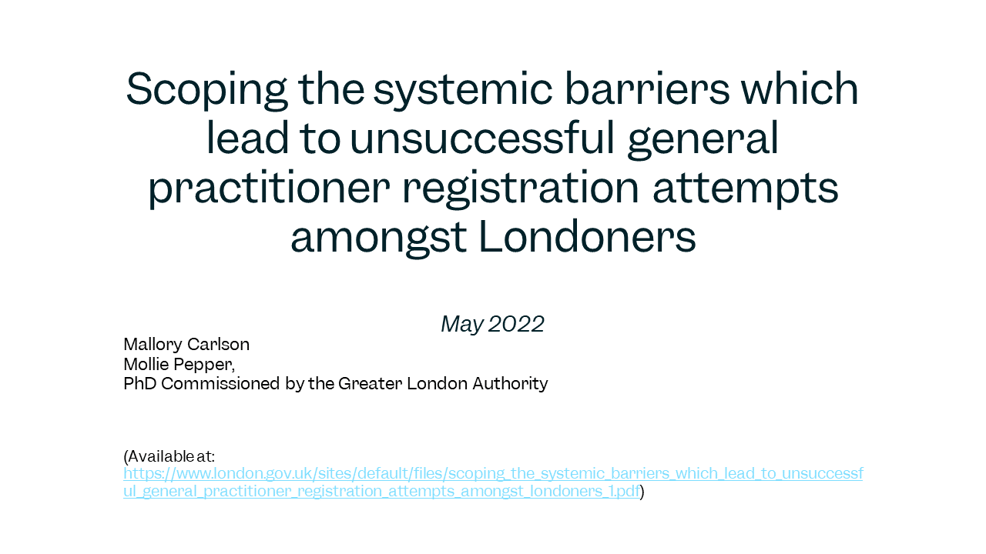
Appendix 1 : Scoping the systemic barriers which lead to unsuccessful general practitioner registration attempts amongst Londoners.
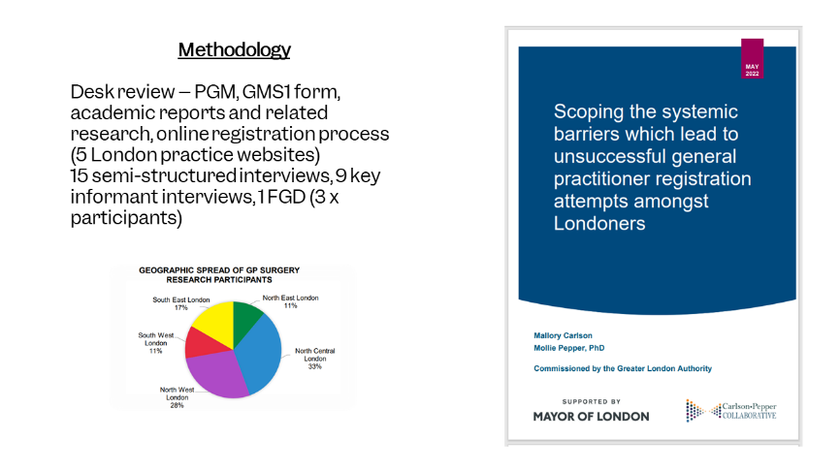

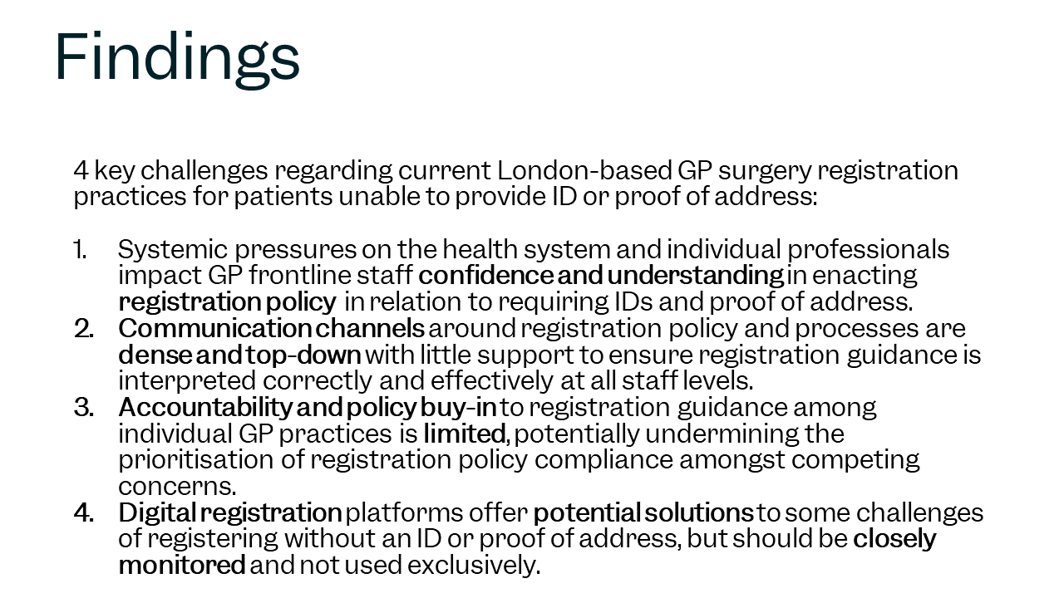

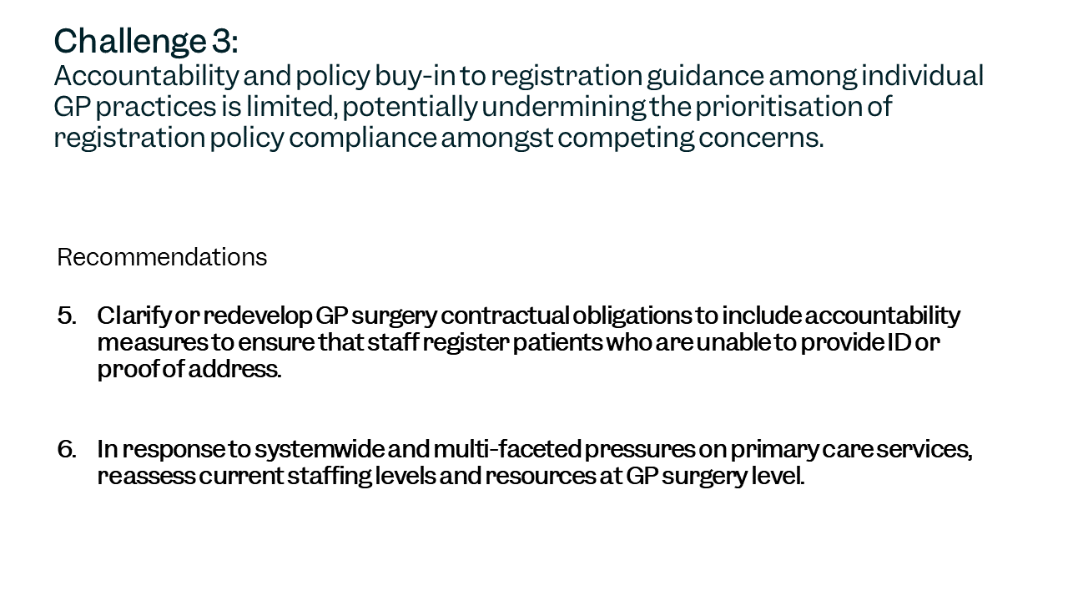
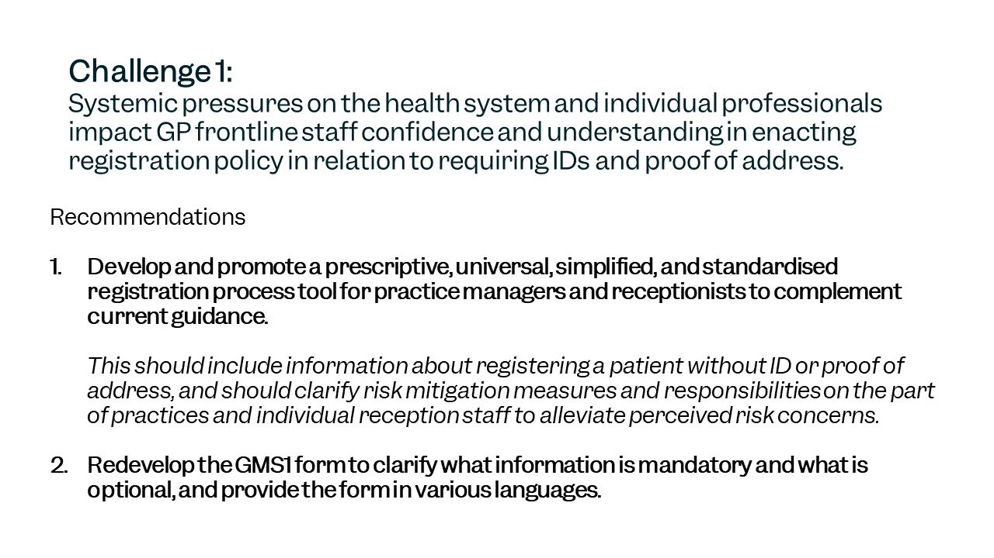
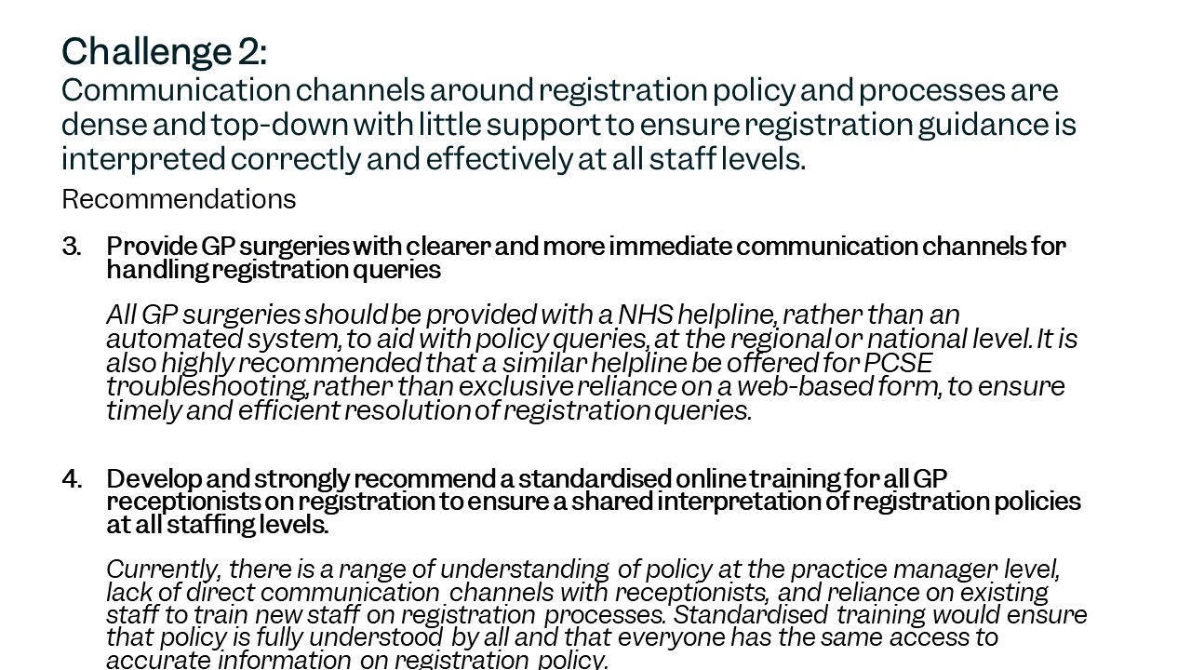

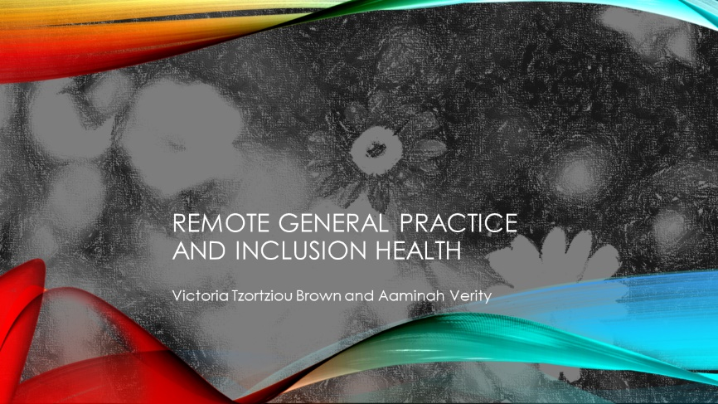
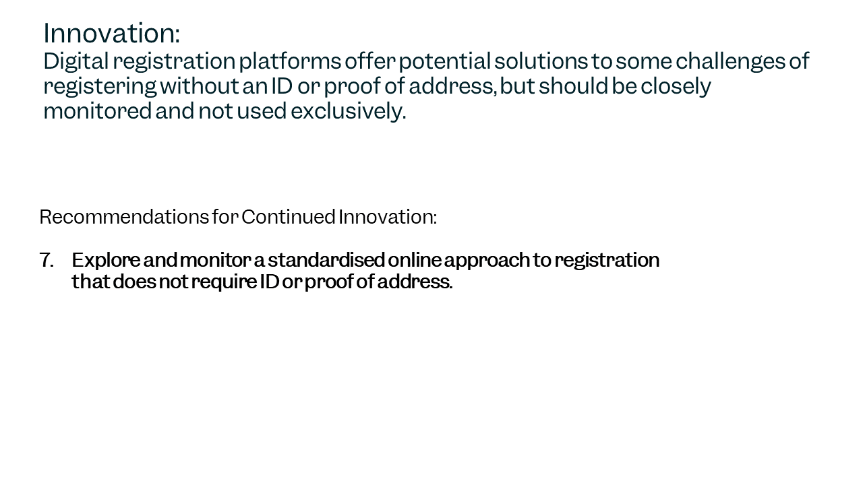
Appendix 2 : Remote General Practice and Inclusion Health: a qualitative study
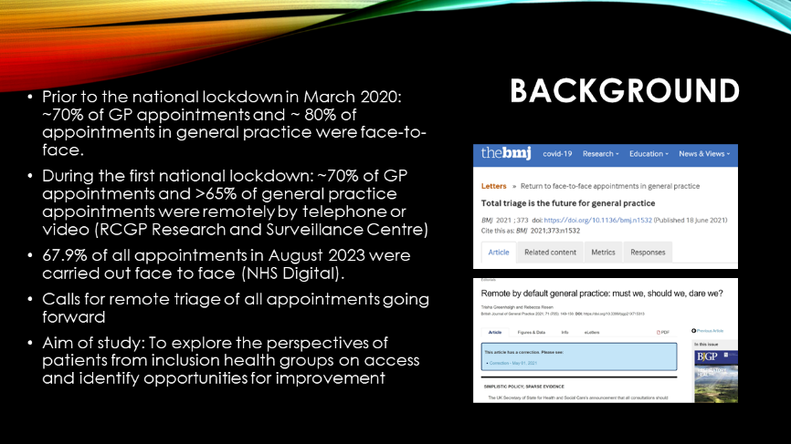

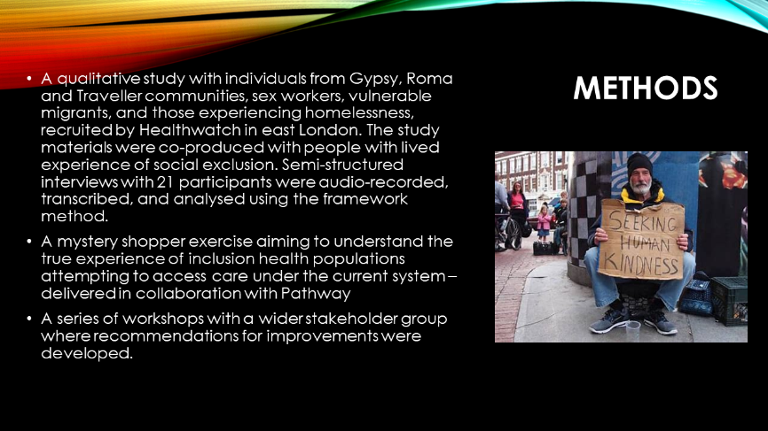
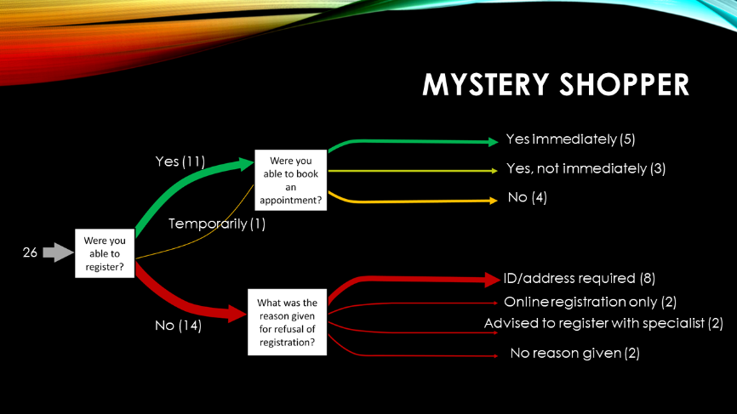
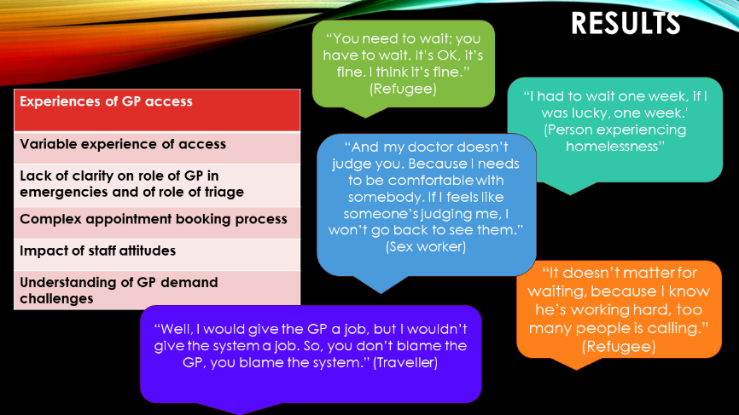

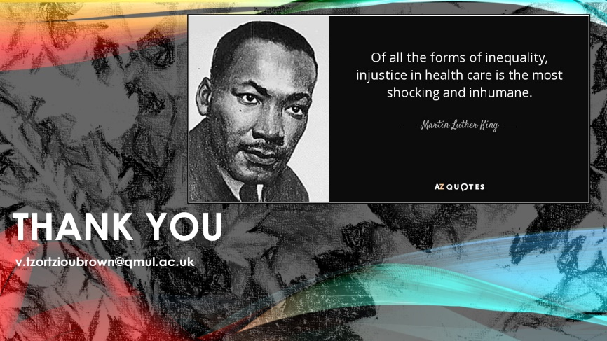
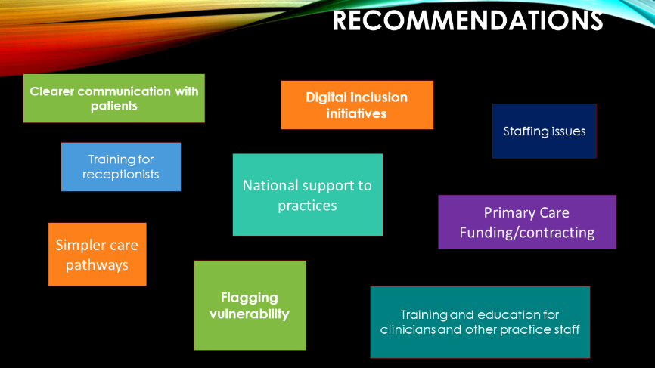
Appendix 3: Primary Care Programme Overview and Summary of Fuller Stocktake Report, GP contract & the Access Recovery Plan
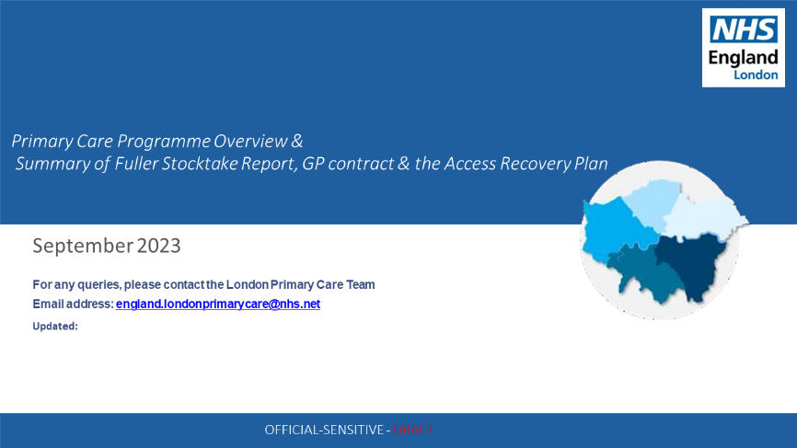

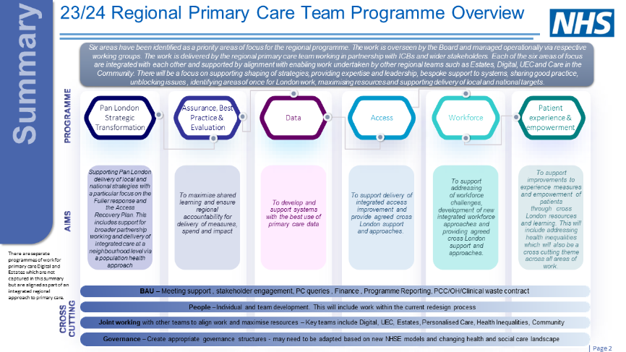
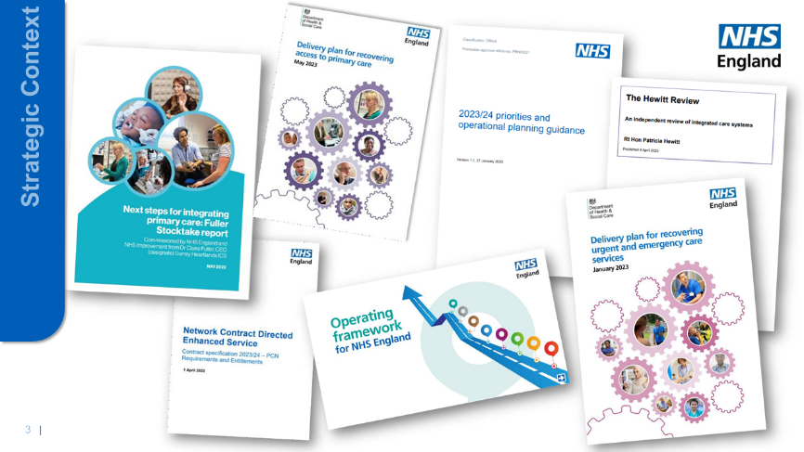

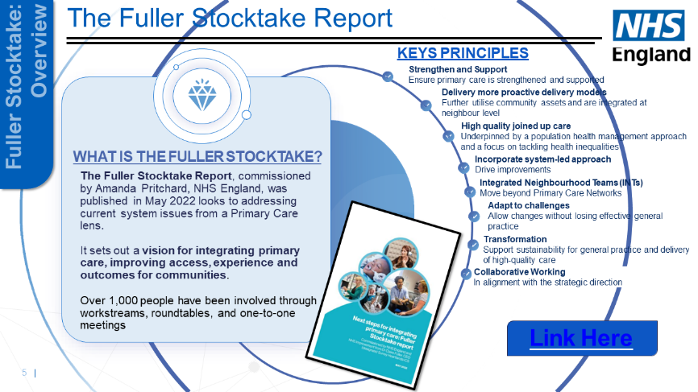
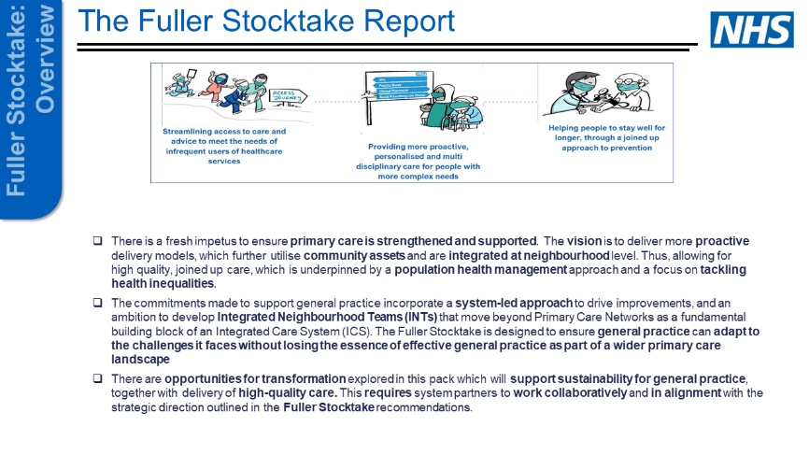
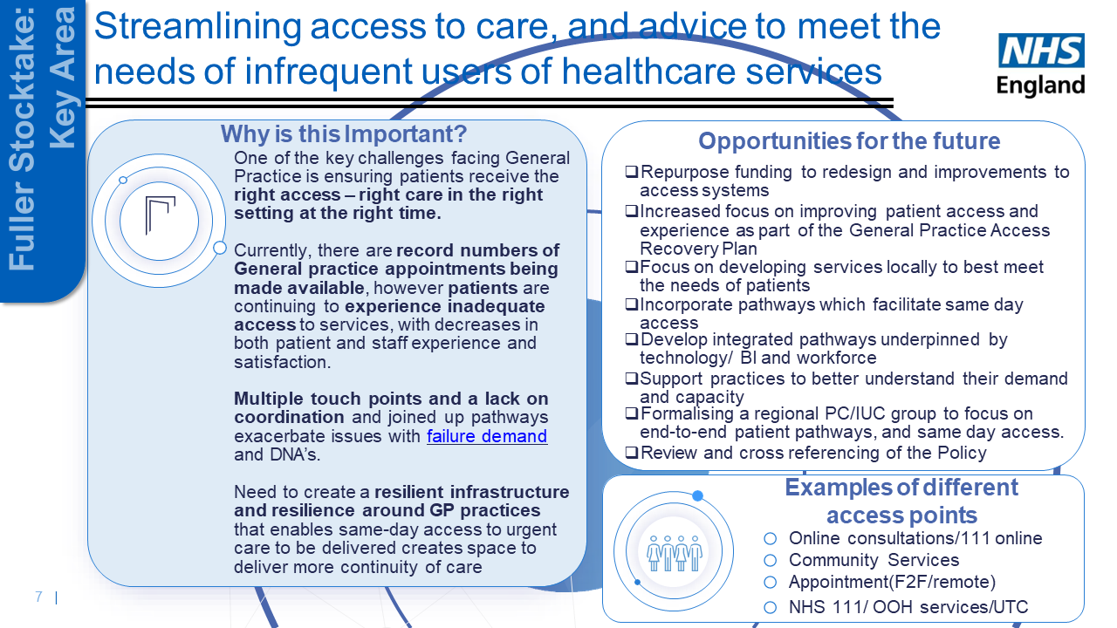

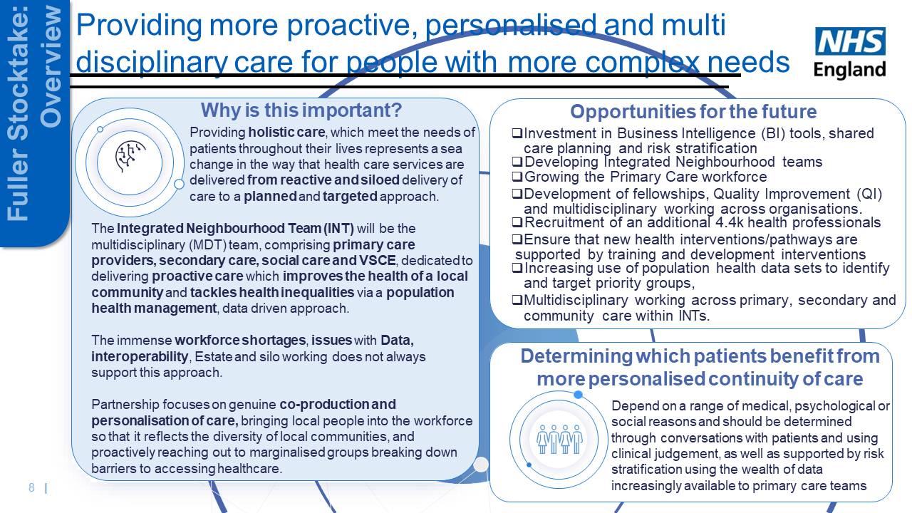

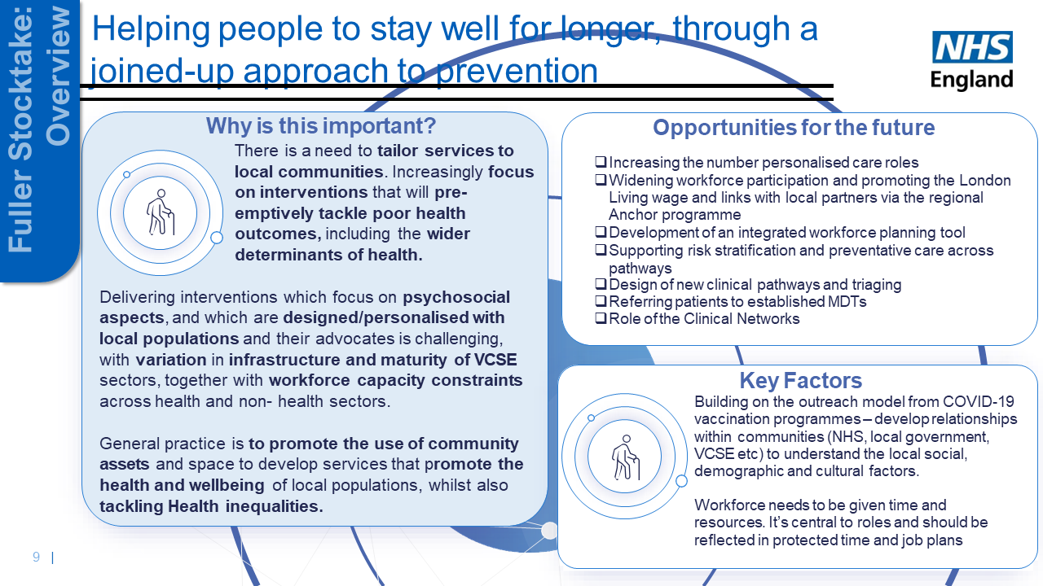

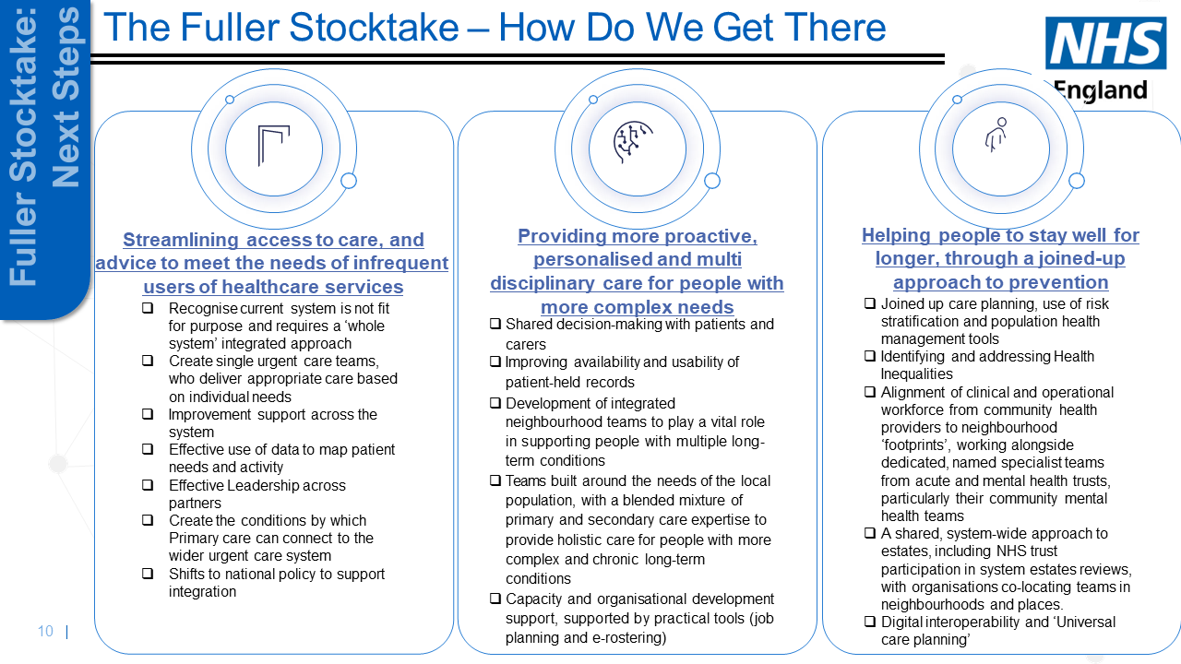

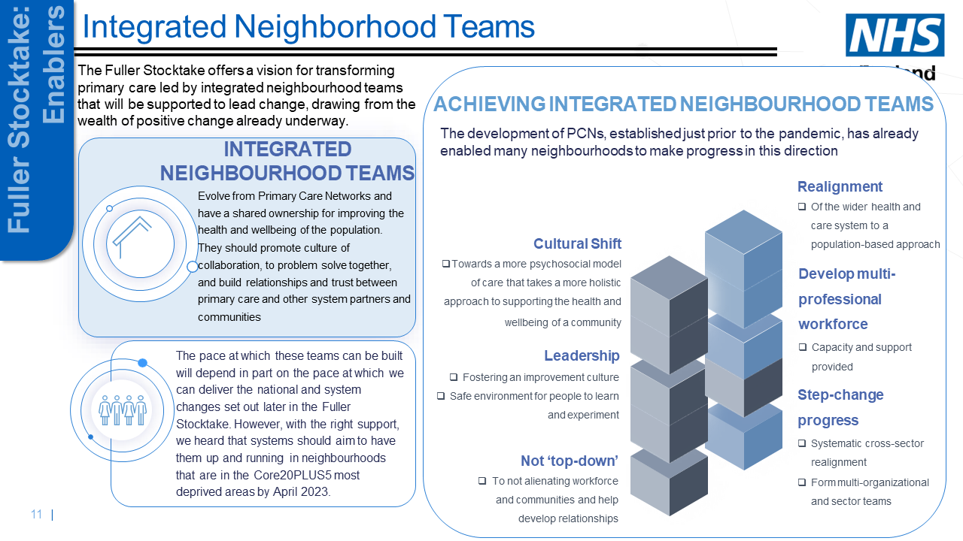

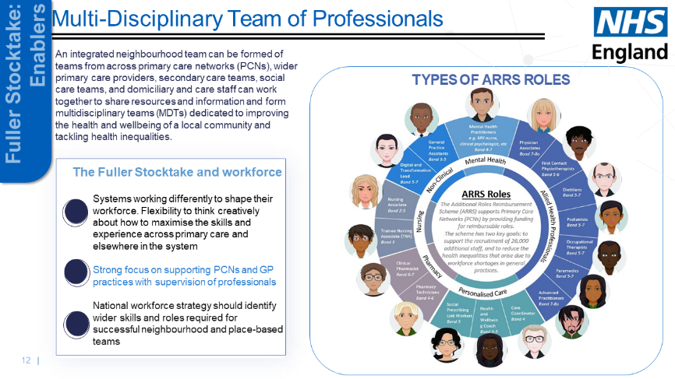

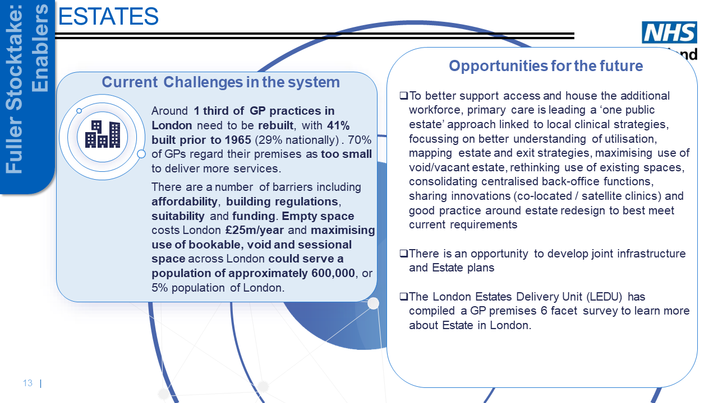

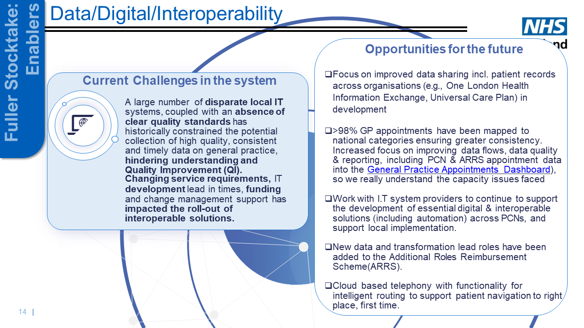
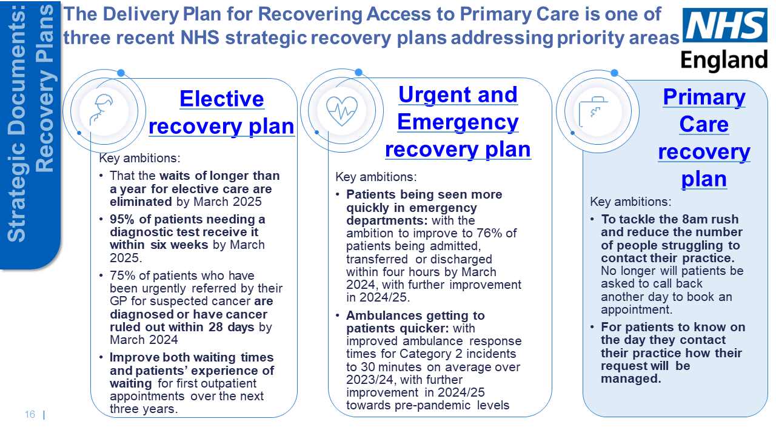

Appendix 4: BJGP Guidance on meeting the GP access needs of patients from Inclusion Health groups
This document aims to support general practices and Primary Care Networks (PCNs) to meet the access needs of patients from Inclusion Health groups. The guidance has been drawn together following a review of publications from statutory organisations (NHSE/CQC/NICE/BMA), voluntary and third sector organisations (DOTW/Groundswell/Pathway), and after incorporating expert opinion from inclusion health specialists.
The term “Inclusion health groups” refers to people who face the most acute impact of health inequality and who are most marginalised and includes people experiencing homelessness (including those in temporary accommodation/insecurely housed, not just rough sleepers), vulnerable migrants (asylum seekers, undocumented migrants), sex workers, people from Gypsy, Roma and Traveller communities and those in contact with the criminal justice system among others.
Having an inclusion health focus may mean reallocating finite and overstretched general practice resources to meet this need, but the population and individual health benefits of ensuring access to GP care for this population are numerous. General practice managers, staff and clinicians could be empowered to prioritise requests for appointments focusing on clinical need and using the principles of proportionate universalism within the limited resources available to them. This may require ICS and wider support.

The guidance is divided into three sections:
- Expected standards for practices: these include the expected standards for inclusion health populations as articulated by NHSE and CQC.
- Good practice recommendations for practices: these recommendations constitute evidence-based advice, expert recommendations and guidance from organisations working in inclusion health. Practices are not currently measured on or expected to achieve these standards by CQC or NHSE, but achieving these recommendations would result in significantly improved access for inclusion health populations.
- Aspiring to excellence for inclusion health populations: Implementing these recommendations may require restructuring of appointment and triage systems and may be easier at PCN level. Implementation may require strategic reallocation of resources with consequent implications for staff and patients. These recommendations may not be currently achievable due to capacity and staffing challenges and under-resourcing within general practice. PCNs and practices in areas of high deprivation and high representation of inclusion health populations may want to consider starting conversations with local commissioners on whether additional resources can be released to achieve these recommendations.

Type of Guidance | Website | Making Appointments | Registration | Accessibility
Expected standards for practices | Must have an up-to-date web page and nhs.uk GP profile page ¹ | 25% of practice appointments should be bookable online ¹ ²  (This is a requirement from NHSE although we feel this may be unachievable in some practices) | GP practices should register all patients unless their list is closed or there are reasonable grounds for refusal. These should not include a lack of ID, proof of address, immigration status or any protected characteristic ³ ⁴ ⁵ ⁶ ⁷ | Practices should use communication methods based on the person's preferences and abilities, for example, phone call, text message, email, letter, face to face⁶
 | Opening hours of practice should be clearly visible ^{8, 9} | Patients should be offered a choice of face to face or remote appointment¹⁰ ⁸ | Practices should offer support to fill out registration forms for those who need it ⁶,^{11,12} | Reasonable adjustments should be made to provide professional interpreting and translation services reflective of the practice population’s dominant languages. There should be evidence that the practice is responding to the accessibility needs of its population: e.g., translators, leaflets in different language etc ¹³ ¹⁴ ¹⁵ ¹⁶ ¹⁷ ⁶ ⁸
 | Methods to make appointments should be clearly laid out ^{1, 8, 16, 13} | Practices should have a system that identifies and prioritises those with most urgent clinical needs ^{8,} ^{9,} ¹³ | Whilst full registration process is underway to allow immediate and necessary clinical care, temporary registration should be suggested ³ | Practice materials should meet NHS accessibility standards ¹⁸,¹⁹ ⁶ ¹¹
 | The practice website should meet NHS accessibility standards ^{18,19} | Patient’s privacy should be respected both at reception and in clinical rooms^{13,} ¹¹ | Practices should offer to use a proxy address/address of the practice if patients have no fixed address or do not want to share their address ^{4,} ¹¹ | Practices should support/promote the use of an advocate for the patient if one is available, while being alert to the possibility of exploitation, coercive control ¹¹ ¹³
 | Practices should have an online consultation tool which is easily accessible through their website^{1,20} |  | Patients should be offered referral to a specialist homelessness service, if appropriate and available, but if they decline, they should be registered at the practice unless there are reasonable grounds not to. ⁴
 | It should be clear how to use the online consultation tool ¹³
 | Patients should be able to order and manage prescriptions online ^{20,21}
 | There should be information for inclusion health groups about their rights to health and social care services ⁶
Good practice recommendations for practices | There should be some signposting to support services appropriate for the local population ^{11,12} | There should be options for making appointments for those who do not have telephone or internet access e.g. walking into the practice to request appointments^{11,} ⁸ | Practice access policies should work to mitigate the combination of barriers to GP registration and provide staff training in equity of registration. ⁸ | Practice staff should become familiar with common cultural practices found in the practice population, and develop protocols to accommodate for these. Often practice staff are from the local population and may have great insights to offer. ¹¹ ¹²
 | How to access help out of hours should be easily visible. | It should be clear that the practice is open during opening hours when visiting the practice with easy to understand instructions on how to enter the premises if the door is not kept open. | If practices refuse a registration this should be recorded and the refusal, explaining the reasons, should be communicated in writing to the patient at the time of the refusal. ¹¹ ¹² | Patients should be asked whether they consent to communication between practice staff and support workers/advocates etc. and it should be made clear to patients they have the right to withdraw consent.
 | Details of how to register should be available on the practice website. | For remote and triaging appointments patients should be made aware of the process for receiving a call back. e.g. a clear contact time for a call back aiming within a 2-hour window, and how to contact the practice if they miss the call.⁸ | Staff training / sharing of guidance to ensure registration guidance is adhered to consistently regardless of which member of the team is supporting registration on a given day.
 |  | The system for booking appointments should be flexible and not involve fixed contact times e.g. only between 8-10am.⁸ | The registration of new patients should be a shared responsibility and the practice policy should be kept up to date and covered at induction of new staff.
 |  | Practices should have information available to share with patients at registration on how to make appointments and consider how this information is reaching patients. | The reception team should have access to expert support within the practice/PCN to deal with registration queries (e.g. senior receptionist, practice manager or practice partner)
 |  | The triage system should identify those who have complex needs or may be vulnerable and tailor the practice`s response to their needs. Triaging should identify those for whom remote consultation is unsuitable either due to clinical or social reasons.
Aspiring to excellence for inclusion health populations | There should be a validated symptom checker and self-care health information (although this is suggested by NHSE we are aware there is no consensus on which checker is validated)²⁰ | Practices should make adjustments and be flexible and accommodating to overcome the barriers some patients face. E.g. walk-in appointments, longer appointments, flexible appointment times and flexible appointment booking. ²² ⁶ ⁴ ¹¹ ⁸ ¹³ |  | Practices should have enough capacity to ensure that calls to the practice can be answered in a timely manner or a call waiting/call back system should be used to avoid barriers for those with pay as you go phones, low battery life etc¹⁷
 |  | Once a patient has been identified as having complex needs/vulnerability there should be a system for flagging this to clinical and reception staff at every interaction. |  | Practice staff should receive training on trauma informed approaches and de-escalation practices.

Note: Please note that this is a working document and is under review. If you have any comments or suggestions on its content, please contact Dr Aaminah Verity: Aaminah.verity@nhs.net
With warm thanks to all those who contributed so generously of their time and expertise to develop this first version. We would particularly like to acknowledge the following contributors to this first version:
- Dr Claire Wilson, Homeless health program manager, NWL CCG
- Dr Nigel Hewett, Medical Director, Pathway
- Rachel Brennan, Groundswell
- Dr Rhiannon England, East London ICS
- Dr Lisa Harrod- Rothwell, LMC/ Doctors of the World
- Elliott Singer
- Joanna Dawes, UCL Collaborative Centre for Inclusion Health
- David Groom, HLP
- Ella Johnson, GLA/Doctors of the World
- Dr Beatrice Foster, Haringey GP Federation Homeless Lead
- Dr Jasmin Malik, co-clinical lead, Homeless health programme, HLP
- Dr Caroline Shulman, co-clinical lead, Homeless health programme, HLP
- Sandra Tejero, HLP
- Atiyah Patel, HLP
- Rachel Burns, UCL
- Samantha Dorney-Smith, Pathway
- Experts by experience: Jeff Parker, Mandy Pattinson, Tony Jablonski, Mattey Mitchell, Annie Igangan.

Appendix 5: Comparison of ICB Homeless Health LCS/LES Service Specifications – Mainstream practices

 | NCL (Enfield, Haringey, Islington, Barnet, Camden) | NEL (BHR, Tower Hamlets, Newham, Hackney) | NWL (Westminster) | SEL (Lewisham)
Mainstream GPs
Access | - Offer of permanent registration via a dedicated GP Practice  - Outreach/in-reach – hub and hostel based clinics led by GP or nurse  - Access to ICB interpretation services  - Referral to other local clinical and non-clinical services (e.g. housing, legal, immigration, employment, etc) | - Offer of permanent registration via a dedicated GP Practice  - Outreach/in-reach – across key homeless congregation points and asylum seeker hotels |  | - Outreach/in-reach – to rough sleepers and GP led clinics at local homeless hostels  - Piloting a remote homeless health crisis support service for residents
Engagement | - Peer led advocacy and engagement to support GP registration and engagement with services | - Peer led advocacy and engagement to support GP registration and engagement with services
Partnership | - Integrated delivery model alongside mental health team and other HIT teams  - Weekly MDT meetings and quarterly CoPs  - Joint working – sharing expertise and co-development of plans  - Support with the development of personalised care plans to take into account the holistic needs of the patient. | - MDT team  - MDT/hospital lead working with hospital teams and inpatient mental health services  - Collaborative working with other services including social care, housing, secondary and community services |  | - Attend MDT meetings
Support | - Education and training for primary care staff, including mandatory annual session on homeless health and training for GP receptionists. | - Education and training for primary care staff |  | - Education and training for homeless service provider staff
Business Model | - Adopt safe surgeries approach (in some boroughs) |  |  | - Develop shared protocols and pathways for homeless health
Reporting | - Develop an electronic register (or similar) to identify homeless adults using agreed code. | - Annually agree and deliver an inclusion and improvement plan with partners.
Screening/health services | - Long-term chronic condition reviews (asthma, diabetes, CKD)  - Physical health screening and Holistic Health Checks  - Onward referrals to community/secondary care services  - Blood tests  - Wound care  - Basic diagnostics (B/P chks, urinalysis)  - Medication reviews and acute prescribing  - Health Education  - Sexual health screening  - Cervical screening
Specialist practices
Access |  |  | - Offer of permanent registration via a dedicated GP Practice  - Access to supported accommodation including specialist and women-only  - In-reach by nurse or specialist practice into hostels and day centres  - Transition to mainstream GP practice within 18 months, where possible.
Engagement |  |  | - Peer led advocacy and engagement to support GP registration and engagement with services
Partnership |  |  | - Collaborative working with other services including social care, housing, safeguarding, mental health and substance use.  - Fortnightly Homeless Health Partnership Group meeting
Support |  |  | - Education and training for mainstream GP practice staff
Business Model |  |  | - Psychologically/trauma informed and personalised care.
Reporting
Screening/health services

References:

1. NHS England and NHS Improvement. Letter: General practice contract arrangements in 2022/23. Published 2022. https://www.england.nhs.uk/publication/letter-general-practice-contract-arrangements-in-2022-23/
2. NHS England. A five-year framework for GP contract reform to implement The NHS Long Term Plan. Published 2019. https://www.england.nhs.uk/publication/gp-contract-five-year-framework/
3. British Medical Association. Patient registration. Published 2022. https://www.bma.org.uk/advice-and-support/gp-practices/managing-your-practice-list/patient-registration
4. Care Quality Commission. GP mythbuster 29: Looking after homeless patients in General Practice. Published 2021. https://www.cqc.org.uk/guidance-providers/gps/gp-mythbuster-29-looking-after-homeless-patients-general-practice
5. Care Quality Commission. GP mythbuster 36: Registration and treatment of asylum seekers, refugees and other migrants. Published 2021. https://www.cqc.org.uk/guidance-providers/gps/gp-mythbuster-36-registration-treatment-asylum-seekers-refugees-other
6. National Institute of Clinical Excellence (NICE). Integrated health and social care for people experiencing homelessness NICE guideline [NG214].
7. NHS England. Patient Registration Standard Operating Principles for Primary Medical Care (General Practice). Published 2015. Accessed July 23, 2022. https://www.england.nhs.uk/south/wp-content/uploads/sites/6/2019/04/patient-registration-standard-operating-principles-nov-2015.pdf
8. Healthy London Partnership. London General Practice Access Guide.; 2021. https://www.healthylondon.org/our-work/primary-care/gp-access/hlp-london-general-practice-access-guide-v6/
9. Care Quality Commission. GP mythbuster 55: Opening hours. https://www.cqc.org.uk/guidance-providers/gps/gp-mythbuster-55-opening-hours
10. NHS England. Improving Access to General Practice - National slidepack. Published 2017. https://www.england.nhs.uk/publication/improving-access-to-general-practice-national-slidepack/
11. Pathway, Faculty for Homeless and Health Inclusion, Commission Care Quality. GP Reception Standards for Primary Care. Accessed August 17, 2020. https://www.pathway.org.uk/wp-content/uploads/2017/02/GP-reception-standards-for-primary-care-v10.pdf
12. The Faculty for Homeless and Inclusion Health. Homeless and Inclusion Health standards for commissioners and service providers Version 3.1. Pathway. Published 2018. https://www.pathway.org.uk/wp-content/uploads/Version-3.1-Standards-2018-Final.pdf
13. Care Quality Commission. Regulations for service providers and managers. Published 2021. https://www.cqc.org.uk/guidance-providers/regulations-enforcement/regulations-service-providers-managers
14. Care Quality Commission. GP mythbuster 20: Making information accessible. Published 2021. https://www.cqc.org.uk/guidance-providers/gps/gp-mythbuster-20-making-information-accessible
15. British Medical Association. GP access: meeting the reasonable needs of patients. https://www.bma.org.uk/advice-and-support/gp-practices/gp-service-provision/gp-access-meeting-the-reasonable-needs-of-patients
16. NHS England and NHS Improvement. Improving access to general practice. https://www.england.nhs.uk/gp/improving-access/
17. Care Quality Commission. What standards you have a right to expect from the regulation of your GP practice.
18. Adams C, Campbell A, Montgomery R, Cooper M, Kirkpatrick A. Web Content Accessibility Guidelines (WCAG) 2.2. Published 2021. https://www.w3.org/TR/WCAG22/
19. Gov.uk Service Manual. Accessibility and assisted digital Understanding WCAG 2.1. Published 2018. https://www.gov.uk/service-manual/helping-people-to-use-your-service/understanding-wcag
20. NHS England and NHS Improvement, BMA. Supporting General Practice in 2021/22. Published online 2021. https://www.england.nhs.uk/publication/supporting-general-practice-in-2021-22/
21. British Medical Association. Previous GP contracts in England.
22. Care Quality Commission. GP mythbuster 90: Population groups. Published 2021. https://www.cqc.org.uk/guidance-providers/gps/gp-mythbuster-90-population-groups

ONS. 2022. Deaths of homeless people in England and Wales: 2021 registrations. Available here: https://www.ons.gov.uk/peoplepopulationandcommunity/birthsdeathsandmarriages/deaths/bulletins/deathsofhomelesspeopleinenglandandwales/2021registrations
Aldridge R et al. 2018. Morbidity and mortality in homeless individuals, prisoners, sex workers and individuals with substance use disorders in high-income countries: a systematic review and meta-analysis, Lancet V 2018;391:241-50. Available here: https://www.thelancet.com/journals/lancet/article/PIIS0140-6736(17)31869-X/fulltext
Adverse Childhood Experiences, Katie Scott, 2021 https://journals.sagepub.com/doi/full/10.1177/1755738020964498
The Lancet Public Health, Adverse childhood experiences and homelessness: advances and aspirations, 2021 https://www.thelancet.com/journals/lanpub/article/PIIS2468-2667(21)00210-3/fulltext
Murison-Bowie. 2023. Two-thirds of GPs refuse to register homeless patients. The Health Service Executive. Available here: https://www.hsj.co.uk/primary-care/two-thirds-of-gps-refuse-to-register-homeless-patients/7035028.article

