Primary Care and Homelessness: Removing Barriers and Improving Access for People Experiencing Multiple Disadvantage
Homeless Health Primary Care Workshop
Wednesday 26 April 2023
Contents
EXECUTIVE SUMMARY 3
REPORT OUTLINE 4
CONTEXTUAL BACKGROUND 5
WORKSHOP OVERVIEW 6
Overview of presentations 6
Presentation 1: View from Primary Care 6
Presentation 2: The benefits of multidisciplinary, flexible support for people who are experiencing homelessness 7
Presentation 3: Enhanced Vulnerability Forum. 8
Breakout session summary 9
Breakout room discussion 9
Multi-disciplinary coordinated care 9
The role of primary care in coordinated case management 9
The importance of flexibility in primary care access 10
The Importance of training in trauma and psychologically informed practice 10
Supportive funding structures 10
Access to adult social care 10
Co-occurring conditions 11
Cross-borough working 11
Data & building the business case 11
Partnership and integrated approaches 11
KEY ISSUES AND PROPOSED RECOMMENDATIONS 13
Suggestions for identifying patients for MDT case meetings 17
Suggestions for engaging with primary care 18
CONCLUSION 19
FURTHER RESOURCES: 20
APPENDIX: 1 21
APPENDIX: 2 26
APPENDIX: 3 29

EXECUTIVE SUMMARY
People experiencing homelessness face severe health disparities, often dying young from preventable conditions. Their complex needs, including mental and physical health issues and substance use problems, often go unmet due to barriers in accessing care, particularly in primary care, mental health and substance use settings. Tackling these health inequalities requires a multidisciplinary (MDT), trauma-informed, and partnership-based approach across the healthcare system.
On April 26 2023, the first of three workshops was held as part of the work conducted by the London Homeless Health Primary Care Steering Group. The workshop focused on subgroup three, which looked at bringing together a MDT approach between mental health, substance use and primary care. Stakeholders from various backgrounds convened, including Integrated Care Board (ICB) Commissioning Leads, frontline clinical and non-clinical teams, public health and local authorities, outreach services, colleagues from NHS England London region and voluntary sector partners. The workshop aimed to identify barriers, showcase effective practices, and propose measures to improve access to services for people experiencing homelessness with multiple disadvantages. The workshop emphasised collaboration and inclusivity and the importance of centring people with lived experience in service design and delivery.
Three presentations featured during the workshop and highlighted key practices and approaches around London and the UK, informing workshop breakout discussions. They were:
- View from Primary Care: Dr Natalie Miller shared examples of good practice at Great Chapel Street Medical Centre, including multidisciplinary teams, flexible appointments, and trauma-informed care. (Appendix 1)
- The benefits of multidisciplinary, flexible support for people who are experiencing homelessness: Fran Busby discussed the START Homeless Outreach Service's model, emphasising assertive outreach, collaboration, and personalised, trauma-informed care. (Appendix 2)
- Enhanced Vulnerability Forum: Victoria Aseervatham outlined the Enhanced Vulnerability Forum's MDT approach in City of Westminster, emphasising collaborative case working and support. (Appendix 3)
Throughout the workshop, participants identified key issues and proposed recommendations in several priority areas, some recommendations included:
- MDT and workforce development: Develop local homeless health community of practices, coordinate care through MDTs, and assign Lead Workers/Case Managers.
- Co-production of referral pathways and models of care: Person-centred care, training on multiple disadvantages, trauma-informed approaches, and co-designing services.
- Shared care approaches: Develop shared approaches to risk and care, multiagency MDTs, and standardised templates.
- Barriers to engaging with patients: Address dual diagnosis barriers, provide training in trauma-informed approaches, improve patient engagement, and offer flexibility in appointments.
- Suggestions for identifying patients for MDT case meetings and engaging with primary care: Establish clear processes and informal MDT meetings for patient concerns.
The report outlines recommendations for different services including primary care; training hubs; hospital services; and multiagency, multidisciplinary teams working across health and social care. A summary of potential short-, medium- and long-term next steps has also been included in the Transforming Primary Care for Homeless and Inclusion Health report which consolidates all three workshops that took place in 2023. The proposed recommendations and next steps aim to improve access, coordination, and care for people experiencing homelessness with multiple disadvantages.
The workshop highlighted the value of partnership working and recommended collaborative actions to address the complex needs of people experiencing homelessness. While some solutions are more straightforward than others to implement, some require further exploration and discussion. Local community of practices for Homeless and Inclusion Health can tailor approaches to local needs.

REPORT OUTLINE
This report is intended for system partners working across the following sectors:
- Primary care
- Mental health
- Substance use
- Acute & intermediate care
- Primary care networks (PCN)
- Integrated neighbourhood teams
- Local authority
- Social care
- Training Hubs
- Voluntary Community Social Enterprise (VCSE)
- Health & Social Care Service Commissioners
It provides a summary of key issues impacting access to services for people experiencing multiple disadvantages and provides recommendations to address them at PCN, neighbourhood, borough, and ICB levels.

CONTEXTUAL BACKGROUND
People experiencing homelessness exhibit some of the poorest health outcomes in society due to the staggering health inequalities they face. They frequently die young, often from preventable and treatable conditions. Studies comparing against the general population show mortality rates that are three to six times higher and an average age of death around 30 years younger in those experiencing homelessness.
Many will experience multiple disadvantages, with an overlapping of needs including mental health, physical health and substance use problems that usually stem from a history of complex trauma or trauma from being homeless. However, these needs are unlikely to be met due to poor and delayed access to services, particularly primary care. This means that they often don’t receive the care they need until they are in a critical condition, resulting in high rates of unplanned secondary care usage.⁴ One study found that people experiencing homelessness attended A&E around 60 times more than that of the general population. Although there are specialist homeless practices that focus on providing care for this patient cohort, a significant proportion of people experiencing homelessness are registered in mainstream practices that do not have the same resources. Some practices are supported by locally enhanced or commissioned services (LES/LCS) on homelessness, but this is not widespread across the region.
Over the past couple of years, there have been several pieces of research and deep dives into the health needs of people experiencing homelessness in London. One example of this is from North Central London (NCL), who conducted an Inclusion health needs assessment which identified the common challenges to accessing care amongst inclusion health groups (e.g., people experiencing homelessness, sex workers, vulnerable migrants, individuals with a history of imprisonment, and Gypsy, Roma and Traveller communities). These included:
- instability from dealing with co-occurring substance dependency and mental health conditions;
- housing instability;
- personal safety whilst sleeping rough;
- difficulties associated with transitioning out of prison;
- lack of desire and difficulty to prioritise physical health needs, but not being able to due to mental health issues or competing life priorities for basic survival.
Partnership working and outreach were viewed as essential in providing wraparound support, sharing learning, and preventing vulnerable people from falling through the gaps. These findings are likely to be similar across other subregions in London.
Tackling health inequalities requires an integrated and partnership approach across the system to address the complex needs of this population, with multidisciplinary services that can deliver personalised and trauma-informed care.

WORKSHOP OVERVIEW
This workshop was brought together through the collaborative working of sub-group three (bringing together and working in a multi-disciplinary approach between mental health, substance use and primary care) of the London Homeless Health and Primary Care Steering Group. This group’s focus was on aligning primary care with co-occurring conditions and multiple disadvantages.
It was led by ICB commissioning colleagues from Southwest London and North West London, in partnership with the TPHC Homeless Health Programme.
The workshop was held to:
- Showcase examples of effective practice taking place across London that show the benefit of coordinated MDT support and case management. As well as showing effective GP/primary care models in place to support people experiencing multiple disadvantages.
- Identify barriers and gaps within the system, and establish measures needed to address these issues in order to improve access to services and delivery of care for people experiencing homelessness and facing multiple disadvantages.
The workshop comprised of various stakeholders (77 attendees) including representation from ICBs, frontline clinicians, local authority, public health teams, outreach services, and NHSE and VCSE partners. Two breakout sessions were held, focusing on:
- existing examples and approaches; and
- solutions to barriers faced when delivering effective services.
As the group comprised of multiple stakeholders from different backgrounds, the use of the term “patient” and “client” have been used interchangeably through the report.

Overview of presentations

Presentation 1: View from Primary Care
Presented by Dr Natalie Miller, Joint-lead GP at Great Chapel Street Medical Centre and Clinical Lead for Homeless Health Northwest London (NWL) ICB.

About
This presentation provided suggestions and shared examples of good practice to help remove barriers and improve access to primary care for people experiencing multiple disadvantages. The team shared an example from Great Chapel Street Medical Centre which provides a range of services including those on-site (podiatry, counselling, sexual health, alcohol), drop-in clinics, same day service, in-reach and outreach, MDT, complex case management, care navigation, access to step up/down beds, a women’s health improvement project and a Roma clinic.

Barriers to consider
The presentation highlighted the importance of commissioning multidisciplinary, trauma-informed, holistic care that considers the individual’s health, housing, and social care needs. It emphasised barriers to consider including digital exclusion, challenges with engagement, safeguarding concerns, mental capacity, and premature frailty.

Recommendations
Recommendations on removing barriers experienced by mainstream or non-specialist GP practices included Safe Surgeries training, booking multiple appointments, drop-in sessions, in-reach and outreach services, a flexible ‘did not attend’ (DNA) policy, considerations for patient preferences and use of HC2 certificates for access to medication.

Presentation 2: The benefits of multidisciplinary, flexible support for people who are experiencing homelessness
Presented by Fran Busby, Clinical Service Lead for the START Homeless Outreach Service.

About
The START Homeless Outreach team was set up in 1990 the Homeless Mentally Ill Initiative (HMII) but is now baseline funded by Southeast and Southwest London integrated care boards. More recently, they have received funding from NHS England, the Office for Health Improvement and Disparities (OHID), and the Department for Levelling Up, Housing and Communities (DLUHC) to work with clients with co-occurring conditions through an MDT approach.

Recommendations
The team presented some areas of good practice exhibited in their model, which included:
- Assertive outreach: a MDT statutory team (social work, nursing, occupational therapy, medical and psychology) delivering mental health, mental capacity, care act and safeguarding assessments, as well as treatment, housing and social support, to clients wherever they are.
- Collaboration: close working with third sector partners to provide joint outreach and support, as well engagement with local housing, police, street warden and primary care colleagues.
- Engagement: flexible working to build rapport with clients and offer a service that is personalised and trauma-informed.

Presentation 3: Enhanced Vulnerability Forum.
Presented by Victoria Aseervatham, Rough Sleeping Commissioning Manager at Westminster City Council.

About
This presentation provided an overview of an effective MDT approach in the City of Westminster. The Enhanced Vulnerability Forum is a monthly MDT forum attended by various partners including adult social care, housing, safeguarding, statutory mental health, substance use, health and voluntary sector colleagues. It was established in 2019 to discuss high risk clients accessing the rough sleeping pathway who may have fallen between the criteria of different services, may be very resistant to change and where there isn’t already an MDT plan in place. The forum provides a space for creative MDT case working and support in navigating the system, with key local partners who offer a range of expertise and resources.

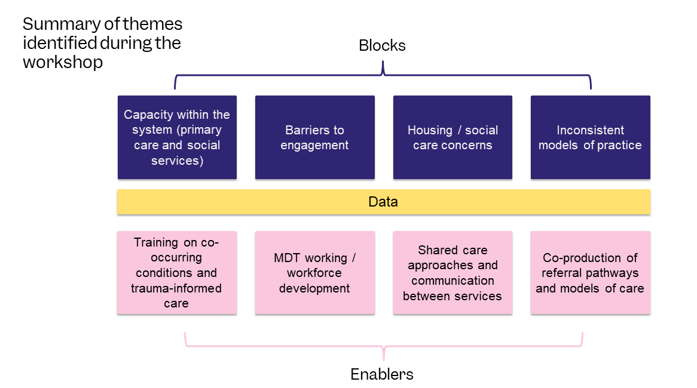
Breakout session summary

Breakout room discussion

Multi-disciplinary coordinated care
It was widely recognised within the three breakout groups that although some areas in London have a good framework of MDTs with clear referral pathways in place, overall, there is a general lack of formal MDT or Integrated Networks and meetings for this population group that incorporates health, housing and social care. It was heard that a substantial proportion of current pathways do not work and that tailored approaches are required. There is some exception with this when it relates to a safeguarding concern.
It was identified that without formal structures in place it can be challenging to draw the appropriate teams together to discuss patients. Also, without an assigned Lead Worker/Case Manager that works alongside the client, coordinating care is difficult and collaboration with what the client wants and needs is unlikely to happen. It was unanimously accepted that the patient voice needs to be heard and should be at the centre of service design and delivery.

The role of primary care in coordinated case management
It was also recognised that GPs and social workers have limited capacity to allow them to contribute to MDT meetings, but that they do attend when capacity allows. The contribution from GPs was recognised as ‘piecemeal’ and that there are different response levels between different practices.
It was largely agreed, particularly with GPs in the workshop, that it is virtually impossible to effectively manage and take care of someone experiencing homelessness and with multiple disadvantages in a Make Every Contact Count (MECC) approach. This is within the framework of a mainstream surgery setting that does not have additional resource in place to enable the principles of MECC. As such, it was recognised that patients are continually falling through the cracks.

The importance of flexibility in primary care access
Flexible appointments and point of care blood tests are key examples of preventing disengagement and non-attendance of appointments from this cohort, which consequently puts the individual at considerable risk of falling off the radar. It was also noted that there was a general lack of consideration and understanding of the challenges faced by hostel staff, particularly if they have multiple clients to advocate for and have multiple barriers to overcome for each. For example, having long waiting times on telephones when trying to book an appointment or negotiating other reasonable adjustments in relation to engaging their client to attend.

The Importance of training in trauma and psychologically informed practice
It was recognised by the group that, in general, there is inadequate training for frontline staff in trauma and psychologically informed approaches as well as understanding the complexities and prevalence of unresolved trauma in people experiencing homelessness. It was widely agreed by the group that front facing staff would benefit from training and development of understanding around behavioural responses to trauma and how it can present in clinical settings.

Supportive funding structures
Practices that receive additional funding through locally commissioned or enhanced services (LCS/LES) engaged people experiencing homelessness better, as GPs with an interest in this area of healthcare will be more able to participate, allowing additional time and resource for focused work. GP surgeries signed up to be a Safe Surgery through the Doctors of The World Safe Surgeries Initiative, also showed a general improvement in terms of access and registration. That said, unfortunately even within practices signed up to the initiative, there appears to be substantial inconsistency with approaches adopted between practices.
It was also recognised that some areas have GP fellowship programmes that focus on homeless or inclusion health, PCN Health Equity Leads in place, borough level or ICS level Inclusion Health Leads. Again, unfortunately, there remains inconsistency between the London boroughs and ICS sub-regions.
The topic of Safe Surgeries and GP fellowship programmes have been discussed further during the July workshop.

Access to adult social care
The lack of adult social care was highlighted as a gap and concern in each group. It was shared that the Life off the Streets programme is liaising with ADASS (Association of Directors of Adult Social Services) to advocate for improvement in this area. It was felt that these conversations appear to be challenging for several reasons such as: workforce shortages, lack of capacity, stigma, and poor understanding of the needs of the client group.

Co-occurring conditions
We heard from participants about dual diagnosis (DD) and the circles that patients, and clinicians trying to support them, go in when trying to address their mental health and substance use needs. Although there are several DD services operating across London, there continues to be a lack of understanding and appreciation by a wide number of clinicians about co-occurring conditions in general, and the impact it has on an individual in terms of addressing health needs and moving toward recovery. There continues to be inflexibility with services where patient referrals and cases are being closed from their list due to DNA (did not attend) appointments. This was recognised as services being extremely unhelpful and lacking insight into the challenges people who experience multiple disadvantages may have when trying to engage with the system.
Cross-borough working
Cross-borough movement was recognised as challenging for both primary and secondary care, for various reasons. Being outside of a practice catchment area was flagged, as were issues around which borough was responsible for inpatient health costs when they occurred. The issue of local connection was also flagged when it came to hospital discharge and possibly being offered accommodation that may be out of area.
Regarding hospital inpatient approaches, where there is a Pathway team embedded within the hospital, all patients referred to their service have an MDT case management approach. There are also Homeless Intermediate Care Resettlement Teams (HICT) that also aim to support people to leave hospital safely and provide step down and move on coordination.

Data & building the business case
There were discussions regarding obtaining data through pilot projects to build a case for change. It was acknowledged that obtaining the relevant data can be difficult as goals which focus on prevention, particularly where proving something did not happen, is not straightforward.
Moving towards a full picture view of the impact on the wider public pocket was suggested, as opposed to focusing only on health savings.

Partnership and integrated approaches
In terms of positive steps being made in relation to a coordinated approach to care, participants reflected on the potential benefits and concept behind the proactive care model (formerly known as the anticipatory care model), as well as a homeless template being considered for the London Universal Care Plan (UCP). Although not yet actively in place, both approaches were recognised to potentially unblock some of the challenges encountered by people experiencing homelessness and multiple disadvantages.

KEY ISSUES AND PROPOSED RECOMMENDATIONS
The following table includes key issues and proposed recommendations relating to four priority areas of primary care within the context of the workshop, these are: MDT and workforce development, co-production of referral pathways and models of care, shared care approaches, and barriers to engage patients.
Priority area | Key issues identified | Proposed recommendations
MDT and workforce development | - Inconsistency of approaches and models of care.  - Unclear pathways into services.  - Understanding and education on the needs of people experiencing homelessness and multiple disadvantages.  - Limited trauma informed, psychologically informed practice.  - Lack of shared care type approach between mental health, substance use and primary care – for prescribing and holistic management.  - Limited capacity in PC and social services.  - MARAC (multi-agency risk assessment conference) or Community MARACS are effective when working with probation, housing & third sector – but barriers exist when interacting with health. | - Develop local homeless health community of practice – as a minimum, include mental health (MH), substance use (SU) and primary care (PC) teams.  - Develop a shared approach to risk and care between MH, SU and PC services.  - Services to be trained on trauma-informed and psychologically informed care. Local areas to explore with their MH trusts what is in place and can be shared locally.  - Local exploration of developing proactive care models that address health, housing, and social care – safeguarding is a common denominator where each sector overlaps.  - Development of LCS/LES on homelessness to support practices in being able to engage with provision of care.  - Address formal agreements for sharing information and unifying systems of communication.  - Assigned Lead Worker/Case Manager to work alongside the client to aid with coordinating care and collaborate with what the client wants and needs.  - MDT includes: primary & secondary care teams for physical and mental health, substance use services, local authority teams and social worker.  - Physical and mental health review – GP, MH case workers.  - MDT reviews to include patient wellbeing review, housing review, care act assessment eligibility, safeguarding and shared risk approach  - London UCP – to include homeless template.
Co-production of referral pathways and models of care | - General lack of coordinated approaches and models.  - Current referral criteria and framework excludes a large proportion of people experiencing homelessness and multiple disadvantages.  - Rigidity within services and the system as a whole can lead to disengagement. | - Patient focused and centred care with a MECC approach is needed.  - Training around multiple disadvantages is required for PC, MH and SU services.  - Training around trauma-informed approaches and psychologically informed practices is required.  - Service development should be co-designed by all stakeholders.  - The voice of lived experience should form the cornerstone of discussions and shape the overall direction of travel.  - Informal MDT meetings convened when concerned about an individual – health teams leading on this – integrated network meeting.  - Replication of the START team model.
Shared care approaches | - Current sharing between services is very difficult.  - Different systems that don’t talk to each other.  - Although there are some shared care agreements in place between primary care & mental health relating to some mental health drugs, and shared care agreements between substance use services and primary care, there is frequently no triangulation between primary care, mental health and substance use services. | - Develop a shared approach to risk and care between Mental Health, Substance use services and Primary Care.  - Multiagency MDT working around a model of proactive care.  - London UCP – to include Homeless Template.
Barriers to engage with patients | - Dual diagnosis barriers – problems for getting mental health treatment for people with addictions.  - Trauma informed approaches not always adopted by services.  - Lack of awareness and understanding of multiple disadvantages by clinicians in primary and secondary care.  - Digital barriers – e-consult – limited phone data, multiple irrelevant questions have to be answered in order to progress to the next stage.  - Language barriers. | - MDT should include: primary & secondary care teams for physical and mental health, substance use services, local authority teams and social worker.  - Training to include trauma-informed approaches  short video for GP practices around multiple disadvantages and how to engage this cohort.  - Flexibility around appointment, offer alternate forms of booking an appointment.  - Patient information leaflets to be available in multiple languages.  - When appointments are being made, ensure sufficient time (double appointments) is available for the consultation.  - Clarify with patient at the point of booking if interpretation is required.  - Use of language interpretation services - details to be entered clearly by administration ahead of the consultation.

Suggestions for identifying patients for MDT case meetings
A clear process is required to improve identification of people at risk or currently experiencing homelessness who are falling through gaps within the system and would benefit from a multi-agency MDT approach. This could align and run in parallel with existing statutory MDT approaches, such as MARAC and/or safeguarding processes (Care Act Assessment). The below table illustrates possible avenues to identify people who may benefit from MDT case meetings and where they typically encounter the system.

HOSPITAL – ACUTE AND MENTAL HEALTH
- A&E high intensity users;
- Obtained through history at the point of admission;
- Inpatient and hospital discharge teams.
COMMUNITY
- Someone who has been identified as being vulnerable and at high risk of
self-neglect;
- Women who are exposed to violence and abuse and at risk of becoming homeless;
- From a local authority perspective, clients on the Target 1000 list *;
- Those identified by a hostel and/or outreach team.
FALLING THROUGH THE GAPS
- Identification of those who recurrently fall through the gaps - e.g. have a dual diagnosis but unable to engage with services due to lack of provision of dual diagnosis service in the area;
- Identification of clients who are non-engaging and have unmanaged health conditions.

*The T1000 (Target Thousand) project was launched in July 2020 with the intention of providing a focused and collaborative approach to ending rough sleeping for some of London’s most vulnerable people experiencing homelessness, particularly those most at risk of returning to the street and those who have been sleeping rough for a significant period. At the time of this report, there were 883 T1000s in London, with approximately 300 of those sleeping rough. The project is delivered sub-regionally with Westminster and the London Navigator Team treated as single sub-regions due to their cohort size.

Suggestions for engaging with primary care
The below table outlines how the wider system stakeholders, including local authority actors, to link in with primary care and engage them as part of case management.

SPECIALIST OVERVIEW
- Identify the local ICS Lead for inclusion health;
- Identify the PCN Equalities Champion;
- Allocating people experiencing homelessness as the dedicated cohort for either personalised care (e.g., through the proactive care model), and/or through the "tackling neighbourhood health inequalities" PCN DES (directed enhanced service).

INTERACTION WITH PATIENT’S GP AND GP SURGERY
- Direct engagement about client via email;
- Urgent cases can be discussed with duty GP;
- Link in with the local GP practice meetings;
- Inviting GPs to MARAC meetings;
- Invite GPs to T1000 meetings.

POLICY RECOMMENDATIONS THAT PROMOTE THIS APPROACH
- Fuller Report – encourage primary care to act as the anchor institution to help coordinate local community resources.

CONCLUSION
The workshop outcomes emphasise the importance and benefit of joined-up partnership working. Recognising that there are strained resources and limited capacity within the system, additional support is required to enable practices to act upon the recommendations identified through the workshop. It is proposed that ICBs, sub-regional and regional teams work together in actioning some of these recommendations in partnership with front-line teams, and those with lived experience.
There are some clear and relatively straightforward actionable recommendations, and others that require further exploration and discussion. The benefit of local community of practices for homeless and inclusion health would aid in tailoring approaches to what is required locally.
The outcomes and recommendations from this workshop have been combined with the outcomes of the two other regional workshops that took place throughout 2023. All three workshop reports, their findings and overlapping intersectional themes have been analysed and formulated into a final set of recommendations grouped into 10 thematic areas. These are outlined in the ‘Transforming Primary Care for Homeless and Inclusion Health’ report.

FURTHER RESOURCES:
- [Video] A Journey to Making Integration Work – Dr Aaminah Verity
- [Video] Top tips for GPs to support people with multiple disadvantage - Groundswell
- [E-learning] Co-occurring conditions training modules on Aneemo - https://academy.aneemo.com/p/improving-access-to-services-for-clients

APPENDIX: 1
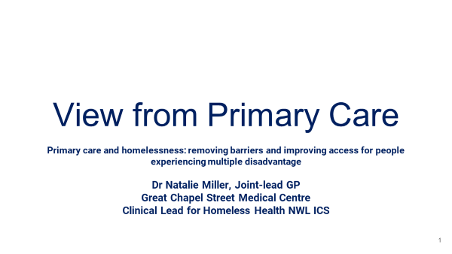

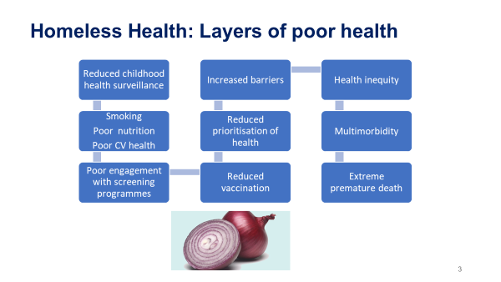

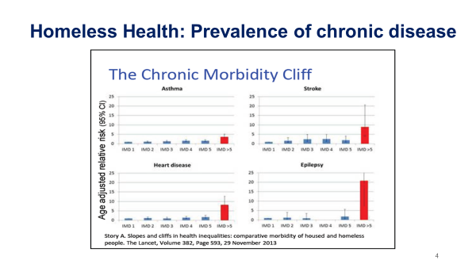

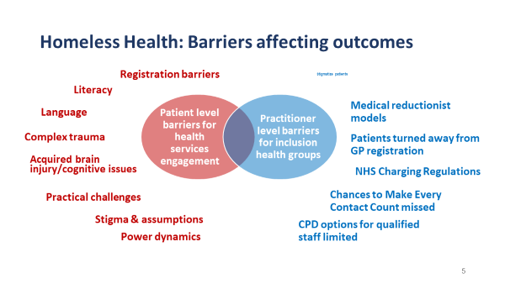

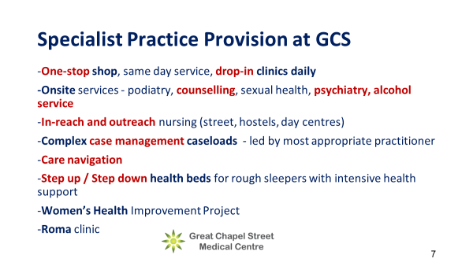

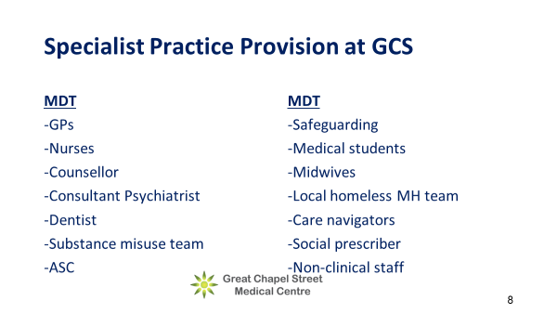

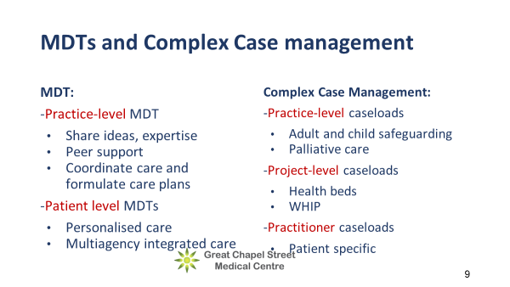

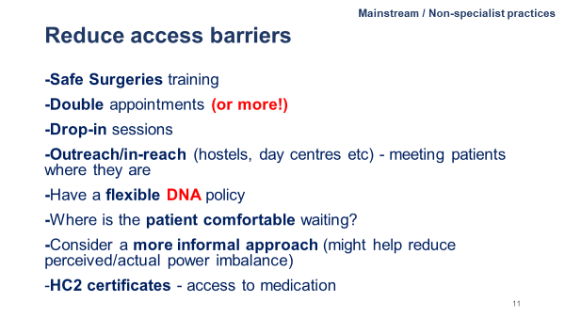

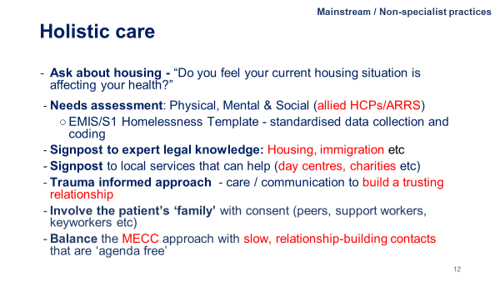

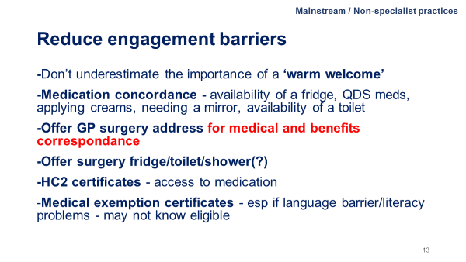

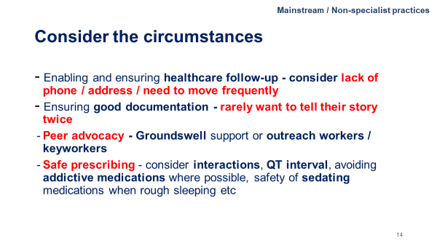

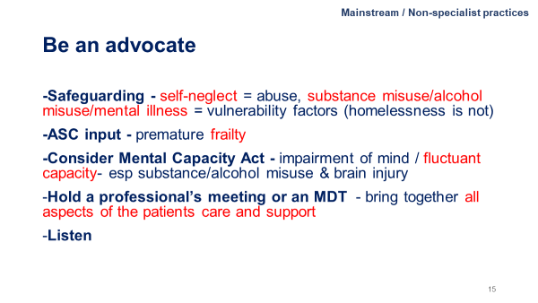

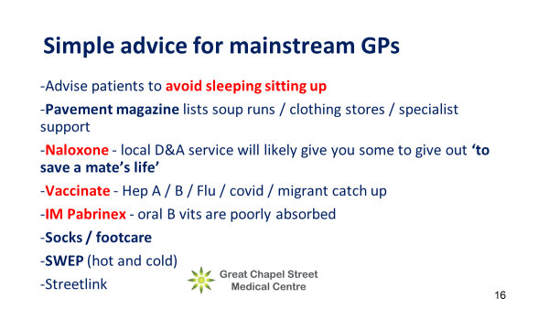

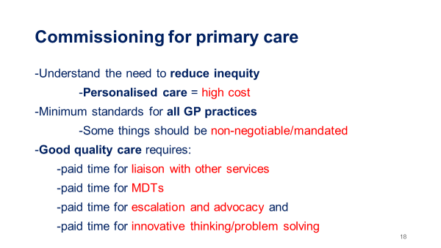

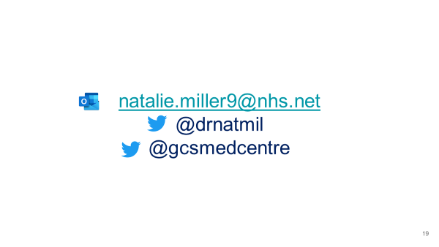

APPENDIX: 2
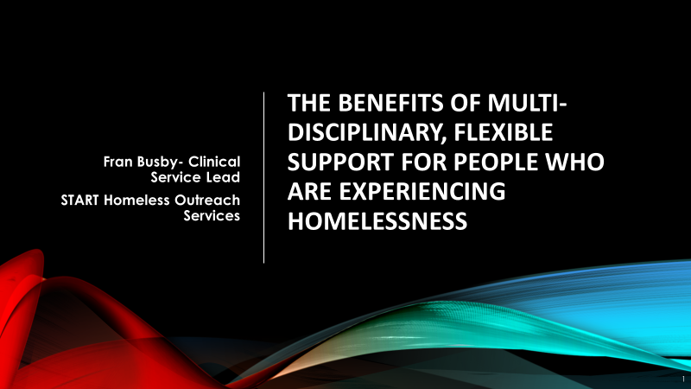

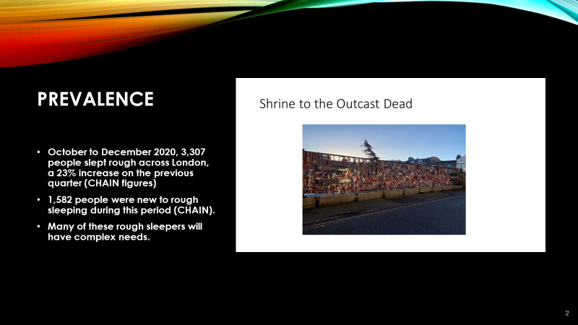

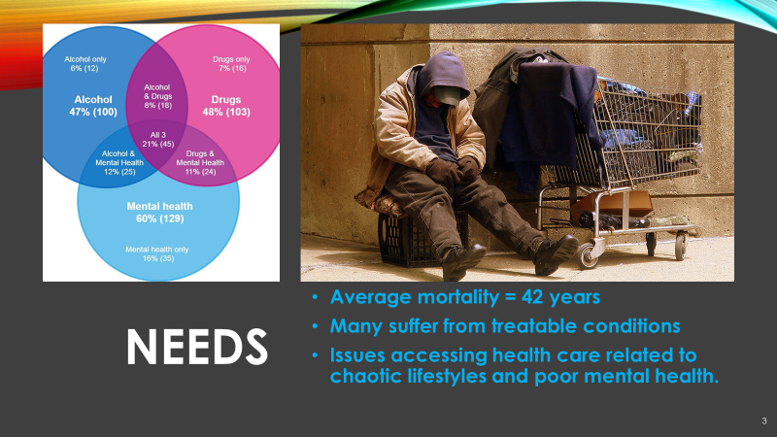

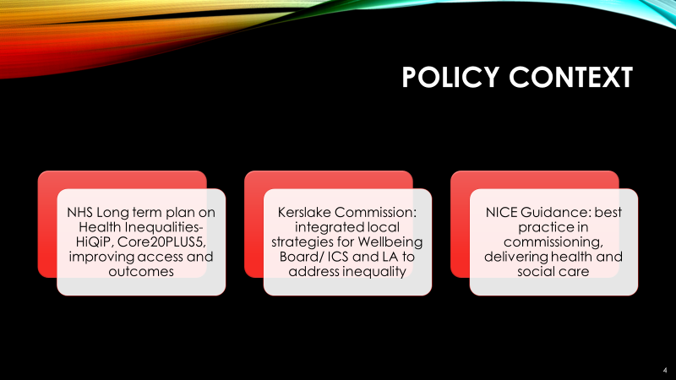

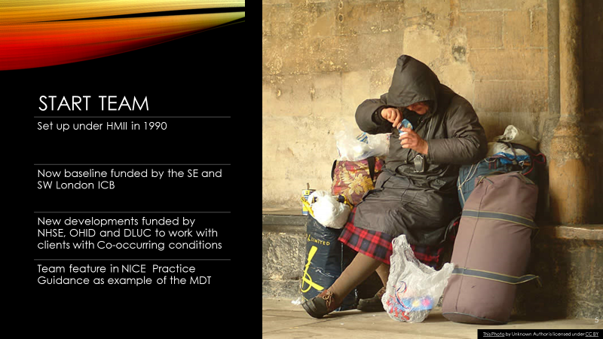

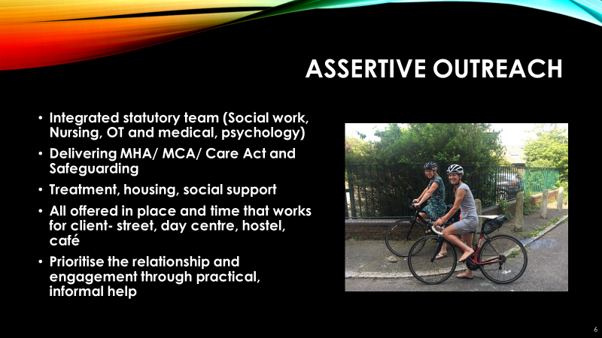

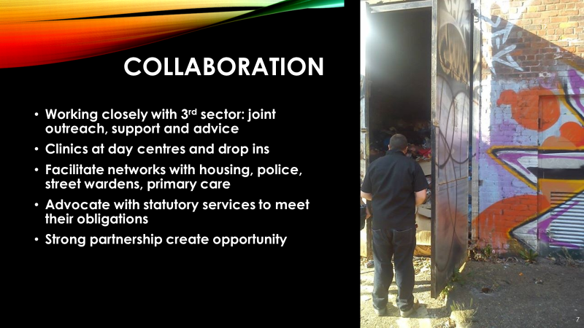

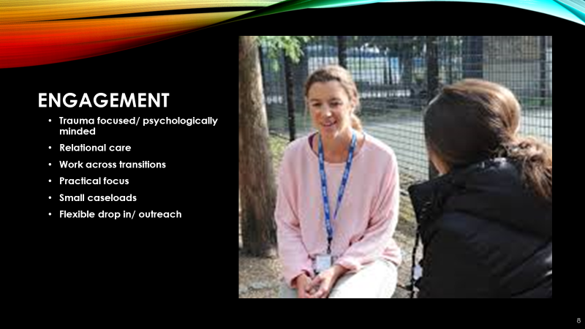

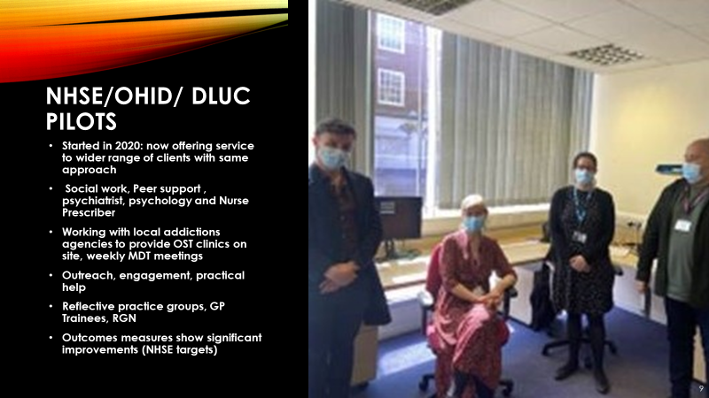

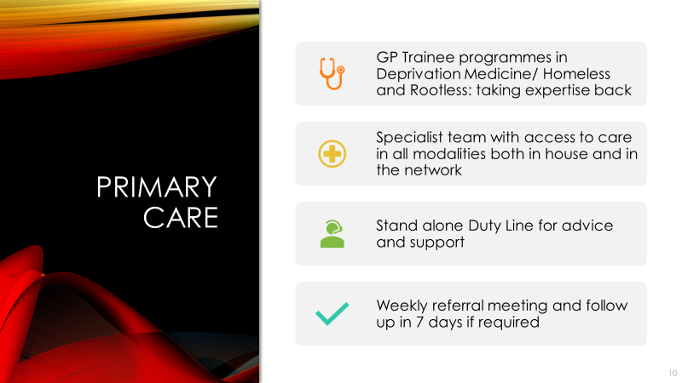

APPENDIX: 3

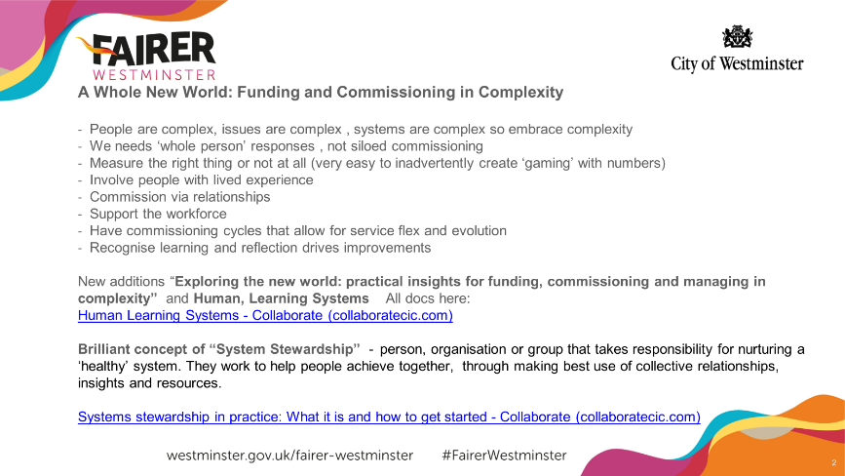

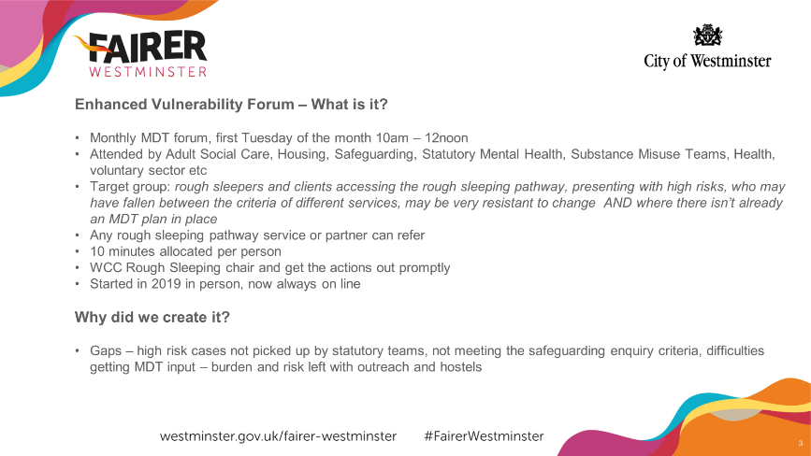

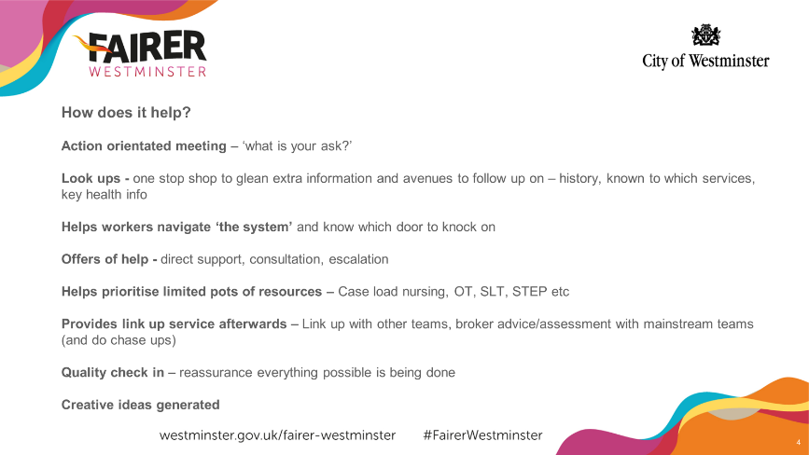

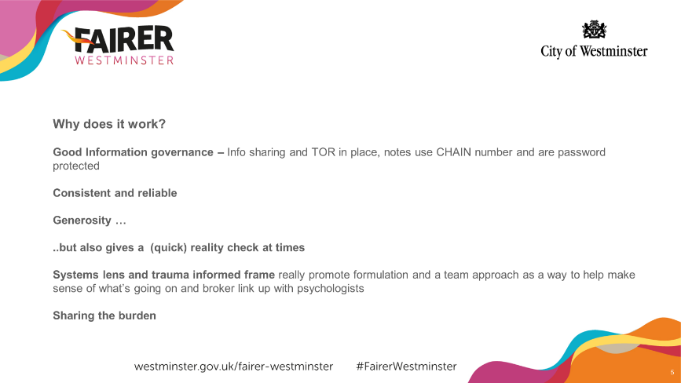

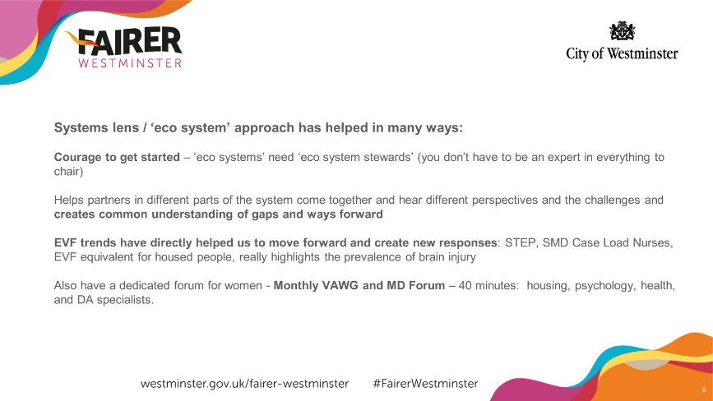

https://bmjopen.bmj.com/content/9/4/e025192#block-system-main
https://www.nice.org.uk/guidance/ng214
https://link.springer.com/article/10.1007/s00127-014-0937-6
https://homelesslink-1b54.kxcdn.com/media/documents/Homeless_Health_Needs_Audit_Report.pdf
https://www.ncbi.nlm.nih.gov/pmc/articles/PMC6607834/

