

Breathing Control Exercises:

**Asthma** - When you wheeze with triggers like dust, pollen, furry animals, and exercise as well as with a virus or cold.

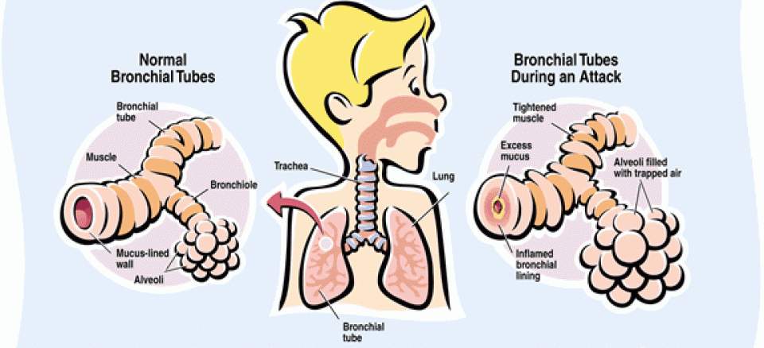

**What to do next?**

If you have attended the EMERGENCY DEPARTMENT (ED/A&E) following an episode of ASTHMA or VIRAL-INDUCED WHEEZE, you should make an appointment to see your General Practitioner (GP) within 2 working days for a review. British Thoracic Society/ Scottish Intercollegiate Guidelines Network (BTS/SIGN, 2019).

**Measuring your Peak Flow**

Your Asthma Nurse may ask you to measure your Peak Flow over time to show how controlled your asthma is. The Peak Flow meter measures how fast you can blow into the device. If you have any questions speak to your asthma team

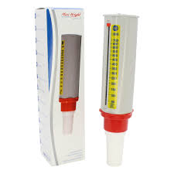

**My Asthma SMART Care Plan**

**(Over 5 years old)**

**______________________**

**:**

**Asthma Team Contact Details:**

Dr John Moreiras,

Nurses: Charlotte and Maria

* [whittpaedasthma@nhs.net](mailto:whittpaedasthma@nhs.net)
* 0207288 EXT: 5017
* CNS Mobile: 07435264332



**What do my inhalers do?**

Combination inhalers are usually red/ white (Symbicort) or purple (Seretide) and they contain an inhaled steroid and a long-acting reliever medication and are to be taken every day, as prescribed.



Peak Flow Diary:



Asthma and Allergy App:



Manage your asthma:



How to avoid triggers

(Damp & Dust Mites):

**Having an Asthma attack when:**

* My reliever inhaler isn’t helping, OR
* I can’t talk, walk, or eat easily, OR
* I’m finding it hard to breathe, OR
* I’m coughing or wheezing a lot, or my chest is tight/hurts, OR
* **My peak flow is less than 50% ______**

My PREVENTOR Medication is called: Symbicort (Budesonide/ formoterol) and I take ____ Puffs EVERY morning and ____ Puffs EVERY night. Its colour is Red/ White.

My RELIEVER Medication is also: **Symbicort**, I can take **1-2 puff/s** of my inhaler when I wheeze or cough, my chest hurts or it’s hard to breathe.

* Sit quietly and if you are feeling better continue with normal activities.

•My best peak flow is ___________

**Other Medications:**

**My Regular Medications:**

**Signs my symptoms are getting worse:**

* I am wheezy,
* My chest is hurting,
* I am finding it difficult to breathe ***OR***
* I am waking up at night because of my asthma ***OR***
* My peak flow is **less than 80%** ______

**What do I need to do:**

1. Get help!
2. **Call 999 for an ambulance: if you do not have your RESCUE/ RELIEVER inhaler, or if it is not helping, or if you are worried at any time.**
3. Try to keep calm, sit up straight, and don’t lie down, remember breathing control exercises,
4. Take one puff of your SYMBICORT inhaler, if no improvement after 1-3minutes, take another inhalation (MAX of 12 puffs in a day total)
5. If you only have Salbutamol, take 1-2 puffs via spacer (up to 10 puffs every 15minutes) until help arrives,
6. If your symptoms are no better, and the ambulance has still not arrived, contact 999 again immediately.

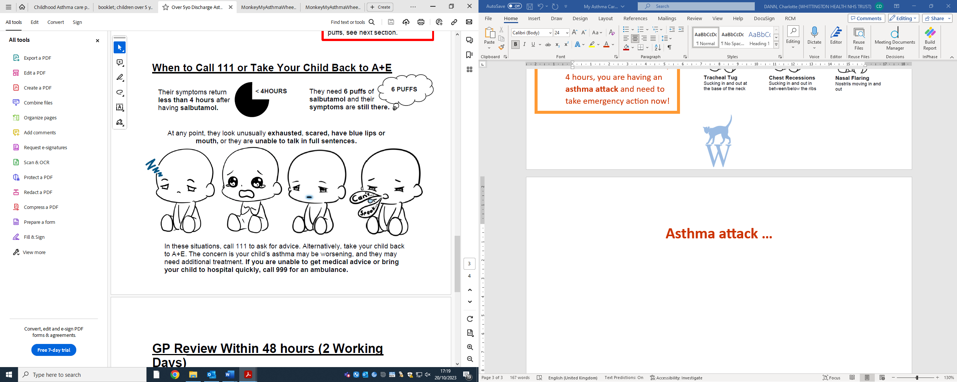

|  |  |
| --- | --- |
| NAME and STRENGTH | DOSE |
|  |  |
|  |  |
|  |  |
|  |  |
|  |  |

**What Do I Need To Do When This Happens:**

* **Keep taking your regular medications,**
* **AND** you can take UP TO an extra _____ puffs of your Symbicort inhaler, in 24 hours.
* See a doctor (E.G: A&E or walk in centre) within 24 Hours if you do not feel better OR need a total of 8 puffs of Symbicort in a day.