**Asthma** - When you wheeze with triggers like dust, pollen, furry animals, and exercise as well as with a virus or cold.

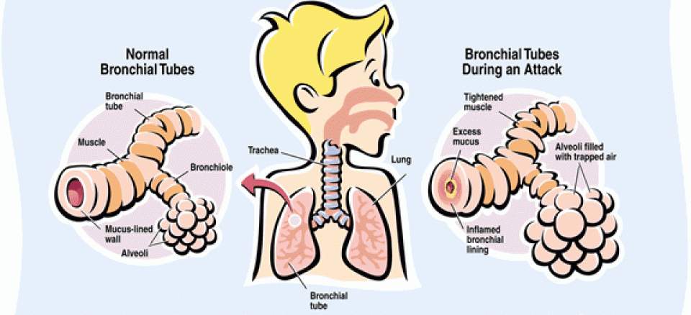

**What to do next?**

If you have attended the EMERGENCY DEPARTMENT (ED/A&E) following an episode of ASTHMA or VIRAL-INDUCED WHEEZE, you should make an appointment to see your General Practitioner (GP) within 2 working days for a review. British Thoracic Society/ Scottish Intercollegiate Guidelines Network (BTS/SIGN, 2019).

**Measuring your Peak Flow**

Your Asthma Nurse may ask you to measure your Peak Flow over time to show how controlled your asthma is. The Peak Flow meter measures how fast you can blow into the device. If you have any questions speak to your asthma team

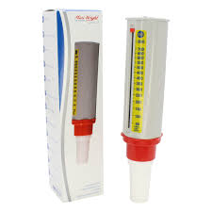

**My Asthma Care Plan (Over 5 years Old)**

**______________________**

**:**

**Asthma Team Contact Details:**

Dr John Moreiras,

Nurses: Charlotte and Maria

* [whittpaedasthma@nhs.net](mailto:whittpaedasthma@nhs.net)
* 0207288 EXT: 5017
* CNS Mobile: 07435264332

**What do my inhalers do?**

**Salbutamol** (**‘the blue inhaler’**) is a medication used to **relieve** the **symptoms** of asthma. It only helps once the symptoms of asthma are present, it **doesn’t stop them happening.**

**Preventor’** inhalers are prescribed for some children to **prevent** the **symptoms** of asthma. They generally contain a steroid.

Combination inhalers are usually red/ white (Symbicort) or purple (Seretide) and they contain an inhaled steroid and a long-acting reliever medication and are to be taken every day, as prescribed.



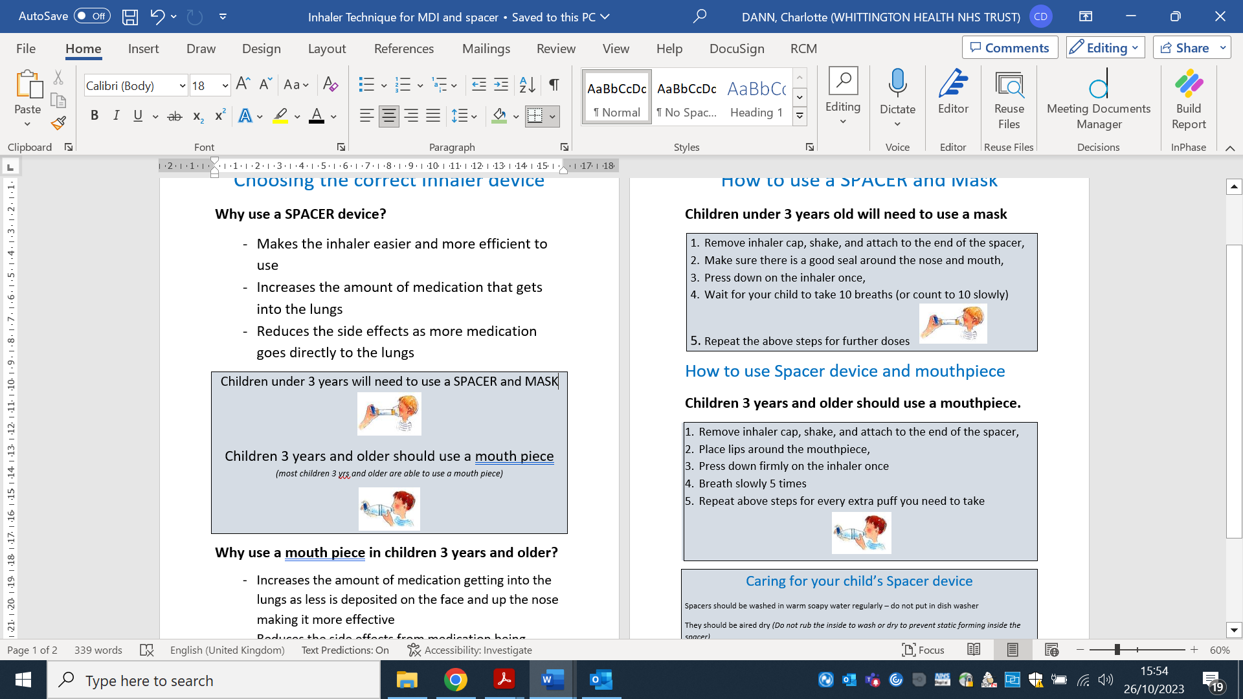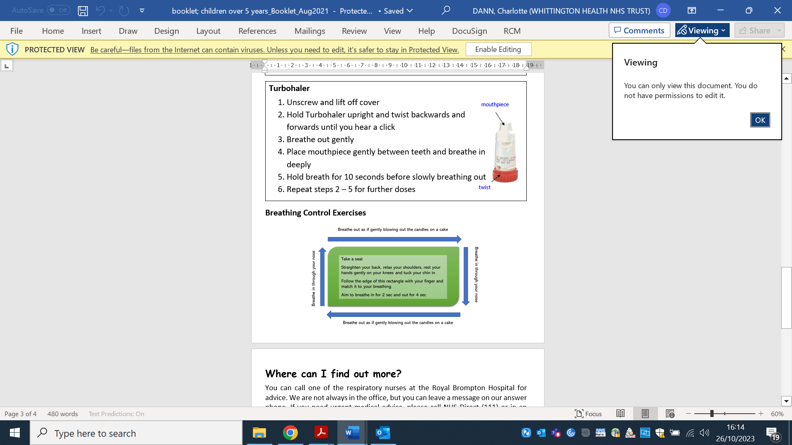

*Children 5 years and older should be using a mouthpiece.*

**How to take your inhaler**



Peak Flow Diary:



Asthma and Allergy App:



Manage your asthma:



How to avoid triggers

(Damp & Dust Mites):

**Having an Asthma attack when:**

* My reliever inhaler isn’t helping, or I need it more than every four hours, OR
* I can’t talk, walk, or eat easily, OR
* I’m finding it hard to breathe, OR
* I’m coughing or wheezing a lot, or my chest is tight/hurts, OR
* **My peak flow is less than 50% ______**

My PREVENTOR Medication is called: ______________ and I take ____ Puffs EVERY morning and ____ Puffs EVERY night. Its colour is ___________

My RELIEVER Medication is called: **Salbutamol**, I can take **1-2 puff/s** of my reliever inhaler when I wheeze or cough, my chest hurts or it’s hard to breathe.

•My best peak flow is ___________

**Other Medications:**

**My Regular Medications:**

**Signs my symptoms are getting worse:**

* I am wheezy,
* My chest is hurting,
* I am finding it difficult to breathe ***OR***
* I am waking up at night because of my asthma ***OR***
* My peak flow is **less than 80%** ______

**What do I need to do:**

1. Get help and stay with a grown up!
2. **Call 999 for an ambulance: if you do not have your RESCUE/ RELIEVER inhaler, or if it is not helping, or if you are worried at any time.**
3. Try to keep calm, sit up straight, and don’t lie down,
4. Take one puff of your RESCUE/ RELIEVER inhaler via the spacer every 30 to 60 seconds up to 10 puffs.
5. If the ambulance has not arrived after 10 minutes and your symptoms are not improving, repeat step 2,
6. If your symptoms are no better after repeating step 2, and the ambulance has still not arrived, contact 999 again immediately.

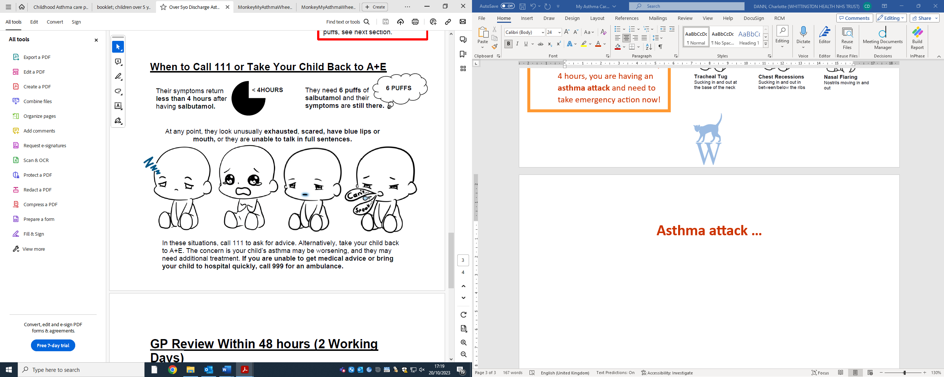

|  |  |
| --- | --- |
| NAME and STRENGTH | DOSE |
|  |  |
|  |  |
|  |  |
|  |  |
|  |  |

**What Do I Need To Do When This Happens:**

* **Keep taking your regular medications,**
* Also, take UP TO 6 Puffs of your Salbutamol Every 4 Hours,
* See a doctor (E.G: A&E, walk in centre or GP) within 24 Hours if I do not feel better.

If you are needing your Salbutamol more than every 4 hours, you are having an **asthma attack** and need to take emergency action now!