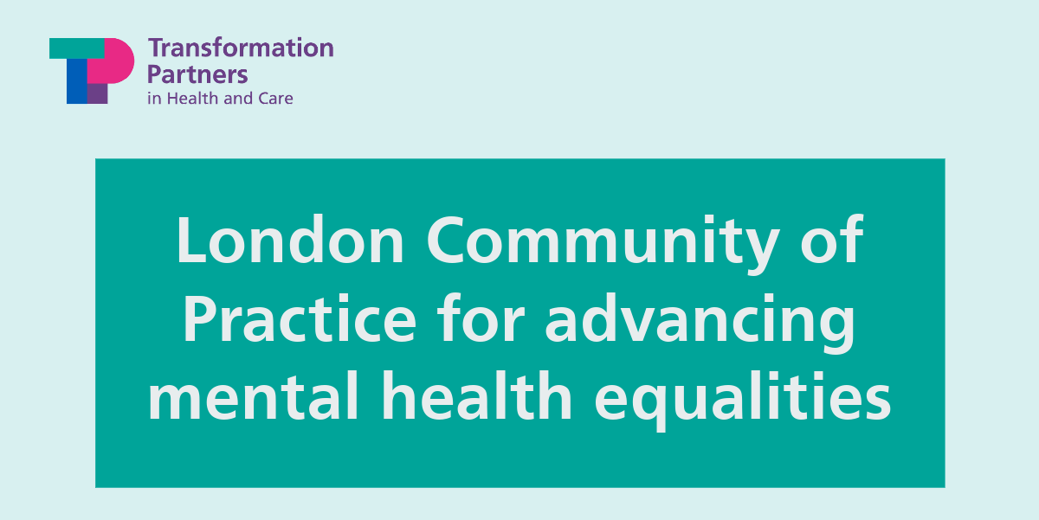
London Community of Practice for advancing mental health equalities

Event time and date: Thursday 5 October 2023, 12pm-2pm

Join the next Community of Practice (COP) meeting for advancing mental health equality in London. This COP aims to bring together the diverse range of organisations and experts working in this space across the capital and is part of a wider Advancing Mental Health Equalities programme, established by the London Mental Health Transformation Programme.

Agenda

During this COP event, there will be three presentations showcasing examples of mental health equalities programmes and services, including:

- Andrew Brown: Croydon BME Forum
- David Woodhead: Made in Communities – The Better Mental Health Fund
- Dr Ed Beveridge, Aileen Jackson and Jill Owens and Shilpi Shobowale: Addressing Physical Health Inequalities in the SMI (Serious Mental Illness) population

The meeting will be chaired by Abdirahim Hassan, Founder of Coffee Afrik CIC.

Attendees will also take part in breakout sessions to:
- Discuss and think collaboratively about what themes should be taken forward by the COP and agreeing what we want to collectively achieve through this forum.
- Think about how to make the COP participatory and inclusive.
- Understand how the COP can meaningfully benefit the work of the range of organisations and stakeholders working in this space.

The London Community of Practice for advancing mental health equalities aims to:
- Create a space for people and organisations to come together, share expertise and knowledge, and collaborate.
- Help to build a picture of common challenges, gaps, and enablers for advancing mental health equality across London.
- Collaboratively celebrate and analyse good practice, highlighting successes that have the potential to be spread across different areas.
- Support continuous communication on relevant programmes, policies, and initiatives at local, regional and national levels.

Contact: for more information about the COP or to receive the calendar invite, please email: s.tejero@nhs.net or tim.hess@nhs.net.

Organisations and speaker biographies
Croydon BME Forum
Croydon BME (CBME) Forum was established in 2003 to ensure that health and public services meet the needs of the diverse communities in Croydon. CBME Forum is the umbrella organisation for Croydon’s Black and Minority Ethnic voluntary and community sector; engaging people, building capacity, and promoting equality and cohesion.
Andrew Brown, Chief Executive Officer, will provide an overview of their range of mental health programmes and services aimed at improving the mental health of ethnic minority communities in Croydon, working to improve access to services, challenge stigma and reduce stark health inequalities.
CBME are incredibly engaging with the community to offer support and they were one of the 10 winners of the 2023 GSK IMPACT Awards which are delivered in partnership with leading health and care charity The King’s Fund. CBME Forum is a registered charity and company limited by guarantee.
For more info, visit: https://www.cbmeforum.org/about-us/

Andrew Brown – Chief Executive Officer
Andrew Brown is an experienced Director with a demonstrated history of working in the education and management industry and he has been working at Croydon BME Forum for the last 6 years.
Andrew is Skilled in Coaching, Strategic Planning, Business Development, Curriculum Development, and Public Speaking and is a Strong professional, graduated from Croydon College.
Andrew has a passion for helping others and this passion has motivated him to help the community and give opportunities to others, who would not have received it otherwise.
Andrew has also very proudly opened two community centres, The Wellness Centre and The Health and Wellbeing Space at the Whitgift Centre.
Andrew is a creative and focused driven leader, in charge of 20+ employees and volunteers at the Croydon BME Forum.

Made in Communities report – The Better Mental Health Fund
The ‘Made in communities’ report showcases what is possible with wise investment in the public’s mental health. The Better Mental Health Fund (TBMHF) was a government-backed grant scheme administered by the Office for Health Improvement and Disparities (OHID) that put communities at the heart of improving the public’s mental health and wellbeing by providing funding to 40 of the most disadvantaged areas of England in 2021.
Centre for Mental Health was commissioned by OHID to evaluate the Better Mental Health Fund nationally and they have written the ‘Made in Communities’ report. Findings showed that strong relationships between local councils and voluntary and community sector organisations is essential as this led to local councils utilising TBMHF to support a wide range of activities such as improving housing quality, bereavement support as well as supporting people facing financial insecurity and debt. This has led to many local areas now exploring ways to sustain longer term projects.
Thirteen case study sites were made to bring depth to their understanding of the successes and challenges of implementation as well as impacts of the local projects.

David Woodhead PhD, Associate Director of Research at the Centre for Mental Health
David Woodhead is a research and policy professional with almost 30 years’ experience of working in health and social care. His work has focused on improving the health and wellbeing of disadvantaged and excluded communities. He has a particular interest in issues relating to racism, intersectionality, and LGBT health.
David has worked for world class research organisations, including the UCL Institute of Health Equity, King’s Fund and Cancer Research UK, building knowledge about health inequalities and how best to tackle them. He has also designed and delivered high profile research for national voluntary sector organisations, including Homeless Link, Consortium, and the LGBT Foundation.
David has held Head of Service, Deputy Director, and Assistant Director roles in the NHS and local government – in public health, social care, and cultural services – and has also led strategy and policy development for two national regulatory bodies.
He is a Fellow of the Royal Society of Arts and Royal Society of Public Health.
In 2007, he won the James Mayes Award and was seconded to the Haute Autorité de Santé in Paris. He researched how French health care systems are funded and governed.
His work is grounded by his experiences of poor mental health.

Addressing Physical Health Inequalities in the SMI (Serious Mental Illness) population
The London Physical Health Leads Network, hosted by UCLPartners, the Health Innovation Network, King’s Health Partners Mind and Body Programme and the Physical Health Leads from across the nine London NHS Mental Health Trusts was established in 2018 to bring together clinicians and expertise across the London region and aims to reduce the mortality gap in people with a serious mental illness (SMI).
People with a SMI are at a much greater risk of poor physical health and have a significantly reduced life-expectancy, on average, they die 15 to 20 years earlier than the general population from preventable causes and diseases. In order to meet their physical health needs, people with a SMI should receive an annual physical health check either in primary or secondary care.
NHS England have published Core20PLUS5, an improvement approach to reduce health inequalities at both national and system level. One of the five focus clinical areas requiring accelerated improvement is individuals living with a SMI requiring annual health checks.
The Physical Health Leads Network are currently working on a project funded by Cavendish Square Group focused on secondary care physical health check data in the SMI population, with a particular interest in protected characteristics of those who are not receiving checks.
They aim to understand if there is a pattern of people with defined characteristics not accessing health checks and then will look at how access can be improved. The hypothesis is that there may be different engagement and access requirements that need to be met in different or innovative ways.
This project is led by the Health Innovation Network and South London and Maudsley NHS Foundation Trust.

Dr Ed Beveridge – Clinical Director for Hospital Services Barnet, Enfield, and Haringey MH NHS Trust and Clinical Lead for Mental Health and Behaviour Change at UCL Partners
Dr Ed Beveridge trained in medicine at Cambridge and Oxford, and he undertook specialist training in London. He is a general Adult Psychiatrist experienced in working with the full range of adult mental illnesses.
He is passionate about improving physical health of patients with a severe mental illness and worked with NIHR CLAHRC NW London designing interventions to improve physical health screening.
He is Presidential Lead for Physical Health at the Royal College of Psychiatrists. He also co-chairs the Pan-London Physical Health Leads’ Network since its establishment.
Other interests include psychodynamic approaches to SMI, and psychosomatic disorders.

Aileen Jackson – Head of Mental Health, Health Innovation Network
Aileen is Head of Mental Health at the Health Innovation Network, the Academic Health Science Network for south London. She has worked extensively in the health and social care sector including: commissioning, service development, organisational development and social work management. Aileen is also a registered social worker.

Jill Owens – Senior Programme Manager for Mental Health, Health Innovation Network
Jill has led several mental health programmes, including the national Early Intervention in Eating Disorders programme on behalf of the Academic Health Science Network, and worked across healthcare innovation, upskilling the healthcare workforce with Health Education England, local authority public health commissioning and public health at national policy level. Previously Jill has run a private limited company and has studied and worked in law.

Shilpi Shobowale – Project Manager for Digital Transformation and Technology, Health Innovation Network
Shilpi is an experienced health and social care project manager with a proven track record in delivering digital transformation projects for NHS and local authority. She has broad experience working across primary and secondary care and has gained an MBA in healthcare management.

