#AskAboutAsthma2023 communications toolkit for London’s integrated care systems (ICS)

#AskAboutAsthma returns for its seventh year, led by the NHS England – London Babies, Children and Young People’s Transformation team. The #AskAboutAsthma campaign is about making simple changes to children and young people’s care that will make a big difference to how they experience their asthma. The campaign week of learning and engagement events takes place this year from 11-17 September 2023.

Our aims
The #AskAboutAsthma campaign encourages children and young people, their families, and those involved in their care, to follow four simple and effective measures to help manage their asthma:

1. Get an asthma action plan in place
A written asthma action plan drawn up between a clinician and patient means people are four times less likely to have to go to hospital for their asthma.

2.Understand how to use inhalers correctly
Less than three-quarters of children and young people have any form of instruction in how to use their inhaler. Poor inhaler technique means patients don’t get the full benefit of their asthma medication.

3. Schedule an asthma review – every year and after every attack
An asthma review by an appropriately trained clinician after every attack helps to work out what went wrong. An annual review ensures effective management of the condition.

4. Consider air pollution and its impact on lung health
We want to ensure that every asthma conversation considers the impact of outdoor and indoor air pollution on children and young people’s asthma.

Theme:
This year’s theme is “Widening our view”. We’re shining a light on the wider factors of children and young people’s asthma care including issues such as housing, mould and vaping.
We also recognise that health inequalities mean that not everyone gets the same standard of care. By widening our view, we can help to raise the profile of asthma by reaching out to everyone who has asthma, their friends, families and the whole system that cares for them.

Toolkit contents
- How to get involved with the #AskAboutAsthma 2023 campaign
  - Suggested copy for your websites, newsletters and publications
  - Social media assets and accompanying messages for Twitter, Facebook, Instagram and LinkedIn
  - Downloadable resources
- Asthma fact sheet
- Other useful resources

Getting ahead of week 38
#AskAboutAsthma campaign week will take place from 11-17 September 2023.
Supporters of the campaign can take the learning, resources and key information shared to be even more prepared for week 38 (in 2023 this is from 18-24 September) – the week where, nationally, there is a rise in asthma attacks following the return to school after the summer holidays.

How to get involved with the #AskAboutAsthma 2023 campaign
Can your Integrated Care System (ICS) and associated board and partnerships help us raise the profile of childhood asthma and good asthma care across your boroughs?
Your ICS can play an important part by bringing together partners and highlighting local examples of good practice to raise awareness of the asthma management measures that should be taken to enable children and young people in your boroughs to live full, active lives.
This communications toolkit has been prepared for colleagues working within London’s ICSs to get involved in the #AskAboutAsthma 2023 campaign week. Show your support by:
- Encouraging local teams and partners to develop their understanding of children and young people’s asthma by attending the #AskAboutAsthma conference and daily webinars, reading our blogs and listening to our podcasts.
- Using our resources to develop your own ICS #AskAboutAsthma campaign which brings the audience closer. Examples from previous years include sending regular emails to all staff within CYP asthma networks highlighting the campaign resources and local initiatives and content; developing blogs from local stakeholders showing what they do to support good asthma care; running asthma training sessions within local primary and secondary care settings, etc.
- Developing your ICS intranet page highlighting local events and activities taking place to mark #AskAboutAsthma 2023 as well as local examples of good practice or innovations.
- Asking if your local teams and partners are aware of the campaign asks and are routinely recommending them to children and young people and their parents and carers. Do they have an asthma action plan? Have they had an inhaler technique check and asthma review by an appropriately trained clinician in the last year? Do they know the impact of air pollution on their asthma?

- Commissioners and programme leads can:
  - Lead on capturing data and case studies on the impact of air quality to inform your planning and development of CYP whole system asthma programmes.
  - Actively plan CYP asthma projects and campaigns alongside local environmental health teams to address the impact of air pollution (both indoor and outdoor) on asthma sufferers.
  - Consider how health inequalities are worsening the effects of asthma among children and young people across your local boroughs.
  - Work in partnership with your local authorities’ health and environment teams in your boroughs to help improve residents’ awareness that smoking, vaping and mould in homes can trigger asthma and other respiratory conditions.

Virtual events and daily content
A week of events is planned, with daily webinars, an online conference, podcasts, videos, blogs and other content from people working with children and young people with asthma from all over the country. Information about the events will be uploaded throughout the week so do check the page for more details and join in with as much as you can.
You can view the 2023 campaign web page here: https://www.transformationpartnersinhealthandcare.nhs.uk/ask-about-asthma.
Below you can find a range of resources to help publicise the campaign across your ICS area, including newsletter copy, social media assets and a downloadable campaign poster.

Tailored resources for your use
Longer article copy for use in your newsletters, bulletins, intranets

#AskAboutAsthma 2023 – widening our view
#AskAboutAsthma is back for 2023. Now in its seventh year, the campaign encourages simple changes to children and young people’s care that will make a big difference to how they experience their asthma. The 2023 #AskAboutAsthma campaign will run from 11 – 17 September, ahead of the rise in asthma attacks in September when students go back to school after their summer holidays. The campaign is run by the NHS England – London Babies, Children and Young People’s Transformation team and centres around four steps to help manage asthma:
1. get an asthma action plan in place.
2. understand how to use inhalers correctly.
3. schedule an asthma review every year and after every attack.
4. consider air pollution and its impact on lung health – every asthma conversation should include indoor and outdoor air pollution.
This year’s theme is “Widening our view” and is shining a light on the wider factors of children and young people’s asthma care including housing, mould and vaping. “Widening our view” also helps us to raise the profile of asthma; reaching out to everyone who has asthma, their friends, families and the whole system that cares for them.
See our intranet page for more information on local events and activities taking place to mark #AskAboutAsthma 2023: [INSERT LINK or remove line if not applicable].
Find more information and resources on the #AskAboutAsthma 2023 campaign webpage.
(228 words)

Short form article copy for newsletters, bulletins, community forums or WhatsApp groups:

#AskAboutAsthma 2023 – widening our view
#AskAboutAsthma 2023 takes place from 11 – 17 September. The campaign encourages children, young people and their parents and carers to understand how to best manage their asthma by following four steps:
1. get an asthma action plan in place,
2. understand how to use inhalers correctly,
3. schedule an asthma review – every year and after every attack, and
4. consider air pollution and its impact on lung health.
See our intranet page for more information on how [insert your organisation] is marking #AskAboutAsthma 2023: [INSERT LINK or remove all if not applicable].
Visit the campaign webpage at www.transformationpartnersinhealthandcare.nhs.uk/ask-about-asthma to learn more about the campaign, including the 2023 theme: widening our view – shining a light on the wider factors of children and young people’s asthma care.
(125 words)

Social media assets and accompanying messaging

You can post about #AskAboutAsthma on your social media channels leading up to, and during the campaign week, and ahead of week 38 (18-24 September). Remember to use the campaign hashtag: #AskAboutAsthma so we can reshare your posts.

You can find social media suggested messaging below. To download full-sized images for each social media channel, follow this link to our Google Drive folder.

Suggested messaging and which assets to use
Twitter asset 1 (carousel) – four asks:  - 4 asks overview:  There are four steps that can help children and young people to manage their asthma and live full, active lives.  🔗Learn more about asthma care: https://www.transformationpartnersinhealthandcare.nhs.uk/your-asthma-care/  #AskAboutAsthma  2.1  An asthma action plan has all the information you need to manage a child or young person’s asthma. Speak to a GP or asthma nurse if you do not have an asthma plan.  🔗Find out more about asthma action plans for children and young people: http://www.asthmaandlung.org.uk/conditions/asthma/child/manage/action-plan  #AskAboutAsthma  2.2  Knowing how to use an inhaler correctly can help prevent 75% of asthma hospital admissions in London each year.  Check your child is using their inhaler correctly:  www.asthmaandlung.org.uk/conditions/asthma/child/medicines/help  #AskAboutAsthma  2.3  Scheduling an asthma review once a year (and after every attack) can help children and young people to manage their symptoms.  Speak to your GP or asthma nurse to book your child’s next asthma review.  🔗Learn more about asthma care: https://www.transformationpartnersinhealthandcare.nhs.uk/your-asthma-care/  #AskAboutAsthma  2.4  Indoor and outdoor air pollution can trigger asthma, but knowing the triggers can help children and young people to manage their condition.  🔗Learn more about managing air pollution triggers: https://www.asthmaandlung.org.uk/living-with/air-pollution  #AskAboutAsthma | Asset: Upload rotating .mp4 file, or 4 x static images as a carousel post.  Tag: @BCYP_NHSLDN  Alt text: An animation showing four steps to help manage your child’s asthma. 1. Get an asthma action plan in place. 2. Understand how to use inhalers correctly. 3. Schedule an asthma review – every year and after every attack. 4. Consider air pollution and its impact on lung health  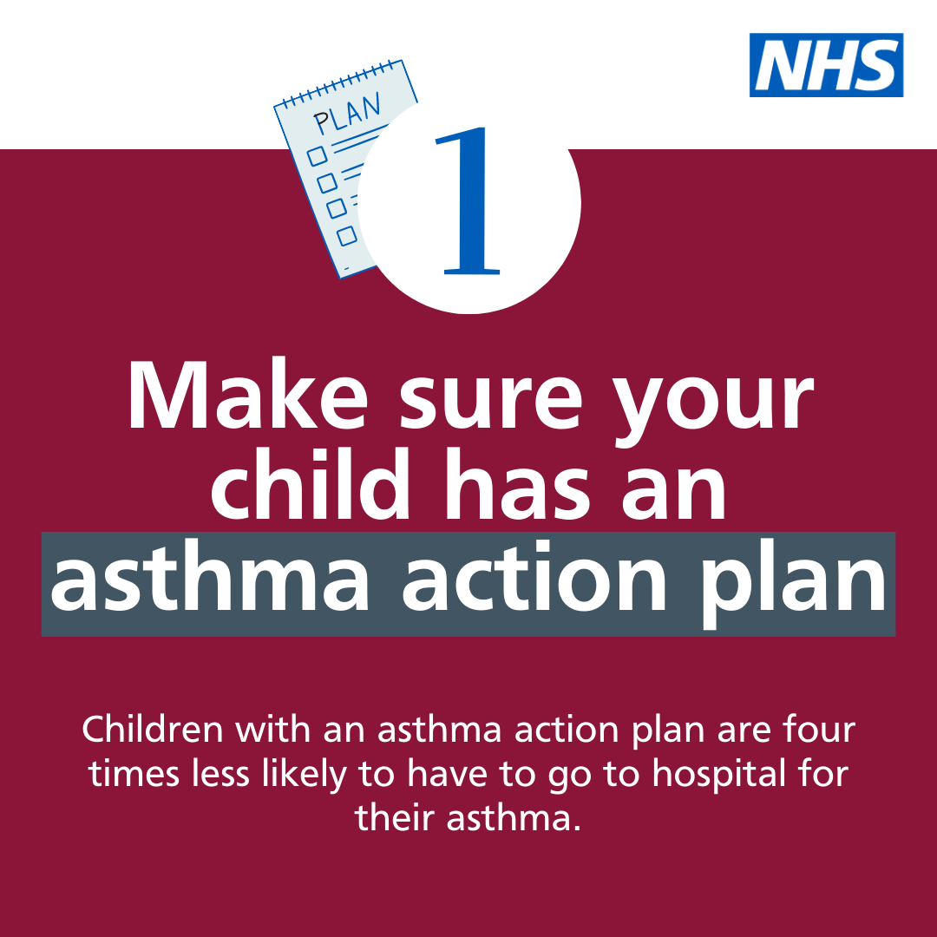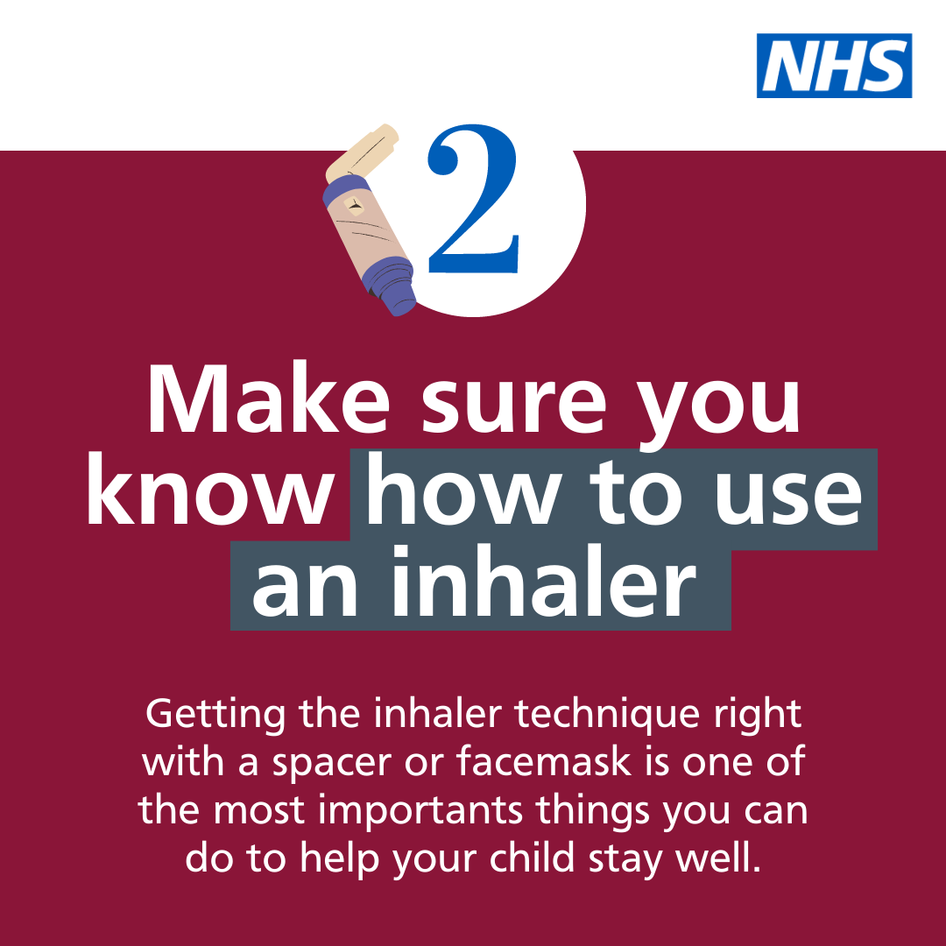  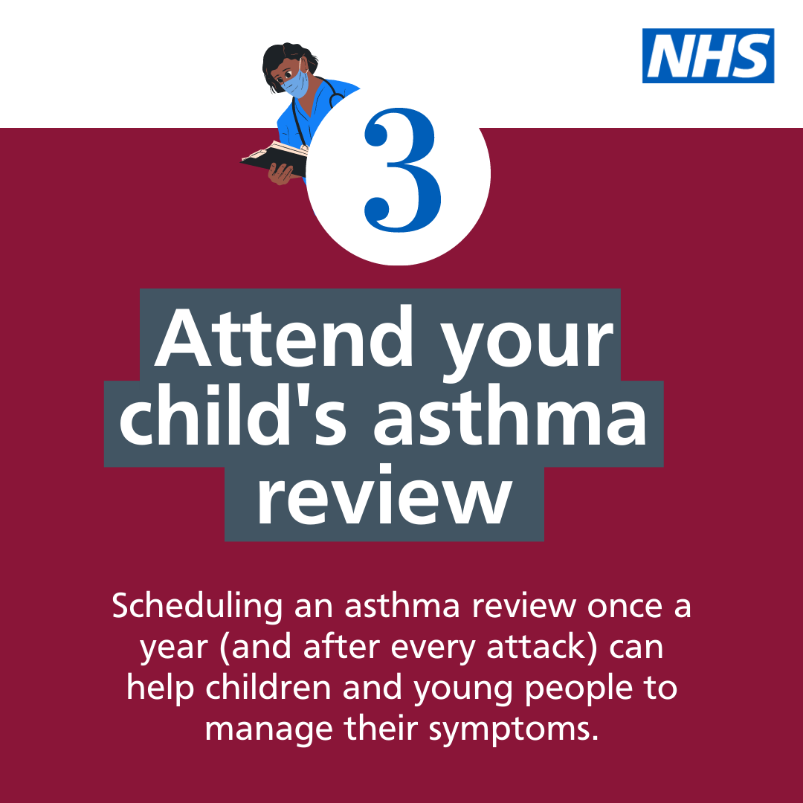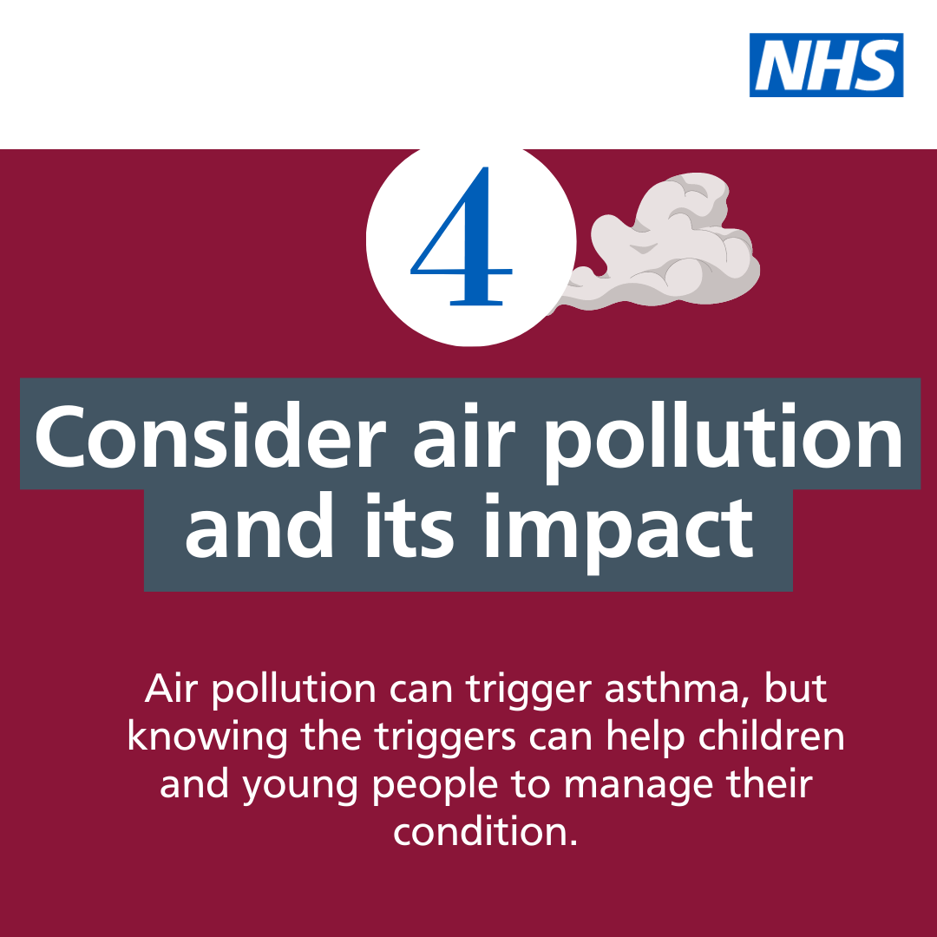  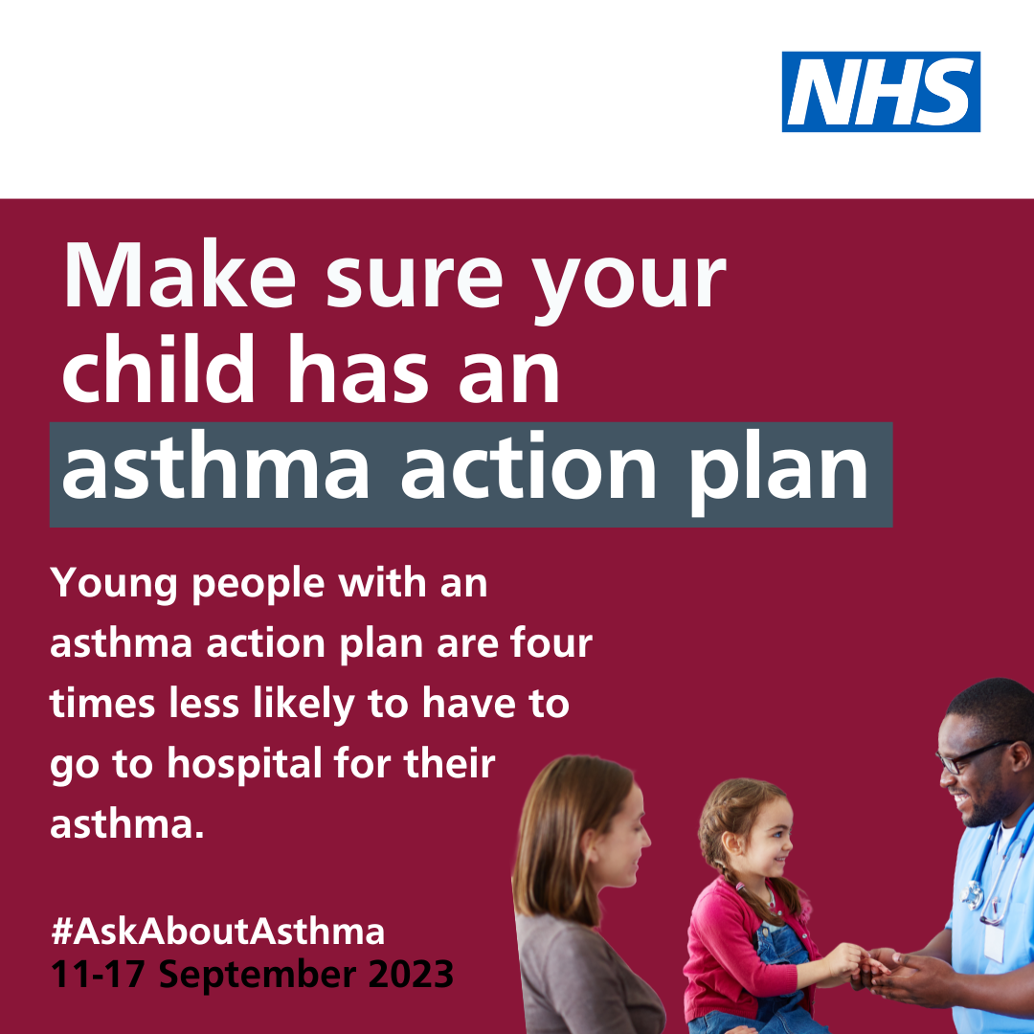  Alt text: An image of young girl, her mother and male nurse. Text reads: Make sure your child has an asthma action plan. Young people with an asthma action plan are four times less likely to have to go to hospital for their asthma. #AskAboutAsthma. 11-17 September 2023  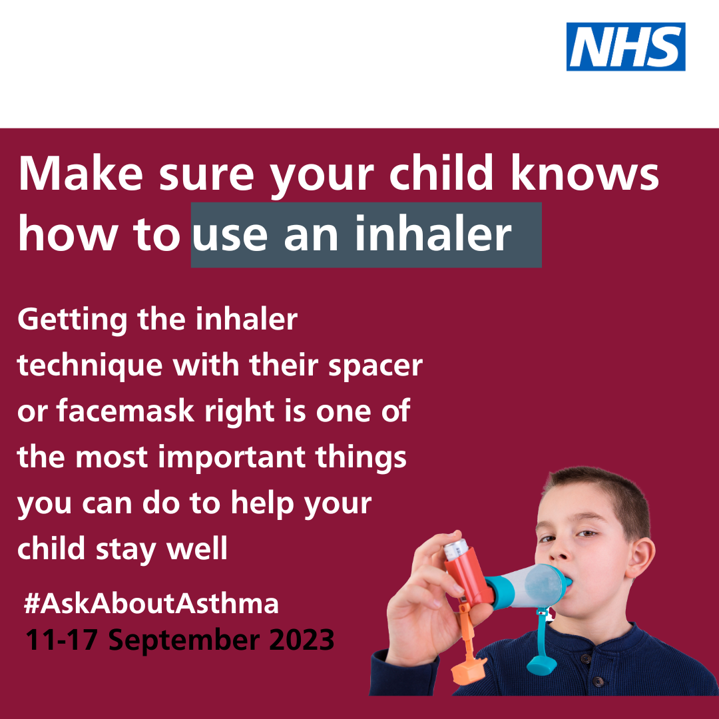  Alt text: An image of a young boy using an inhaler and spacer device. Text reads: Make sure your child knows how to use an inhaler. Getting the inhaler technique right is one of the most important things you can do to manage your asthma and stay well. #AskAboutAsthma. 11-17 September 2023  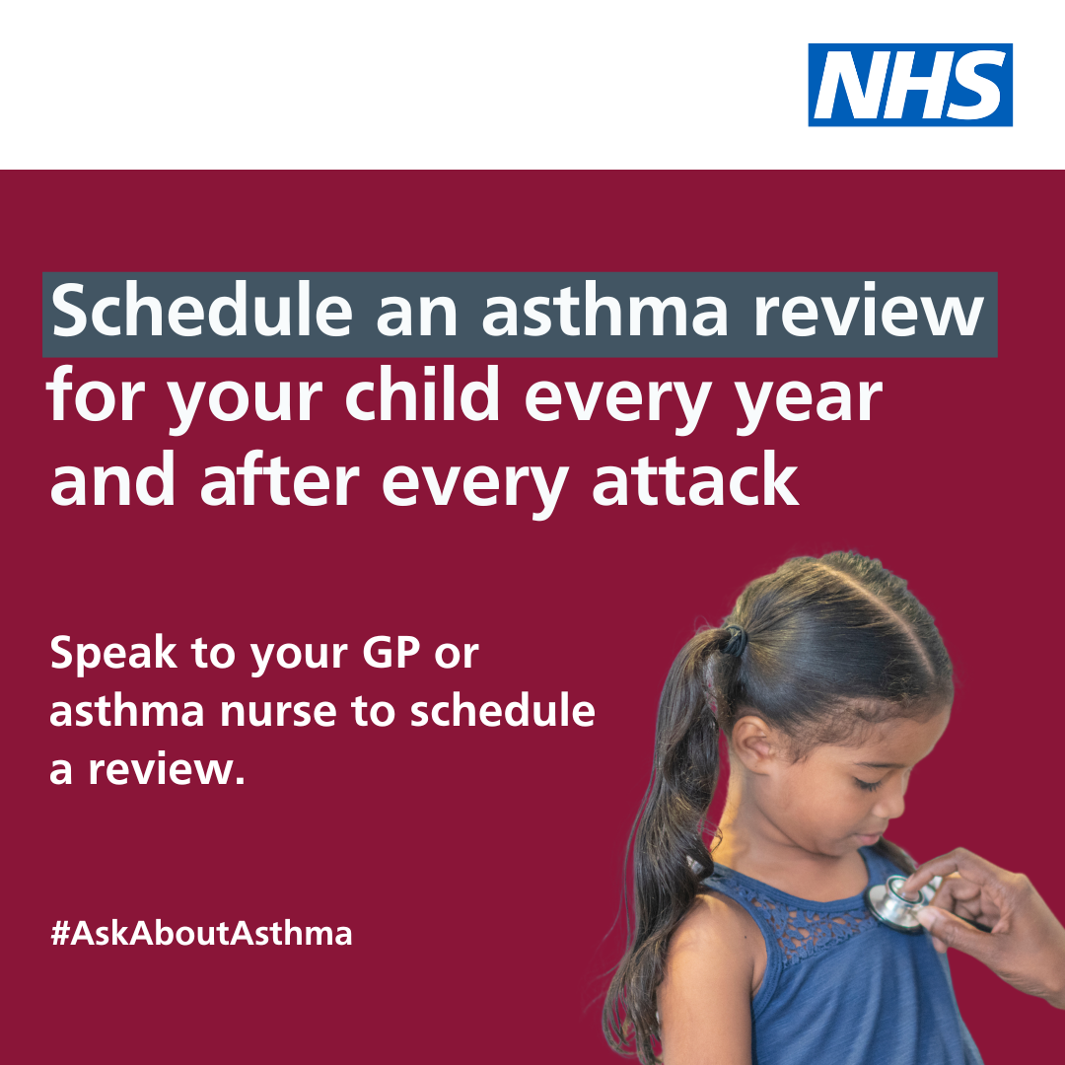  Alt text: An image of a young girl being checked with a stethoscope. Text reads: schedule an asthma review for your child every year and after every attack. Speak to your GP or asthma nurse to schedule a review. #AskAboutAsthma. 11-17 September 2023  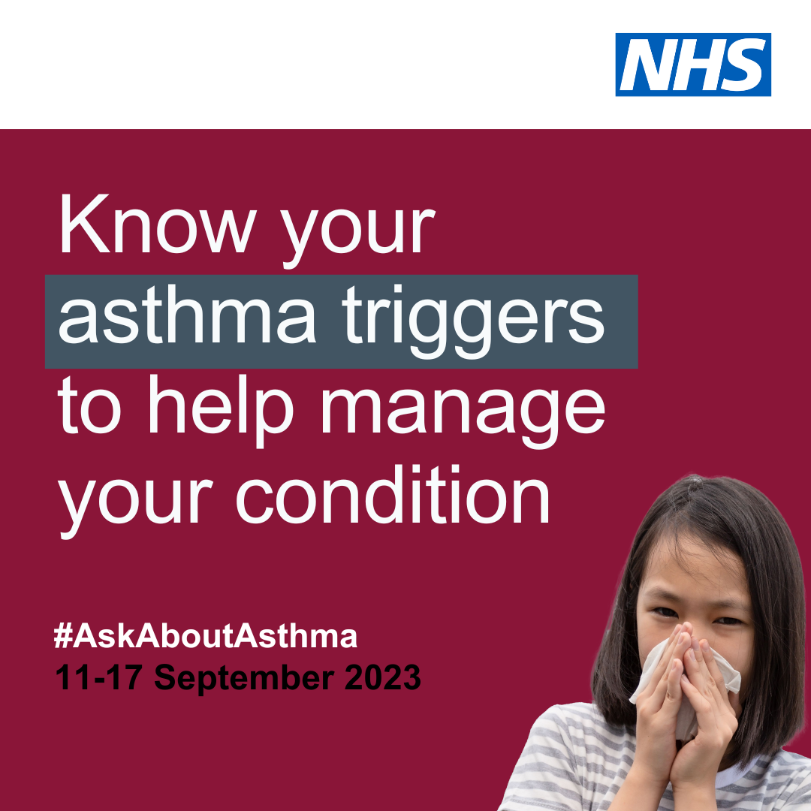  Alt text: An image of a young girl coughing into a tissue. Text reads: Know your asthma triggers to help manage your condition. #AskAboutAsthma. 11-17 September 2023
Twitter asset 3: widening our view  With the right support, children and young people with asthma can learn to manage their condition.  That’s why #AskAboutAsthma 2023 is encouraging us all to widen our view of children and young people’s asthma.  🔗Learn more at: https://www.transformationpartnersinhealthandcare.nhs.uk/your-asthma-care/ | 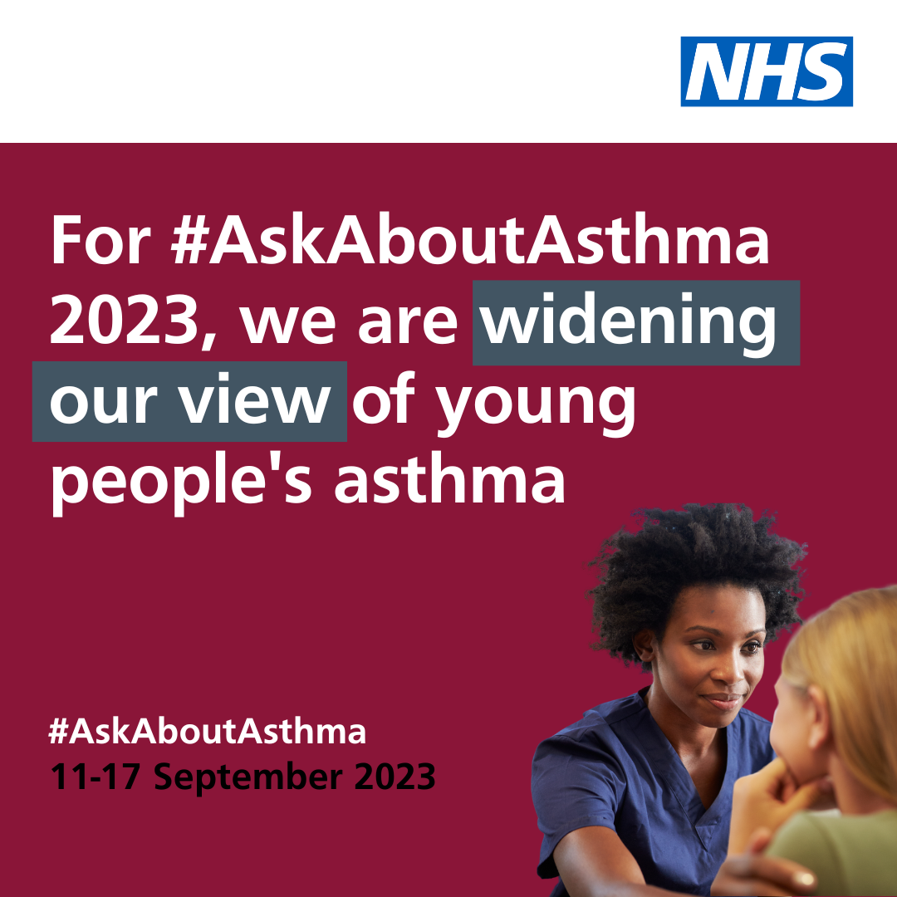  Alt text: An image of a nurse and young patient. Text reads: For #AskAboutAsthma 2023, we are widening our view of young people's asthma. #AskAboutAsthma. 11-17 September 2023  Tag: @BCYP_NHSLDN
Instagram asset 1 (carousel video post) – four asks:  There are four steps that can help children and young people to manage their asthma and live full, active lives:  1. Get an asthma action plan in place  2. Understand how to use inhalers correctly  3. Schedule an asthma review – every year and after every attack  4. Consider air pollution and its impact on lung health  🔗 Search #AskAboutAsthma or follow the link in our bio to learn more about children and young people’s asthma care. | Asset: Upload rotating .mp4 file, or 4 x static images as a carousel post.  Tag: @BCYP_NHSLDN  Change bio link to: https://www.transformationpartnersinhealthandcare.nhs.uk/your-asthma-care/  Asset: Upload rotating .mp4 file, or 4 x static images as a carousel post.  Alt text: An animation showing four steps to help manage your child’s asthma. 1. Get an asthma action plan in place. 2. Understand how to use inhalers correctly. 3. Schedule an asthma review – every year and after every attack. 4. Consider air pollution and its impact on lung health
Instagram asset 2 – widening our view:  #AskAboutAsthma 2023 is encouraging us all to  widen our view of children and young people’s asthma and reach out to everyone who has asthma, their friends, families and the whole system that cares for them.  The campaign is shining a light on the wider factors of asthma care including housing, mould and vaping, as well as the key four steps you can take to help manage asthma:  1. Get an asthma action plan in place  2. Understand how to use inhalers correctly  3. Schedule an asthma review – every year and after every attack  4. Consider air pollution and its impact on lung health.  🔗 Search #AskAboutAsthma or follow the link in our bio to learn more about children and young people’s asthma care. | Alt text: An image of a nurse and young patient. Text reads: For #AskAboutAsthma 2023, we are widening our view of young people's asthma. #AskAboutAsthma. 11-17 September 2023  Tag: @BCYP_NHSLDN  Change bio link to: https://www.transformationpartnersinhealthandcare.nhs.uk/your-asthma-care/
Facebook/LinkedIn asset 1 – 4 asks (carousel video post):  There are four steps that can help children and young people to manage their asthma and live full, active lives:  1. Get an asthma action plan in place  2. Understand how to use inhalers correctly  3. Schedule an asthma review – every year and after every attack  4. Consider air pollution and its impact on lung health.  Learn more about children and young people’s asthma care at: https://www.transformationpartnersinhealthandcare.nhs.uk/your-asthma-care/ | Asset: Upload rotating .mp4 file, or 4 x static images as a carousel post.  Alt text: An animation showing four steps to help manage your child’s asthma. 1. Get an asthma action plan in place. 2. Understand how to use inhalers correctly. 3. Schedule an asthma review – every year and after every attack. 4. Consider air pollution and its impact on lung health
Facebook/LinkedIn asset 2 – widening our view:  #AskAboutAsthma 2023 is encouraging us all to  widen our view of children and young people’s asthma, helping to raise the profile of asthma and reach out to everyone who has asthma, their friends, families and the whole system that cares for them.  The campaign is shining a light on the wider factors of asthma care including housing, mould and vaping, in addition to the four campaign asks:  - have an asthma review after every attack and at least once a year by an appropriately trained clinician,  - know how to use your inhaler correctly,  - have a written asthma action plan, and,  - know about the potential impact of air pollution on your lungs.  🔗Learn more at: www.transformationpartnersinhealthandcare.nhs.uk/ask-about-asthma | Alt text: An image of a nurse and young patient. Text reads: For #AskAboutAsthma 2023, we are widening our view of young people's asthma. #AskAboutAsthma. 11-17 September 2023  Tag: @BCYP_NHSLDN  Change bio link to: https://www.transformationpartnersinhealthandcare.nhs.uk/your-asthma-care/

Downloadable campaign posters
- #AskAboutAsthma campaign poster and easy read version which can be printed out and displayed locally
- Click here to download a digital poster about signs/symptoms of asthma

Further information

- Children and young people’s asthma fact sheet
- Asthma and Lung UK
- NHS England – London children and young people’s asthma programme
- London toolkit for children and young people with asthma
- London schools’ guide for the care of children and young people with asthma
- The International Primary Care Respiratory Group (IPCRG) image gallery
- Messaging on vaping for young people
- Advice on indoor allergies including mould

We do not have to wait for new medicines or a cure for asthma: we need to educate and support everyone treating or supporting children and young people with asthma to use these tools and work together to achieve improved outcomes.

