#AskAboutAsthma 2023 communications toolkit for secondary schools

#AskAboutAsthma is back for 2023. Now in its seventh year, the campaign is about making simple changes to children and young people’s care that will make a big difference to how they experience their asthma. Around 1 in 11 children in every London school have asthma, that’s 3 children in every classroom. There’s a lot that you can do to help keep them safe and well while they’re in your care.
This year’s campaign takes place from 11 to 17 September.

How to get involved with #AskAboutAsthma 2023 campaign week
Schools can support this campaign in a number of ways:
- Display the #AskAboutAsthma campaign poster (found later in this toolkit) in reception areas to encourage students and parents and carers to speak to a GP, nurse or pharmacist if they need help managing their asthma.
- Checking in with students at your school who have asthma and their parents/carers – also in particular checking directly with students in year 11 and Sixth Form who may be transitioning to Further/Higher Education: are they confident that they can manage their asthma independently?
  - Do they know that asthma is a chronic condition that can be managed? If asthma is controlled young people will be less likely to have an asthma attack, miss school, clubs and sports and have better overall quality of life.
  - Encourage parents and carers to check if they have each of the four asks in place: Does their child have an asthma action plan? Have they had an inhaler technique check and asthma review by an appropriately trained clinician in the last year? Do they know how air pollution affects their asthma?
  - Encourage parents and carers to think about the impact of indoor and outdoor air quality at home and on the way to/from school – air pollution, smoking and vaping can trigger asthma so it’s important to minimise exposure where practical and possible. Support and more information is available on smoking cessation from Stop Smoking London.
- Discover how your school can better look after children with asthma with the Asthma Friendly Schools programme.
- Teachers and welfare staff can encourage pupils with asthma to think about asthma care as part of their overall health/wellbeing.
- Promote an inclusive classroom environment by teaching about asthma and common triggers more generally. Find some lessons plans here and see our spotting signs of asthma poster to help you get started.
- While vaping can help smokers quit, it is not harmless and is not for young people under 18. It is especially important to protect young lungs and brains. Schools can help by talking to young people about vaping.
- Staff and parents and carers can develop their understanding of children and young people’s asthma by attending the #AskAboutAsthma conference and daily webinars, reading our blogs, watching our short videos and listening to our podcasts.
- Circulate this briefing on asthma with your school governors.

Our aims
The #AskAboutAsthma campaign encourages children and young people, their families, and those involved in their care, to follow four simple and effective measures to help manage their asthma:
1. Get an asthma action plan in place
A written asthma action plan drawn up between a clinician and patient means people are four times less likely to have to go to hospital for their asthma.

2.Understand how to use inhalers correctly
Less than three-quarters of children and young people have any form of instruction in how to use their inhaler. Poor inhaler technique means patients don’t get the full benefit of their asthma medication.

3. Schedule an asthma review – every year and after every attack
An asthma review by an appropriately trained clinician after every attack helps to work out what went wrong. An annual review ensures effective management of the condition.

4. Consider air pollution and its impact on lung health
We want to ensure that every asthma conversation considers the impact of outdoor and indoor air pollution on children and young people’s asthma.

Theme:
This year’s theme is “Widening our view”. We’re shining a light on the wider factors of children and young people’s asthma care including issues such as housing, mould and vaping.
We also recognise that health inequalities mean that not everyone gets the same standard of care. By widening our view, we can help to raise the profile of asthma by reaching out to everyone who has asthma, their friends, families and the whole system that cares for them.

Campaign week
During September 11-17 we will run daily webinars, an online conference and release podcasts, videos and blogs from young people, parents and healthcare professionals working with children and young people with asthma.
This communications toolkit will help you to get involved during the #AskAboutAsthma 2023 campaign week and raise awareness of the measures that can help children and young people to manage their asthma.
We have also prepared tailored toolkits to help spread the message to specific settings and audiences including primary schools, GP practices, youth organisations and others.
Find these toolkits and more information on the campaign here.

What’s included in the toolkit:
  - Suggested copy for your websites, newsletters and publications
  - Social media assets and accompanying messages for Facebook, Instagram, Twitter and LinkedIn
  - Downloadable campaign poster
- Asthma fact sheet
- Other useful resources

Tailored resources for your use

Long form article copy for websites, blogs, publications etc:

#AskAboutAsthma 2023: widening our view
#AskAboutAsthma is back for 2023. Now in its seventh year the campaign encourages simple changes to children and young people’s care that will make a big difference to how they experience their asthma. The 2023 #AskAboutAsthma campaign will run from 11 – 17 September, ahead of the rise in asthma attacks in September when students go back to school after their summer holidays. The campaign is run by the NHS England – London Babies, Children and Young People’s Transformation team and centres around four steps to help manage asthma:
1. get an asthma action plan in place.
2. understand how to use inhalers correctly.
3. schedule an asthma review every year and after every attack.
4. consider air pollution and its impact on lung health – every asthma conversation should include indoor and outdoor air pollution.
This year’s theme is “Widening our view” and is shining a light on the wider factors of children and young people’s asthma care including housing, mould and vaping. “Widening our view” also helps us to raise the profile of asthma; reaching out to everyone who has asthma, their friends, families and the whole system that cares for them.
Please help share the #AskAboutAsthma campaign so more people learn about these four steps to managing asthma. Visit the 2023 campaign webpage for more information and resources.
(218 words)

Short form article copy for newsletters, bulletins, community forums or WhatsApp groups:

#AskAboutAsthma 2023 – widening our view
#AskAboutAsthma 2023 takes place from 11 – 17 September. The campaign encourages children, young people and their parents and carers to understand how to best manage their asthma by following four steps:
1. get an asthma action plan in place,
2. understand how to use inhalers correctly,
3. schedule an asthma review – every year and after every attack, and
4. consider air pollution and its impact on lung health.
Visit the campaign webpage: www.transformationpartnersinhealthandcare.nhs.uk/ask-about-asthma to learn more about the campaign, including the 2023 theme; widening our view – shining a light on the wider factors of children and young people’s asthma care.
(100 words)

Social media assets and accompanying messaging

You can post about #AskAboutAsthma on your social media channels leading up to the campaign week. Follow the NHS England – London BCYP team on:

Twitter: @BCYP_NHSLDN
Instagram: @BCYP_NHSLDN

Remember to use the campaign hashtag: #AskAboutAsthma so we can reshare your posts.
You can find social media suggested messaging below. To download full-sized images for each social media channel, follow this link to our Google Drive folder.

Twitter asset 1 – four asks rotating video:  - 4 asks overview:  There are four steps that can help young people to manage their asthma and live full, active lives.  🔗Learn more about asthma care: https://www.transformationpartnersinhealthandcare.nhs.uk/your-asthma-care/  #AskAboutAsthma  2.1  An asthma action plan has all the information you need to manage a young person’s asthma. Speak to a GP or asthma nurse if you do not have an asthma plan.  🔗Find out more about asthma action plans for children and young people: http://www.asthmaandlung.org.uk/conditions/asthma/child/manage/action-plan  #AskAboutAsthma  2.2  Knowing how to use an inhaler correctly can help prevent 75% of asthma hospital admissions in London each year.  Find out if you, or someone you know with asthma, is using their inhaler correctly: www.asthmaandlung.org.uk/conditions/asthma/child/medicines/help  #AskAboutAsthma  2.3  Scheduling an asthma review once a year (and after every attack) can help young people to manage their symptoms at home and at school or college.  Speak to your GP or asthma nurse to book your next asthma review.  🔗Learn more about asthma care: https://www.transformationpartnersinhealthandcare.nhs.uk/your-asthma-care/  #AskAboutAsthma  2.4  Indoor and outdoor air pollution can make asthma worse, but knowing the triggers can help young people to manage their condition.  🔗Learn more about managing air pollution triggers: https://www.asthmaandlung.org.uk/living-with/air-pollution  #AskAboutAsthma | 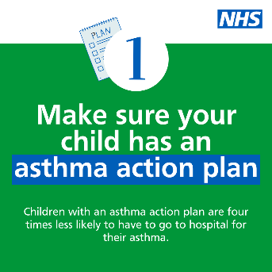  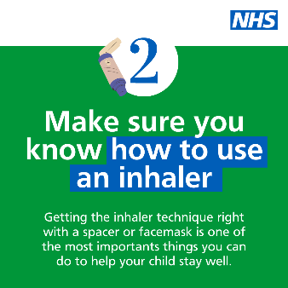  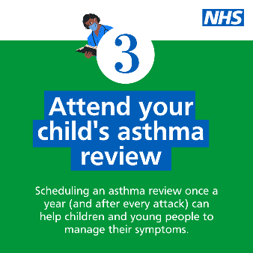  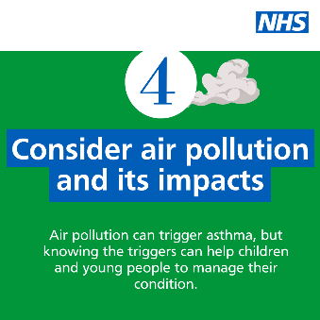  Tag: @BCYP_NHSLDN  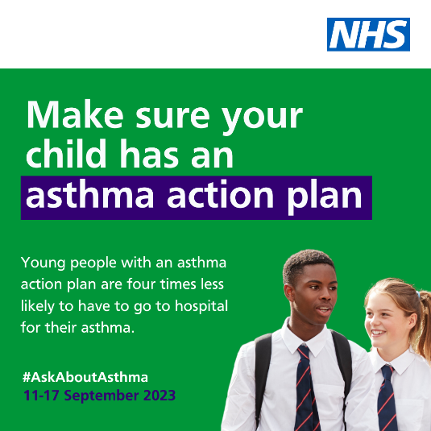  Alt text: An image of two teenagers. Text reads: Make sure your child has an asthma action plan. Young people with an asthma action plan are four times less likely to have to go to hospital for their asthma. #AskAboutAsthma. 11-17 September 2023  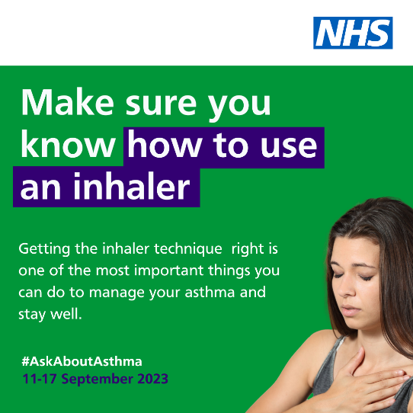  Alt text: An image of a teenage girl holding her chest wheezing. Text reads: Make sure you know how to use an inhaler. Getting the inhaler technique right is one of the most important things you can do to manage your asthma and stay well. #AskAboutAsthma. 11-17 September 2023  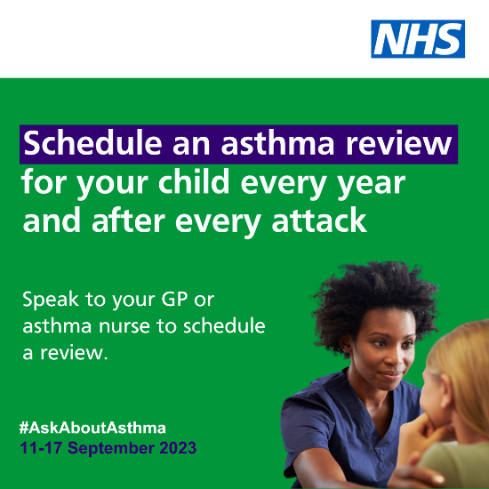  Alt text: An image of a nurse speaking to a teenage girl. Text reads: Remember to schedule an asthma review for your child every year and after every attack. Speak to your GP or asthma nurse to schedule a review. #AskAboutAsthma. 11-17 September 2023  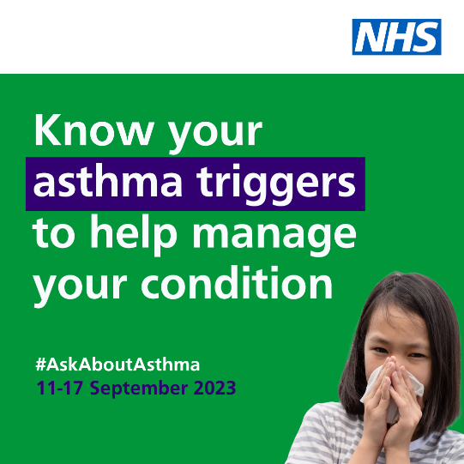  Alt text: An image of a young girl coughing into a tissue. Text reads: Know your asthma triggers to help manage your condition. #AskAboutAsthma. 11-17 September 2023
Twitter asset 2: widening our view  With support and encouragement, young people with asthma can learn to manage their condition independently.  That’s why #AskAboutAsthma 2023 invites us all to widen our view of children and young people’s asthma.  🔗Learn more at: https://www.transformationpartnersinhealthandcare.nhs.uk/your-asthma-care/ | 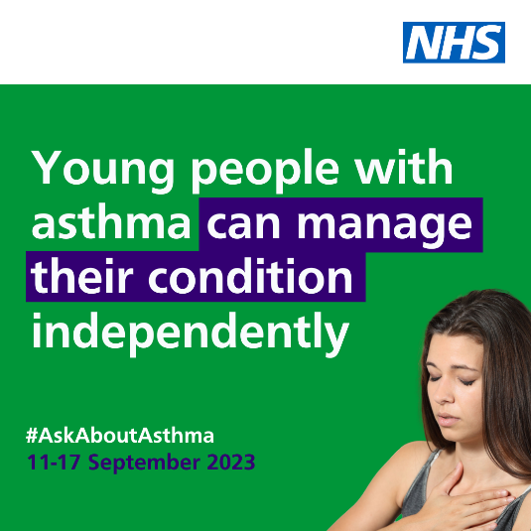  Tag: @BCYP_NHSLDN  Alt text: An image of a teenage girl holding her chest wheezing. Text reads: Young people with asthma can manage their condition independently. #AskAboutAsthma. 11-17 September 2023
Instagram asset 1 – four asks:  There are four steps that can help young people to manage their asthma and live full, active lives:  1. Get an asthma action plan in place  2. Understand how to use inhalers correctly  3. Schedule an asthma review – every year and after every attack  4. Consider air pollution and its impact on lung health  🔗 Search #AskAboutAsthma or follow the link in our bio to learn more about children and young people’s asthma care. | 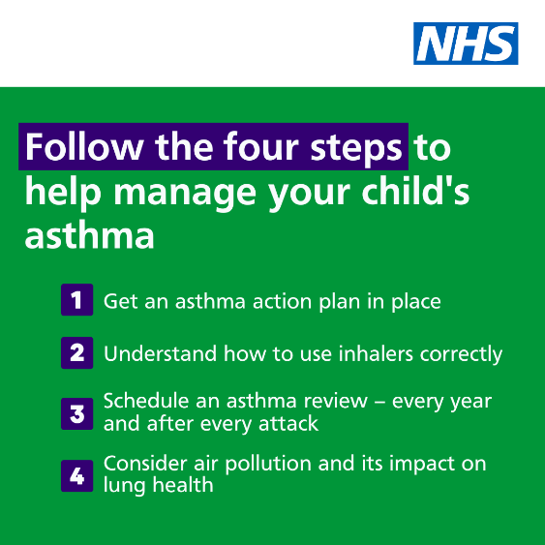  Alt text: Text reads: Follow the four steps to help manage your child’s asthma. 1. Get an asthma action plan in place. 2. Understand how to use inhalers correctly. 3. Schedule an asthma review – every year and after every attack. 4. Consider air pollution and its impact on lung health  Tag: @BCYP_NHSLDN
Instagram asset 2 – widening our view:  #AskAboutAsthma 2023 is encouraging us all to  widen our view of children and young people’s asthma and reach out to everyone who has asthma, their friends, families and the whole system that cares for them.  The campaign is shining a light on the wider factors of asthma care including housing, mould and vaping, as well as the key four steps you can take to help manage asthma:  1. Get an asthma action plan in place  2. Understand how to use inhalers correctly  3. Schedule an asthma review – every year and after every attack  4. Consider air pollution and its impact on lung health.  🔗 Search #AskAboutAsthma or follow the link in our bio to learn more about children and young people’s asthma care. | 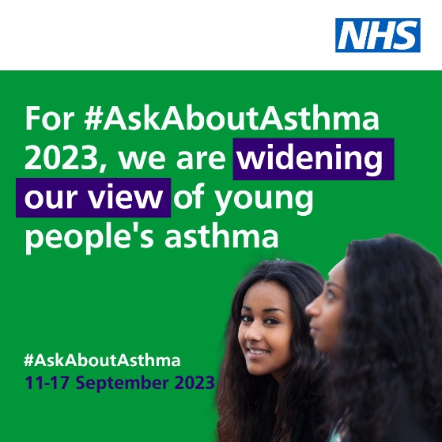  Alt text: An image of two teenage girls, one looking at the camera and one looking away. Text reads: For #AskAboutAsthma 2023, we are widening our view of young people’s asthma. #AskAboutAsthma. 11-17 September 2023  Tag: @BCYP_NHSLDN  Change bio link to: https://www.transformationpartnersinhealthandcare.nhs.uk/your-asthma-care/
Facebook/LinkedIn asset 1 – 4 asks:
There are four steps that can help children and young people to manage their asthma and live full, active lives:
1. Get an asthma action plan in place
2. Understand how to use inhalers correctly
3. Schedule an asthma review – every year and after every attack
4. Consider air pollution and its impact on lung health.

Learn more about children and young people’s asthma care at: https://www.transformationpartnersinhealthandcare.nhs.uk/your-asthma-care/

Facebook/LinkedIn asset 2 – widening our view:  #AskAboutAsthma 2023 is encouraging us all to  widen our view of children and young people’s asthma, helping to raise the profile of asthma and reach out to everyone who has asthma, their friends, families and the whole system that cares for them.  The campaign is shining a light on the wider factors of asthma care including housing, mould and vaping, in addition to the four campaign asks:  - have an asthma review after every attack and at least once a year by an appropriately trained clinician,  - know how to use your inhaler correctly,  - have a written asthma action plan, and,  4. know about the potential impact of air pollution on your lungs.  🔗Learn more at: www.transformationpartnersinhealthandcare.nhs.uk/ask-about-asthma | Alt text: An image of two teenage girls, one looking at the camera and one looking away. Text reads: For #AskAboutAsthma 2023, we are widening our view of young people’s asthma. #AskAboutAsthma. 11-17 September 2023

Downloadable poster and digital resources
- #AskAboutAsthma campaign poster and easy read version which can be printed out and displayed locally
- Click here to download a digital poster about signs/symptoms of asthma
Asthma fact sheet
Good asthma management reduces exacerbations and allows children and young people to lead full lives. Find information and facts which highlight the risks and outcomes of poorly managed asthma below.
1 in 11 children and young people are affected by asthma, which is around 3 in every London classroom – it is the most common long-term medical condition affecting this group
Many have badly managed asthma, with over 20,000 admitted to hospital every year in England. Over 4% of these have such a severe episode that they are admitted to intensive care
Children die in London because of asthma every year. 90% of asthma deaths are preventable with good asthma management: these children should have gone on to lead full and productive lives
London has a higher rate of illness and death in children and young people because of asthma compared to other European countries
Asthma is one of the top three causes of emergency admission to hospital (4,000 in London each year).
75% of these admissions would be avoidable through the implementation of simple interventions such as having a regular asthma review by an appropriately trained clinician, knowing how to use inhalers correctly, having a written asthma action plan and knowing about the potential impact of air pollution
Nearly half of children admitted to hospital have had an asthma attack in the previous year and 30% have had daytime symptoms in the previous week. But only a fraction have a personalised asthma action plan on how their asthma should be managed
Nitrogen dioxide, particulate matter and other forms of air pollution are known triggers for asthma and poor health more widely, particularly in children and young people
In 2022 London Ambulance Services (LAS) took 1,375 children to hospital for asthma and 6,191 children for breathlessness.
In 2021/22 there were 132 children admitted into London intensive care units who had a primary diagnosis of asthma (compared to 76 in 2020/21). The average length of stay was 3.7 days.
Rates in 2020/21 were lower due to lower exposure to pollution as well as (non-Covid) viral infections.
While COVID-19 is not thought to be a particular risk for children and young people with asthma, good asthma control and avoidance of unnecessary ED attendances is more important than ever
Using nebuliser devices at home for the acute treatment of asthma in children and adolescents, without medical supervision, can make it harder to spot signs of worsening asthma. This could result in delays in seeking medical attention and have serious and even fatal consequences.
Only use nebuliser devices at home for the acute treatment of asthma in under 18s if recommended, initiated, and managed by an asthma specialist.

We do not have to wait for new medicines or a cure for asthma: we need to educate and support everyone treating or supporting children and young with asthma to use these tools and work together to achieve improved outcomes.

Other useful resources
- Asthma briefing for school governors
- Asthma and Lung UK
- NHS England – London children and young people’s asthma programme
- London toolkit for children and young people with asthma
- London schools’ guide for the care of children and young people with asthma
- The International Primary Care Respiratory Group (IPCRG) image gallery
- Talking about vaping with young people
- Advice on indoor allergies including mould

