

**Safeguarding Children with Asthma – an Integrated Care System approach**

**(Health, Social Care, Education, Housing, Police, Voluntary Services)**

Identifying and supporting management of **modifiable factors**

**Statutory Intervention (Levels 3 & 4) – significant harm**

School / Education

**Multidisciplinary Approach** – working together to develop management plans and supporting child and family. This should include consideration of:

**Suboptimal Asthma Control** 1

* Admission to Hospital / Unscheduled attendances (2 or more/year)
* Severe / life threatening episode
* Using reliever inhaler more than 2 times/week or more than 3 inhalers/year
* Use oral corticosteroids (more than 2 courses/year)
* Persistent chronic symptoms (3 months or over)
* Asthma impacting normal life activities, including school attendance and physical activity.
* The impact of asthma and any other health conditions.
* Any mental health needs, psychological factors, learning needs & communication needs and language barrier.
* Family circumstances – including what agencies are involved.
* Adherence & compliance issues (i.e. frequent Was Not Brought / non-attendances to asthma review appointments; poor compliance with medical treatment or medical advice)
* Indoor air quality (including second hand smoke) & nutrition
* What asthma education has been provided for child and carer / family and has this taken in consideration their needs.
* Social deprivation & Housing conditions impacting on asthma
* Outdoor air quality
* Any unresolved parental / professional concerns.

GP Community Asthma teams

Secondary or Tertiary Care

Severe Asthma clinics

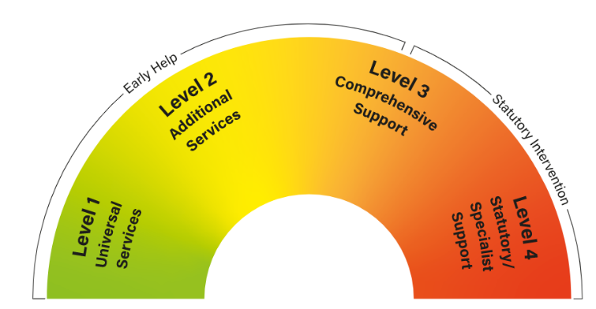

**All cases**

* Clear and explicit communication – what are the risks to the child?
* Quantify impact: what is like for the child? Impact on school attendance, daily activities, normal child development. Impact of *Was Not Brought* appointments
* Seek expert advice – including your organisation’s safeguarding leads
* Seek and record the views of the child and the family
* Follow your local safeguarding Policy

**Urgent:** referral to Police (999)

**Child has an allocated Social Worker** - they are aware of concerns and involved in management plans

**Links for Thresholds and Children’s Social Care information**:

[**Essex**](https://www.escb.co.uk/working-with-children/concerns-about-the-welfare-of-a-child)**:** 0345 603 7627 / Out of Hours 0345 606 1212

[**Southend**](https://www.southend.gov.uk/childrens-social-care/child-protection)**:** 01702 215 007 /Out of Hours 0845 606 1212

[**Thurrock**](https://www.thurrock.gov.uk/childrens-care-professionals-processes/referral-pathways-and-services)**:** 01375 652 802 / Out of Hours 01375 372 468

[**Suffolk**](https://www.suffolk.gov.uk/care-and-support-for-adults/protecting-people-at-risk-of-abuse/mash/): 0808 800 4005

[**Hertfordshire**](https://www.hertfordshire.gov.uk/services/childrens-social-care/child-protection/report-child-protection-concern.aspx): 0300 123 4043

Safeguarding threshold

Statutory Intervention (Levels 3 & 4) – child has suffered or is likely to suffer **significant harm**

* Clear asthma management plan that can be understood by all
* Are the expectations on the child for self-management realistic / appropriate to age / development?
* Compile evidence of poor adherence to management plan
* Be clear on the level of risk to the child – what is likely to happen to the child if asthma management is not improved?

**Medical Neglect2**: carers minimising or ignoring child’s illness or health needs and failing to seek medical attention or administrating medication and treatments.

**Referrals to Children’s Social Care, include:**

* Description of all the concerns
* Full description of the harm to the child (against local thresholds) and explicit level of risk
* Chronologies that evidence extent, pattern, and severity
* Explanations on diagnoses and functional implications.
* Description of the help offered to the child and the family and all Early Help / Multidisciplinary support

**Perplexing presentation3** - discrepancies between reports, child presentation and independent observations, implausible descriptions and unexplained findings or parental behaviour. **Fabricated or Induced Illness3** - child is harmed due to parent’s behaviour/action, carried out to convince that the child’s physical and/or mental health or neurodevelopment is impaired (or more impaired) (emotional, physical abuse and neglect).

* Ascertain child’s state of health and daily functioning (chronologies, liaising with all other health professionals involved, verifying diagnoses)
* Compile evidence of discrepancies, implausible descriptions, unexplained findings, or parental fabrication / induction.
* Iatrogenic harm – only necessary investigations and medications are prescribed

Links: [SET Procedures](https://www.escb.co.uk/media/2739/set-procedures-may2022.pdf) (p375) [RCPCH guidance](https://childprotection.rcpch.ac.uk/resources/perplexing-presentations-and-fii/)

If you remain concerned or in case of Professional Disagreement, follow SET Escalation Pathway

V2 – 04/2023 [Draft] *Developed by Ines Paris Designated Safeguarding Lead Nurse*

1 NHS Asthma Care pathway (draft)

2 Child Neglect: Identification and Assessment Horwath 2007

3 RCPCH 2021