JOB DESCRIPTION

PEER SUPPORT COORDINATOR – LEEDS MENTAL WELLBEING SERVICE

Grade: NJC Scale Points 23 – 25, starting at £26,999 pa
Hours: 37 hours per week
Responsible to: Touchstone Manager
Employing Body: Touchstone – Board of Trustees
Location: Leeds

This post will include some weekend and evening work.

Any job offer will be dependent on the outcome of enhanced DBS and reference checks.
Background

Touchstone is part of the new Primary Care Mental Health Service (PCMHS) for Leeds the Leeds Mental Wellbeing Service (LMWS). This exciting new partnership will mobilise and deliver an integrated service to offer primary care based mental health support for people with mild to moderate common mental health problems. Together, our partnership will help thousands of people in Leeds to increase their resilience and live their best lives within their community. The service comprises:

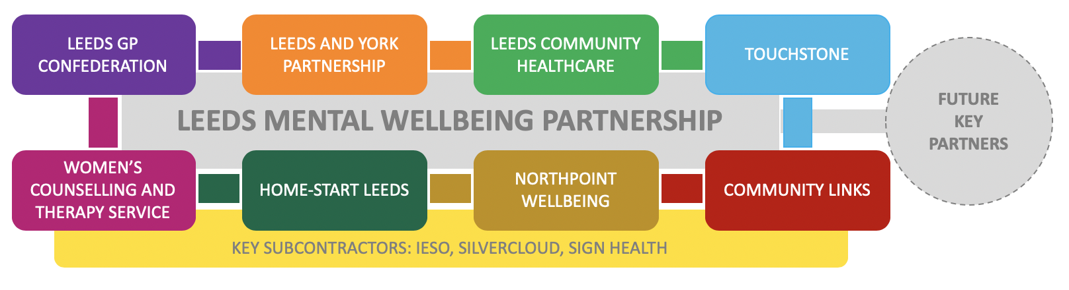

Purpose of the role

To effectively establish and then lead Peer Support and volunteering within the newly commissioned Primary Care Mental Health Service for Leeds. This will include the performance management of a small team including Peer and Volunteer Development Workers and some paid Peer Support Workers, as well as supporting many volunteers who have used the service to get involved in helping their peers gain and maintain positive mental health. You will have responsibility for the strategic and operational development of the Peer Support offer across IAPT and Primary Care Liaison as these services and others come together under the Primary Care Mental Health umbrella.
Key responsibilities
- To provide leadership and direction so that peer volunteers are able to deliver effective interventions in primary care mental health services.

- To manage the Peer Support Team. This includes the recruitment, induction, training oversight and personal supervision of a Peer and Volunteer Development Worker and Peer Support Workers who will support the implementation of the annual plan.

- To adopt an ‘insight’ approach – using a broad range of data, information and feedback to gain consensus across this partnership on the focus for volunteering and peer support each year through an annual plan, against which progress will be reviewed each quarter.

- To understand that there is a social gradient to mental health, and that some groups are disproportionately at risk of developing poor mental health. To support people from marginalised communities to volunteer as peers and contribute to tackling health inequalities as a result.

- To develop a training programme, deliver training to peer volunteers and then supervise regularly (group and 1:1) as they support the delivery, and become an integral part of the Leeds Mental Health Service.

- To develop a broad range of roles for peer volunteers, as determined by the annual plan, so that people who have benefitted from the LMWS can support their peers.

- To work to actively combat mental health inequalities, applying your knowledge of the social determinants of mental health in Leeds, and how some communities are at greater risk of poorer mental health

Engagement and Access

- Active outreach and engagement into neighbourhoods or among populations where there is under-representation/ low uptake.

- In neighbourhoods or among populations where there is under-representation/ low uptake having helpful conversations with potential service users about their mental health, improving understanding of the nature of the support on offer and self management.

- Attending drop ins and other outreach sessions with paid staff so that peer volunteers can actively support people to enter into the service who may otherwise find it difficult, for example using language skills or engendering confidence.

- Overcoming practical barriers for example supporting people to use the internet and other systems to choose and then book onto interventions provided by LMWS

- Acting as Trusted Assessors, particularly within under represented communities, providing a gateway to support people from marginalised groups into the most appropriate intervention for them.

- Supporting people if they are waiting for a treatment.

Ongoing support, treatment and maintaining recovery
- Acting as buddies to support people who would otherwise drop out of interventions to complete support/ treatment.

- Active outreach to people who have failed to attend appointments to support them where possible to overcome barriers and remain in the service.

- Supporting the delivery of group mental health interventions, such as workshops provided by paid Psychological Wellbeing Practitioners.

- Facilitating peer support groups and other activities, at all steps in the primary care mental health pathway, including post discharge. This will include developing specialist groups, for example for people with Long Term Conditions or for those who speak community languages to prevent relapse among the groups most at risk.

- To work with colleagues across Primary Care Mental Health Services, who are employed by a range of partner organisations, so that they promote Peer Support among service users and successfully engage people to become future peer volunteers.

- To provide central oversight of volunteers across LMWS and liaise effectively with host organisations.

- To develop, oversee and implement a range of policies and procedures for the Primary Care Mental Health Service, in line with Touchstone’s values and practice.

- To recognise people as assets and positively manage risk and recovery to enable Peer Supporters to meet their full potential.

- To enable Peer Support Workers to facilitate peer support groups/activities.
- To ensure that Peer Support Team staff and volunteers adhere to the policies and practices of Touchstone.

- To performance manage paid employees, including providing supervision and other support on a regular basis, in line with Touchstone's policies and procedures, carrying out staff appraisals and monitoring performance against agreed targets.

- To attend strategic and other meetings according to the needs of the service

- To complete monitoring and evaluation of work undertaken, including the impact on diverse communities and demographic groups, in line with required timescales and a high standard.

- To work alongside Touchstone’s Management team to ensure that all monitoring, impact assessment and evaluation of the work is collected, analysed and used to develop the service.

- To implement and oversee the maintenance of up to date records required for the effective running of the project, in line with GDPR requirements. This includes compiling reports based on qualitative and quantitative monitoring and evaluation data.

- To have day to day responsibility for managing agreed expenditure in line with the Primary Care Mental Health Service Peer Support budget, maintaining records in accordance with Touchstone’s policies.

- To promote Touchstone and LMWS to people/agencies who are interested, including through events, through giving talks/presentations to interested groups/individuals and 1:1 meetings.

- To contribute to the future development of Touchstone and the LMWS through contributing to strategy and writing and supplying information for tenders.

General
- To be inducted, supervised, performance managed and appraised in line with the organisation’s performance management policies and procedures.

- To be responsible for personal learning and development where appropriate and undertake training, both mandatory and optional, to increase knowledge, skills and awareness.

- To work at all times as part of a multi-agency and multi-disciplinary team. This includes working with other staff who are dispersed across a broad range of projects and in external organisations, attending team and staff meetings and developing a teamwork approach to all aspects of the organisation's work. To be an active member of Touchstone’s Management Team and to undertake any work arising from it as appropriate.

- To operate within the aims, policies and practices of Touchstone at all times and to be committed to and promote the organisation’s equal opportunities and anti-discriminatory policies.

- To ensure information is dealt with in accordance with Touchstone’s policies around Confidentiality, Communications, Internet, Email and Telecommunications and steps are taken to ensure that confidential information is secure.

6. To be aware of and employ the general practices of Touchstone’s Safeguarding and Health and Safety policies and ensure these are adhered to at all times

- To provide monitoring information and reports as part of funding and organisational requirements and for the Board of Trustees as requested by Touchstone management.

- To work flexibly in accordance with the needs of the Service, including undertaking out of hours and weekend work as required.

- The post holder may be required to carry out similar duties in other parts of the LMWS to contribute to the effective operation of the service.

July 2019

