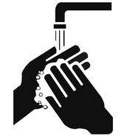
Patient and Visitors Guide
- Wash and Clean your Hands – Use soap and water or a hand sanitiser when you arrive in
reception. The soap and water can be used in the toilet facilities and hand sanitisers are on
the wall by our main entrance.

- Wear a mask – Please ensure you have your mask on at all times throughout the premises.
If you do not have a mask then ask reception and they will be able to give you one.

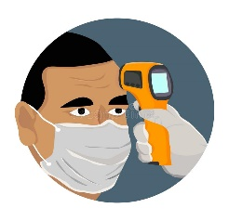

- Temperature Check - All Staff and Patients must complete a temperature check upon arrival
to our service. Please go to reception and check your temperature.

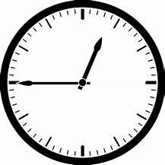
- Arrive on time – Please arrive on time and not more than 10 minutes early to your appointment.
If you are late then your appointment may be cancelled and rearranged for another day and time.

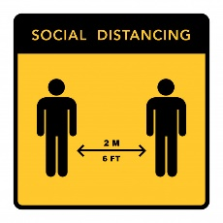

- Social distancing – Please ensure you maintain 2-meter distance from other people across our
service. We have put signage up highlighting the appropriate distance required.

WE FOLLOW GUIDELINES TO KEEP YOU SAFE.
PLEASE FOLLOW GUIDELINES TO KEEP US SAFE
SYMPTOMS OF COVID-19

If you have any of the following symptoms then DO NOT COME into our service or go into your GP

- A New Continuous Cough
- A High Temperature
- A Loss of Taste or Smell

Instead call 111 and seek further guidance

WE FOLLOW GUIDELINES TO KEEP YOU SAFE.
PLEASE FOLLOW GUIDELINES TO KEEP US SAFE

