Homeless Hotels Drug and Alcohol Support Service
(HDAS-London)

Spice Workbook
Spice recovery workbook for completion on your own or with support.

Speak to your hotel worker if you feel you may need support with this workbook. They will be able to advise on the best person to help.

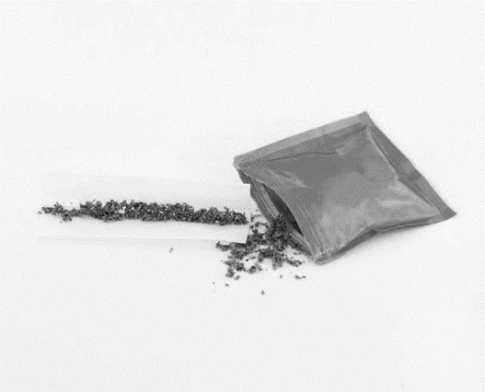

This workbook belongs to: _

These workbooks have been provided by partner agencies as part of the HDAS service,

Homeless Hotels Drug and Alcohol Support Service
(HDAS-London)

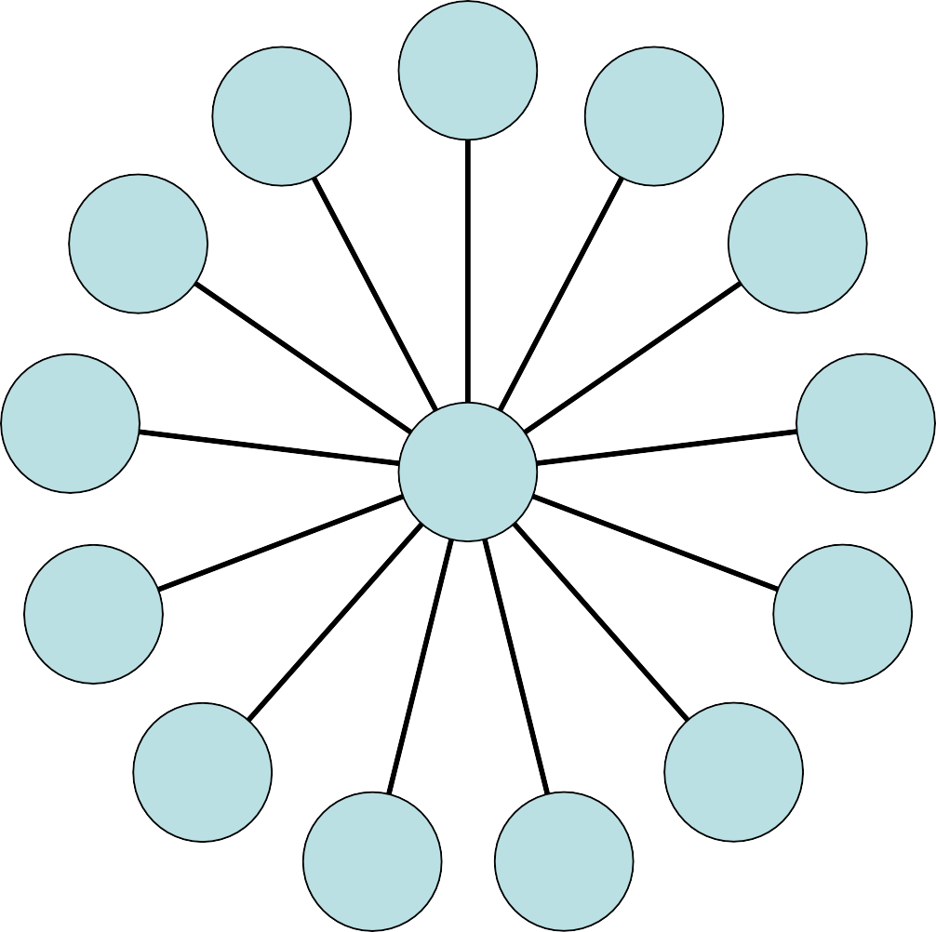
K2
Zombie Spice
Fake weed
Man Down
Bliss
Rice
Spice
Yucatan Fire
Green Crack
Genie
Zohai
Bombay Blue
Moon Rocks
Black Mamba

Spice belongs to a group of drugs called the Synthetic Cannabinoid Receptor Agonists or SCRAs. There are many types with many different names, as you can see from the diagram above.

INTRODUCTION

This is a self-study workbook for you to work through. Please take time to work through this pack and be as honest as possible. This pack is for your own reflection on your use of spice, however if you wish to discuss it further please contact a member of the hotel team who can speak to HDAS or the local drug and alcohol team.

CONTENTS
Worksheet 1 | What is Spice?
Worksheet 2 | Sensations, Effects and Safety
Worksheet 3 | You and your use of spice
Worksheet 4 | Different types of drug users
Worksheet 5 | You and your life
Worksheet 6 | Your drug use
Worksheet 7 | Effects on you
Worksheet 8 | The legal stuff
Worksheet 9 | Harm reduction

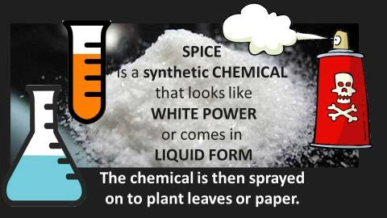

WORKSHEET 1: WHAT IS SPICE? (Bears no relation to the cannabis plant)
- Spice belongs to class of drugs called the Synthetic Cannabinoid Receptor Agonists or SCRAs, there are
many types with many different names
  - Spice is a man-made mind-altering chemical that is sprayed on to dried, shredded plant material or paper, that mimics the effects of a chemical in cannabis called THC, However Spice Contains NO THC as it is a laboratory made substance. Spice was previously often labelled “Not for Human Consumption” and disguised as incense, to get around thelaw.
  - Spice is poly drug use in one bag. It Can have up to 100 different combination of chemicals- this is one of the reasons why the effect is never thesame.
- Most people smoke whatever “spice” comes in the packet.

  - The chemicals used in Spice have a high potential for abuse and no medical benefit, the Drug Enforcement Administration has made many of the active chemicals most frequently found in Spice illegal. However, the people who make these products try to avoid these lays by using different chemicals in their mixtures.
  - Spice hits the cannabinoid receptors onbrain cells to produce a high, but comparing spice to natural marijuana is like comparing a BB gun to an M- 16.
  - Sellers of Spice try to lead people to believe they are ‘natural’ and therefore harmless, but they are neither.

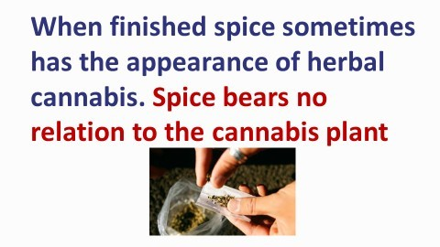

WORKSHEET 2: SENSATIONS, EFFECTS AND SAFETY

‘Spice has the physical addictive qualities of heroin and the
psychologically addictive qualities of crack’
Robert Ralphs, senior lecturer in criminology at the Manchester Metropolitan University and an expert on the drug.

Using Spice: Spice has been linked to increase in violence, hallucinations, anxiety and psychotic episodes-often resulting in the development or worsening of mental health problems or even death. Remember the risks-is it worth it?

Synthetic cannabinoids (spice) bears no relation to the cannabis plant. It is sometimes misleadingly called ‘synthetic marijuana’ or ‘fake weed’, and they are often marketed as ‘safe’, legal alternatives to that drug. In fact, their actual effects can be unpredictable and, in some cases, severe or even life-threatening.
Additionally, there are many chemicals that remain unidentified in products sold as Spice and it is therefore not clear how they may affect the user. Different mixtures come with different side effects, spice users have withdrawal and addiction symptoms. Most of them report ‘feeling obliged’ to smoke spice if they have it nearby, and other may go as far as craving for it just like with ‘harder drugs’.

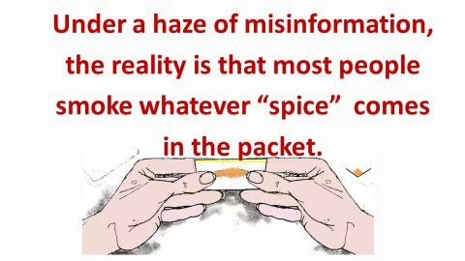

Mental effects on people using Spice are many and various with symptoms of….

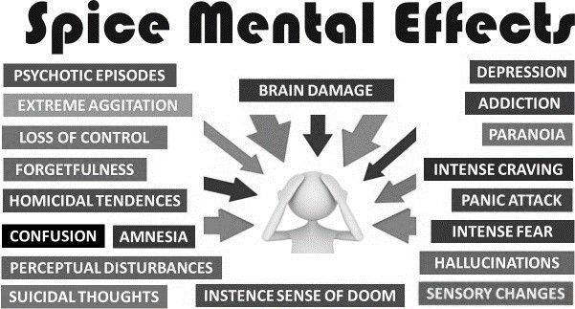

Spice can, and does, kill. Most spice-related deaths are abrupt, a minority occur after being admitted in hospital, for example after a coma.

The physical effects on people using Spice are many and various with symptoms of….

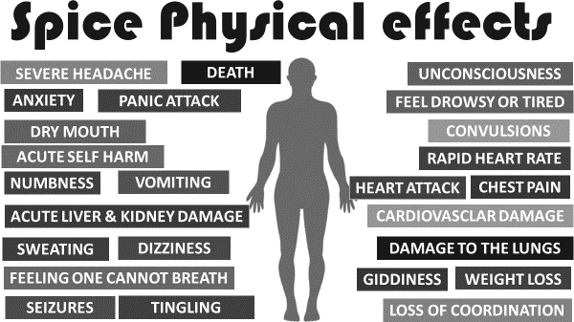

WORKSHEET 3: YOU AND YOUR SPICE USE

- When did you start using spice?

- What made you start using it?

- How often do you use spice?

- How much do you spend on it per week?

- How have you managed to handle your finances whilst using Spice?

- Will you carry on smoking Spice? Is so why?

- What support would you need to cut down/stop using Spice?

Food for thought

Spice attack. This may include people vomiting, screaming, and being unable to function. Just because it hasn’t happened to you yet doesn’t mean it won’t ever. You may also think this happens to others and not yourself because ‘you know how to dose it’…just because you know how to walk doesn’t mean you never trip. Also remember, with Spice you don’t know what you’re smoking for sure. Every batch is different. Think of the image you portray yourself as before you smoke. It may put you in a vulnerable position. Remember spice is addictive so even if you do not have side effects at first, they may develop later.

WORKSHEET 4: Different types of drug users’

People use drugs for different reasons in different situations. The following explanations may be helpful in understanding why you may use drugs.

  - Experimentation – people take a drug because they are curious aboutwhat the effects feel like.

  - Recreational drugs – people use this term when they take drugs for pleasure, or in a social setting such as a party or a club.

  - Problem drug use – this is when using drugs has a harmful effect ona persons life. They may feel like they need to use a certain drug to cope with their life. Using in this way is likely to have a negative effect on relationships, finances, health and staying on the right side of the law.

Can you relate to one of the above statements, if so which of the above describes you and why?

Do you think you are, have been or will develop a problem using Spice?

What would be the biggest challenges to stop?

WORKSHEET 5: YOU AND YOUR LIFE

How do you think Spice has affected . . . . . .

- Your sleep?

- Your social life?

- Your mental health?

- Your physical health?

- Your family life?

- Any other aspects of your life? Please state and give reasons.

WORKSHEET 6: YOUR DRUG USE

- How have you funded your Spice use in the past?

- Have you had any periods when you have not used Spice? If yes, for howlong and what stopped you from using?

- Have you noticed a difference in the way you smoke from the first time you tried and now?

WORKSHEET 7: EFFECTS ON YOU

Does Spice make you feel…

Better about yourself and your life? Please explain how.

Worse about yourself and your life? Please explain how.

More confident about yourself and your life? Please explain how.

More relaxed about yourself and your life? Please explain how.

Do you think there is a link between spice use and your behaviour? Please explain your answer.

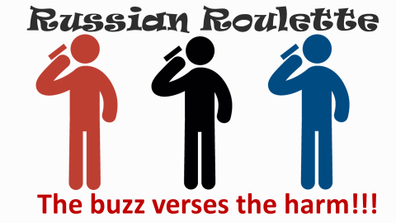

WORKSHEET 8: THE LEGAL STUFF

  - The Psychoactive Substances Act [PSA], became law on May 26th 2016.
  - A large number of the chemicals in spice and any mixtures that contain these including Black Mamba and Annihilation,are Class B drugs and are illegal to have, give away or sell.
  - The possession and supply of Spice in prisons criminal offences, with maximum sentences up to two and seven years and/or an unlimited fine.
  - The availability of improved testing for Spice increases the likelihood of testing positive for Spice use and, thereby, suffering the Criminal Justice consequences of a positive test.

‘It’s awful to come off it — you rattle, I’ve tried to get off it, but it’s harder than gear’

WORKSHEET 9: HARM MINIMISATION
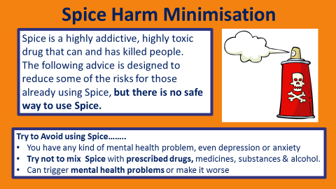

.
Tips for a friends/family

If someone’s having a bad time
If they start to panic and breathe fast, sit with them and reassure them they’ll soon be OK.
- Get them to breathe deeply and slowly.
- Give them sips of water (nothing else). NO Sweets ( They could choke and die)
- Try not to leave them alone
and get medical help.
- Try not to let them fall asleep or
lose consciousness.
If you are going to smoke.
DANGER IN THE DOSE
Test dosing: taking a very small amount

Sit down before you use. In case you fall over.
Test dosing: ALL YOU NEED IS A SIZE OF A MATCH STICK
HEAD OR A PINCH and wait an adequate amount of time before re-dosing.
Ideally Wait 2 hours before re- dosing

Spice should not be smoked neat
With white powder DO NOT sniff like a line-it is a
PURE CHEMICAL, again a
PINCH like above.

.
If someone is unconscious: there’s always the risk of death.
DON’T LEAVE THEM UNATTENDED
Lay the person on the floor in the ‘recovery position’.
This means:
- Rolling them onto their side.
- The person should not be on their back, this can kill.
- Check their mouth is empty. Tilt their head back slightly and lift chin back to open their airway.
- So that their head has something to rest on, take the arm they’re not lying on and place it under their cheek. Don’t put a pillow under their head.
- Take the leg that’s not being rested on and bend it up towards their chest at a right angle.
- Check to see how their breathing is. Don’t give them anything to drink
  - Call for HELP

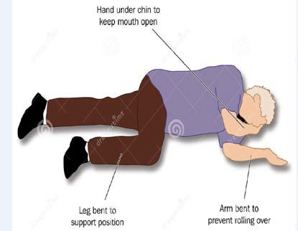
See below – The recovery position

Specialist support services are available to help with problems with drinking or drugs. You can access non-judgemental advice and information about how to keep safe and discuss potential treatment and support options.
Speak to the hotel staff who can help put you in touch with a local service.

