Homeless Hotels Drug and Alcohol Support Service
(HDAS-London)

Activity Pack 2

Activity Pack for completion on your own or with support.
Speak to your hotel worker if you feel you may need support with this workbook. They will be able to advise on the best person to help.

This activity pack belongs to: _____________________________________________

These workbooks have been provided by partner agencies as part of the HDAS service.

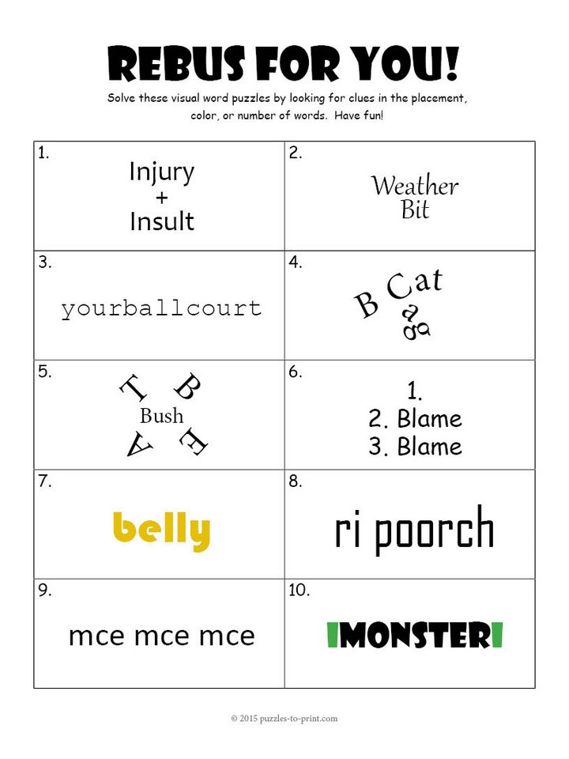

MAZE
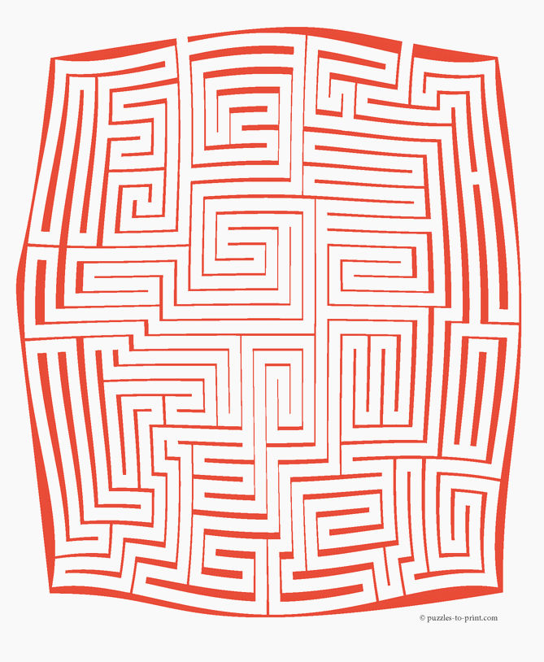
SUDOKU
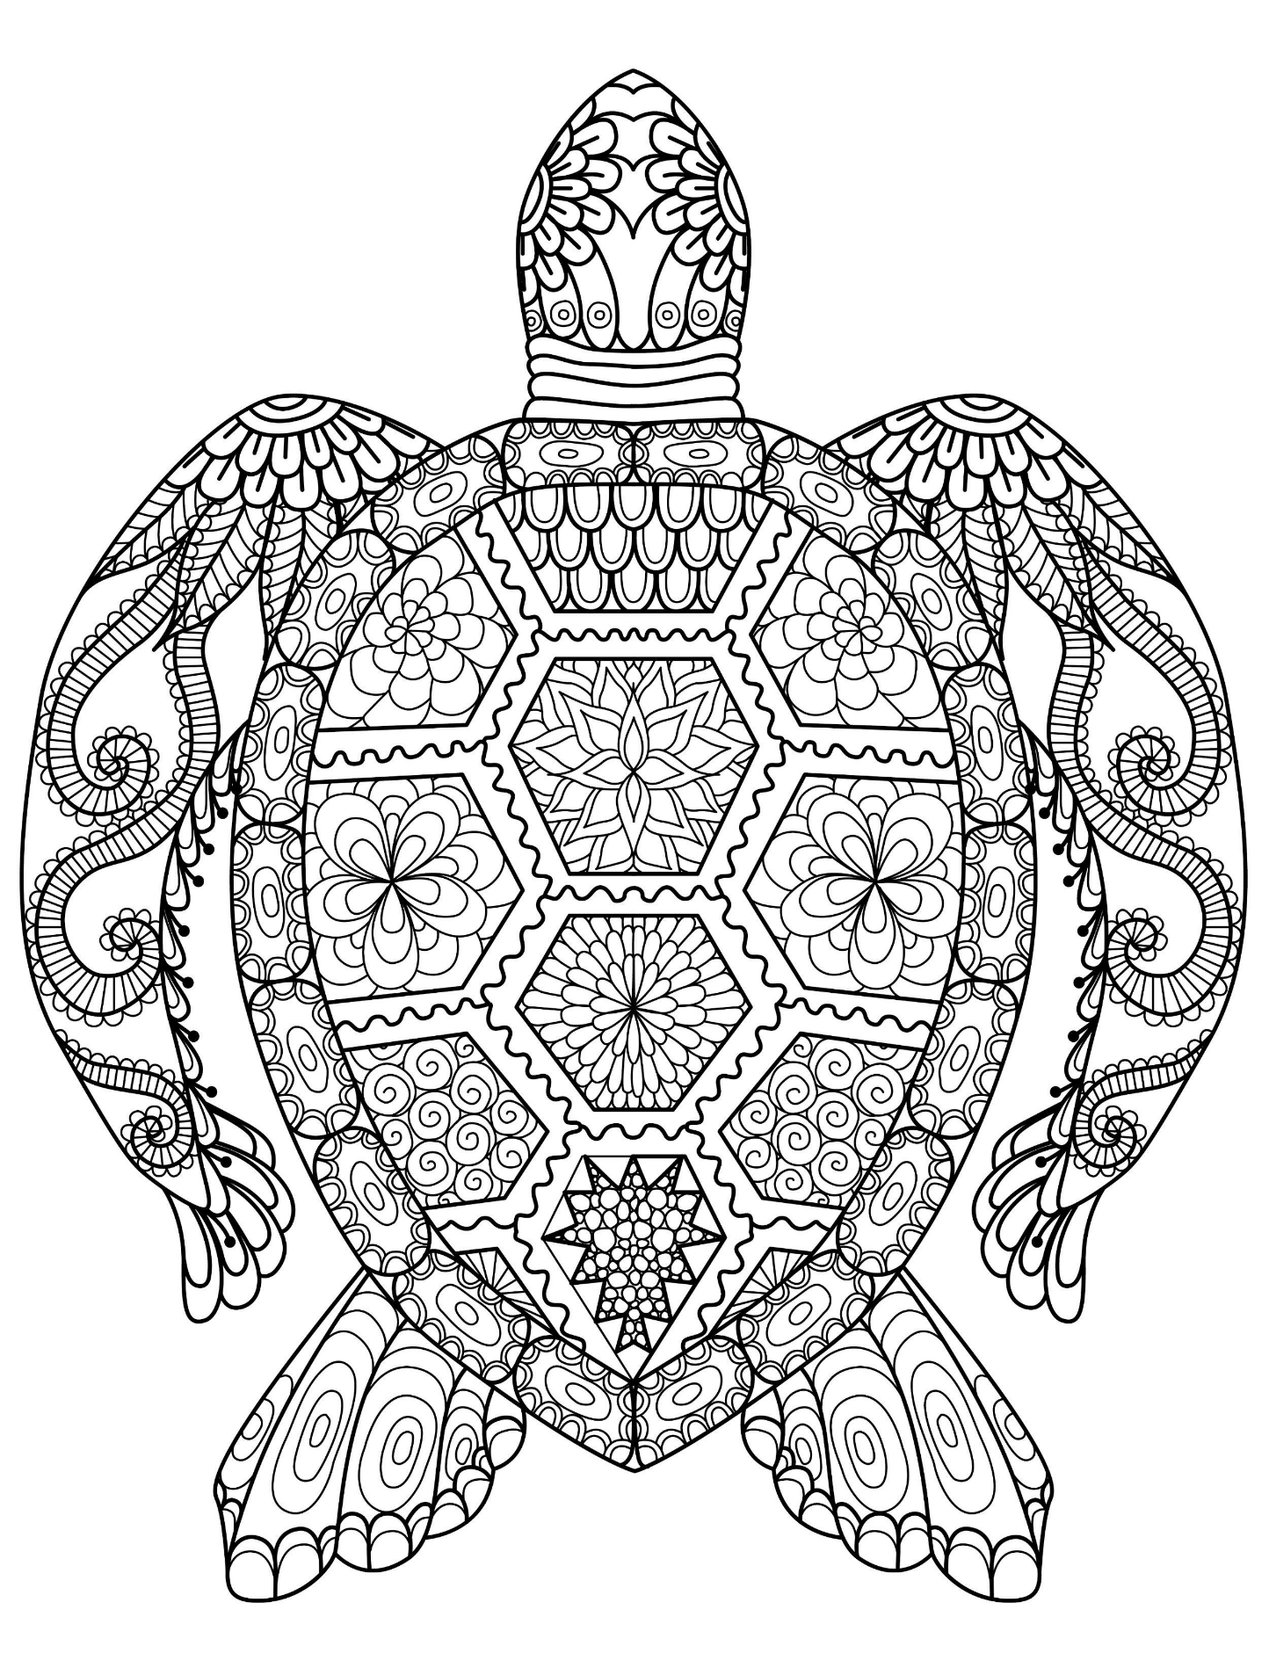
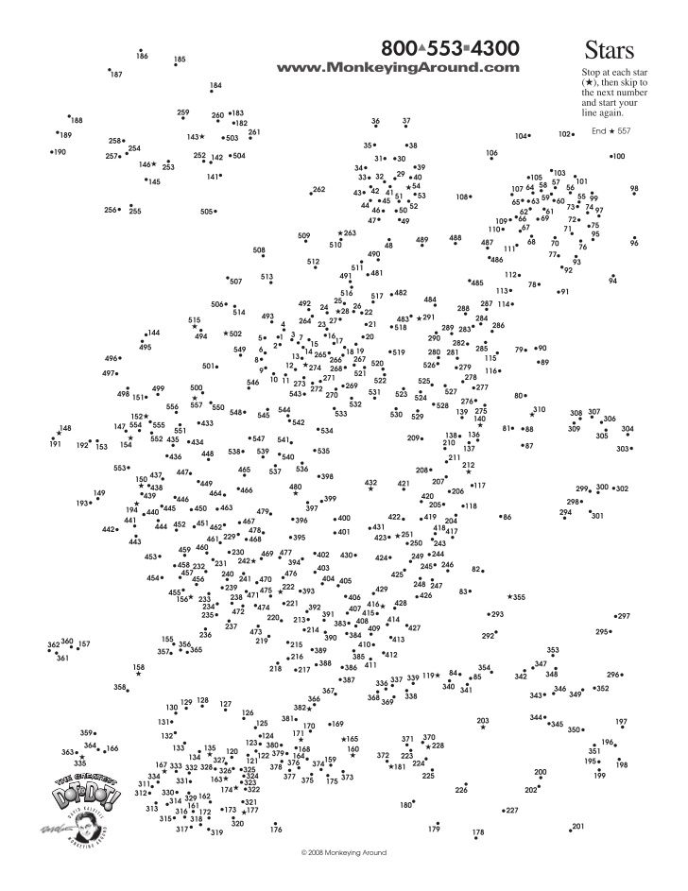

Arithmagon

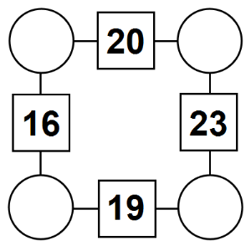
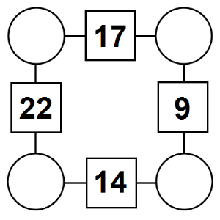
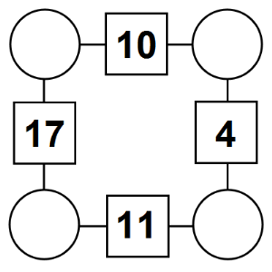
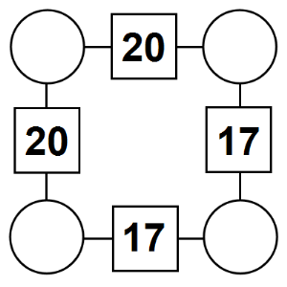
The aim is to work out which numbers go in the empty circles.
The numbers in the square boxes are made by adding together the numbers in the circles either side. For example, if the number in the square box was 10 you could try 6 and 4, but the numbers must also add up on the other edges, making this more difficult than it first appears.
CROSSWORD

1 |  | 2 |  | 3 |  | 4 |  | 5
 |  | 6
7 | 8 |  |  |  |  | 9 | 10
 |  |  | 11 |  | 12
13 |  |  |  |  | 14
 |  |  | 15 | 16
17 |  | 18 |  |  |  | 19 |  | 20
 |  | 21
22 |  |  |  |  |  | 23

Across  1. Bring up the rear  4. Pea soup weather  6. Heavenly being  7. Slippery fish  9. Affirmative  11. Yes vote  13. Stride  14. Pinnacle  15. Eastern Standard Time  17. Sample  19. School gp.  21. Marry in haste  22. Convent resident  23. Slinky or doll, e.g. | Down  1. Fib  2. A girl  3. Unattractive  4. Take flight  5. Helium or neon  8. Go into  10. Notable occurrence  11. Orangutan, e.g.  12. Nosh  16. Sluggish  17. A heavy weight  18. Craving  19. Household critter  20. Whatever amount

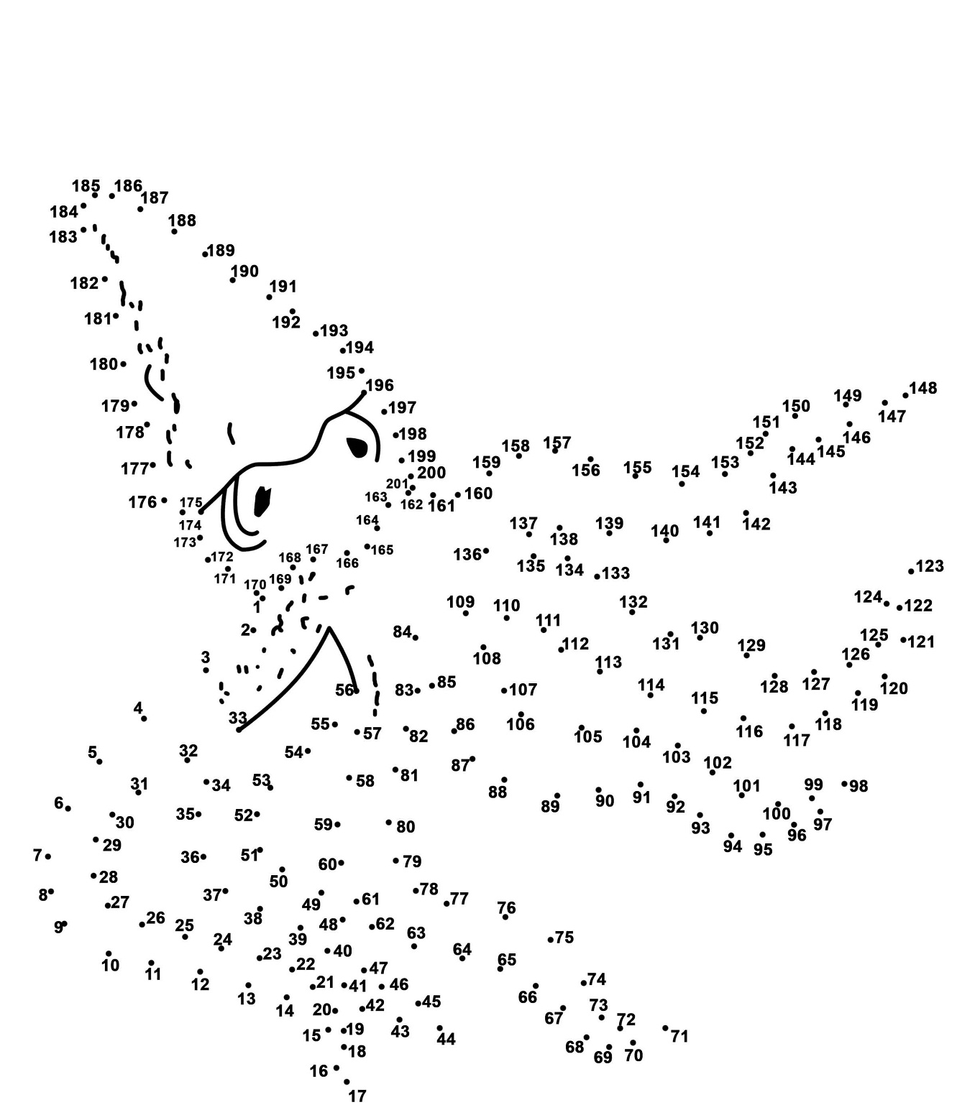
DOT TO DOT
MAZE
SUDOKU
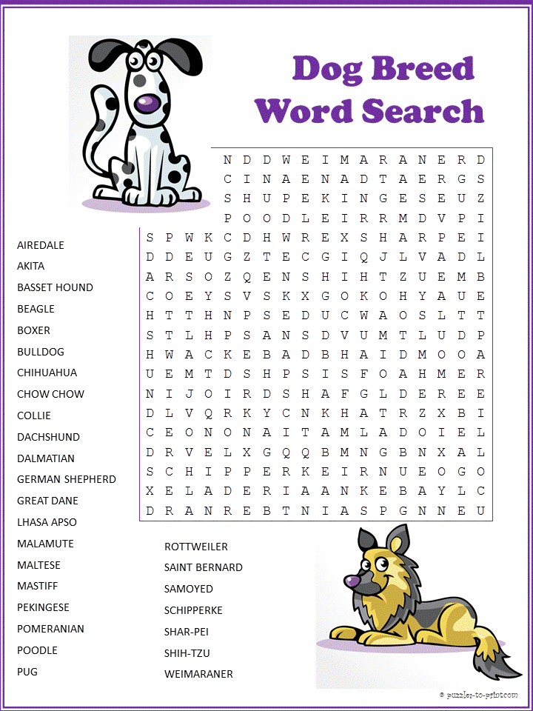

CROSSWORD

Across  1. Worn on the head  4. Italian wine city  8. "Get outta here!"  12. Half: Prefix  13. Avenue or boulevard  14. Bank caper  16. Spoken  17. Calm  18. City on the Rhone  19. Wt. units  20. Talent for music  21. Calendar pg.  23. Vane dir.  24. Written report  26. Make do  28. Bumped into  30. "__-ching!"  32. Table supports  36. Edible seaweed  39. Proficient  41. Flames  42. Seventh Greek letter  43. Saloon fight  45. Actress __ Dawn Chong  46. Apiece  48. Tolstoy's Karenina  49. Department store sign  50. An entreaty  51. Writing liquid  52. Graphy or logy prefix  54. Doctor (slang)  56. Likeness  60. Long period of time  63. Commandments number  65. Texting abbr. for oversharing  67. Morsel  68. Depleted  70. Niagra river source  72. Spoiled kid  73. Fixed gaze  74. Departed  75. Italian mount  76. Our sun is one  77. Eyelid infection  78. Father | 1 2 3 4 5 6 7 8 9 10 11  12 13 14 15  16 17 18  19 20 21 22 23  24 25 26 27  28 29 30 31 32 33 34 35  36 37 38 39 40 41  42 43 44 45  46 47 48 49  50 51 52 53  54 55 56 57 58 59  60 61 62 63 64 65 66 67  68 69 70 71 72  73 74 75  76 77 78  Down 1. Rosemary and thyme 2. Accumulate 3. "Shop __ you drop" 4. Specialty 5. Fly high 6. Profs' aides 7. New thought 8. Ocean predator 9. That lady 10. Lubricates 11. Sugar suffixes 12. Food fish 15. Philosopher Lao-___ 20. See with it 22. Small round veggie 25. Hi-fi component 27. Santa's helper 29. Computer key, near Caps Lock 30. Sword-on-armor sound 31. Chopped down 33. Emerald isle 34. Mom's mom, for short 35. Notices 36. Hold on to 37. List ending abbr. 38. Frilly fabric 40. Cereal grain 44. Chem room 47. Owned 49. May honoree 51. Frozen water 53. Clock numeral 55. Web-footed mammal 57. Main heart artery 58. Kind of piano 59. Blues singer James 60. Double curved letter 61. Makes a choice 62. Tidy 64. Recent information 65. Very small 66. Dole out 69. Gun lobby grp. 71. Not in workforce anymore (abbr.) 72. Garden spot

This pack has been produced by the Homeless Hotels Drug and Alcohol Support Service. If you want to speak to someone about your drug or alcohol use at this time, speak to the hotel staff who can help put you in touch with specialist services.

