**Homeless Hotels Drug and Alcohol Support Service**

**(HDAS-London)**

**Activity Pack 1**

*Activity Pack for completion on your own or with support.*

*Speak to your hotel worker if you feel you may need support with this workbook. They will be able to advise on the best person to help.*

**

*This activity pack belongs to: _____________________________________________*

*These workbooks have been provided by partner agencies as part of the HDAS service.*

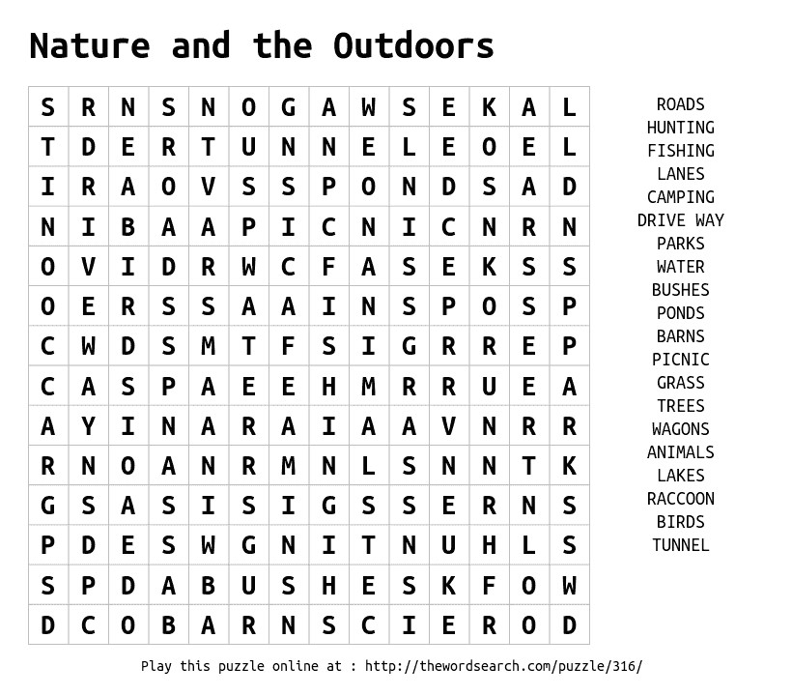© thewordsearch.com

MAZE

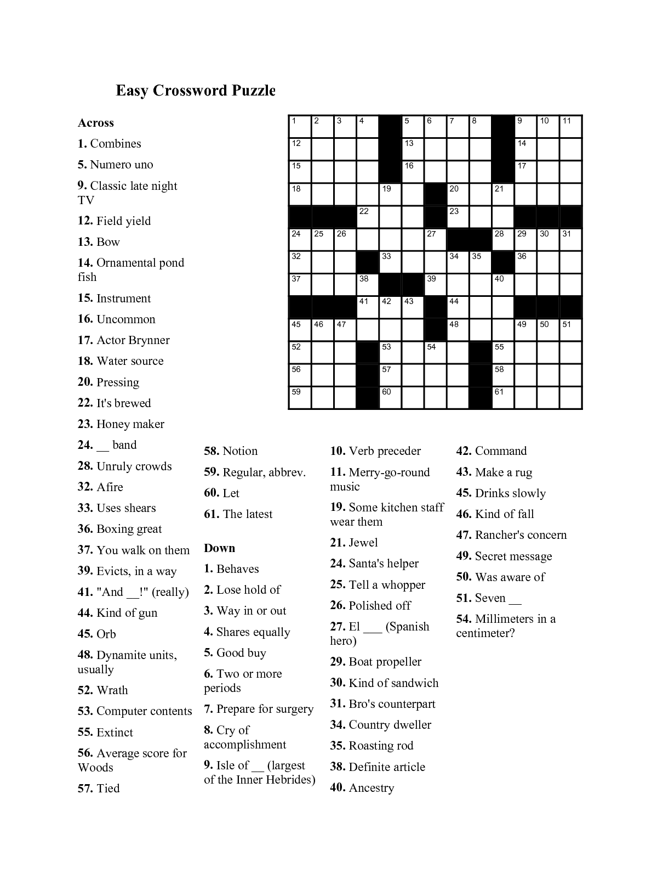CROSSWORD

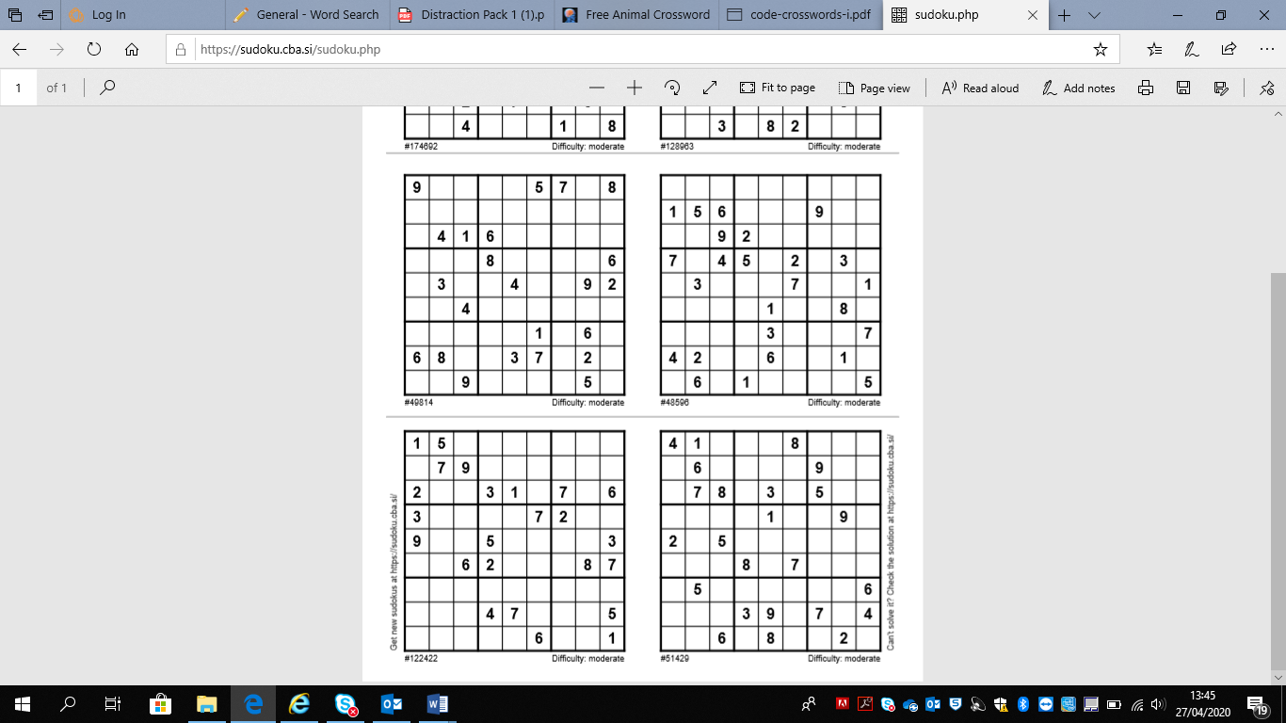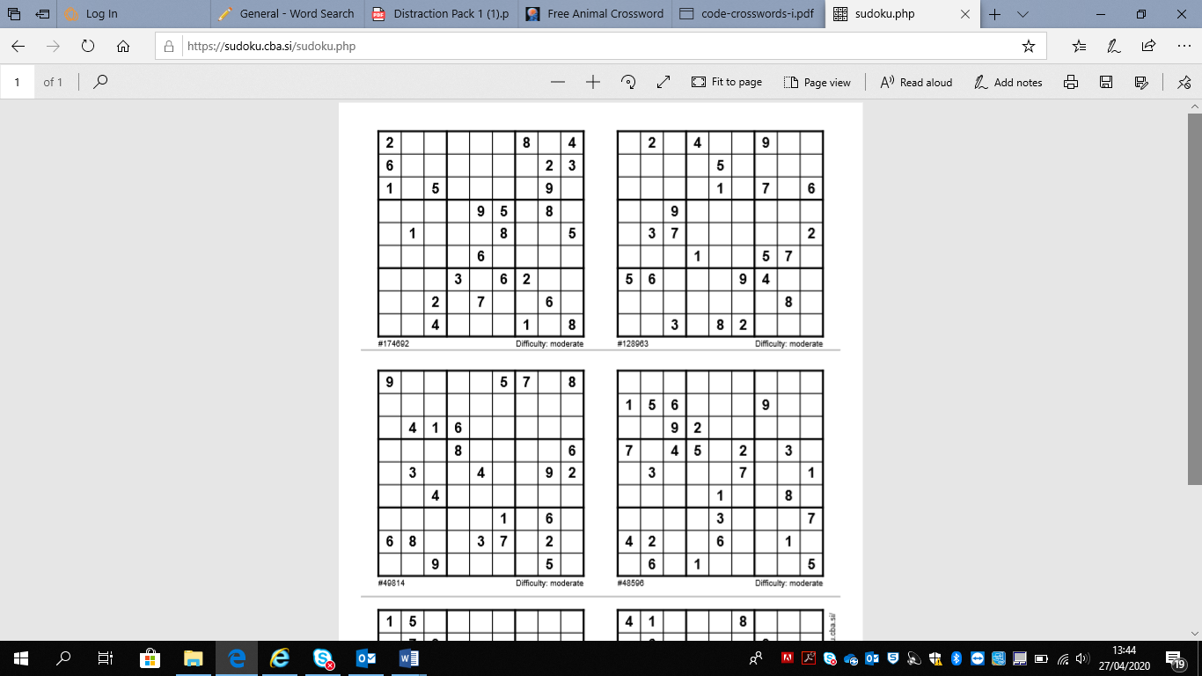SUDOKU

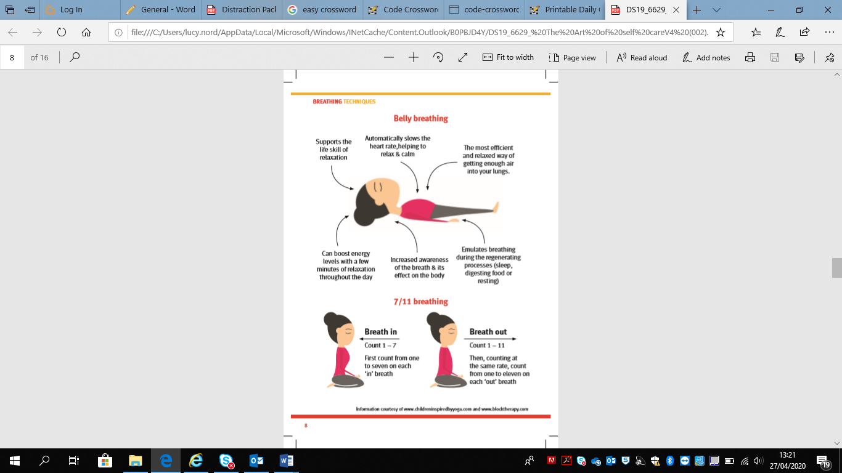

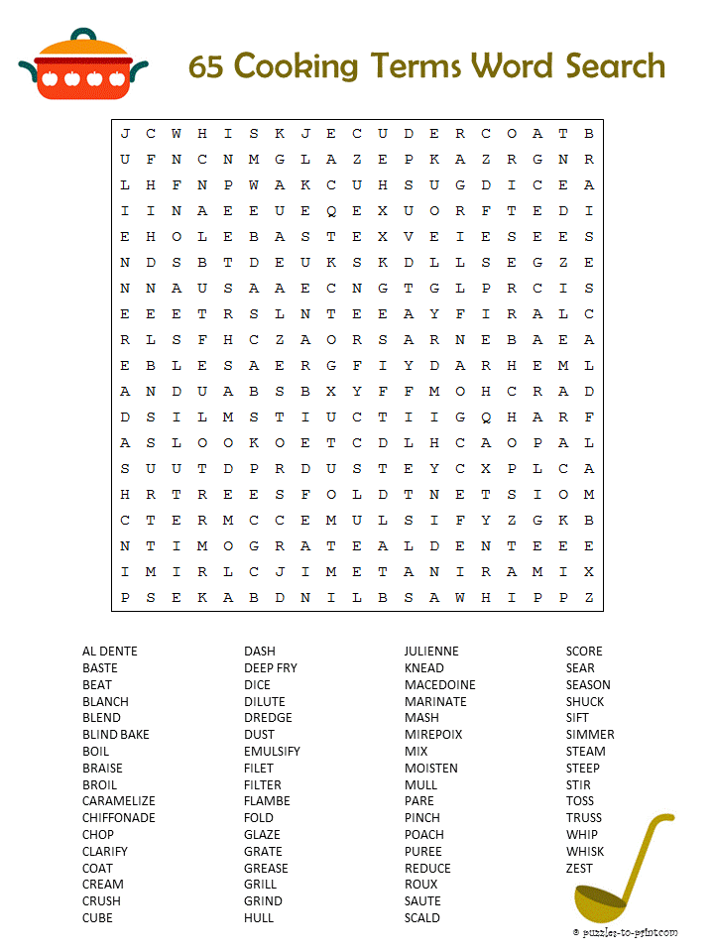

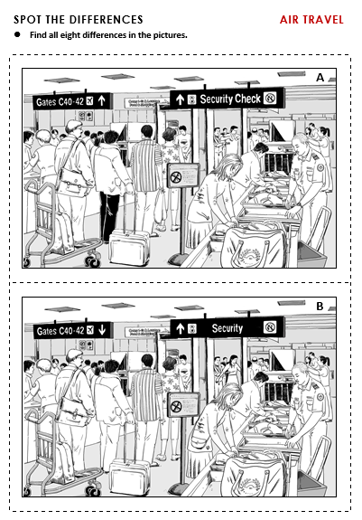

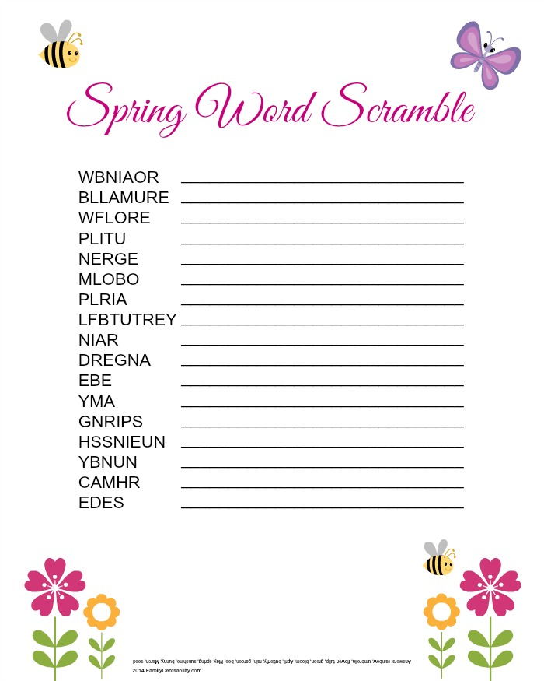[](https://www.google.com/url?sa=i&url=http%3A%2F%2Fsoftspotbar.com%2Fcoloring-for-teens%2Fcoloring-pages-coloring-book-wild-animal-for-adults-and-free-3%2F&psig=AOvVaw10qQ5nblcii-Ltb23ZgKX8&ust=1588080082348000&source=images&cd=vfe&ved=0CAIQjRxqFwoTCJjtl7zZiOkCFQAAAAAdAAAAABAa)

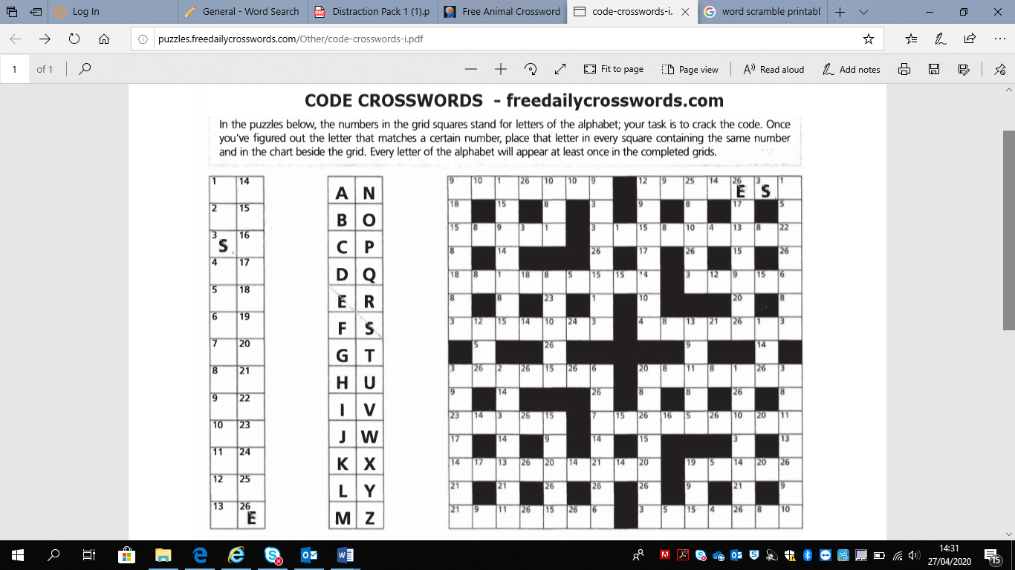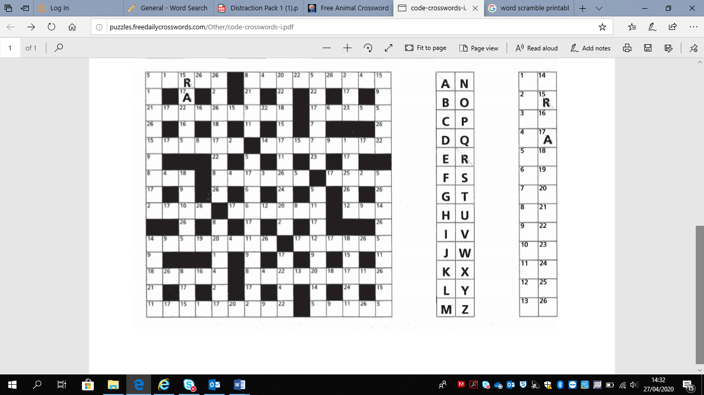

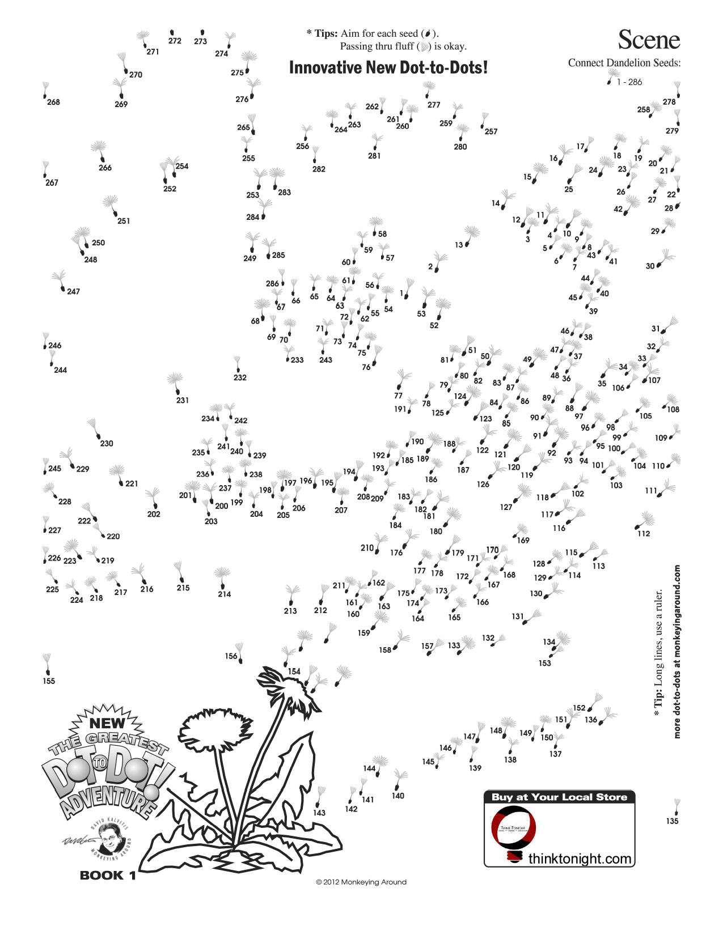  
MAZE

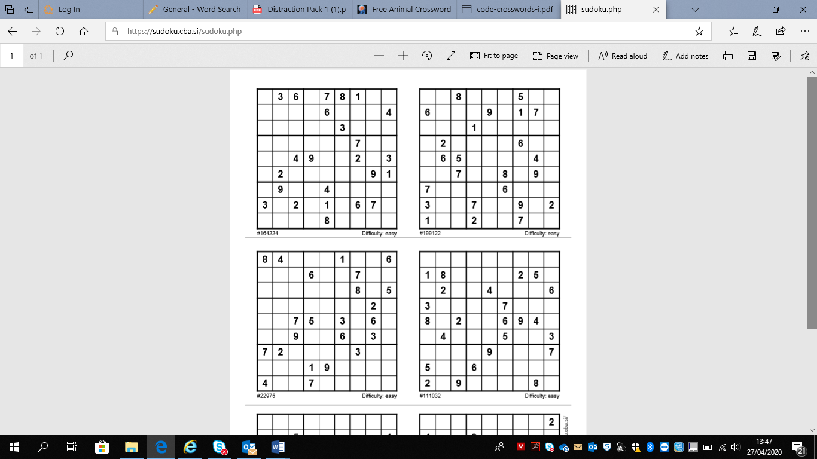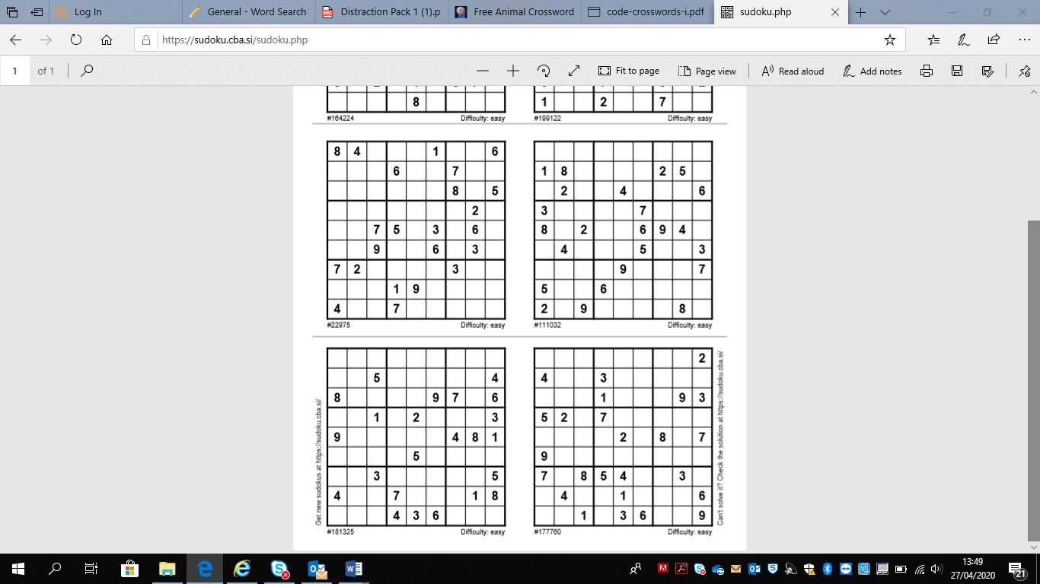SUDOKU



*This pack has been produced by the Homeless Hotels Drug and Alcohol Support Service. If you want to speak to someone about your drug or alcohol use at this time, speak to the hotel staff who can help put you in touch with specialist services.*