Homeless Hotels Drug and Alcohol Support Service
(HDAS-London)

Cocaine and Crack Workbook

Cocaine and Crack recovery workbook for completion on your own or with support.
Speak to your hotel worker if you feel you may need support with this workbook. They will be able to advise on the best person to help.

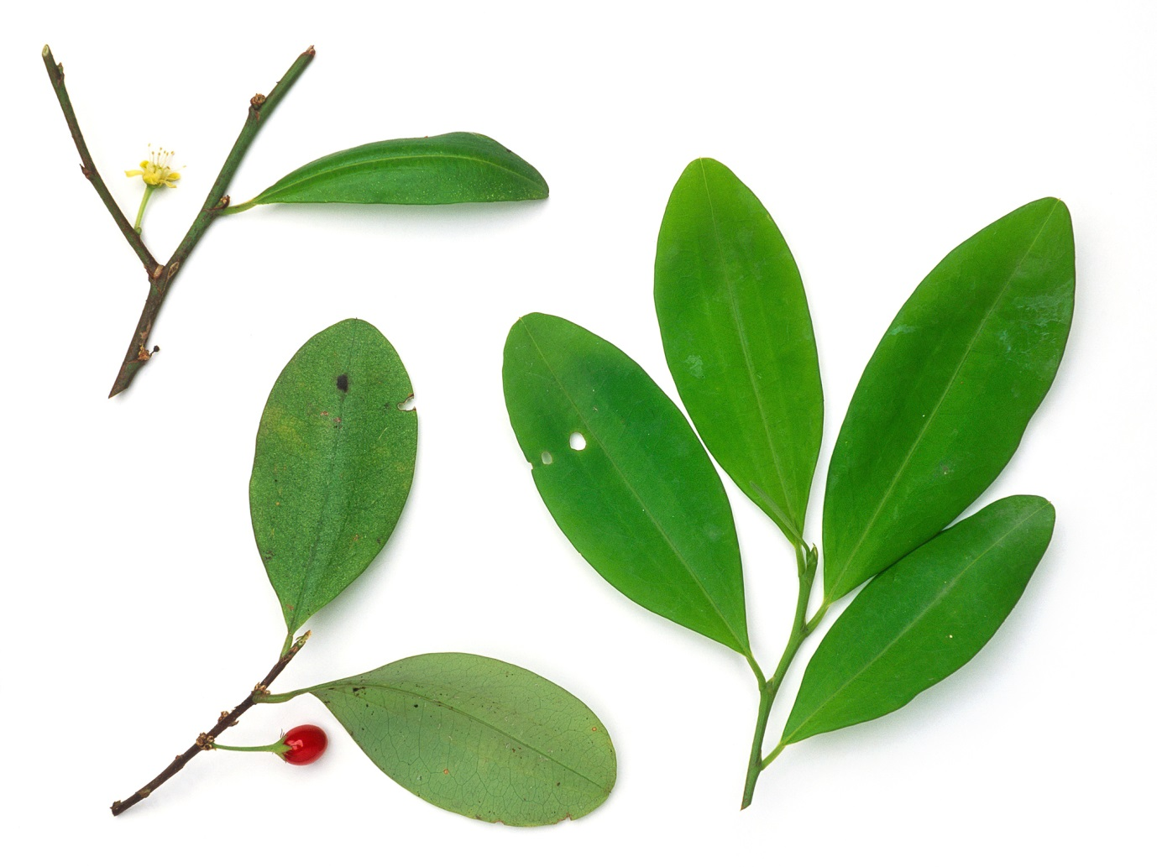
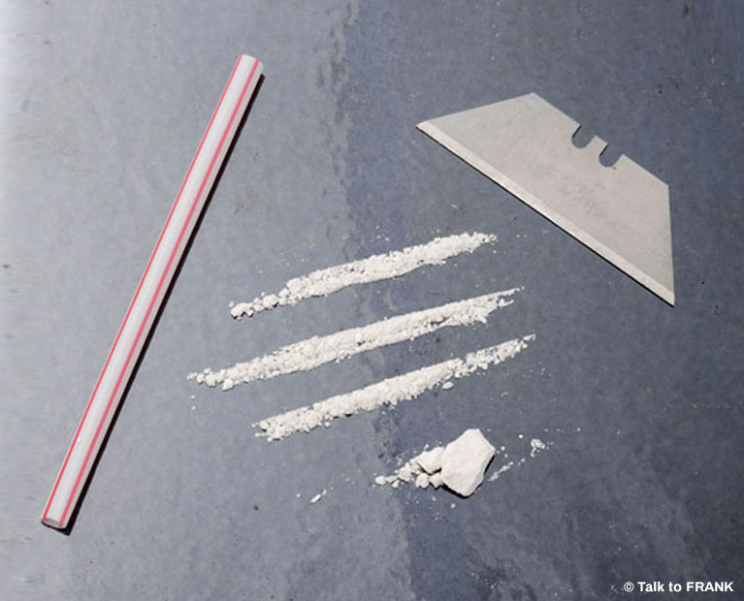

This workbook belongs to: _____________________________________________

These workbooks have been provided by partner agencies as part of the HDAS service.

INTRODUCTION

This is a workbook for you to work through. Please take time to work through this pack and be as honest as possible. If you would like to talk through this workbook please ask a hotel worker to get in touch with HDAS who can support you to access support from a local drug and alcohol service.

CONTENTS

Worksheet 1 | What is cocaine, crack and freebase?
Worksheet 2 | How is it used?
Worksheet 3 | The law – true or false
Worksheet 4 | Crack / Cocaine and you
Worksheet 5 | How it works
Worksheet 6 | The first natural chemical affected - adrenaline
Worksheet 7 | The second and third natural chemicals affected: Serotonin and Dopamine
Worksheet 8 | Adrenaline and Dopamine
Worksheet 9 | Continued use
Worksheet 10 | Effects on health
Worksheet 11 | Consequences of use
Worksheet 12  Worksheet 13  Worksheet 14 | Cycle Of Use  The Ladder of Change  Change Plan Sheet

WORKSHEET 1: WHAT IS COCAINE, CRACK AND FREEBASE?

COCAINE:
Cocaine is derived from the Coca Leaf found in certain parts of South America. Cocaine hydrochloride is also known as snow, charlie, powder and coke.

FREEBASE:
Freebase is cocaine hydrochloride that has been chemically treated with ammonia to ‘free’ the potent ‘base’ material from the salt. This process produces crystallised pieces of cocaine like rock salts. These rocks can be smoked in a pipe or in a spliff.

CRACK:
Crack and freebase are more or less the same thing. The difference is that ammonia is used for freebase, and baking soda is used for crack. This is cooked in a microwave thus mass production and distribution. Crack crystals are larger than freebase crystals.
Cocaine is put through a boiling down process called washing, using either ammonia or bicarbonate of soda. This formulates a crystallised rock like substance known as crack. The rock is then broken down in amounts typically to the value of £20 to £25.

Crack derives its name from the crackling sound it makes when being smoked. This is due to the sodium chloride (table salt) being left in the base when baking soda is used in the washing process.

Which types of cocaine have you used?

____________________________________________________________________________________________________________________________________________________________________________________________________________________________________________________________________________________________________________________________________________________________

Why did you first start to use it?

____________________________________________________________________________________________________________________________________________________________________________________________________________________________________________________________________________________________________________________________________________________

Why do you then continue to use it?

____________________________________________________________________________________________________________________________________________________________________________________________________________________________________________________________________________________________________________________________________________________

WORKSHEET 2: HOW IS IT USED?
SNIFF IT
Cocaine is chopped up finely and drawn into two inch long lines and sniffed up one nostril at a time using various tools, e.g. straw, note etc.
Sniffing drugs increases the risk of:
- Contracting blood born viruses (BBV’s) such as HIV and Hepatitis C through sharing or using dirty equipment
- Damage to your nose
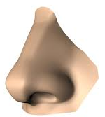

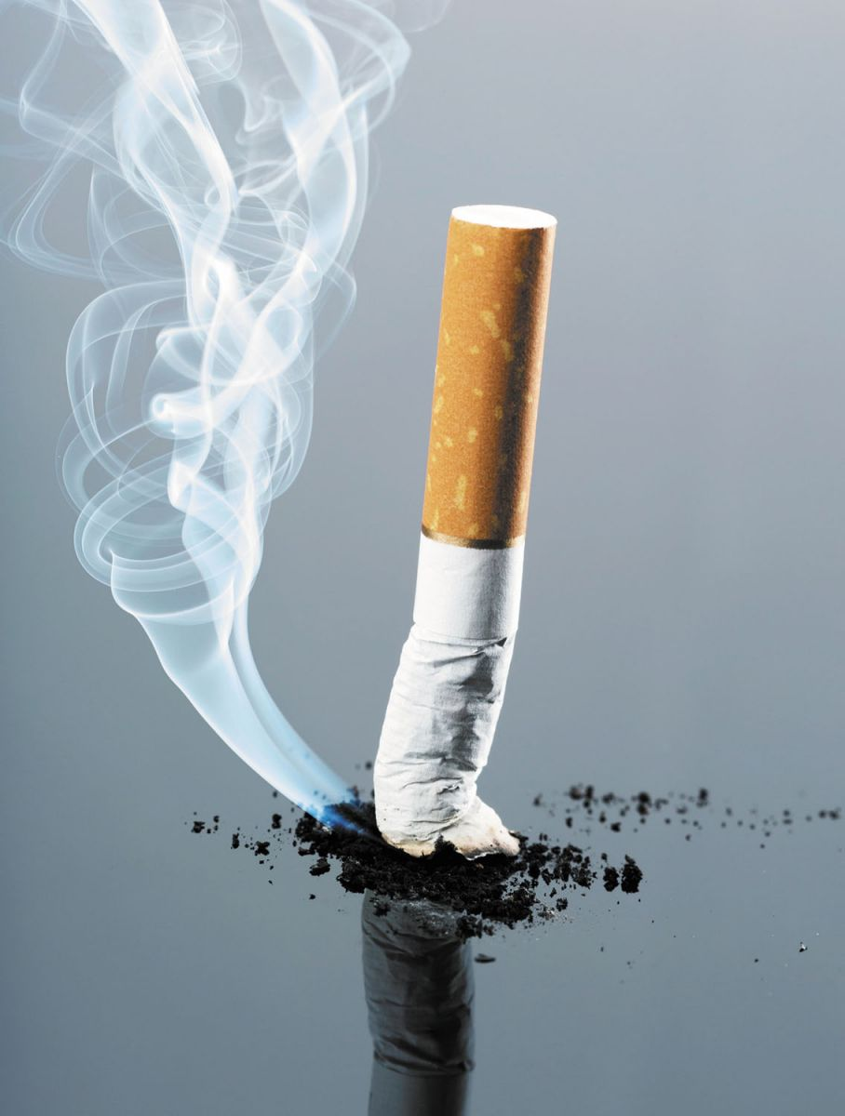

SMOKING IT

It is smoked from pipes, often made from a soft drinks can or other fashioned like containers. It can also be mixed with cannabis or tobacco in a spliff / joint, or burnt on a piece of tin foil.

In the interest of harm reduction it is advisable not to use tin foil or cans, etc. because of aluminium poisoning hence, the usage of Kit-Kat foil is common amongst users.
Smoking drugs increases the risk of:
- Irritation and damage to the lungs
- Contracting BBV’s through sharing or using dirty equipment

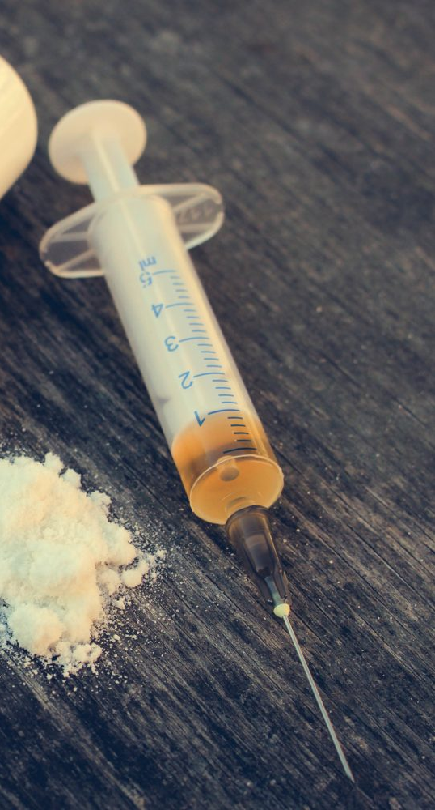

INJECTING IT

Because of its insolubility in water, freebase/crack cannot be sniffed or satisfactorily injected (unless treated) by the adding of an acid such as vitamin C, or more dangerously by heating the crack in water or alcohol. This forms a viscous substance which blocks the gauge of the needle.The characteristics of injecting crack are the increased incidence of abscesses and damage to veins and the surrounding tissue.

Injecting drugs increases the risk of:
- Contracting BBV’s through sharing or using dirty equipment
- Deep vein thrombosis (DVT)- blood clots in the veins
- Abscesses

Which method do you use and why do you choose to use this method?

________________________________________________________________________________________________________________________________________________________________________________________________________________________________________________________________________________________________________________________________________________________________________________________

Does your using put your health at risk? If so, how?

________________________________________________________________________________________________________________________________________________________________________________________________________________________________________________________________________________________________________________________________________________________________________________________

WORKSHEET 3: THE LAW – TRUE OR FALSE

CLASSIFICATION OF CRACK / COCAINE:  Crack and cocaine are class ‘B’ drugs | TRUE / FALSE
PRODUCTION OF COCAINE / CRACK:  Producing crack and cocaine is illegal | TRUE / FALSE
PERSONAL CONSUMPTION:  It is legal to possess crack / cocaine for personal use only | TRUE / FALSE
IF YOU ARE CAUGHT CARRYING:  If you are caught carrying 2 to 3 rocks you do not run the risk of being charged with possession with the intent to supply | TRUE / FALSE
IF YOU BUY CRACK:  If you buy crack for your friend and get caught you can be charged for supplying a class ‘A’ drug | TRUE / FALSE
IF YOU GIVE A LINE OR A PIPE:  You can not be charged with supplying if you get caught giving a friend a pipe or a line | TRUE / FALSE
IN YOUR HOUSE:  If you allow your friend or acquaintance to smoke or ‘wash rock’ in your house for their personal use you may still expect to face legal proceedings if you get caught | TRUE / FALSE
THE PENALTY FOR POSSESSION:  The maximum penalty for possession of crack or cocaine is 5 years | TRUE / FALSE
THE PENALTY FOR SUPPLYING:  The maximum penalty for supplying crack or cocaine is life | TRUE / FALSE

Check your answers at the back of this workbook!

WORKSHEET 4: CRACK / COCAINE AND YOU

How does cocaine/crack make you feel? Circle the ones that apply to you and add any others you would like:
Happy
Excited
Wide Awake
Confident

It can also have physical and behavioural effects. Do any one of the following happen to you? Tick them if they do:

❐ make your heart beat faster
❐ raise your body temperature – so you feel hot
❐ stop you feeling hungry
❐ make you feel sick
❐ make you need to poo
❐ make you anxious and panicky
❐ make you paranoid
❐ make you so confident that you do things you wouldn’t normally do (which might be risky)

Cocaine affects people differently, but most users become:

- chattier
- more animated
- more confident
Does this happen to you?
❐ Yes  No

Some people become:

- overconfident and arrogant
- agitated
- restless
- edgy

Does this happen to you?
❐ Yes  No

The high is usually short lived. The more you use, the highs become less and the comedown gets bigger. Is this true for you? Please explain the affects you gain from using.

_____________________________________________________________________________________________________________________________________________________________________________________________________________________________________________________________________

Have you become more prone to depression, lack of confidence, experience more mood swings and low self-esteem as your use increased? Please explain how you have changed since you started using.

_____________________________________________________________________________________________________________________________________________________________________________________________________________________________________________________________________

Does your thinking become distorted the more you use? Please explain your answer.

_____________________________________________________________________________________________________________________________________________________________________________________________________________________________________________________________________

What effects has using crack/ cocaine has had on your sleeping pattern?

_____________________________________________________________________________________________________________________________________________________________________________________________________________________________________________________________________

Crack/ cocaine may start out as a sociable drug, but can develop into a habit. Did this happen to you? If so, how did it develop to become a habit?

_____________________________________________________________________________________________________________________________________________________________________________________________________________________________________________________________________
_____________________________________________________________________________________________________________________________________________________________________________________________________________________________________________________________________

WORKSHEET 5: HOW IT WORKS

The feeling experienced from using crack/ cocaine is produced from the release of natural chemicals which are present in the human body.

It is the chemicals already present in the body which get affected by the use of crack/ cocaine that produce the feeling.

How easy do you think it was/ will be to give up crack/ cocaine? Why do you think this was/ is the case?

___________________________________________________________________________________________________________________________________________________________________________________________________________________________________________________________________________________________________________________________________________________________________________________________________________________________________________________

Did you become addicted quickly and were you surprised by this? If so, why?

___________________________________________________________________________________________________________________________________________________________________________________________________________________________________________________________________________________________________________________________________________________________________________________________________________________________________________________

WORKSHEET 6: THE FIRST NATURAL CHEMICAL AFFECTED - ADRENALINE

Adrenaline heightens your state of awareness and prepares the body for action. When you first start using crack or cocaine the release of adrenaline is triggered, which eventually comes to be known as the craving. The thought or anticipation of using crack or cocaine can begin to release adrenaline.

Your heart rate increases due to the release of adrenaline. This pumps more blood around your body in order to get more oxygen to your muscles.

Your breathing rate gets faster and becomes shallower in order to get more oxygen into your blood.

The butterflies in your stomach or that churning feeling is due to the blood leaving your stomach and being diverted to your legs where it will be needed more.

Sweating is your body’s way of cooling down, which it needs to do as you are getting hotter.

Shakes in your body or hands are due to the adrenaline in your system and muscles which have been primed and are ready to be used.

To help with the reduction of adrenaline try to relax. Nature has given you a cut-off switch and this switch is deep breathing.

Have you experienced any of these sensations? Please describe how you felt and any concerns you may have had at the time.

_____________________________________________________________________________________________________________________________________________________________________________________________________________________________________________________________________________________________________________________________________________________________________________________________________________________________________________________________________________________________________________________________________________________________________________________________________________________________________________________________________________________________________________________________________________________________________________________________________________________________________________________________________________________________________________________________________________________________________________________________
WORKSHEET 7: THE SECOND AND THIRD NATURAL CHEMICALS AFFECTED: SERATONIN AND DOPAMINE

Most people use crack or cocaine for the high or the buzz. Some people describe it as an orgasmic feeling. This is because the same areas of the brain are being stimulated.

Describe the high / buzz you get from using crack/ cocaine:

____________________________________________________________________________________________________________________________________________________________________________________________________________________________________________________________________________________________________________________________________________________________

THE CRASH

The crash that is experienced describes you coming down from the ‘high state’. Nobody likes to comedown, hence the feeling of compulsion to use again occurs in a very short period of time. You felt good but you are now left with just the after effects of the adrenaline, which are not all that pleasant.

Describe how you feel when you are coming down:
____________________________________________________________________________________________________________________________________________________________________________________________________________________________________________________________________________________________________________________________________________________________

How do you manage the coming down feelings?
____________________________________________________________________________________________________________________________________________________________________________________________________________________________________________________________________________________________________________________________________________________________

Usually the first hit you have or the one at the beginning of a binge is the strongest and gives the biggest buzz. This is because the use of the crack or cocaine also releases serotonin which blocks the dopamine after it has been released.

Have any of your subsequent buzzes ever been as good as the first?
___________________________________________________________________________________________________________________________________________________________________________________________________________________________________________________________________________________________________________________________________________________________
WORKSHEET 8: ADRENALINE AND DOPAMINE

A D R E N A L I N E  INITIAL USE  ↓  - Release of initial adrenaline  - Increased heart rate  - Breathing (faster and shallower)  - Increased sweating  - Butterflies in stomach  - Shaking (particularly hands)  - Pupils dilate  - Heightened state of sexual arousal | D O P A M I N E  INITIAL USE  ↓  - Release of dopamine  - The buzz  - Orgasmic feeling  - Feeling of wellbeing  - Heightened feeling of confidence  - Increased sense of self esteem
PROLONGED USE  ↓  - High adrenaline levels in the body  - Decreased need to sleep  - Decreased need to eat  - Paranoia  - Need to use toilet before smoking  - Visual and auditory hallucinations  - Very sensitive skin  - Weight loss  - Increased sense of hearing  - Lessened state of sexual arousal | PROLONGED USE  ↓  Severe lack of dopamine  - The crash (bad comedown)  - Headaches (irritability)  - Lethargy (no interest in life)  - Mood swings  - Severe depression  - Thought distortions (suicidal thoughts)

Do you recognise or have you experienced any of these feelings?
____________________________________________________________________________________________________________________________________________________________________________________________________________________________________________________________________________________________________________________________________________________________

WORKSHEET 9: CONTINUED USE

Continued or long term use can severely deplete your levels of dopamine. Low dopamine levels can make you feel depressed and even suicidal. The inability to find pleasure in everyday things can lead to lethargy (can’t be bothered feeling) and reinforces the desire to use, so you can experience pleasure of some sort in your daily life.

The feelings of depression can stay with you for some time after you have stopped using, as it takes time for your natural levels of dopamine to return again (between 6 to 12 weeks). Low feelings can last for weeks or even months after you last used. There is no easy way around this or an instant solution, but there are things you can do to help build your levels back up again and help cope with those feelings. You need to find things that work for you but could include exercise, listening to music, getting a good sleep pattern, eating well and relaxation activities such as meditation.

How long have you been using cocaine / crack for?

____________________________________________________________________________________________________________________________________________________________________________________________________________________________________________________________________________________________________________________________________________________________

Have you experienced depression due to continued use of crack / cocaine?

____________________________________________________________________________________________________________________________________________________________________________________________________________________________________________________________________________________________________________________________________________________________

How do you cope when you experience depression?

____________________________________________________________________________________________________________________________________________________________________________________________________________________________________________________________________________________________________________________________________________________________

Have you ever experienced a drug induced psychosis? If so how did you feel?

____________________________________________________________________________________________________________________________________________________________________________________________________________________________________________________________________________________________________________________________________________________________

WORKSHEET 10: EFFECTS ON HEALTH

HEART PROBLEMS:  High blood pressure, irregular heart contractions, chest pains and poor oxygenated blood, greyness of skin.  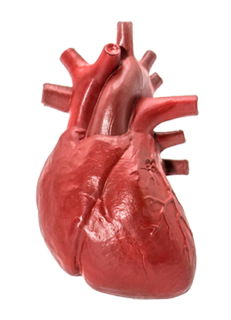 | RESPITORY PROBLEMS:  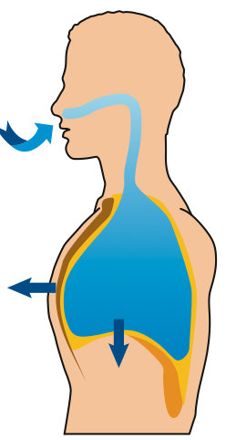  Build-up of fluids in the lungs, shortness of breath, wheezing, chest pains and coughing.
DEPRESSION:  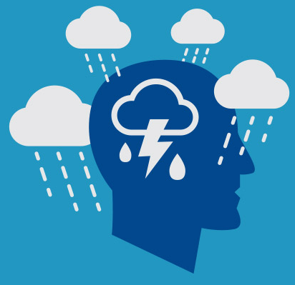  Combination of life’s problems can create the feelings of depression. This can be so strong that you may have suicidal thoughts and may even act upon these. | LIVER DAMAGE:  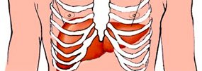  The liver is a strong organ and can repair itself, however the prolonged use of alcohol to come down from the crack can result in serious liver damage.
PREGANCY:  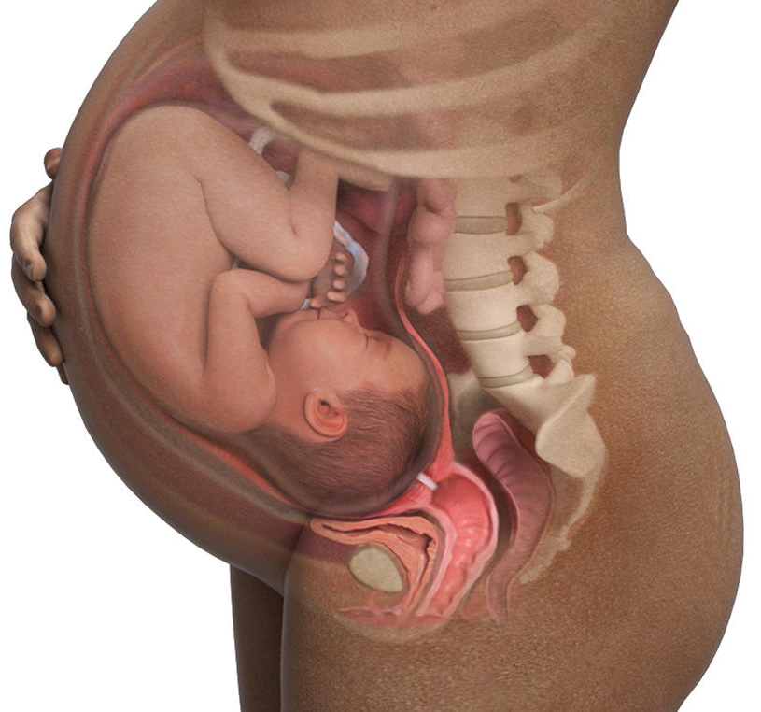  Can lead to spontaneous abortions, premature delivery, restricted blood supply. | IMMUNE SYSTEM:  Damaging of the white blood cells, ‘suppressor T cell’ which protects you from all sorts of infections. Vitamin, minerals and amino acid deficiency.  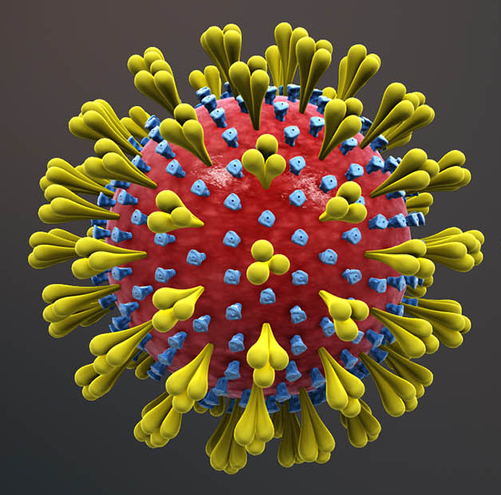
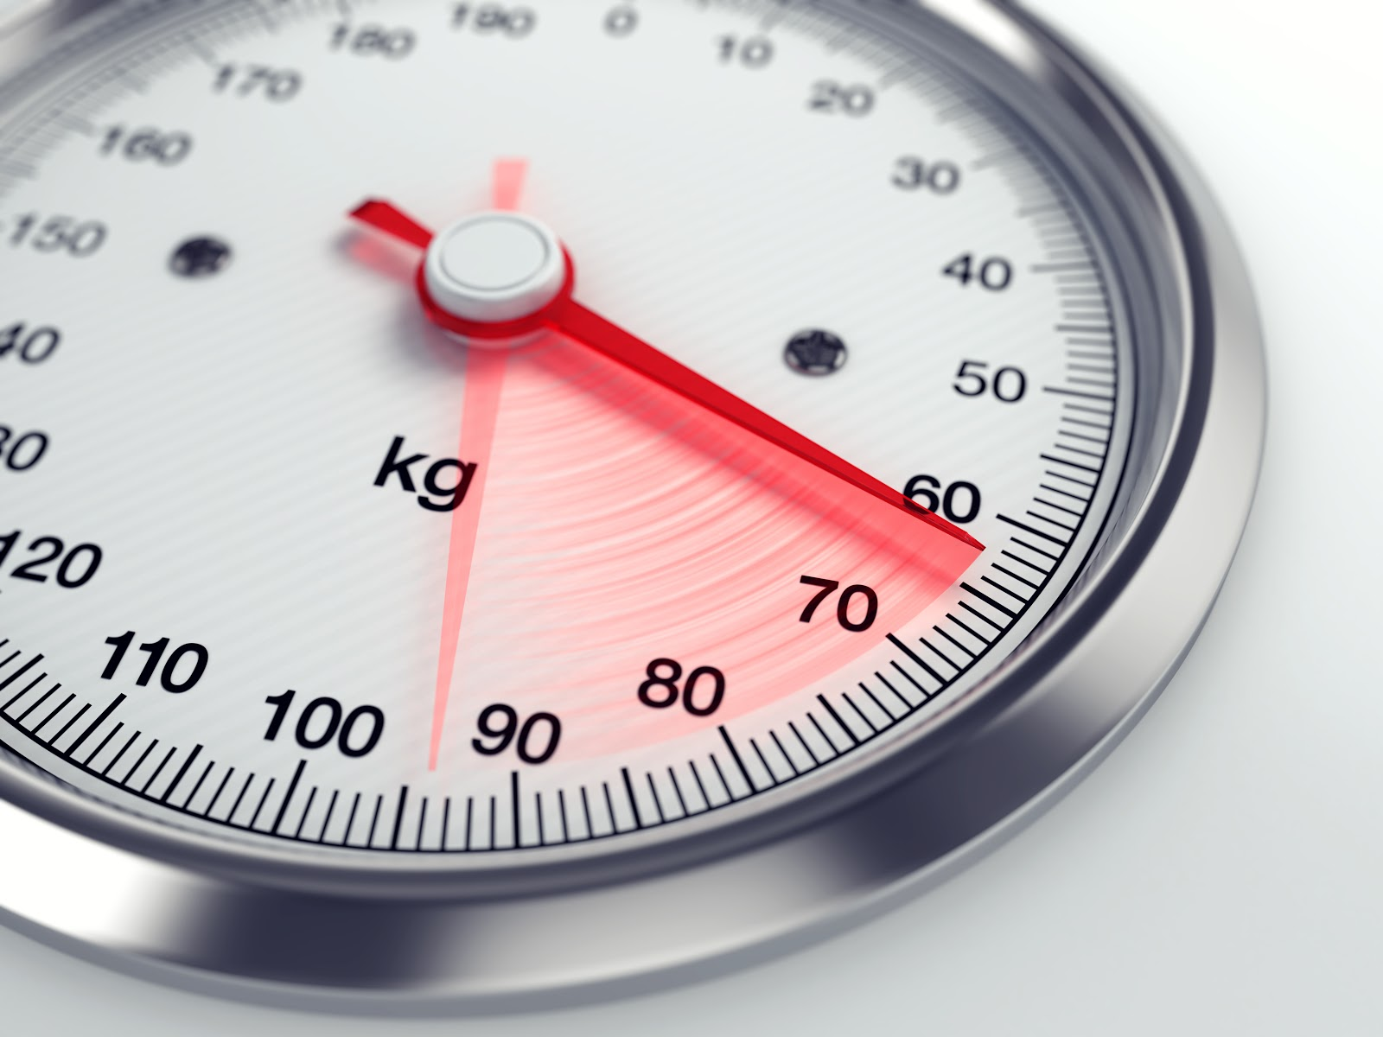  WEIGHT LOSS:  Suppression of appetite leading to a lack of nutrition intake. | PSYCHIATRIC PROBLEMS:  Induced psychosis as a result of using large amounts coupled with the experience of having high levels of stress.  
OTHER PROBLEMS:
Crack and cocaine use can also cause dehydration, headaches, physical and mental fatigue, stress, anxiety and muscle pains.

Have you experienced any of these effects due to crack / cocaine use?
_____________________________________________________________________________________________________________________________________________________________________________________________________________________________________________________________________
Have you any concerns about your health?
__________________________________________________________________________________________________________________________________________________________________

WORKSHEET 11: CONSEQUENCES OF USE

The consequences of using are usually the reason why people start thinking that they need to give up. These consequences will differ from person to person but can range from the habit taking up too much money to serious illness.

The one thing that you can be sure of is that if you use a drug like crack or cocaine for any length of time there will be consequences and that these will get worse the longer that you use.

What are the consequences of continued use of crack/ cocaine with regards to yourself?

____________________________________________________________________________________________________________________________________________________________________________________________________________________________________________________________________________________________________________________________________________________________

What are the consequences of continued use of crack/ cocaine with regards to other people?

____________________________________________________________________________________________________________________________________________________________________________________________________________________________________________________________________________________________________________________________________________________________
____________________________________________________________________________________________________________________________________________________________________________________________________________________________________________________________________________________________________________________________________________________________

What can you do to help overcome these consequences?

____________________________________________________________________________________________________________________________________________________________________________________________________________________________________________________________________________________________________________________________________________________________
____________________________________________________________________________________________________________________________________________________________________________________________________________________________________________________________________________________________________________________________________________________________

WORKSHEET 12: CYCLE OF USE

Most habits usually develop into a cycle, which is similar to a washing machine cycle (wash, rinse, spin and back to wash again). With crack and cocaine it can feel a bit like you are constantly stuck on fast spin.

1. DRUG USE:

- Using crack / cocaine
- Highs and lows experienced
- Paranoia
- The Buzz
5. THE MISSION:

- High craving
- Drug seeking
- Excitement and anticipation
- Justifications to use
- “I’ll only have the one pipe/ line”

2. BEGINNING CRASH:

- High cravings
- Don’t want to sleep / eat
- Anxiety and paranoia
- Feelings of depression
- Use of other drugs for come down

4. FEELING OK:

- Feeling better
- Body’s recovered a little
- Things don’t seem so bad
- Feel more in control
- “I’m ok now”

3. LATE CRASH:

- Low craving
- Remorse and depression
- Wanting to sleep / eat
- “I’ll never use again!”

You may bounce between the first two stages all night, or for days, but eventually you will move through the cycle. If you want to give up you have to interrupt this cycle, usually between feeling ok and the mission.

Can you relate to this cycle? ______________________________________________________________________________________
_____________________________________________________________________________________________________________________________________________________________________________________________________________________________________________________________________
_____________________________________________________________________________________________________________________________________________________________________________________________________________________________________________________________________
WORKSHEET 13: THE LADDER OF CHANGE

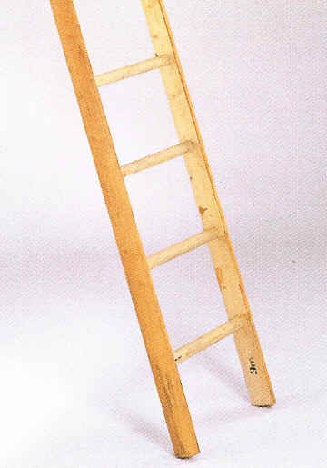
STOP USING

↑

CONTROL USING

↑

CONTINUE AS NORMAL

Where do you see yourself on the ladder?

Where would you like to be on the ladder and why?

How will you get there?

WORKSHEET 14: CHANGE PLAN SHEET

What do I want to change (this could be anything!)

The reasons I want to do this are:
To do this, I will need to take these actions
People who could support me in this area
What are my possible obstacles to change?
How will I deal with obstacles?
I will know my plan is working when….

WORKSHEET 3: THE LAW – TRUE OR FALSE – ANSWERS

CLASSIFICATION OF CRACK / COCAINE:  Crack and Cocaine are class ‘B’ drugs | FALSE  They are Class A
PRODUCTION OF COCAINE / CRACK:  Producing Crack and Cocaine is illegal | TRUE
PERSONAL CONSUMPTION:  It is legal to possess Crack/Cocaine for personal use only | FALSE  It is illegal
IF YOU ARE CAUGHT CARRYING:  If you are caught carrying 2 to 3 rocks you do not run the risk of being charged with possession with the intent to supply | FALSE  You could be charged
IF YOU BUY CRACK:  If you buy Crack for your friend and get caught you can be charged for supplying a class ‘A’ drug | TRUE
IF YOU GIVE A LINE OR A PIPE:  You can not be charged with supplying if you get caught giving a friend a pipe or a line | FALSE  You could be charged
IN YOUR HOUSE:  If you allow anyone to use cocaine in your house, you may still expect to face legal proceedings if you get caught | TRUE
THE PENALTY FOR POSSESSION:  The maximum penalty for possession of Cocaine is 5 years | FALSE  You can get up to 7 years, an unlimited fine or both
THE PENALTY FOR SUPPLYING:  The maximum penalty for supplying Cocaine is life | TRUE  You can also get an unlimited fine

Specialist support services are available to help with problems with drinking or drugs. You can access non-judgemental advice and information about how to keep safe and discuss potential treatment and support options.
Speak to the hotel staff who can help put you in touch with a local service.

