Homeless Hotels Drug and Alcohol Support Service (HDAS-London)

Cannabis Workbook

Cannabis recovery workbook for completion on your own or with support.
Speak to your hotel worker if you feel you may need support with this workbook. They will be able to advise on the best person to help.
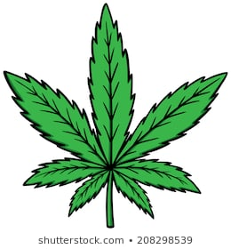
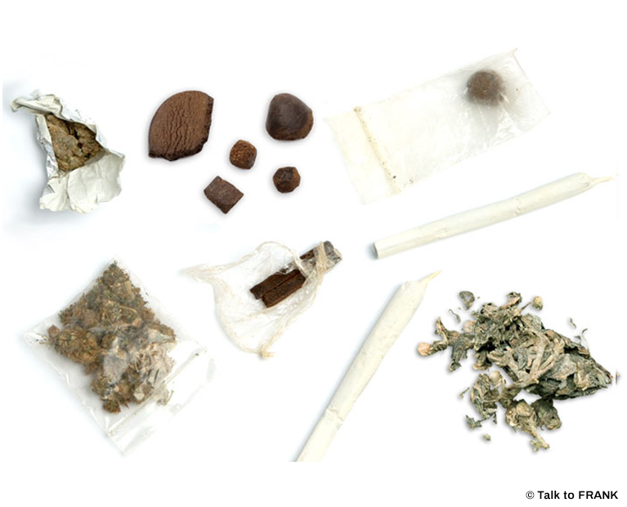

This workbook belongs to: _____________________________________________

These workbooks have been provided by partner agencies as part of the HDAS service.

INTRODUCTION

This is a workbook for you to work through. Please take time to work through this pack and be as honest as possible. If you would like to talk through this workbook please ask a hotel worker to get in touch with HDAS who can support you to access support from a local drug and alcohol service.

CONTENTS

Worksheet 1 | What is cannabis?
Worksheet 2 | Sensations, Effects and Safety
Worksheet 3 | You and your Cannabis use
Worksheet 4 | Drug testing and you
Worksheet 5 | Different types of drug users
Worksheet 6 | You and your life
Worksheet 7 | The dangers of Cannabis
Worksheet 8 | Myth or reality quiz
Worksheet 9 | Your drug habit
Worksheet 10 | Effects on you
Worksheet 11 | The legal stuff

WORKSHEET 1: WHAT IS CANNABIS?

- Cannabis is a natural substance derived from the Cannabis Satavia plant.

- It can be processed into three different forms:

  - Herbal – these are the parts of the plant that have been dried out and chopped up.
  - Resin – This is scraped off from the plant and compressed into blocks, which are usually a dark brown colour.
  - Oil – This is usually processed by filtering a solvent through the resin.

- There are different strengths of Cannabis depending upon the way the plant is grown and what it is mixed with. For example, Skunk is one of the stronger forms.
Other names that cannabis is known as:

Weed
Draw
Hash

Puff
Grass

Ganga
Marijuana

Pot
Wacky Backy

Solid
Dope

WORKSHEET 2: SENSATIONS, EFFECTS AND SAFETY

Common effects of using Cannabis are:

- Changes in feelings and perceptions
- Dreaminess
- Heightened awareness
- Vomiting
- Paranoia
- Panic
- Anxiety
- Palpitations
- Food cravings

Prolonged use can create:

- Loss of ambition
- Apathy
- Laziness
- Self neglect in appearance and health
- Affected ability to carry out day to day tasks i.e. driving

Safety

Cooking and then eating the drug can make its effects more intense and harder to control.

It is dangerous to use cannabis and drive or operate machinery. If you experience any problems, stop smoking and lie in a safe place until the feeling passes.

Be aware that skunk and home grown cannabis can be very strong and can have unpredictable effects including hallucinations.

To reduce the risks to the throat and lungs, smoke it without tobacco and eat at the same time.

WORKSHEET 3: YOU AND YOUR CANNABIS USE

- When did you start using cannabis?
____________________________________________________________________________________________________________________________________________________________________________________________________________________________________________________________________________________________________________________________________________________________________________________________________________________________________________________________________________________________________________

- What made you start using it?
____________________________________________________________________________________________________________________________________________________________________________________________________________________________________________________________________________________________________________________________________________________________________________________________________________________________________________________________________________________________________________

- How often do you use cannabis?
____________________________________________________________________________________________________________________________________________________________________________________________________________________________________________________________________________________________________________________________________________________________________________________________________________________________________________________________________________________________________________

- How much do you spend on it per week?
____________________________________________________________________________________________________________________________________________________________________________________________________________________________________________________________________________________________________________________________________________________________________________________________________________________________________________________________________________________________________________

WORKSHEET 4: DRUG TESTING AND YOU

Cannabis can be detected in urine samples for a longer period of time than most other drugs.

Cannabis use can be detected in the system for up to 28 days. However, detection periods can vary depending upon a person’s metabolism, the sensitivity of the test and the amount of cannabis taken.

Have you tested positive for cannabis? If yes, why do you think you used and what were the consequences of this?

__________________________________________________________________________________
__________________________________________________________________________________________________________________________________________________________________________________________________________________________________________________________________________________________________________________________________________________________________________________________________________________________
____________________________________________________________________________________________________________________________________________________________________________________________________________________________________________________________________________________________________________________________________________________________________________________________________________________________________________________________________________________________________________

WORKSHEET 5: DIFFERENT TYPES OF DRUG USERS

People use drugs for different reasons in different situations. The following explanations may be helpful in understanding why you may use drugs.

- Experimentation – people take a drug because they are curious about what the effects feel like.

- Recreational drugs – people use this term when they take drugs for pleasure, or in a social setting such as a party or a club.

- Problem drug use – this is when using drugs has a harmful effect on a person’s life. They may feel like they need to use a certain drug to cope with their life. Using in this way is likely to have a negative effect on relationships, finances, working life and staying on the right side of the law.

Which of the above describes you and why?
__________________________________________________________________________________________________________________________________________________________________________________________________________________________________________________________________________________________________________________________________________________________________________________________________________________________

Do you think you are, have been or will develop a problem using cannabis?
__________________________________________________________________________________________________________________________________________________________________________________________________________________________________________________________________________________________________________________________________________________________________________________________________________________________

How hard would you find it to stop?
__________________________________________________________________________________________________________________________________________________________________________________________________________________________________________________________________________________________________________________________________________________________________________________________________________________________

WORKSHEET 6: YOU AND YOUR LIFE

How do you think cannabis has affected . . . . . .

- Your love/sex life?
________________________________________________________________________________________________________________________________________________________________________________________________________________________________________________________________________________________________________________________________________

- Your social life?
________________________________________________________________________________________________________________________________________________________________________________________________________________________________________________________________________________________________________________________________________

- Your mental health?
________________________________________________________________________________________________________________________________________________________________________________________________________________________________________________________________________________________________________________________________________

- Your physical health?
________________________________________________________________________________________________________________________________________________________________________________________________________________________________________________________________________________________________________________________________________

- Your family life?
________________________________________________________________________________________________________________________________________________________________________________________________________________________________________________________________________________________________________________________________________

- Any other aspects of your life? Please state and give reasons
________________________________________________________________________________________________________________________________________________________________________________________________________________________________________________________________________________________________________________________________________

WORKSHEET 7: THE DANGERS OF CANNABIS

Cannabis effects . . . . . .

- The Heart – Somebody who has smoked Cannabis is likely to suffer palpitations, an irregular heartbeat and a drop in blood pressure, which may induce dizziness. There have been isolated cases of heart attacks in young people after cannabis use.

- The Brain – Cannabis use can lead people to develop signs of schizophrenia.
It can also bring about or worsen other psychotic and neurotic conditions and other mental health conditions such as anxiety and depression. A common effect is that a person’s short term memory deteriorates over time with use. High doses when the user is depressed or anxious can also lead to paranoia.

- The Hormones – there is anecdotal evidence that smoking cannabis may lead to an underdeveloped penis and testicles – even breast growth – in men. It reduces sexual potency and sperm counts in men.

- Developing Cancer – Regular smokers of Cannabis are 30 times more likely to develop cancer of the neck, throat, mouth and larynx than those who have not smoked cannabis. These tumours also appear between 10 and 30 years earlier than in non- cannabis users. Research also suggests that cannabis can induce cancer of the lungs.

- Coordination – Smoking cannabis affects a person’s coordination and reaction speeds, increasing the risk of accidents. It will impair someone’s driving skills, and ability to work effectively.

Have you ever considered yourself being in danger of any of the above whilst using cannabis, or have any of the above applied to you in the past?

________________________________________________________________________________________________________________________________________________________________________________________________________________________________________________________________________________________________________________________________________
____________________________________________________________________________________________________________________________________________________________________

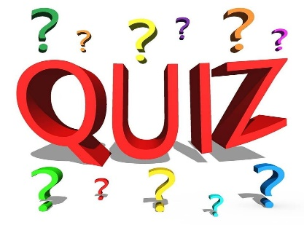
WORKSHEET 8: MYTH OR REALITY QUIZ

QUESTION | REALITY OR MYTH?
Cannabis can be eaten, smoked and vaped | REALITY | MYTH
You can get arrested for having cannabis on you | REALITY | MYTH
Cannabis is not addictive | REALITY | MYTH
Cannabis is one of the least used drugs in the UK | REALITY | MYTH
It can be dangerous to drive whilst using cannabis | REALITY | MYTH

CHECK YOUR ANSWERS AT THE BACK OF THIS WORKBOOK!

WORKSHEET 9: YOUR DRUG HABIT

- Has your cannabis use led you to use other drugs or drink more alcohol? If so why do you think this is?
________________________________________________________________________________________________________________________________________________________________________________________________________________________________________________________________________________________________________________________________________________________________________________________________________________________________________________________________________________________________________________________________________________________________________________________________________________________________________________________________________________

- How have you funded your cannabis use in the past?
________________________________________________________________________________________________________________________________________________________________________________________________________________________________________________________________________________________________________________________________________________________________________________________________________________________________________________________________________________________________________________________________________________________________________________________________________________________________________________________________________________

- Have you had any periods when you have not used cannabis? If yes, for how long and what stopped you from using?

_________________________________________________________________________________________________________________________________________________________________________________________________________________________________________________________________________________________________________________________________________________________________________________________________________________________________________________________________________________________________________

WORKSHEET 10: EFFECTS ON YOU

Does Cannabis make you feel . . . . .

Better about yourself and your life? Please explain how.
__________________________________________________________________________________________________________________________________________________________________________________________________________________________________________________________________________________________________________________________________________________________________________________________________________________________

Worse about yourself and your life? Please explain how.
__________________________________________________________________________________________________________________________________________________________________________________________________________________________________________________________________________________________________________________________________________________________________________________________________________________________

More confident about yourself and your life? Please explain how.
________________________________________________________________________________________________________________________________________________________________________________________________________________________________________________________________________________________________________________________________________

More relaxed about yourself and your life? Please explain how.
________________________________________________________________________________________________________________________________________________________________________________________________________________________________________________________________________________________________________________________________________

Why do you think this is?

______________________________________________________________________________________________________________________________________________________________________________________________________________________________________________________

If you had a child and they wanted to use cannabis what would you say to them?

________________________________________________________________________________________________________________________________________________________________________________________________________________________________________________________________________________________________________________________________________________________________________________________________________________________

Would you tell them the risks involved? If so, how would you explain this to them?

________________________________________________________________________________________________________________________________________________________________________________________________________________________________________________________________________________________________________________________________________________________________________________________________________________________

WORKSHEET 11: THE LEGAL STUFF

What is the legal position?

Cannabis is a Class B drug. Cannabis Is ILLEGAL and it is a criminal offence to either possess it or supply it. It is also ILLEGAL to grow cannabis or allow people to smoke it on your premises.

It is illegal to have for yourself, give away or sell.

- Possession can get you up to 5 years in prison, an unlimited fine or both.
- Supplying someone else, even your friends, can get you up to 14 years in prison, an unlimited fine or both
Cannabis also comes under the ‘discretionary warning scheme’. This means a police officer can choose to issue you with a street warning only. Providing:
- You’re in possession of a small amount for your own use
- It’s the first time you’ve been caught with an illicit drug and no previous record of offence
- You are compliant
It is recorded but doesn’t form a criminal record. If its your second offence the police can issue an on the spot fine to pay within 21 days. If its your third occasion you will be arrested.

If you could change the law on cannabis how would you change it and why?

____________________________________________________________________________________________________________________________________________________________________________________________________________________________________________________________________________________________________________________________________________________________________________________________________________________________________________________________________________________________________________________________________________________________________________________________________________________________________________________________________________________________________________________________________________________________________________________________________________________________________________________

WORKSHEET 8: MYTH OR REALITY QUIZ ANSWERS

Cannabis can be eaten, smoked and vaped | Reality  Cannabis can be smoked, eaten and vaped
You can get arrested for having cannabis on you | Reality  Cannabis is a Class B Drug. It’s illegal to have for yourself, give away or sell.  It also comes under the discretionary warning scheme.  This means that a police officer can choose to issue you with a street warning only for example if you have a small amount, its your first time and you are compliant.
Cannabis is not addictive | Myth  Users often get cravings and find it hard not to take it
Cannabis is one of the least used drugs in the UK | Myth  It is one of the most widely used drugs in the UK
It can be dangerous to drive whilst using cannabis | Reality  Cannabis interferes with the brains ability to function properly including parts of the brain that control the body’s movements, balance, coordination, memory, and judgment. This makes driving very dangerous.  Like drink-driving, driving when high is dangerous and illegal. If you’re caught driving under the influence, you may receive a heavy fine, driving ban, or prison sentence.

Specialist support services are available to help with problems with drinking or drugs. You can access non-judgemental advice and information about how to keep safe and discuss potential treatment and support options.

Speak to the hotel staff who can help put you in touch with a local service.

