OPERATIONAL GUIDANCE FOR THE RECOVERY CARE PATHWAY DOCUMENTATION (INCLUDING eCPA)

MARCH 2018

Version: | 1.0
Ratified by: | Operations Meeting
Date ratified: | 7th March 2018
Name of originator/author: | Trust Social Care Lead
Name of responsible committee/individual: | Trust Social Care Lead
Circulated to: | Directors, Managers and Clinical Staff involved in the provision of care under the Care Programme Approach
Date issued: | 8th March 2018
Review date: | April 2019
Target audience: | Directors, Managers and Clinical Staff involved in the provision of care under the Care Programme Approach

- Purpose and Overview

The purpose of this new Operational Guidance is to introduce the new Care Pathway Documentation on RIO which includes the new Recovery CPA documentation. The Guidance clarifies how and when to use it: who completes which document, when and for what purpose?

It is important for staff to have a broader knowledge of the functionality of RIO and the benefits of using these Care Pathway Documents and so this Guidance should be read in conjunction with the CPA Policy (which is available on Trust Intranet).

Clinical information that is held in these documents can be used to automatically generate editable letters that can be used for different reasons and improve both the quality and efficiency of communication.

This document is divided into four parts. This is the first.

The second details process: how the Care Pathway Documentation is used in different clinical setting. There are Process Boxes throughout this section which explain how and when to complete the various forms and editable letters:
  - Process – Screening
  - Process – Patients Seen in A&E
  - Process – Inpatient Admissions
  - Process- New Referral via Home Treatment Team
  - Process – Community Assessment
  - Process – Care Coordination /Care Planning
  - Process – CPA Review/ Meeting

The third part details how to complete the individual RiO forms. The fourth part details how to generate the editable letters.

- Processes

2.1 Screening Process.
Process – Screening
WHAT NEEDS TO BE COMPLETED
There are differing pathways for new referrals in different parts of the Trust e.g. CHAMHRAS in City & Hackney, Assessment Brief Treatment (ABT) in Newham and direct referrals to CMHTs/Recovery teams in Tower Hamlets, Luton and Bedfordshire. In Bedfordshire they also conduct a telephone triage. However, whatever the pathway, the process is recorded in the RiO Referral Screening & Triage form.

- Screening confirms the referral is appropriate.
- The Initial assessment is triage, and is recorded in this form.
- This form records the outcome of triage/screening.

WHEN
The Referral Screening & Triage form in RiO is to be used for all new external referrals and re-referrals from the community, whether GPs or other referrers.

- In the case of referrals from inpatient wards to community teams of patients who were not previously known to the service, the recipient of the referral fills in the screening and triage form.
- When an internal referral is made to another ELFT service the next service does not need to complete a new screening and triage form.
- Note: The outcome of the initial assessment may also be summarised in progress notes including any immediate plan.

WHO COMPLETES THIS FORM
- This may be different for each team. If Admin receive the referral then they complete the start of the form. The form can be completed in a referrals meeting and/or by the clinician who does the assessment.

OUTPUTS
- Response back to the Referrer

2.2 A&E Process
Process – Patients Seen in A&E
WHAT NEEDS TO BE COMPLETED
- As a minimum Mental Health Staff in A&E/RAID should complete the RiO Adult/CAMHS Risk Assessment form and complete the My Safety Plan on discharge from their service.

WHO COMPLETES THE FORMS
- Completed by the assessing Clinician.

OUTPUTS
- My Safety Plan ( a copy given to the Service User)

2.3 Inpatient Process
When a service user is admitted to the ward it is essential that the inpatient clinical team utilise the Recovery Care Pathway Documentation. This will ensure clinical information is held in the correct place and can be used to generate letters.

For patients who are known to the service they may already have completed forms and information available. However, for all patients, new forms must be created on each admission.

Process – Inpatient Admission
WHAT NEEDS TO BE COMPLETED

On Admission to Inpatient Care

- A new History and Context form must be created when the patient is admitted to the ward. This will pull the information through from the previous form and this can be updated throughout the inpatient stay as more information becomes available.
- A new Clinical assessment/ Review form must be completed on Admission.
- An Entry to be made in Progress Notes – which will include the initial plan.
- Dialog+ to be started on admission for new patients.
- For patients already known to services the Dialog+ should be updated.
- Commencing Dialog+ or updating for existing patients happens within 72 hours of admission.
- My Safety Plan – to be commenced or updated on admission and completed for the Discharge CPA.

On Discharge from Inpatient Care
- A discharge CPA should be arranged for each patient prior to discharge.
- For those patients who are being discharged on CPA. their ‘My Recovery Care Plan’ which includes my safety plan will be produced following their discharge CPA. A copy will be given to the patient
- My Recovery Care Plan’ uploaded on RIO as a CPAT.
- For patients who are discharged from the ward not on CPA ‘my safety plan’ must be completed, a copy given to the patient and the discharge plans recorded on RIO.

WHO COMPLETES THESE FORMS
- History and Context Screen - completed by the clerking in Doctor and Nurse.
- Clinical assessment/ Review - completed by the clerking in Doctor and Nurse.
- DIALOG+ - started by the admitting Nurse. Any member of the Ward MDT can input into the form.
- My Safety Plan - started by the admitting Nurse. Any member of the Ward MDT can input into the form.
- For patients being discharged on CPA The Dialog+ needs to be developed in time for the Discharge CPA, so that a new My Recovery Care Plan can be created for the CPA Meeting. This needs to be agreed with the Care Coordinator in the CPA Meeting.

OUTPUTS

On Discharge from Inpatient Care
- My Recovery Care Plan (for CPA patients only)
- My Safety Plan
- Discharge Liaison Form (NODF) sent to the GP - uploaded on RiO

2.4 New Referral via Home Treatment Team

Process: New Referral via Home Treatment Team
WHAT NEEDS TO BE COMPLETED

As Part of Initial Assessment
- A new History and Context form must be created when the patient is assessed. This will pull the information through from any previous forms.
- A new Clinical assessment/ Review form must be completed as part of the Assessment
- An Entry to be made in Progress Notes – which will include the initial plan.
- Risk Assessment form - to be completed or updated as part of all assessments
- My Safety Plan – to be commenced or updated

- WHO COMPLETES THESE FORMS
- The Health Care Professional who is completing the assessment or another relevant member of the MDT

OUTPUTS

On Transfer to another Service in the Trust

- Risk Form

- My Safety Plan

2.4 Community Assessment
Process – Assessment
WHEN
- When a patient has been discharged from the ward and been referred to a Community Team, accepted and allocated for assessment
- Or when a new referral has been accepted and allocated for assessment in a Community Team.

WHAT NEEDS TO BE COMPLETED
- Clinical Assessment/Review form
- History And Context form
- Dialog+ form
- Risk Assessment form - to be completed or updated as part of all assessments

Important Notes on Dialog+
- Dialog+ is a process, it is never finished.
- By the end of the 28 day assessment period enough of the Dialog+ will have been developed sufficiently to create a meaningful and relevant ‘My Recovery Care Plan’ if the service user is being placed on CPA.
- The ‘My Recovery Care Plan’ will continue to be updated and developed after the 28 day assessment period (for CPA patients).

WHO COMPLETES THESE FORMS
- The Health Care Professional who is completing the assessment or another relevant member of the MDT

OUTPUTS
- Risk Form
- My Recovery Care Plan
- My Safety Plan
- Editable letter or Case Summary to GP

2.5 Care Coordination and Care Planning
RiO Process – Care Coordination /Care Planning
Care Co-ordination/Care Planning
- It is anticipated that the Care Coordinator would continue to use Dialog+ as a therapeutic tool on an ongoing basis. There is no target, BUT TO BE COMPLETED NOT MORE THAN MONTHLY.
- Dialog+ could be used as a structure for future visits and ongoing interventions.
- Dialog+ needs to be completed as much as is relevant and as fully as possible for the patient by the first CPA meeting.
- As a minimum Dialog+ should be updated for every subsequent CPA or at points of significant change. A new Dialog+ form should be created at least for every CPA. This pulls the information through from the previous form and this information can then be updated. This ensures that a chronological record of previous Dialog+ forms is retained.
- My Safety Plan and the Risk Assessment form should be revised and updated after any significant incident and updated for CPA reviews.
- Service user receives My Recovery Care plan and My Safety Plan after the initial CPA meeting.

WHAT NEEDS TO BE COMPLETED
- Dialog+ (The relevant Domains need to be completed including Service User Goals and Action Plans so that a relevant My Recovery Care Plan can be created.)

WHO COMPLETES THESE FORMS
- Care Coordinator

OUTPUTS
- My Recovery Care Plan
- My Safety Plan
- Case Summary to GP

2.6 CPA Review Meeting

RiO Process – CPA Meeting
- Dialog+ to be completed before the meeting and should be discussed in the meeting where actions can be added or agreed before the My Recovery Care Plan is generated and given to the service user.
- Use the most up-to-date version of Dialog+ when preparing for the CPA meeting. To be revised not a new form started.
- My Recovery Care Plan should be given to the service user immediately after the CPA.
- Initial CPA Meeting should take place by 12 weeks after the referral.
- Other professionals can contribute to the Dialog+ outside CPA e.g. OT plans etc.
- Carer’s views should be captured.
- Following the CPA Meeting Care Coordinator uploads the My Recovery Plan as a CPAT on RiO and also sends it directly to GP with a Case Summary via eCorrespondence (where it is fully deployed).

Inpatient discharge CPAs
- Create a new dialog+ when patient is admitted to the hospital. (See RiO Process – Inpatient Admissions – above)
- Care co-ordinator is responsible for reviewing and updating the last Dialog+ before the patient leaves the ward, and generating the My Recovery Care Plan to give to the Service User.

WHAT NEEDS TO BE COMPLETED
- Dialog+
- My Safety Plan

WHO COMPLETES THESE FORMS
- Care Coordinator

OUTPUTS

Service User
- My Recovery Care Plan
- My Safety Plan

GP
- Case Summary - To be uploaded to RiO as CASE
- My Recovery Care Plan – To be uploaded to RiO as the CPAT

Note: It important that both these documents are uploaded to RiO on the completion of the CPA Meeting

- Detailed RiO Screens

Where to find the new documentation
Click on the ‘client record’ icon then ‘case record’

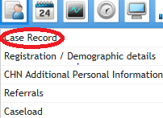

Search for the required client, once in the client record select the ‘Recovery Care Pathway Documentation’ folder from the ‘Case Record Menu’.
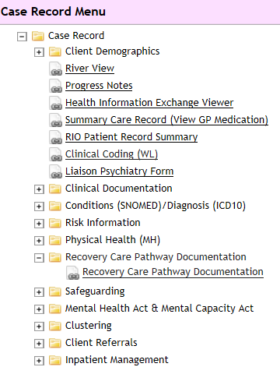

This will display the Recovery Care Pathway documentation (which includes the documents required for the new Recovery CPA), click on the relevant form

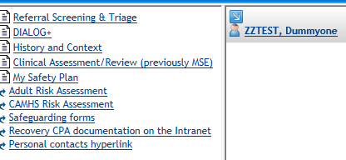

3.1 Referral Screening and Triage form
- Click on the ‘create new’ button at the base of the screen
- Enter the date and time of the initial screening
- Referral / Admission – you can link this to a specific referral or admission
- Upload and attach any relevant referral documentation e.g. GP letter, by clicking on the + sign in the box

Screening
- Screening – please outline the reason for the referral & screening decision e.g. GP has referred because of long standing anxiety and depression which is not being adequately managed in primary care and GP would like specialist assessment and consideration for psychology input. Duty worker has discussed the referral with the GP, checked previous notes on RiO and service user has agreed to assessment.

- Screening outcome – choose from the drop down menu. If the outcome is ‘signposted to another agency’ or ‘signposted to another ELFT service’ please state which service, who has signposted and evidence of this e.g. onward referral letter (this can also be attached via the referral documentation link above) in the screening decision comments box. If you have rejected the referral / returned to the referrer please clearly outline the reasons why.

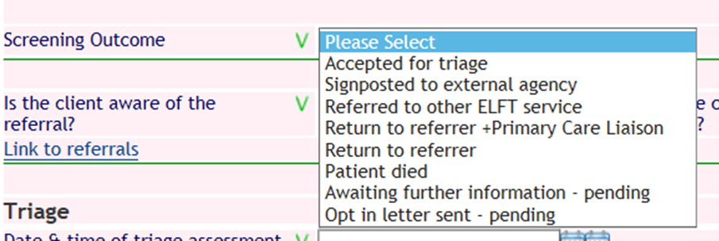

Once you have completed the screening section, the form can be saved or you can go on to the triage section.

Triage

- Complete all the fields in this section of the form
- Triage assessment & decision – complete the free text box to provide a brief summary of the assessment and any decisions taken / action plan agreed at the end of the assessment
- Triage outcome decision – choose the outcome from the drop down list. If you are signposting to another agency or another ELFT service please state which ones and ensure there is evidence of this e.g. letter uploaded, state who you spoke to on the phone from external agency etc. in the triage assessment & decision comments box.

The hyperlinks at the bottom of the screen will take you to the Progress notes, Clinical Assessment/Review form or the History and Context form

Once you have completed the form press ‘Save’.

3.2 DIALOG+

Select the DIALOG+ form and then click on the ‘create new’ button to create a new DIALOG+ assessment. The new form will auto-populate with the responses from the previously completed DIALOG+ form, unless this is the first DIALOG+ form being completed when it will be blank. You can delete or edit these responses depending on what is discussed at this assessment.

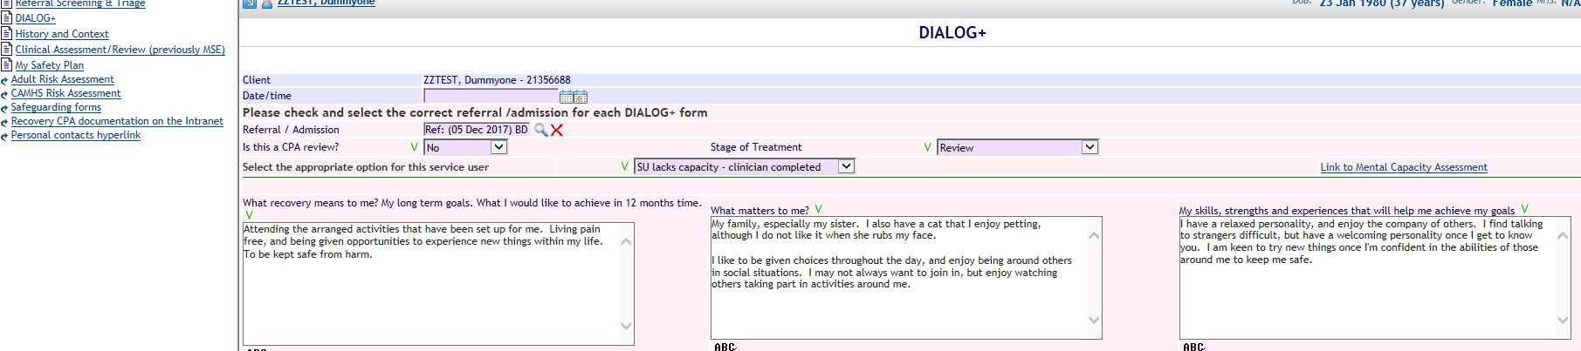

- This form must be completed at the point of entry into the service, at regular intervals throughout the clinical contact, and at discharge.

- Complete the date and time field using the date of assessment/review
- Referral / Admission – you can link this to a specific referral or admission
- Is this a CPA review? – choose yes or no from the drop down menu
- Stage of Treatment – choose assessment, review or discharge from the drop down menu

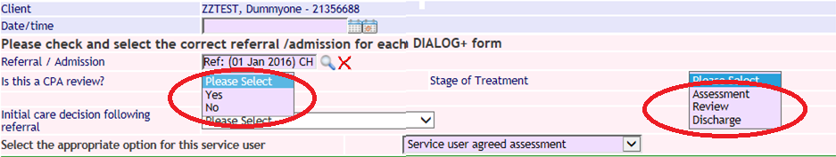

Assessment – for assessing a service user
Review – for reviews meetings (CPA/non CPA) or when a service user is discharged from a ward/service
Discharge – for when a service user is discharged from CPA / or from the Trust

Service user engagement with DIALOG+ - choose from the drop down menu ‘Select the appropriate option for this service user’
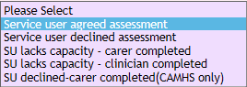

There is a link to the RiO mental capacity assessment form to the right of the screen, if you need to complete an assessment of capacity or refer to a previous assessment.

Complete the next three free text boxes using the service user’s own words and priorities

- What recovery means to me? My long term goals. What I would like to achieve in 12 months’ time

- What matters to me?

- My skills, strengths and experiences that will help me achieve my goals

You will now start the DIALOG+ questions.

Ask the service user to rate their satisfaction using the Likert Scale in the screenshot below:

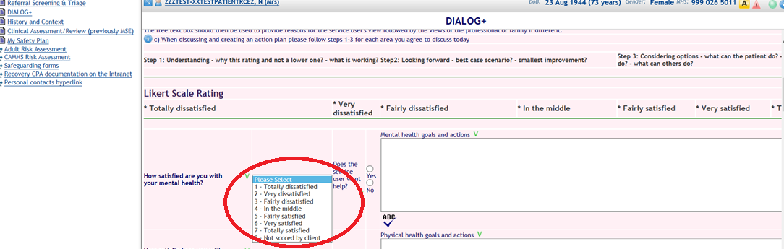

Moving through the list of questions, (apart from the first two domains - mental health and physical health - which are mandatory questions), you will ask the service user if s/he requires help in this area. If they do not and you also have no concerns you can select “no” on the Yes/No radio button and move onto the next area if there is no discussion or actions to reflect in the free text box.

If the service user reports they do not require help in a particular area but you have concerns you can select the “yes” on the Yes/No radio button and then reflect both perspectives and any agreement or disagreement.

You will then use the free text box next to each question to reflect the discussion, ensuring that you reflect
- the service user’s views and your understanding of why s/he has chosen this rating and not a lower one (i.e. what is working)
- best case scenario in this area and the smallest improvements to start working towards this
- Considering options – what the service user can do, what the clinician can do and what others can do?

Further explanation of the above can be found by clicking the question mark icon at the top left hand corner of the screen, when completing the DIALOG+ form



The ‘ABC’ icon below each of the free text boxes will allow you to spell check your text before saving.

At the base of each DIALOG+ screen, there is an option which will allow you to upload and attach (or attach a previously uploaded document) any relevant documentation including Local Authority funding agreements to a service user’s record. A list of associated documents will appear at the bottom of the screen. When you have completed the form click ‘save’. The clear button at the base of the screen will clear all fields.
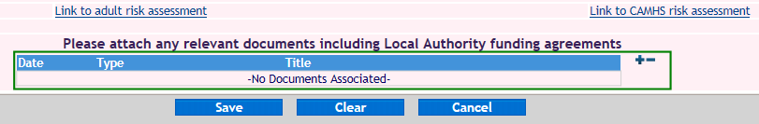
There are links to progress notes, adult risk assessment or CAMHS risk assessment forms, if you want to reflect extra information or changes in risk based on this discussion.

Is this a CPA review?
The DIALOG+ screen produces extra boxes to complete if you choose ‘yes’ to the ‘Is this a CPA review?’ field.

These appear at the bottom of the DIALOG+ screen to reflect, who has attended the CPA meeting and who has been sent a copy of the care plan.

During the CPA DIALOG+ screen if there is a disagreement regarding whether the service user needs help in a particular area you should reflect the discussion as outlined above and then at the bottom of the screen there is a prompt “Does the service user agree with this care plan?” If there has been any disagreement you should select the “no” on the Yes/No radio button and then reflect this in the free text box.

The Responsible Clinician (or their representative attending the CPA meeting) will need to tick the box ‘Does the Responsible Clinician agree to this care plan?’ if they agree to the plan. Where there is a disagreement, this should ideally be resolved in the meeting, or any issues clearly recorded in the DIALOG+ screen (in the relevant free text box).

Please tick the box if this review was unplanned; also complete the drop downs for the ‘care decision following review’ and ‘If this client is receiving a package of care, who is responsible for funding?’

If appropriate, the date the client was entitled to S117 and the end date for S117 are pulled through as read only fields. If this needs to be updated please contact your local MHA office. There is also a free text box to enter details of the S117 entitlements of this care plan

When you have completed the CPA review and My Safety Plan, these can be printed for the client and attached to RiO as a CPAT document, see section 4.1, My Recovery Care Plan.

3.3 History and Context

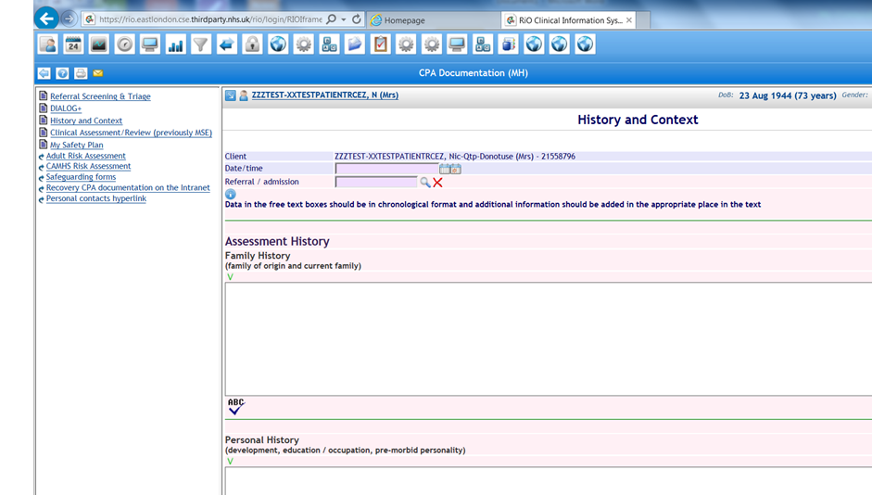

- Complete the date and time of assessment by using the left hand calendar icon next to the date/time field, to input an earlier date and/or time in the past, or the right hand calendar to input today’s date and current time
- Referral / Admission details – you can link this to a specific referral or admission
- Fill and complete the rest of the form as necessary
- Complete each of the free text boxes where you have information to record:

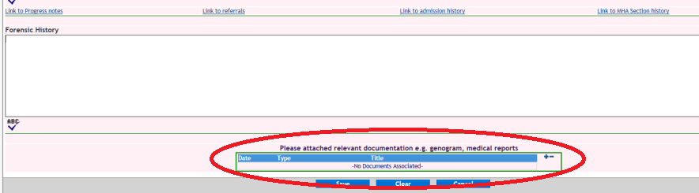

Upload any relevant documentation to a patient’s record e.g. GP summary.

Links to the medical physical health form, lifestyle assessment form, progress notes, referrals, admission history and MHA Section history can be found in the History & Context form. When you have fully completed the form, click on the save icon at the base of the screen, to save your work.

3.4 Clinical Assessment/Review

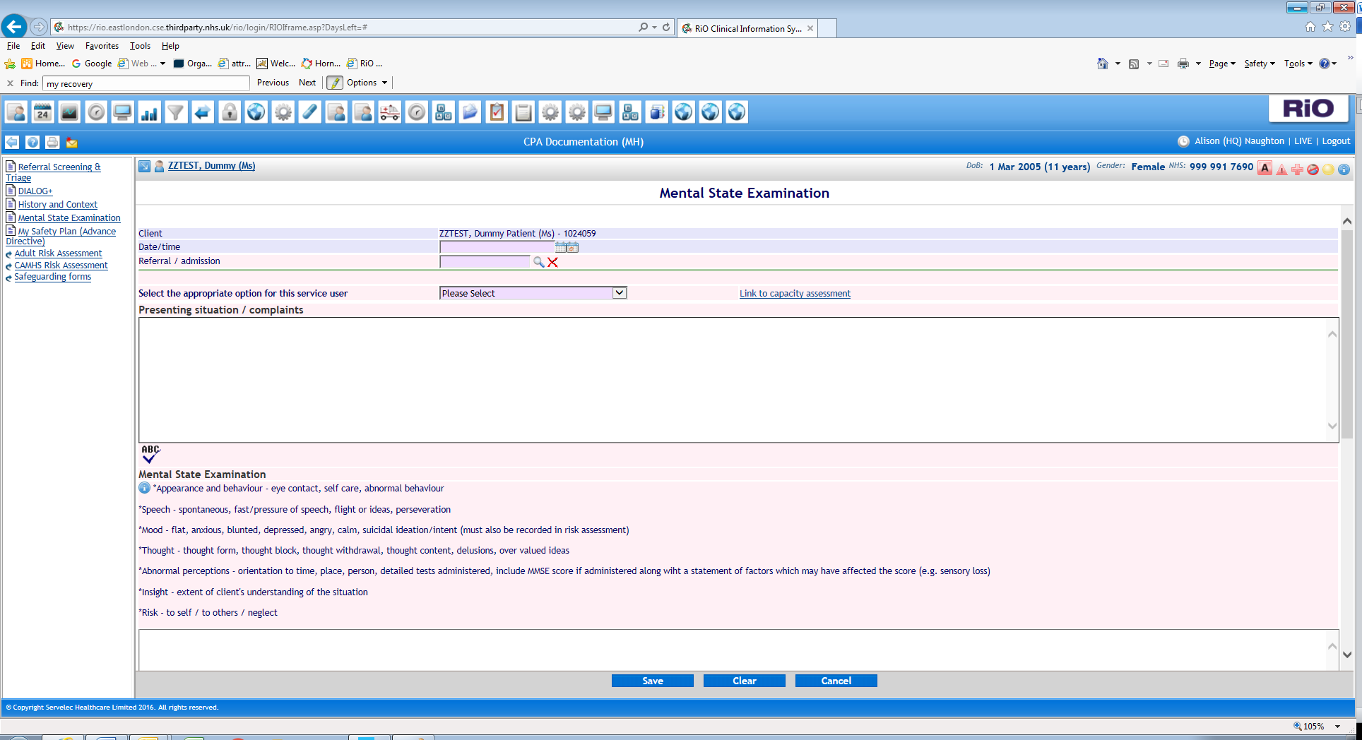
- The most appropriate clinician (care coordinator, psychologist or psychiatrist) should complete a clinical assessment including a mental state examination to reflect the service user’s current mental state. This is not recorded on the DIALOG+ screen in detail as DIALOG+ is a subjective discussion focusing on how satisfied the service user is with his/her mental health, whereas the clinical Assessment/Review form includes an objective assessment of the service user’s current mental state.
- Complete the date and time of assessment by using the left hand calendar icon next to the date/time field, to input an earlier date and/or time in the past, or the right hand calendar to input today’s date and current time.
- Referral / Admission details – you can link this to a specific referral or admission
- Fill and complete rest of form as necessary.

3.5 Adult/CAMHS Risk Assessment

There are hyperlinks to the Adult and CAMHS risk assessment forms in the ‘Recovery CPA Documentation’ folder.

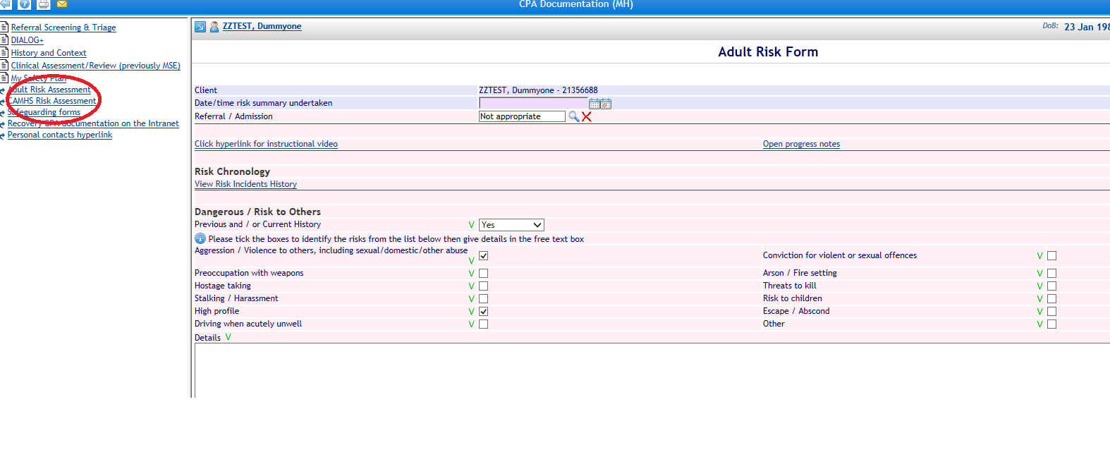

- Complete each section as required.
- This form has links to Risk Incidents History.
- Complete the date and time of assessment by using the left hand calendar icon next to the date/time field, to input an earlier date and/or time in the past, or the right hand calendar to input today’s date and current time.
- Referral / Admission details - you can link this to a specific referral or admission.
- Press save once you have completed the risk form.

3.6 My Safety Plan (Advance Directive)

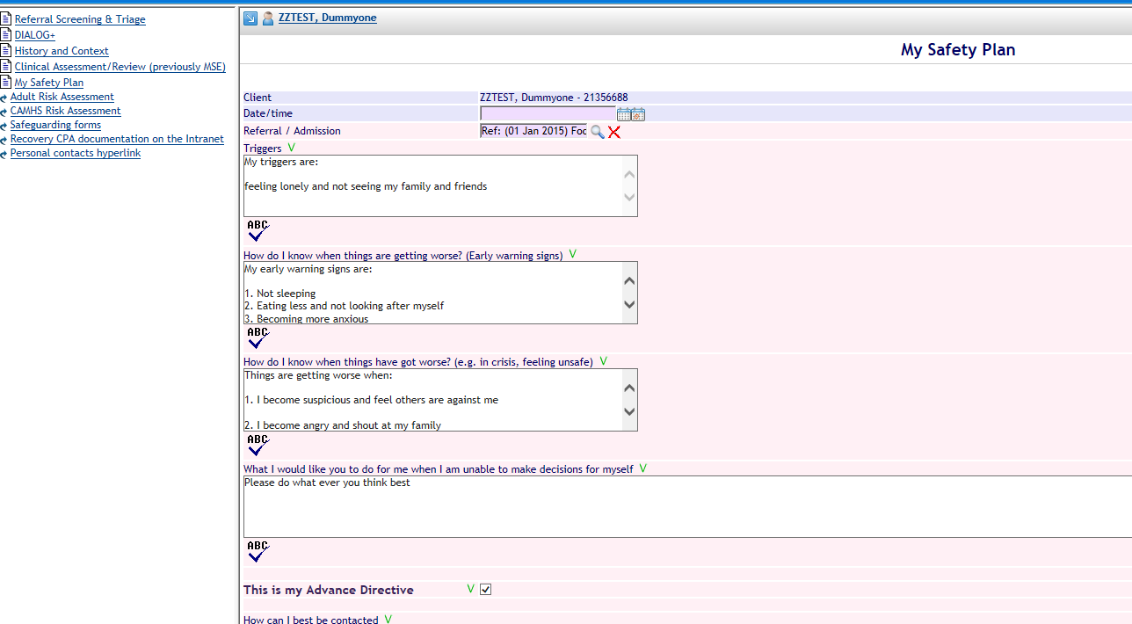

This screen should be completed for any service user who would benefit from having a crisis and contingency plan. This should be developed with the service user, and the clinician should encourage the service user to identify factors which contribute to risk and help in managing or minimising risk. There are four key areas to focus on with the service user

- Triggers
- Early Warning Signs
- When things are getting worse
- How will I know when I am out of crisis
- What I would like you to do for me when I am unable to make decisions for myself

An action plan for each point can then be identified. The discussion and plan will be written in the free text box.

If the service user agrees to this form being their Advance Directive then check the tick box.

The clinician will also discuss how to contact the service user and who else can be contacted and how. This information should not contradict what has been stated on the Permission to Share Information form (and if it does then the Permission to Share Information form should be updated to reflect the service user’s wishes regarding information sharing).

Wherever possible this should be a service user led plan and it is important that the service user agrees to the safety plan and the box at the bottom of the form is ticked.

The type of items which can be added here are, an individual’s mobile phone number, their point of contact in emergency’s, trigger points, early warning signs and other action plans.

The Safety Plan can be created and printed as a stand-alone document – this is useful for service users who are not on CPA and will not have a Recovery care plan.

There is a link here to the Adult risk form, CAMHS risk form and progress notes.

- Editable Letters.

The following table lists forms within the Recovery Pathway Folder and the Editable letters they populate.

RiO Form Completed | Editable letter Populated
DIALOG+ | My Recovery Care Plan  Adult Case Summary  Adult Case Summary (Plus full MSE)
My Safety Plan | My Safety Plan  My Recovery Care Plan
Clinical Assessment/Review (previously MSE) | Adult Case Summary (Plus full MSE)
History and Context | Adult Case Summary  Adult Case Summary (Plus full MSE)
Referral Screening & Triage | Adult Case Summary  Adult Case Summary (Plus full MSE)

4.1 My Recovery Care Plan

My Recovery Care Plan is a printout which pulls information from the DIALOG+ form and My Safety Plan.

To generate the document go to the ‘Clinical Documents’ icon at the top of the screen and select ‘Edit and Print Letters’

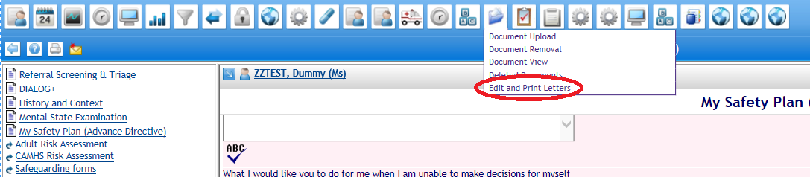

Search for the relevant client

In ‘Letter Type’ search for ‘My Recovery Care Plan’, then press the ‘Create’ button at the bottom of the screen

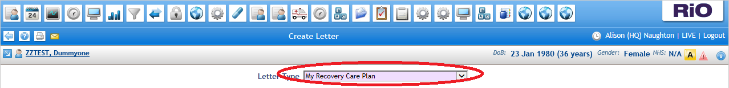

This displays the printable care plan as a Word document

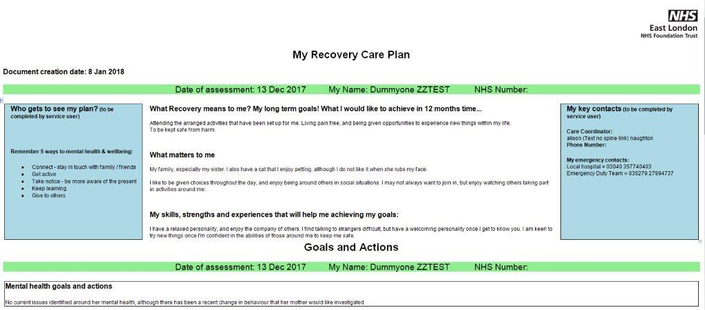

Select the ‘File’ option in Microsoft Word at the top of the screen and then ‘Print’ to produce paper copy to hand to the patient.

My Recovery Care Plan must be attached to RiO using document upload.

Within Microsoft Word select the ‘DropZone’ option then click ‘Send To RiO’
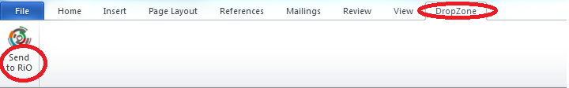

A pop up box will appear, complete all the fields:
- Enter CPAT in the ‘Title’ field
- The default will be ‘Final Version’ do not change this selection
- Enter My Recovery Care Plan in the ‘Description’ field
- ‘Document Date/Time’ field should be the date of the DIALOG+ review
- Select MH Care Plans in the “Type” picklist.
- Where eCorrespondence has been fully deployed, tick the “Send to GP” tick box to enable the My Recovery Care Plan to be sent to the GP. If eCorrespondence has not been deployed in your area, do not tick this box, the My Recovery Care Plan will be sent the conventional way.
- Click ‘OK’ and the document will be saved and can be viewed in the Document List View. Where eCorrespondence has been deployed, clicking ok with the “Send to GP” box ticked will simultaneously send the document to the GP.

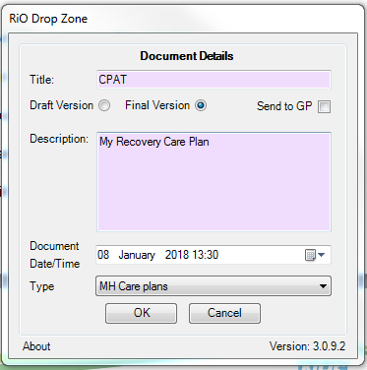

4.2 Case Summary

Case summary is an Editable letter that pulls information from the following areas of the Recovery Care Pathway documentation:
- DIALOG+
- My Safety Plan
- Clinical Assessment and Review
- History and Context
- Referral Screening and Triage.

It also includes information from other areas in RiO including Diagnosis ICD 10, Risk Assessment and Physical Health forms.

To generate the document go to the ‘Clinical Documents’ icon at the top of the screen and select ‘Edit and Print Letters’

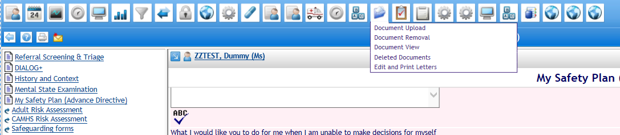

Search for the relevant client

In ‘Letter Type’ select ‘**Adult Case Summary (plus full MSE), then press the ‘Create’ button at the bottom of the screen

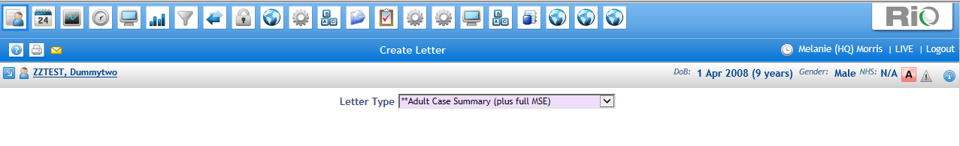

This displays the Adult Case Summary as shown below.

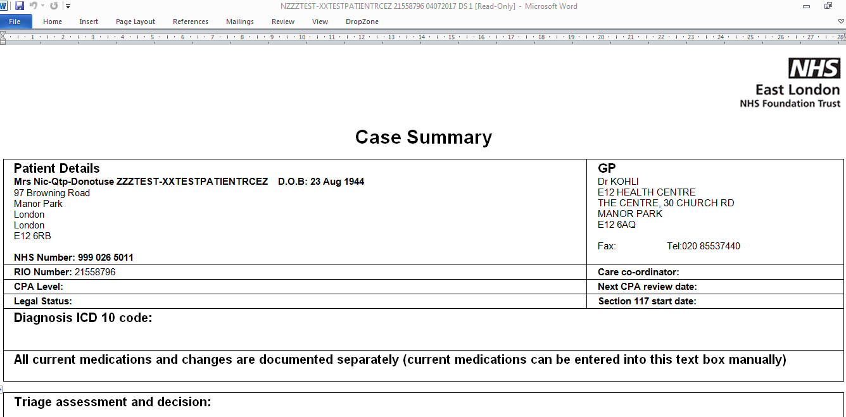

To upload the Adult Case Summary to the RiO record, select the ‘DropZone’ option then click ‘Send To RiO’

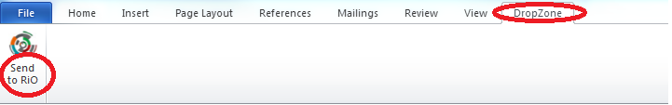

A pop up box will appear, complete all the fields:
- Enter CASE in the ‘Title’ field
- The default will be ‘Final Version’ do not change this selection
- Enter “Case Summary” in the ‘Description’ field
- ‘Document Date/Time’ field should be the date of the DIALOG+ review
- Select MH Reports/Assessments in the the ‘Type’ picklist.
- Where eCorrespondence has been fully deployed, tick the “Send to GP” tick box to enable the Case Summary to be sent to the GP. If eCorrespondence has not been deployed in your area, do not tick this box, the Case Summary will be sent the conventional way.
- Click ‘OK’ and the document will be saved and can be viewed in the Document List View. Where eCorrespondence has been deployed, clicking ok with the “Send to GP” box ticked will simultaneously send the document to the GP.

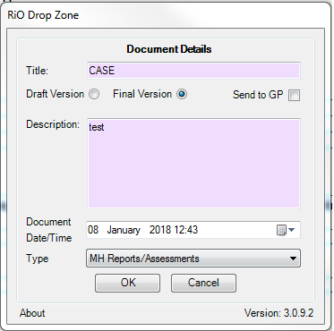

Appendix 1 - Process Maps

