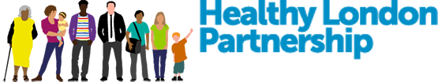
One Thing... for #AskAboutAsthma
This year the #AskAboutAsthma campaign is focusing on the message of ‘One Thing LDN’ – asking Londoners what they have done, will do or would like to see happen to improve asthma care or air quality for CYP in London.
Let us know your #OneThingLDN by either recording a video-selfie or sharing your own One Thing message on social media using #OneThingLDN.
- Please print out the #OneThingLDN poster (page 2 of this document)
- Then either i) record a video saying #OneThingLDN that you have done, will do or would like to see happen to improve asthma care or air quality for children and young people in London OR ii) add some text to the #OneThingLDN speech bubble and take a photo.
- Tweet us @HealthyLDN using #OneThingLDN and #AskAboutAsthma OR attach the video or photo to an email to hlp.cyp-programme@nhs.net. You can also WhatsApp any videos or photos to the CYP team via 07795 800512 or 07795 665488.
- Please let us know who you are so we can include that on our website when we upload your video/photo. If it is a child they may not want to include their name.
- Any questions please contact the team via hlp.cyp-programme@nhs.net.
Thank you for supporting London’s #AskAboutAsthma campaign!
How to record your #OneThingLDN message

#OneThingLDN…

#AskAboutAsthma

