An organisational pledge for acute hospital trusts:

Improving the treatment and management of asthma in children and young people

August 2018
Asthma is the most common long term medical condition affecting children and young people (CYP). 1 in 10 CYP are affected by the condition meaning 240,000 CYP have asthma in London. Many have badly managed asthma – to the extent that 4,000 are admitted to hospital with asthma every year, and 170 have such a severe episode that they require admission to intensive care.
At the worst end of the spectrum around 12 children die of this disease in the capital every year. Poorly controlled asthma affects every aspect of children’s lives – their ability to learn, enjoy time outside school with friends or take part in sport. It affects their time with their families and how they sleep.
There are tools and guidance that exist to help healthcare professionals and others treat and manage asthma and support patients to self-care. We do not have to wait for new medicines or a cure for asthma: we need to educate and support our workforce to use these tools to achieve improved outcomes. However, making a significant change requires agreement and coordinated effort.
Signing the “pledge” in this document represents an agreement from those in key system leadership positions to implement simple measures to improve care and management of children and young people with asthma. In addition, in recognition of the significant role played by air pollution in triggering asthma attacks, we are asking NHS organisations to commit to reducing their contribution to air pollution.
To provide support for this, we have produced a toolkit NHS Trusts: Air pollution reduction toolkit.. This describes simple and free changes NHS organisations can make to reduce their contribution to London’s air pollution.
This year there is also the option of doing a ‘vox pop’ instead of a written pledge – this would be a short film recorded on a mobile phone describing your commitment to improving asthma care or reducing pollution. Instructions are at the end of this document.
The organisational pledges form part of a wider #AskAboutAsthma campaign being run from 3rd to 16th September. This is a campaign to raise awareness of simple measures that should be taken to manage all CYP with asthma. It aims to ensure that existing asthma standards and ambitions are met across London and that no more children die from preventable asthma attacks.
In addition to having organisational pledges, individuals will be showing their support for the campaign by describing their own contribution to improving asthma care through the #MyAsthmaPledge initiative. Both organisational and individual pledges to support the campaign will be visible on the Healthy London Partnership My Asthma Pledge page.
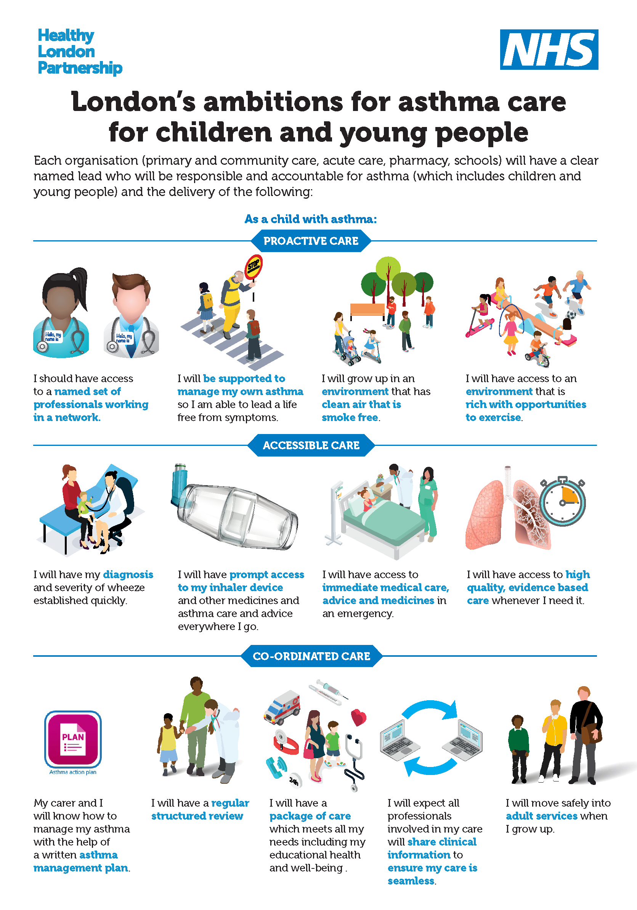

Key facts (reference asthma case for change)
- London has a higher rate of illness and death in children and young people because of asthma compared to other European countries
- It is one of the top three causes of emergency admission to hospital (4,000 in London each year.) 75% of these admissions are avoidable by implementation of simple interventions
- Nearly half of these children have had an asthma attack in the previous year and 30% have had daytime symptoms in the previous week, but only a fraction of these have a personalised asthma plan on how their asthma should be managed
- 170 children were admitted to intensive care in 2016/17, with an average length of stay of 3 days. The represents a spend of over £1million on intensive care for this population

- Nitrogen dioxide, particulate matter and other forms or air pollution are known triggers for asthma and poor health more widely, particularly in children.

- Around 12 children die of asthma in London each year; 90% of these deaths are preventable. These children should have gone on to lead full and productive lives.

The need for action in London
As the most common long term condition in children asthma accounts for one in five consultations with a GP. While London has pockets of world class services for children and young people with asthma, there is unacceptable variation in services, outcomes and patient experience between and across boroughs and from year to year. Hospital admission for asthma is a proxy for failure of asthma management and acts as an indicator of poor symptom management. Emergency admissions for asthma show a threefold variation across boroughs in London. Socioeconomic status, ethnicity and levels of air pollution are all factors in why need and provision may differ, however, variation due to differences in care quality, efficiency and equity needs to be considered and reduced.

The London asthma standards
Healthy London Partnership has developed a set of ambitions for how asthma care should be delivered across the city. The London asthma standards for children and young people bring together these ambitions for London with national and local standards.
The online London asthma toolkit is available to support healthcare professionals, commissioners, schools, parents, carers, children and young people in London implement the asthma standards for children and young people. It has a specific section devoted to acute hospital care. The toolkit provides practical resources for all those involved in caring for children and young people with asthma and can be accessed anywhere, at any time.

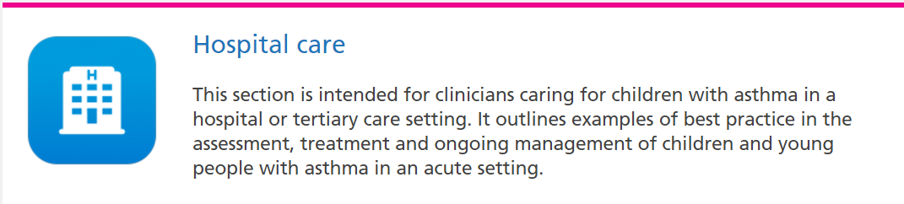

Bringing about change – #AskAboutAsthma
There are three very simple measures which if used consistently for all CYP with asthma would have a massive impact on quality of life for these children and young people.
- The use of a written asthma action plan drawn up between a clinician and asthma sufferer means people are four times less likely to have to go to hospital for their asthma. Only 28 – 48% of CYP with asthma in London have an asthma plan.
- Ensuring every child or young person (and their families/carers) understands how to use their inhaler effectively.. Less than ¾ of CYP have any form of instruction in how to use their inhalers meaning they may not be getting the full benefit of their asthma medication.
- An annual asthma review which will ensure those with asthma have effective regular review of their condition and management
The #AskAboutAsthma campaign encourages CYP and their families to ask for these three simple effective interventions to help them control their asthma. In addition, it identifies questions that healthcare professionals should ask of those CYP with asthma to help optimise care
Bringing about change - system-wide pledges
In addition to the three simple measures outlined above, improving outcomes for asthma is about leadership, accountability and training in every aspect of asthma care. It requires commitment to an integrated approach and outcomes need to be meaningful and based on meeting the asthma standards.
By aligning our efforts, children and young people with asthma and their families would be diagnosed earlier, would receive better management and experience improved quality of life. There would be less illness and fewer deaths associated with asthma, with less burden on the child, family and NHS as a result.

This agreement is aimed at everyone involved in the treatment and management of CYP:

- GP Federations
- Pharmacists
- Acute trusts (providing emergency and routine care)
- Specialist care organisations
- Commissioners
- Schools

We ask these groups to sign a pledge to improve the care and management of children and young people with asthma through supporting and working towards achieving the asthma standards relevant to them.
As part of this pledge, we ask those who sign up to agree to reduce their own contribution to air pollution that is a significant contributor to asthma in our city. Suggestions of how to do this can be found in “NHS Trusts: Air pollution reduction toolkit.”.

An organisational pledge for acute hospital trusts:

Improving the treatment and management of asthma in children and young people

To ensure clinical leadership for asthma care, the trust should have an identified lead for asthma who helps to develop excellent streamlined processes and best practice for admission and discharge.
The London asthma ambitions describe system wide goals. The London asthma standards for children and young people bring together the aspirations for London, the NICE Asthma standards, British Thoracic Society guidelines and a number of other key resources
By signing this pledge your organisation is committing to
- implementing the London asthma ambitions and standards for acute trusts
- taking steps towards improving air quality.
Please sign the organisational pledge document online or at the end of this document.
You are also encouraged to take a photo and tweet us @HealthyLDN about your pledge. If you would rather record a short film of your pledge, instructions are at the end of the document.
The London asthma standards relevant to hospitals are:
All organisations/services must have a named lead responsible and accountable for asthma (which includes children and young people). They must also all meet the organisational standards (No 1-7) and patient family and support information provision and experience (No 9-13). Please also the see the workforce education and training standards that are applicable to the setting (No 38-42)

The London asthma toolkit contains numerous resources to support trusts in implementing the standards.
The hospitals guide is here

Hospital care Standards
19 | The organisation complies with existing standards, such as the London acute care standards for CYP (which incorporate the London Quality Standards) and safeguarding policies.
20 | All CYP who present in an emergency are managed according to local policies and protocols and NICE guidance which incorporate acute management, education on-going treatment and discharge arrangements, including ensuring communication with community care electronically within 24 hours.
21 | NICE Statement 7: People with asthma who present with an exacerbation of their symptoms receive an objective measurement of severity at the time of presentation.
22 | People aged 5 years or older presenting to a healthcare professional with a severe or life-threatening acute exacerbation of asthma receive oral or intravenous steroids within one hour of presentation and seen by the respiratory team directly.
23 | People admitted to hospital with an acute exacerbation of asthma have a structured review by a member of a specialist respiratory team before discharge.  The structured review includes:  - Assessment of control (Children’s Asthma Control Test (ACT) if aged over 4 years) and / or triggers for wheezing.  - Inhaler techniques.  - Self-management and how to manage acute exacerbations.  - Personal asthma action plan.
High risk care
24 | There are systems in place in acute and community care for identifying patients at high risk, poorly controlled or severe asthma and monitoring/tracing and managing those CYP who have had in the last year:  - More than one admission.  - Admission to HDU, ICU, PICU.  - Two or more attendances to the emergency department or out of hours care in the last year.  - Two or more unscheduled visits to the GP (requiring short courses of oral steroids).  - Ten or more salbutamol inhalers.  - 80 per cent or less uptake of repeat preventer prescriptions
25 | There is access to paediatric physiotherapist with an interest in dysfunctional breathing (ideally ability to direct refer from primary care).

#AskAboutAsthma
Acute hospitals should make sure their staff:
- ASK children and young people with asthma about triggers and how to manage them

- ASK if they understand how to use their medications or inhaler before discharge and give help and advice

- ASK if they have an asthma action plan and, if not, ensure they get one

- ASK about and offer flu vaccination to CYP and their families

- ASK about smoking and refer/ offer stop smoking services to children and young people or parents/carers

- ASK for a clinic appointment or a review in 48 hours in the community - Trust asthma clinics should offer an appointment within 1 week to any asthma referral; clinics should be set up with an urgent slot

- ASK about transition to adult services when appropriate

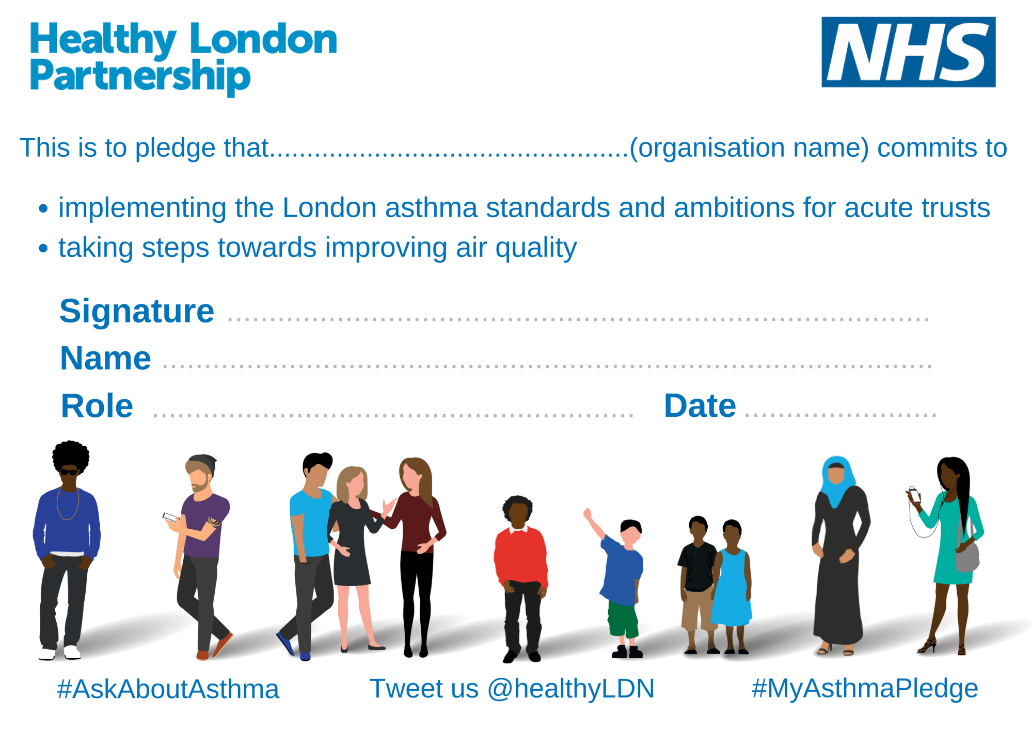
You can cover any aspect of the campaign (improving inhaler technique, asthma reviews or management plans), asthma care for CYP more widely or improving air quality/reducing pollution
Record a short vox pop!

If the audio is not clear, try using your headphone microphone

Five simple steps:

- Open your camera app
- Make sure the camera is on front view or ‘selfie mode’
- Switch on the record button
- Record your video
- Tweet it to us @HealthyLDN or attach it to an email to hlp.cyp-programme@nhs.net

Remember to say who you are at the start!

Good lighting is key, so ensure you are in a well-lit area

Make sure that you are fully visible to the camera and in focus

If you are in a loud or busy place, then move somewhere quieter

