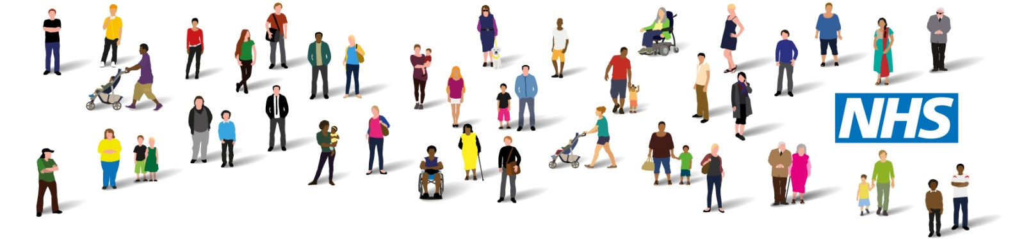
London’s Great Weight Debate: Executive Summary

1. What is the Great Weight Debate?

The Great Weight Debate is a multi-stage conversation to engage and involve Londoners in the health of their children, and to galvanise social action and support to tackle childhood obesity.
- In Stage 1, professionals and members of the public were engaged – key findings from this stage are summarised here.
- In Stage 2, local boroughs are engaging local residents in the debate.
- Stage 3, launched in the autumn, will entail city-wide conversations to revisit regional plans for action alongside the launch of the national strategy for childhood obesity.
- Stage 4 will involve the establishment of shared change platform for ongoing pan-London participation, learning and action on childhood obesity.

The Great Weight Debate is being overseen by London’s Prevention Board, with expert input and guidance provided by the London Obesity Leadership Group.

2. Stage 1 methodology overview

The objectives of Stage 1 were: to gauge public opinion on childhood obesity; to understand levels of support for action on this issue; and to crowdsource public-led solutions.

Stage 1 had 4 elements:
- Desk top review of key policies, opinion and research;
- 2 x focus groups with Londoners (10th February 2016);
- 3 x roundtables with professionals (30th, and 31st March, 5th April);
- Online community with 120 Londoners (18th April – 1st May); and
- The Great Weight Debate event, attended by 110 Londoners and 27 professionals (17th May)

Stage 1 was delivered by independent insight and strategy consultancy BritainThinks.

3. Summary of key insights

There is a need to raise awareness of the scale of the problem
Prior to taking part in the Great Weight Debate, awareness of the scale of the problem of childhood obesity in London was low amongst Londoners. However, information about the severity of the issue was deeply shocking, and led to calls for change.

Londoners felt the first step in bringing about change should involve information provision and awareness raising. This information should:
- be in a simple format, using facts and figures that all Londoners can understand;
- be provided in a location that is accessible to all Londoners, e.g. on public transport;
- strike a balance between shocking Londoners into understanding the scale of the problem, whilst avoiding stigmatising children who are overweight or obese; and
- frame the issue of childhood obesity in environmental and social terms to avoid the issue being dismissed as being about personal responsibility and / or poor parenting.

There is a strong appetite for direct and far-ranging interventions
Given the scale of the challenge facing London, both Londoners and professionals were willing to tolerate – and indeed called for – direct interventions at national, regional and local levels.
There was also strong support for the involvement of the private sector in tackling this issue. This support arose both from a view that the private sector has a moral responsibility to engage with issues affecting society, and a view that, practically, it is likely to be able to bring about considerable change.

When considering possible ideas for tackling childhood obesity, Londoners’ over-riding concern was the probable effectiveness of the ideas.
- The fairness of ideas – i.e. how likely they would be to help all Londoners, including those in deprived areas – was also an important consideration.
- However, although cost and ease of implementation were recognised as factors, these were deemed of secondary importance, given the severity of the issue.

4. Top ideas identified

Across Stage 1, a plethora of ideas for how to tackle childhood obesity were generated. On 17th May, Londoners identified their 5 top ideas.
- Change the way fast food outlets operate, including working with them to produce healthy alternatives to existing foods, limiting opening times and restricting new outlets.
- Ban the advertising of HFSS foods to children.
- Keep a fixed proportion of TfL advertising space for public health messaging.
- Use TfL signage to encourage active travel (e.g. advertising the amount of time it would take to walk to the next bus stop, and the number of calories this would burn).
- Make London’s green spaces safe and appealing for families (e.g. providing child friendly activities, such as green gyms).

5. Next steps

Over the next few months, HLP will be continuing this work by:
- continuing engagement with Stage 1 participants;
- developing a resource hub for local boroughs and CCGs to use when engaging communities in Stage 2;
- working with the Mayor’s office and devolution team to identify London-wide opportunities for change; and
- continuing to facilitate London-wide learning and improvement on this issue.

