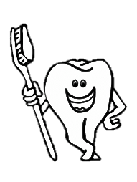
Healthy Teeth Healthy Smiles

First Tooth: First Visit to the Dentist Regular Dental Visits (at least once a year!) Brush twice a day, last thing before bed and any other time of day

0-3 years: use a smear of no less than 1000ppm of fluoride toothpaste (look on toothpaste box for fluoride content)

3-6 years: use a pea size amount of family toothpaste (1350-1400ppm of fluoride) look on toothpaste box for fluoride content

- Brushing should be supervised up to the age of 7 years. Spit, don’t rinse, after brushing

- Reduce the frequency of sugary food and drinks

- Water is the best drink for teeth

- Use a free flow cup from when the child is 6 months old

- Discourage bottle use by age of 1 year

Fluoride Varnish:

Fluoride Varnish is a topical golden colour gel that can be applied to a child’s teeth from 3yrs+ it protects teeth from decay

It is recommended that fluoride varnish is applied at regular intervals by your dentist

Dental Access:

NHS Dental Treatment is FREE for children up to the age of 18 years

NHS Dental Treatment is FREE for pregnant mums up to their child’s 1st birthday

Go to NHS Choices to find your nearest NHS dentist: https://www.nhs.uk

