Troubleshooting Guide
Community Pharmacy

Summary Care Record
Alert Viewer

October 2015

Contents
Getting started: Launching Summary Care Record (SCR) or Alert Viewer 3
Spine Portal URL 3
Alert Viewer URL 3
Summary Care Record (SCR) URL 4
Adding a Favourite or desktop Shortcut 4
Troubleshooting 5
How to check and correct your software versions 5
1. Internet Explorer (IE) 5
2. Java 6
3. Microsoft Windows 8
4. NHS Identity Agent 9

Getting started: Launching Summary Care Record (SCR) or Alert Viewer
Both Summary Care Record (SCR) and Alert Viewer applications are accessed via the Spine Portal.

Spine Portal URL
Locate the Spine Portal by copying the following URL into your browser window:
https://portal.national.ncrs.nhs.uk/portal/dt
The National Health Service Spine Portal screen should be displayed:
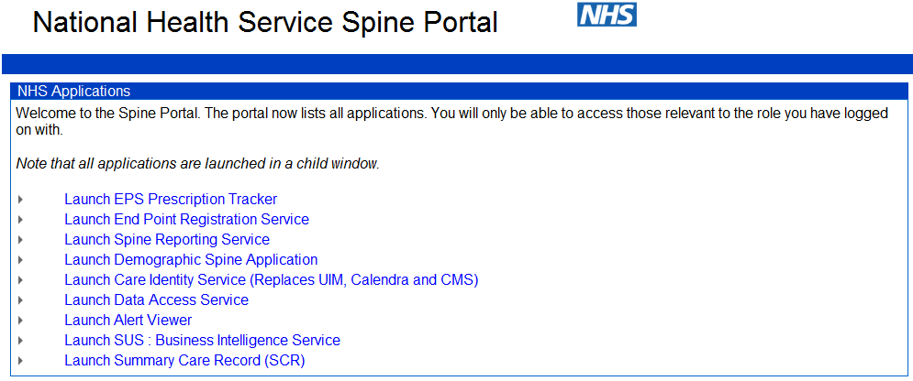
From the list of options select either ‘Launch Alert Viewer’ or ‘Launch Summary Care Record (SCR)’ from the list to access the required application.

Alert Viewer URL
The Alert Viewer application can also be launched directly using the following URL
https://portal2.national.ncrs.nhs.uk/spinealertservice
The Alert Search screen should be displayed:
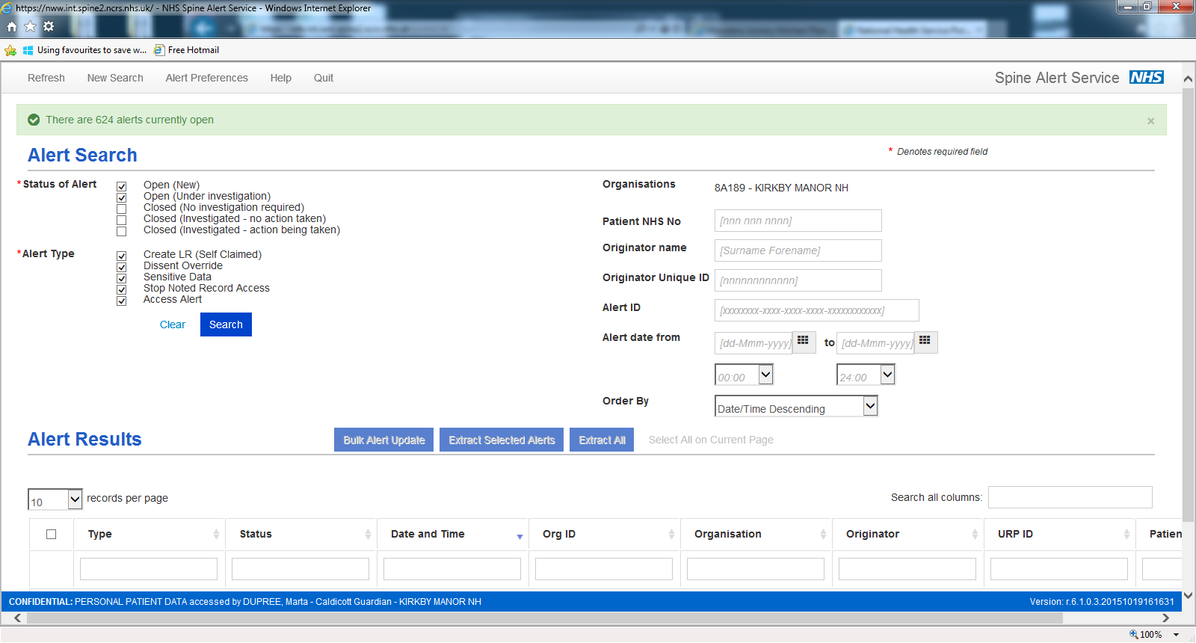

Summary Care Record (SCR) URL
The Summary Care Record (SCR) application can be launched directly using the following URL
https://portal2.national.ncrs.nhs.uk/summarycarerecord/patientsearch
The SCRa Find a Patient screen should be displayed:
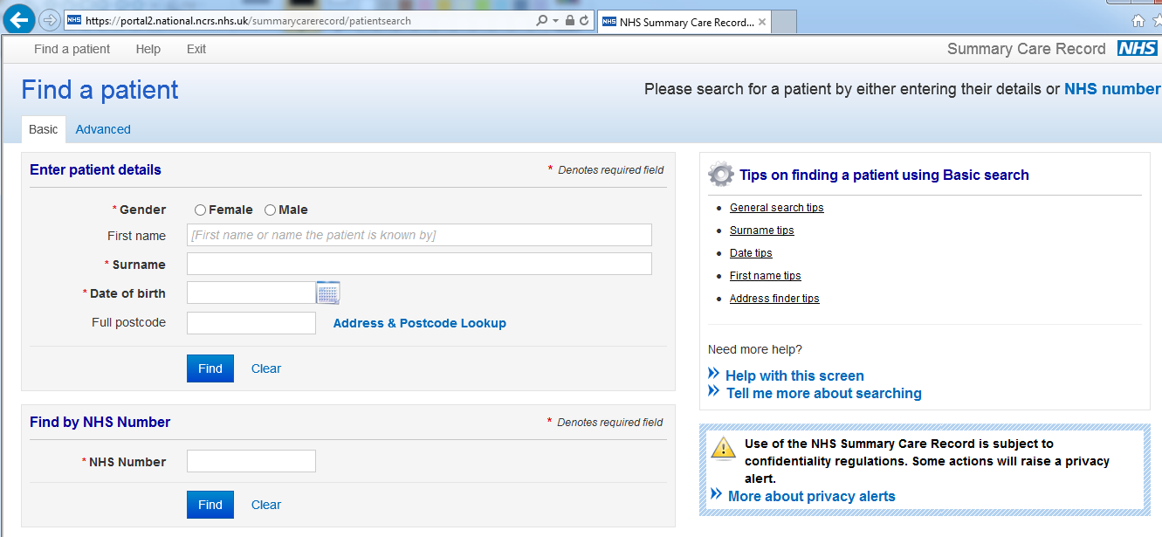

Adding a Favourite or desktop Shortcut
It is recommended to add the required URL(s) either as a favourite:
- Click the Favourites button
- Click the down-arrow next to Add to Favourites
- Select Add to Favourites bar.
- To go to a favourite site, click the Favourites button
Or as a shortcut on your desktop:
- Right click within a webpage
- Click Create Shortcut
- Click Yes

Troubleshooting
If you are experiencing problems with any of the above when accessing the Spine Portal, Alert Viewer or the Summary Care Record (SCR) application, you will need to check that you have the correct versions of:
- Internet Explorer (IE)
- Java
- Microsoft Windows
- NHS Identity Agent
You may find that your IT system supplier helpdesk has locked some of this down in which case you will need to contact them directly in order to resolve any issues.

How to check and correct your software versions

Internet Explorer (IE)
Which Internet Explorer (IE) version are you using? Desktop versions of MS Internet Explorer 8, 9 10 and 11 are supported.
Here's how to find IE version information in the browser:
- Open Internet Explorer
- Click the Tools button (or click Help in the Menu bar)
- Click About Internet Explorer.
- The About Internet Explorer screen will be displayed
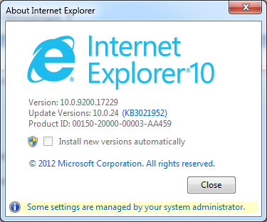
Example

Java
You should be using Java 7. If when you attempt to access the Spine Portal you see this this screen, you should check which version of Java you have installed.
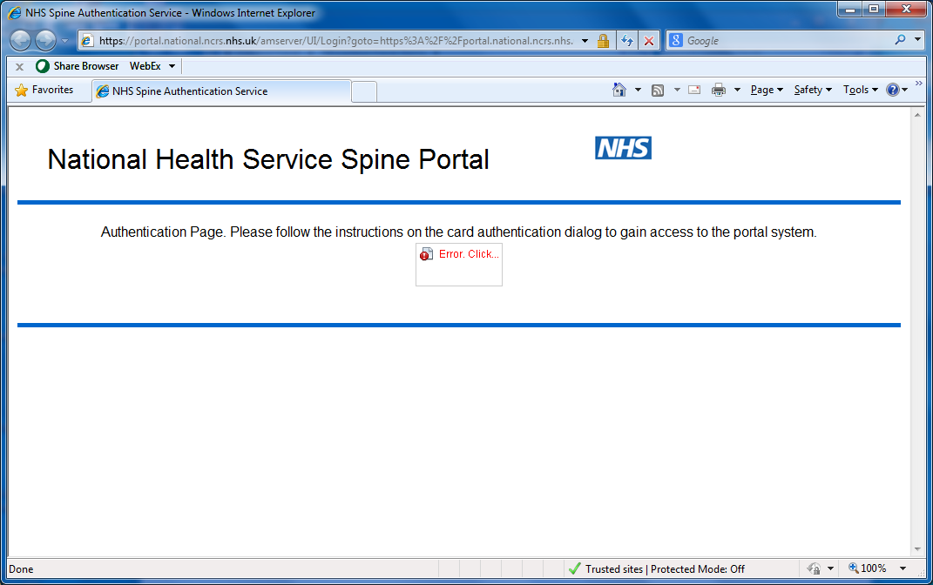


To do this, take the following steps:
- Click on Windows start button, located at the bottom left hand corner of you screen
- Click on Control Panel (if you can’t see it, type “Control Panel” in the Search field)
- Click on Programs and Features

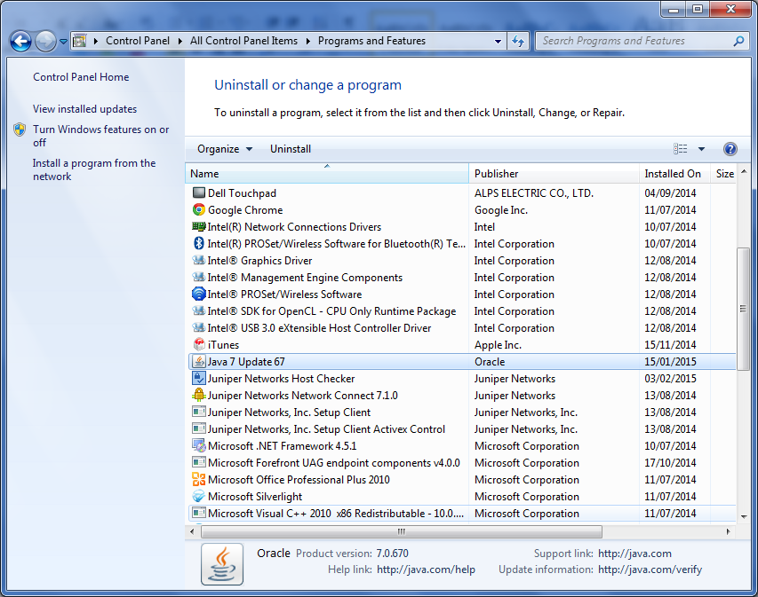

If you have Java 7 installed, this is ok. If you Java 8 installed you need to uninstall this version and install Java 7.

Click on the icon below and follow instructions on how to uninstall Java 8 and install Java 7.
Once Java 7 is installed continue with steps below
- Click on Windows Start button
- Click on Computer
- Click on Control Panel
- Click on Java icon. The Java Control Panel will be displayed.
- Click on Security tab located at the top of the screen
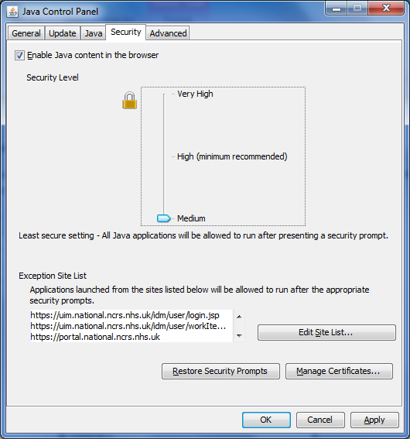

- Drag the Security Level bar down to Medium
- Click the Apply button
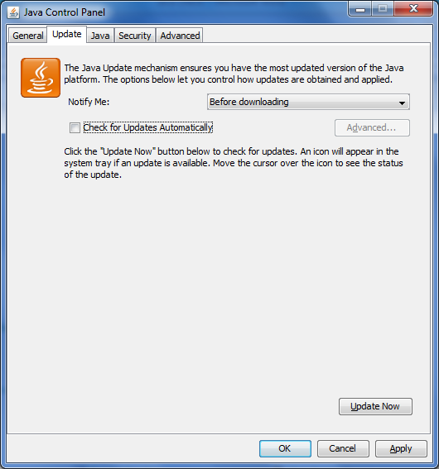

- Ensure the Update tab is selected, then click the Update Now button
- Un-tick Check for Update Automatically. A Warning will be displayed

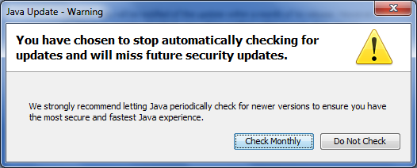

- Click the Do Not Check button
- Click Apply
- Click Ok
(You may need to restart your computer)
Support information is available here:
http://www.oracle.com/technetwork/java/eol-135779.html

Microsoft Windows
You should be using either Windows 7 or Windows 8.1. In the near future Microsoft will be recommending that all organisations upgrade to Windows 8.1. Your organisation will be informed when it is time to upgrade.
Here’s how to determine the version of Windows installed on your PC
- Click the Windows Start button located in the bottom left of your screen
- Ensure your cursor is in the Run or Search field
- Type winver, and press Enter.
This will open a new ‘About Windows’ screen and display the version of Microsoft Windows, the build info, and service pack information, if any service pack is installed. Below is an example of this window.

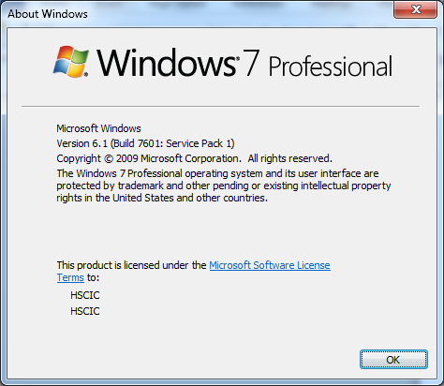

Microsoft support information is available using this link: http://support.microsoft.com/lifecycle/default.aspx?LN=en-gb&x=21&y=17

NHS Identity Agent
This allows access to all national and local services using smart cards and role based access control. The HSCIC IA is now the preferred client and is compatible with 32bit and 64bit operating systems. It is available on the HSCIC website using the following link
http://nww.hscic.gov.uk/dir/downloads
Scroll to the NHS Identity Agent heading and click the Download here hyperlink to download the latest version
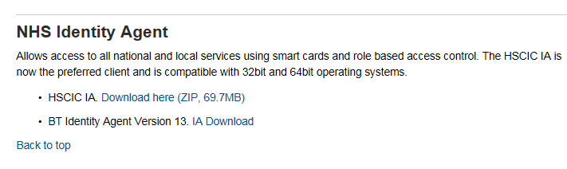
The current version is HSCIC IA v1.0, however this is due to be upgraded to HSCIC IA v2.0 in Q3 2015.
Identity Management (IA support)
iam@hscic.gov.uk

