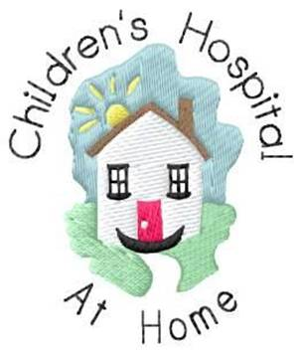

Children’s Asthma Team Follow Up Questions

Name:

Q1. During the past 4 weeks how often did your child’s asthma prevent you from getting as much done at school or home?

All of the time □ Most of the time □ Some of the time □ A little of the time □ None of the time □

Q2. During the past 4 weeks, how often has your child had shortness of breath?

More than once a day □ Once a day □ 3-6 times a week □ 1-2 times a week □ Not at all □

Q3. During the past 4 weeks, how often did your child’s asthma symptoms (wheeze, cough, shortness of breath, chest tightness) wake you up at night or earlier than usual in the morning?

4 or more times a week □ 2-3 nights a week □ Once a week □ Once or twice □ Not at all □

Q4. During the past 4 weeks, how often has your child used their reliever (blue) inhaler?

3 or more times a day □ 1-2 times a day □ 2-3 times a week □ Once a week or less □ Not at all □

Q5. How would you rate your child’s asthma control in the past 4 weeks?

Not controlled □Poorly controlled □Somewhat controlled □ Well controlled□Completely □

Q6. Has your child been to hospital since our last visit? Were they admitted?

Q7. Is your child attending regular GP or Practice Nurse asthma reviews

Q8. Are you using your child’s asthma action plan? Is it useful?

Q9. Any other feedback appreciated

THANK YOU FOR YOUR FEEDBACK IT IS CRUCIAL TO OUR ONGOING SERVICE

