Asthma Models of Care
Introduction
Health services in London are under strain and are bearing the brunt of pressures to meet increasing and changing health needs. The Strategic Commissioning Framework for Primary Care Transformation in London and the London asthma standards for children and young people sets out a number of ambitions to change the way we work based around the following.
Proactive care – supporting and improving the health and wellbeing of the population, self-care, health literacy, and keeping people healthy
Accessible care – providing a personalised, responsive, timely and accessible service
Coordinated care – providing patient- centred, coordinated care and GP-patient continuity
Patients will benefit through receiving care from a collaboration between generalists and specialist care and the wider health system within schools and local authorities, some elements will only be possible to deliver across a network of practices.
This can be done through commissioning new innovative multidisciplinary models of care as outlined in the recent NHS 5 Year Forward View.⁶ Which could be vertically or horizontally integrated
Potential delivery vehicles proposed are:
- Primary and acute care systems (PACS): these build on the vertically integrated model with one organisation (such as a foundation trust) taking a lead
- Multi-specialty community provision (MCPs): these build on emergent primary care federations
- Accountable care organisations (ACOs)
- Urgent and Emergency Care Networks
- Primary Care Home model is an extension of the MCP model. involves integrated provision of care, spanning primary, secondary and social care, to a defined, registered population of between 30,000 and 50,000 that has a combined focus on personalisation and improvements in population health outcomes. There will be aligned financial drivers through a unified, capitated population based budget with appropriate shared risks and rewards
These models all require an appropriately skilled workforce, with the right skills and competencies and access to locally relevant education and training (Appendix C).
Evidence for models
Nuffield trust (2016) The future of child health services: new models of care
dels of care
- Asthma education for children reduces risk of subsequent ED visit by 73% / admission by 68%. (Boyd 2009)
- Paediatrician led upskilling of Primary Care nurses in Asthma management led to a 65% drop in hospital admissions (Bodenheimer ’07)
- Introduction of Epilepsy specialist nurses resulted in 50% reduction for known paediatric epileptics (CWET case study)
- Introduction of Asthma specialist nurse resulted in reduced emergency admissions of 40% over 1 year (Asthma.org.uk)
- Three year programme with Paediatric nurse case managers resulted in a 48% reduction in hospital days and a 72% reduction in specialist appointments (Arch Pediatr Adolesc Med 2007)
- Cost Benefit Analysis of a community Asthma initiative combining Asthma nurses and school education showed the reductions in ED attendance and hospital admission delivered a return on investment of 1.3 (Journal of Asthma 2013)

Development of new commissioning models

Critical to implementing large scale change in asthma care is effective linkages into commissioning. Children’s asthma services need to be commissioned in a seamless integrated fashion across the entire pathway from prevention and self-management to in hospital and out of hospital care. It should be managed and evaluated against national London asthma standards for children and young people and local standards.

Commissioners should take a population / place based approach which addresses the needs of an individual as well as the diverse population needs. CCGs should consider targeting the following groups depending on local needs:

There should be a networked and integrated care approach to CYP asthma services effectively producing a single, seamless service for children and young people that is proactive, accessible and co-ordinated. It could use a hub and spoke model with sharing of resources across the pathway or an integrated community based one.
The approach to asthma improvement should be based on effective partnership between the child, their family/carers and extended family, schools and primary care. This may involve, primary care, CCG, local authority and/or specialized commissioning in order to address:
- Prevention including raising public awareness
- Early and effective diagnosis
- Reduced exposure to triggers
- Improved education of health care professionals, patients, their carers and their schools
- Improved access to timely interventions and management

These could be based on the House of Care framework and should consider whole pathways of care that consider prevention, diagnosis, treatment and follow up as well as encouraging continuous learning and improvement. They should deliver all required services to provide care closer to home this may involve specialist outreach. Models that incentivize innovative contractual solutions that focus on integrating multiple providers by moving towards outcome based commissioning and potential bundled payments for asthma care (insert link) in London. This supports redesigning care around the delivery of outcomes that matter to patients and paying for entire cycles of care and associated outcome reporting. The culture should be based on collective resourcing to improve whole population outcomes.

House of Care
Care for children with long term conditions such as asthma must be proactive, holistic, tailored, preventive and patient-centred. The House of Care framework is a useful model which describes a whole system approach, centred around the child and their family. It assumes an active role which includes care planning and integration. All aspects need concentration on especially the commissioning foundations, not just the roof, or the building will collapse and care for the child will suffer as a result.
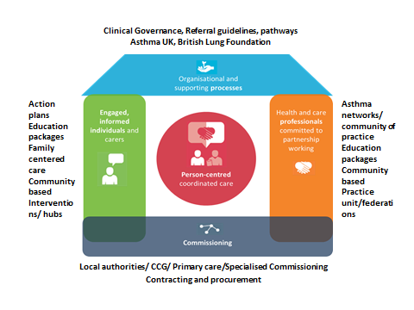
Figure 1 Asthma House of Care
- Integration of care

The aim is to move away from traditional primary and secondary care domains and work towards more integrated care that focuses services around the child and their family. The aim is to break down the barriers between organisations to develop innovative approaches to improve care outcomes. This could be achieved through integrated children’s health services wrapped around the family, integrated multi-specialty practice units or local networks of care
Communication between all health professionals, local authorities, schools and social services is essential to improve continuity of care and share outcomes. This will be enhanced through flexible IT systems that talk to each other.

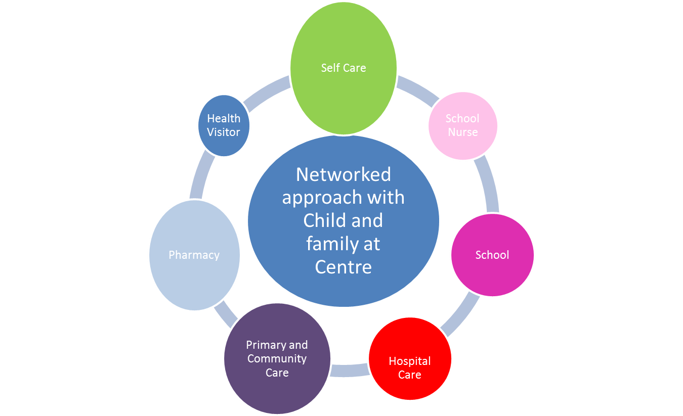

PACS or multispecialty providers with community development initiatives

Integrated out of hospital and in hospital services
Figure 2 CYP integrated multispecialty practice unit/hub
Each localit should have access to clinics that can see children and young people with asthma after svhool (or within the school) supported by asthma trained specialist nurses who will work with their network of named practice nurses, named school nurses and named consultants in hospital. Education, information and support (including clinical supervision) will be a key component
Care should move seamlessly from generalist to community and specialist as the child’s needs require
Timely access to ED and referral for specialist advice
Asthma action plans
Education for family and professionals (including schools)
Protocols and guidelines
Figure 3 Proposed asthma model
Local examples
In Islington, there has been a strong drive to improve care and education for primary care and schools, and care planning alongside the formation of GP networks,

North West London London integrated care project: A collaboration of over 30 organisations, community groups and lay partners that have come together to develop a vision for Whole Systems Integrated Care across North West London

Lambeth and Southwark

Evelina Children and Young People Health programme (CYPHP) programme
The Evelina Children and Young People Health programme is taking a child population approach. It’s local child health care model has 4 components encompassing:
- Support to Primary Care,
- an Acute Care Hub,
- a Non-Acute Care Hub
- and an Evelina Academy.
Their vision is
‘All children, young people and their families in Lambeth and Southwark to have access to everyday healthcare that is safe, clinically effective and delivered as efficiently close to home as possible…as part of a world class person-centred health system’

Outcomes so far: In-reach clinics set up in phase 1 demonstrated a 17% reduction in outpatient appointments Please see information in case study section
Specialist support available to Primary Care through Children’s Acute referral Service hotline data shows that over 35% of calls to the hotline would have resulted in the patient going to A&E or an outpatient appointment.

Croydon Hospital At Home
Croydon have developed a community home based visiting service which utilises both one to one an school learning, innovative social media campaigns and text messaging to focus on the prevention of ill health through education, effective self-care, and accessible and responsive services. 100% of patients visited have inhaler technique check and personalised asthma action plan. Link to case study

Connecting Care for Children
Connecting Care for Children is an innovative programme which connects paediatric expertise, local GPs, commissioning leads and social care partners to provide community support to primary care, where children’s and families’ needs are known and can be managed well.
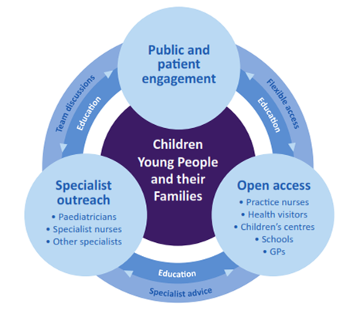
GP practices work together in groups, or ‘hubs’ of three or four GP practices, with a population of approximately 20,000 people, including 3,000 – 4,000 children. There are currently nine hubs in North West London. The whole population approach taken by the hubs means that different group of patients can be discussed and thought about in a very proactive, preventative way. An example might be how the hub can use the MDTs and some clinic slots to make sure that children and young people with asthma are reviewed and appropriate interventions put in place.
http://www.cc4c.imperial.nhs.uk/
What does good care look like?
Care needs to be through a ‘partnership model’ where care is planned, co-ordinated and shared, it may take on a different configuration in each area depending on local needs. The recent Nuffield Trust document Future of child health services: new models of care provides some useful information
In order to meet the London asthma standards for children and young people the following may be useful

Key principles for any future local model of care
- Clinical leadership is essential to take improvements forward but also responsibility for patient care. There should be a lead healthcare professional taking responsibility for asthma within each organisation (Appendix A) Alongside this engagement with all stakeholders including CYP and their families is the key to making transformational changes.
- Governance must be about the relationships specialists and generalists working together for the benefit of children and young people woth specialist having a defined responsibility for the population.
- Develop local or regional networks to encourage stakeholders to collaborate to develop a plan for your local area and to develop strategies for sharing of resources and best practice across London and geographical boundaries
- The CYP team should provide care within a pathway/network model which should include general practice, pharmacy, health visitors, school nurses, children’s community nursing teams, advanced nurse practitioners in addition to secondary and tertiary care clinicians. It could also include peer educators or local champions.
- CYP for urgent and non - urgent care should be cared for, out of the hospital setting, wherever it is safe and possible to do so.
- Develop suitable referral processes across the entire pathway including self-referral for smoking cessation for children over 12 and their families (see smoking cessation section Guidelines and protocols should be in place that include when to refer patient onto secondary care
- All CYP needing urgent care are triaged, and managed where safe to do so in primary care on a 24/7, 7 day a week basis by professionals with the right skills and competencies.
- Future education, training and workforce strategies must ensure that all staff caring for CYP with asthma have the necessary skills and competencies to recognise the sick child
- Develop best practice discharge processes (link to discharge and review sections)
- Identify barriers to communication between health care professionals and develop solutions
- Utilise national and local voluntary support organisations such as Asthma UK and the British Lung Foundation to support your local networks and families and local community networks
- Consider more culturally focused family / community based interventions that cater for the diverse needs of London population such as MIA: Multifaceted intervention for asthma A link to the full report is here and video

Supporting Primary Care Resources / Further reading
RCPCH conference Dec 2015: Facing the future together working with general practitioners http://www.rcpch.ac.uk/improving-child-health/better-nhs-children/service-standards-and-planning/facing-future-together-c-2#,
Future Fit (2014) Clinical Design Workstream Final Report May 2014 Models of Care http://nhsfuturefit.org/key-documents/documents/reports/15-future-fit-clinical-design-report/file

Strategic Commissioning framework () Transforming urgent and emergency care services in England. Safer, faster, better: good practice in delivering urgent and emergency care. A guide for local health and social care communities (Aug 2015) http://www.nhs.uk/NHSEngland/keogh-review/Documents/safer-faster-better-v28.pdf
https://www.youtube.com/playlist?list=PL9gq4FCbIiJWG1hMVCy_LfIuXU0xqsnB1
https://www.england.nhs.uk/commissioning/pc-co-comms/
Outcomes based healthcare & Capsticks (2014) Contracting for outcomes A value based approach

