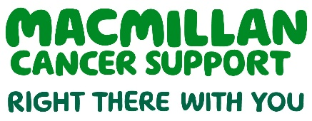
Improving psychologically informed cancer care: implementing the London Integrated Cancer Psychosocial Care Pathway and the development of psycho-oncology services
A business case
February 2020

Acknowledgements
The Transforming Cancer Services Team (TCST) would like to thank Macmillan Cancer Support for enabling this work to be undertaken by funding Dr Philippa Hyman, Macmillan Mental Health Clinical Lead, to carry out this project over the past three years.
We would also like to thank all members of the Pan London Psychosocial Support and Cancer Steering Group who contributed to this work and provided constructive feedback at all stages of this project. Service users have been central to this work and their time, feedback and challenge has been invaluable. Furthermore, partnership working with Macmillan, other third sector organisations, service providers across acute, primary and community care, as well as support from commissioners, has been instrumental to this work. Finally, we would like to thank the Personalised Care for Cancer Team, within the TCST, for their support and guidance during the past year.

This report was funded by Macmillan Cancer Support
We’re here to help everyone with cancer live life as fully as they can, providing physical, financial and emotional support. So whatever cancer throws your way, we’re right there with you. For information, support or just someone to talk to, call 0808 808 00 00 or visit macmillan.org.uk. To give, fundraise or volunteer call 0300 1000 200 or visit macmillan.org.uk

Who we are, what we do
The Transforming Cancer Services programme was established in April 2014 to provide strategic leadership, clinical advice, oversight, cohesion and guidance to improve outcomes for patients through a pan-London clinically led, patient-centred collaborative approach.
The Transforming Cancer Services Team (TCST) is part of the Healthy London Partnership. The Healthy London Partnership brings together London’s health and care system to deliver changes that are best done “once for London”.

Our vision is for all Londoners to have access to world class care before and after a cancer diagnosis. Our mission as a trusted partner, is to drive delivery of world class cancer outcomes through collaboration, commissioning support, clinical leadership, education and engagement.

Our pan-London transformation is responsible for:

• A ‘once-for-London’ approach to implementing the NHS Long Term Plan
• Providing subject matter expertise, evidence and intelligence for cancer commissioning support
• Working with partners to reduce variation and deliver improved cancer outcomes
• Primary care development and education
• Targeted service improvement in secondary care

What is the purpose of this document?
This purpose of this business case is to provide system leaders/commissioners with information to enable the implementation of the London integrated pathway for cancer psychosocial support, which could be delivered within Integrated care systems (ICSs). By implementing this model psychologically informed cancer care will be delivered across the whole cancer pathway ensuring better patient experience, quality of life and clinical outcomes for adults affected by cancer and those significant to them. The model can be localised according to the resources available in the geographical area and the recommendation would be that where there is limited cover or no existing service that a comprehensive psycho-oncology service is commissioned at STP/ICS level. The service should align with STP/ICS objectives and have the appropriate support for implementation. We believe that by taking this approach, services will be more sustainable, will deliver better economic benefits, and will produce better outcomes for patients, their families and carers across the whole cancer pathway.
Much of the content of the document is based on the work of the TCST in partnership with Macmillan Cancer Support who produced a report, published in May 2018, ‘The psychological impact of cancer: commissioning recommendations, pathway and service specifications on psychosocial support for adults affected by cancer’ (available here). The recommendations in the 2018 guidance report were endorsed by London’s Cancer Commissioning Board (CCB) in February 2018. This business case was presented to and endorsed by the London Cancer Transformation and Improvement Board (CTIB) in September 2019.
In this business case, there is a focus on the development of psycho-oncology teams across London as the original mapping (completed in November 2017) identified significant gaps and inequity in provision, which needs to be addressed as a priority1.
Within this document, there are sections where system leaders/commissioners will need to localise the model with consideration of their current service provision, cancer prevalence data for their respective CCGs/STP and other local information including data that addresses health equality (these areas are highlighted in yellow). Additionally, this business case should be considered alongside the 2020 TCST Publication, Pan-London Mapping of Psycho-oncology Services Report, as well as the recently refreshed TCST commissioning guidance document (2020). All of these resources can be found as outlined below:
- Pan-London Mapping of Psycho-oncology Services Report (2020), available here: https://www.healthylondon.org/psychosocial-support/
- Commissioning guidance for Cancer Psychosocial support: A guide to improve psychologically informed care for adults affected by cancer and those significant to them (refreshed 2020), available here: https://www.healthylondon.org/psychosocial-support/
- 2017 Cancer prevalence dashboard, available here: https://www.healthylondon.org/resource/2017-cancer-prevalence-dashboard/
- TCST Cancer Inequalities Toolkit, available here: https://www.healthylondon.org/resource/cancer-inequalities-toolkit/
- National Cancer Patient Experience Survey (2018) results, available here: https://www.healthylondon.org/our-work/cancer/patient-experience-survey/
System leaders/Commissioners are asked to:
- Adopt the proposed London Integrated Cancer Psychosocial Care Pathway
- Localise the pathway by mapping current resources, supporting partnership working and identifying gaps at STP/ICS level.
- Where there are no or very limited Psycho-oncology teams, allocate sufficient resource to ensure a Psycho-oncology service is available to deliver the outcomes indicated in the pathway (including closer working partnerships across Primary Care and Improving Access to Psychological Therapies (IAPT) services).

Executive summary
Cancer and its treatments have the potential to significantly impact on mental health, physical health and socio-economic status in multiple ways, not least by disrupting relationships, finances and employment. Most people will use a variety of resources to cope including their own inner emotional resources, the guidance of trusted healthcare professionals and external support systems such as family, friends, peer networks and third sector organisations.
But for some people where there may be additional social and psychological adversity, these resources may be insufficient to manage the personal impact of cancer and distress, dysfunction and poor health self-management may follow having a significant impact on the person’s quality of life and on the lives of their families and carers. Additionally, psychological obstacles if not addressed, can impact on a person accessing tests, investigations, treatment adherence, engaging with rehabilitation and ultimately impact upon clinical outcomes.
- In the year following diagnosis, around 10% of patients will experience symptoms of anxiety and depression severe enough to warrant intervention by specialist psychological/psychiatric services. Among those who experience recurrence of disease, the prevalence of anxiety and depression rises to 50%. Such difficulties can also be seen in 10-15% of patients with advanced disease
- 58% of people diagnosed feel their emotional needs are not looked after as much as their physical needs
- Cancer patients have a 55% higher risk of suicide than those without cancer
- Even 10 years after treatment, 54% of cancer survivors still suffer from at least one significant psychological issue
- 67% of carers experience anxiety and 42% experience depression. Of these, over three quarters do not receive any support.
The experience of cancer and its longer term physical and psychological consequences can also have a significant economic cost.
- Healthcare costs for people with long-term conditions are 50% higher in people with depression and/or anxiety disorders.
- Psychological therapy reduces physical healthcare costs by an average of 20% (meta-analysis of 91 studies). When data is available on cost of psychological treatment and physical healthcare, savings exceeds costs.
Lending support to the vital role of specialist psychological interventions was a Health Foundation report published in August 2018. This report highlighted that patients who were most able to manage a mental health condition, as well as their physical health conditions:
- experienced 49% fewer emergency admissions than those who were least able.
- had a length of stay in hospital 41% shorter compared to those least able
- 32% fewer A & E attendances
- 18% fewer GP appointments

This business case outlines a proposal to implement the London Integrated Pathway for Cancer Psychosocial Support (See Figure 1), which can only be delivered if supported by a comprehensive psycho-oncology service in (insert name of local area).
System leaders/Commissioners are asked to:
- Adopt the proposed London Integrated Cancer Psychosocial Care Pathway
- Localise the pathway by mapping current resources, supporting partnership working and identifying gaps at STP/ICS level.
- Where there are no or very limited Psycho-oncology teams, allocate sufficient resource to ensure a Psycho-oncology service is available to deliver the outcomes indicated in the pathway (including closer working partnerships across Primary Care and Improving Access to Psychological Therapies (IAPT) services).

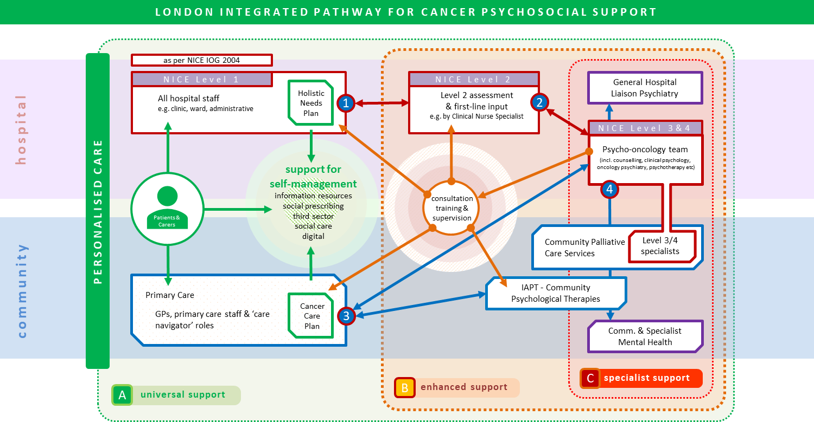
Figure 1: London Integrated Pathway for Cancer Psychosocial Support

This whole system model is based on a core set of principles that has been the result of extensive engagement with stakeholders across London, including system leaders/commissioners, GPs, primary and secondary care providers, the third sector, and service users.
Key features/benefits of the pathway:
- This is an integrated pathway which if implemented will ensure the improved delivery of psychologically informed care across the cancer pathway.
- Distinction between universal, enhanced and specialist support
- Majority of people affected by cancer cope with support from family/friends, trusted healthcare professionals, third sector support, information and signposting. Preventing distress and promoting adjustment at the centre of the pathway.
- Different services have key roles at different points along the pathway-no single service alone is sufficient. The pathway needs both Improving Access to Psychological Therapies (IAPT) services and Psycho-oncology teams, it’s not either/or.
- Psycho-oncology teams will share expertise across the whole pathway, including consultation and training with primary care teams and IAPT services.

Table 1: The benefits of commissioning a psycho-oncology service
Group | Benefits
For patients | Improved quality of care  Improved patient experience and quality of life  Reduced strain on carers/families  Improved clinical outcomes as patient receives specialist psychosocial interventions aimed at:  - Supporting patients with accessing tests  - Supporting patients with treatment adherence  - Supporting patients to engage in cancer rehabilitation and rehabilitation  - Supporting patients to manage their mental health  - Supporting those with Severe Mental Illness (SMI) to engage with services across the cancer pathway  Receiving interventions from psychological specialists with expertise in both psychological/mental health and cancer rather than generalists.  Patient choice and preference- patients want to see psychological specialists with expertise in both mental health and cancer.  Consultation, liaison and training of other staff across the pathway (CNSs, AHPs, GPs and practice nurses, MDT colleagues, IAPT workers) enhances psychologically informed cancer care and develops the skills of other professionals seen by the patient.
For Primary Care | Reduced GP attendances if patient has mental health needs better met.  Increased confidence of GPs to manage psychosocial difficulties associated with cancer  Skills development through stronger links with psycho-oncology teams, training and consultation.  Clearer pathway and knowledge of when to refer to IAPT services and when to refer to psycho-oncology teams resulting in better clinical outcomes and improved patient experience.
For Providers | Psychological specialists embedded within cancer settings where people are diagnosed and treated delivering a range of NICE recommended interventions.  Skills development/training for Level 2 workforce (Clinical Nurse Specialists and Allied Health Professionals)  Skills development/training for medical colleagues and all staff working with adults affected by cancer.  Enhanced multi-disciplinary team working-using psychological approaches  Staff support (improving staff retention/recruitment, reducing sickness) e.g Schwartz rounds  Improved clinical outcomes  Improved patient experience  Impact on wider healthcare utilisation e.g fewer GP appointments, fewer emergency admissions, reduced lengths of hospital stays
For System leaders/ Commissioners | An effective integrated model where psycho-oncology teams share expertise, training and skills across the pathway  Improved quality of cancer psychosocial care for local population  Improved patient experience and outcomes  Reduced variation/inequality  Potential cost savings from reduced healthcare utilisation and quantifiable improvements in quality of life.

We recommend that the London Integrated pathway for cancer psychosocial support is implemented and a comprehensive psycho-oncology service is developed at STP/ICS level for xxx (insert local area). This recommendation is in line with the guidance and recommendations from Healthy London Partnership’s Transforming Cancer Services Team for London. This business case was presented and endorsed by the Cancer Transformation and Improvement Board for London (CTIB) in September 2019.
It is clear from the case outlined in this document that implementing the proposed pathway model and the development of this psycho-oncology service will improve patient experience, quality of life and clinical outcomes. Additionally, the implementation of the pathway and ensuring equity of access to psycho-oncology teams has the potential to impact on wider healthcare utilisation and through Quality Adjusted Life Years (QALY) gains will also contribute monetary benefits.

Frequently Asked Questions (FAQs)
Why do we need a London Integrated Cancer Psychosocial Care Pathway?
There has been widespread recognition in London from service providers, service users and system leaders/commissioners for many years that the psychosocial needs of those affected by cancer, their families and carers have not been adequately met, with confusion regarding when, how and where to refer. Uncoordinated, disjointed and poorly understood services across London has meant that there is huge variability in patient experience, outcomes and quality of life. In January 2017, Macmillan Cancer Support funded a specific post to develop a pan London integrated, whole pathway, considering psychosocial needs from diagnosis, through treatment, living with and beyond cancer and end of life care. The central aim being to develop a pathway to improve patient experience and outcomes which would make sense to service providers, service users and system leaders/commissioners.
The pathway model outlined in this paper is the result of extensive engagement with system leaders/commissioners, GPs and primary care staff, secondary care providers, IAPT colleagues, the third sector and service users who have engaged in a series of pan London stakeholder events where the key principles were agreed. Excellent representation, from all five Sustainability and Transformation Partnerships (STPs) and the cancer alliances in London, at these stakeholder events has ensured that there has been agreement that this integrated whole pathway model is the right approach for London.
Based on feedback from pan London stakeholder events it was agreed that the terminology ‘Psychosocial pathway’ should be used instead of ‘Psychological pathway’. The term ‘psychosocial’ captures the importance of considering the broad range of determinants affecting emotional well-being and that there are a range of beneficial interventions that are delivered by a variety of professionals.
All psychosocial care within the proposed pathway will be provided within the framework of the 4 level model recommended by the NICE Supportive and Palliative Care Guidance 20043 (Figure 2) This guidance has not been refreshed since 2004 but remains in effect and is a well-recognised framework, understood by service providers, the third sector and system leaders/commissioners.

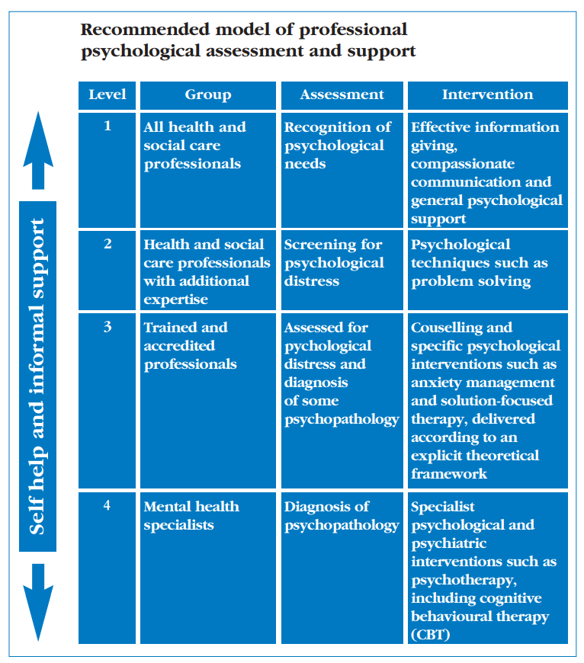
Figure 2: Four Levels of Psychological Assessment and Support (NICE 20043)

The London Integrated Cancer Psychosocial Care Pathway model:
- Delivers excellent psychosocial support across acute, primary care and community settings
- Ensures effective communication, collaboration and partnership working between all staff across the whole pathway.
- Through commissioning psycho-oncology teams as a core component of this model will reduce unwarranted variation within London in access to cancer psychological specialists.
- Psycho-oncology teams will share their expertise, skills and training across the pathway, encouraging psychologically informed cancer care by all professionals working with those affected by cancer, their families and carers, which will improve patient experience, clinical outcomes and quality of life.

What is the role of Improving Access to Psychological Therapy Services for Long term conditions (IAPT-LTC), why can’t they deliver all the support for those affected by cancer?
In 2008, the NHS Improving Access to Psychological Therapies (IAPT) programme began in England. The programme aimed to implement interventions for treating people with anxiety and depression. Integrated IAPT services started to treat people with long-term conditions (LTCs) in January 2017 focusing on evidence based psychological therapies within the context of a long term condition. To date the focus has mainly been on on diabetes, coronary heart disease (CHD), chronic obstructive pulmonary disease (COPD) medically unexplained symptoms and pain.
IAPT-LTC services play an important role along the pathway but cannot deliver the range of psychological interventions required to support adults across the whole cancer pathway and the range of ‘indirect’ interventions delivered by psycho-oncology teams: such as Level 2 training (see levels outlined in Figure 2) for Clinical Nurse Specialists and Allied Health Professionals, rapid case consultation with oncological multi-disciplinary teams or Schwartz rounds. The TCST established a working group covering primary care, IAPT, psycho-oncology and psychiatry to establish a pathway with clear referral criteria for when those affected by cancer are appropriate for IAPT and when their psychological needs are best addressed by psycho-oncology teams.
The London Integrated Cancer Psychosocial Care Pathway has been developed with a huge amount of stakeholder involvement at a London wide level, including IAPT clinical leads. The results of this was an agreement of the criteria outlined in this document which specifies clearly that the role of IAPT will be to treat anxiety and depression within the context of a long term condition:
- when the person is medically stable
- in cancer remission
- when cancer is ‘in the background’
- with few hospital cancer-related contacts/routine follow up
- with nil or mild/well-managed physical consequences of treatment
- where unidisciplinary input is sufficient
- where there are no acute mental health risk concerns.
IAPT forms a critical part of the pathway, and the subsequent activity going to IAPT as a result of implementing the pathway and developing psycho-oncology services will contribute to the IAPT access target. This will be achieved by closer working relationships and clearer referral pathways being developed locally across psycho-oncology teams, IAPT services and Primary Care, so that clinically appropriate referrals are directed to IAPT services.
IAPT clinicians including high intensity and Psychological well-being practitioners (PWPs) will have the opportunity to receive training and consultation with Psycho-oncologists to ensure optimum quality in service delivery and the best outcomes for people affected by cancer in London.
Why do we need to commission Psycho-oncology teams?
For some people the impact of cancer can be overwhelming and severe enough to need interventions delivered by psychological specialists who work with a full range and severity of psychological and mental health difficulties associated with cancer.
Psycho-oncology is a multi-disciplinary speciality focusing on the psychological and mental health care of people affected by cancer, their carers and families. Through both ‘direct’ and ‘indirect’ care, these specialists contribute to improving clinical outcomes, patient experience and quality of life. Psycho-oncology teams (Level 3 and 4 specialists, see Figure 2) are generally composed of a range of professionals, including Clinical Psychologists, Counsellors, Psychotherapists, and Psychiatrists.
These teams provide the following support to patients:
- To enable patients to access medical investigations/treatments (e.g where anxiety/trauma may have been stopping them having a scan/chemotherapy, radiotherapy)
- To enable patients to make decisions about whether to have tests/investigations
- To address psychosocial factors affecting treatment adherence
- To improve physical symptom management e.g dealing with shortness of breath, managing pain.
- To support access to physical prehabilitation and rehabilitation so patient engages with (Physiotherapy, Speech and Language therapy, dietetics etc) thus speeding up recovery.
- To maintain/develop trusting relationships with other members of the multi-disciplinary team or primary care staff thus improving patient experience and outcomes.
- To support patients in making decisions towards the end of life such as to decline treatments that are not primarily focused on enhancing well-being and comfort
- Deliver interventions to patients who are inpatients
- Deliver level 2 supervision and training to CNS and AHPs as outlined in NICE guidance (2004)3
- Share expertise, consultation and training across the whole pathway including to IAPT (Improving Access to Psychological Therapies Services) colleagues and Primary Care.
- Deliver systemic interventions with staff teams and families
- Conduct incident debriefing and Schwartz rounds focusing on enhancing the morale, confidence and well-being of staff teams.
None of the above is delivered by Improving Access to Psychological Therapies Services (IAPT).
These specialists within psycho-oncology teams understand the psychological factors that can affect uptake of screening and investigations, decision-making and adherence to treatment, or those factors that negatively impact trust and relationships with a healthcare team. Psychological specialist working in cancer settings understand the impact of cancer within the context of a person’s current or past history of serious mental health difficulties, significant losses, traumas and early adversity.
Understanding and delivering interventions that address the way that psychological obstacles can impact across the whole cancer pathway is essential in improving patient outcomes and quality of life. In short, specialist psychosocial interventions are an essential component of the cancer pathway and should not be considered a ‘luxury’ or a non-essential element of cancer care.
For the London Integrated Cancer Psychosocial Care Pathway to work successfully in reducing variation in the provision of excellent psychosocial support, there needs to be access to Psycho-oncology teams. Within this new proposed model these teams will not only deliver the range of highly valued interventions within the acute hospital setting but as the experts in cancer and mental health will share expertise across the whole pathway, including providing consultation, training and supervision to primary care staff, IAPT and other community teams. This will ensure that people affected by cancer and those significant to them receive psychologically informed care wherever they are on the cancer pathway.
All workforce calculations need to incorporate this whole pathway approach as this will require the remit of these teams to take on additional roles across the pathway rather than purely delivering services within the acute sector.
What is the role of the Third Sector, can’t they provide all the emotional support?
Third sector organisations play a hugely valuable role but are unable to provide all the complex array of psychological interventions required across the cancer pathway. They have an important role as non-statutory services in supporting the work of the NHS and social care. For some people, small locally based third sector organisations can be excellent at meeting local community needs especially ‘hard to reach’ groups. Additionally, the range of support offered by third sector organisations such as Maggie’s Centres, is very much valued including: information and sign-posting, financial help, complementary therapies, befriending services, providing loans and grants for equipment that might be needed, transport and counselling. Some organisations also run self-help groups or groups for families and carers, which can be separate or effectively work alongside NHS services. But third sector organisations are not a substitute for the NHS commissioning psychosocial specialists in cancer. Nurses and doctors would not be expected to be provided via the third sector and the same should apply to the provision of Clinical Psychologists and other professionals that form part of psycho-oncology teams.
Why treat people affected by cancer as a distinct group, their emotional and functional needs are no different to those with other health conditions?
Some of the symptoms, treatments and outcomes associated with cancer are present in other non-malignant health conditions. However, while the term ‘cancer’ covers a wide range of diseases, there is a configuration of experiences (physical and psychological) that are somewhat distinct. There are over 200 different types of cancer with a huge variation in the range of treatments, consequences and prognosis that people must live with. Cancer treatments can be remarkably arduous. Moreover, for patients diagnosed through screening or as an incidental finding, they often feel well but are faced with the disturbing prospect of having to undergo treatments that can have a systemic impact making them feel extremely ill and/or induce distressing side effects such as hair loss, extreme fatigue, appetite loss, nausea and vomiting, lymphedema, and pain. During the acute phase of diagnosis and treatment, assessment and intervention needs to be rapid, flexible and well-integrated into oncology services. Psychological interventions are frequently provided to support patients who are struggling to engage/cope with medical investigations and treatments. As prompt oncological care is often associated with better outcomes, it is clearly important that psycho-oncology services are flexible and able to be highly responsive if an emotional issue is delaying treatment. Close working relationships with the professionals who deliver the physical aspects of cancer care are crucial. For example, intervening with a patient who is too anxious to undergo radiotherapy is not something that can be done away from the Cancer Centre.
While not all patients require specialist individual input, many have psychological needs that require something more than compassion and good communication. Having psychological specialists based in the acute cancer setting allows for regular consultation and education for the wider multi-disciplinary team. This helps to ensure that all patients are appropriately supported through a cost-effective model of ‘indirect’ support.
When people are in the disease free or remission stage, interventions will need to support patients in returning to a healthy active life. However, for some people, it is hard to move beyond the trauma of diagnosis and treatment and this is often a unique consequence of the cancer experience frequently reported by service users.
Although cancer shares many features with other health conditions, it is unique in its complexity, the broad range of psychological and physical consequences of cancer and its treatment and the value service users place on receiving psychosocial support from those with expertise in both cancer and psychosocial factors.

Contents
1. Introduction 10
2. Background 11
2.1 Cancer Prevalence 11
2.2 Service User Experience 12
2.3. The economic impact of cancer and mental health difficulties 15
2.4. Psychosocial care needs across the cancer pathway 17
3. Implementing the London Integrated Cancer Psychosocial Care Pathway and the development of psycho-oncology services 22
3.1. Theoretical assumptions behind the proposed integrated pathway model for London 22
3.2 The Integrated Pathway for Cancer Psychosocial Support: A solution for London 1
3.3. Service specification 27
3.4. Benefits of a Psycho-oncology service 28
3.5. Impact of lack of Psycho-oncology services 29
4. Cost analysis 30
4.1. Financial impact 30
4.2. Option appraisal 26
4.3. Implementation 28
5. Risks and Issues 28
6. Recommendations 29
References 30
Appendix A: Service Specification 25

1. Introduction
This business case outlines a proposal to implement the London Integrated Pathway for Cancer Psychosocial Support (See Figure 11), which can only be delivered if supported by a comprehensive psycho-oncology service in (insert name of local area).
The aim of this pathway is for adults affected by cancer, families and carers to experience excellent psychosocial care wherever they are on the cancer pathway. This is an integrated whole system model for identifying and providing psychosocial support with clear and flexible referral pathways and processes, which are understood by professionals, patients, their carers and families. The pathway distinguishes between universal, enhanced and specialist levels of support and the service specification in Appendix 1 describes the key role for Improving Access to Psychological Therapy (IAPT) services emphasising that both IAPT and psycho-oncology services are essential but meet the needs of patients at different points along the pathway. It is based on the work of the Transforming Cancer Services Team (TCST) in partnership with Macmillan Cancer Support who produced a report, published in May 2018, ‘The psychological impact of cancer: commissioning recommendations, pathway and service specifications on psychosocial support for adults affected by cancer’. This guidance document has now been refreshed and can be found here: https://www.healthylondon.org/psychosocial-support/
Mapping of psychological support services within acute trusts and STPs, carried out in November 2017, revealed that there remains an inequity in service provision with some areas of London and West Essex having limited or no coverage from Psycho-oncology teams. This mapping has also been refreshed and is available here as the 2020 Pan-London Mapping of Psycho-oncology Services Report: https://www.healthylondon.org/psychosocial-support/
A key recommendation from the TCST commissioning guidance report, published in May 2018 and endorsed by the London Cancer Commissioning Board was that:
“All acute hospitals where cancer is diagnosed and treated should have access to psycho-oncology teams, who are uniquely positioned as cancer specialists with expertise in the area of psychological and mental health”
The service outlined in this proposal will align with the local Sustainability and Transformation Plan (STP)/Integrated Care System (ICS) plans.
This business case seeks support from XXXX (insert CCGs/STP/ICS) to fund a service that is coordinated and coherent for patients across XXX and provides equity across all CCGs in XXXX.

2. Background

2.1 Cancer Prevalence
Recent cancer prevalence data for London shows that, as measured in 2017, there were 231, 740 adults living with cancer. Prevalence figures can be used to estimate the number of patients requiring a service. Comprehensive prevalence data for each CCG, STP and cancer alliance, including age, sex distribution, ethnic breakdown and levels of deprivation can be accessed here.
Figures 3 and 4 below outline the number of people who have been diagnosed with cancer in the last 21 years, and are living with or after cancer, per STP in London. Given the wide-ranging consequences of cancer and its treatment, calculations can be made using this data to give an indication of the likely number of people living with common long-term effects per STP, highlighting the need for well-resourced and integrated cancer psychosocial support services. The TCST has also developed comprehensive integrated system guidance for Cancer Rehabilitation published in July 2019 (available here). This was endorsed by the London Cancer Commissioning Board in April 2019, to reduce variation and improve outcomes, which includes mapping data on cancer rehabilitation services in London.
Figure 3: Numbers of people in London living with and beyond cancer in 2017 (by CCG)
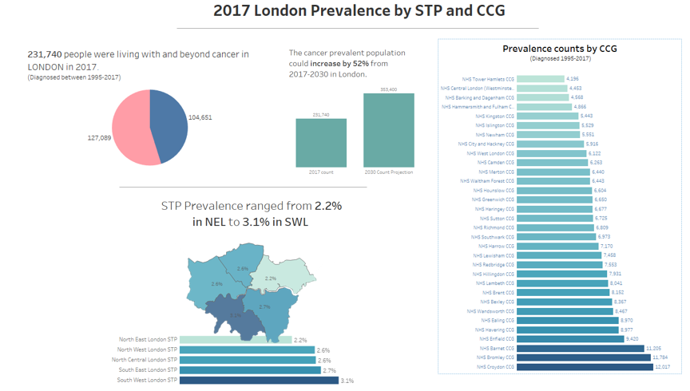

Figure 4: Cancer prevalence by STP in London
STP | Number of people living with or after cancer diagnosis in last 21 years
North Central London | 39,094
North East London | 43,204
North West London | 54,268
South West London | 45,901
South East London | 49, 273

2.2 Service User Experience
Service users consistently identify the importance of having their psychological needs met across the whole pathway and their frustrations at current gaps in services and the lack of coordination in service delivery.
“I do think psychological support is really important. I feel I’m a positive and resilient person and I still feel I need help, so how do people less resilient cope?”
“There’s disconnect between services - in the hospital between physical/medical side and the psychological side.”
“In primary care I was seen within an IAPT (Improving Access to Psychological Therapies) service, there was sympathy about cancer but a lack of understanding”
“During treatment I was told I could see a psychologist, which was so helpful, but after treatment it doesn’t feel like it’s offered”
Case example: 55 year old woman, with an incurable but treatable cancer
“I had been struggling to cope with the side effects of my punishing cancer treatment and in particular with the impact on my mental health. Aware of my plight my consultant and CNS suggested psychological help which I have been receiving within the hospital setting. I liked the fact that my psychologist understood the system, had access to my notes and understood the procedures I had been through. I felt the psychologist was in the centre of things, part of the MDT (multi-disciplinary team) so it was all joined up. My overall well-being has and continues to improve as a result of my sessions. I consider the support and help that I have been receiving from my psychologist an important and invaluable part of my treatment plan. The difference it has made to me is immeasurable and I really don’t know where I would be without it”

The results of the National Cancer Patient Experience Survey 2018 (NCPES) demonstrates that although progress has been made in London across several domains, there remain many areas where further improvements are needed. Figure 5 shows a selection of questions where Londoners still score poorly which may have significant impact on psychological well-being.
Figure 5: NCPES (2018) responses on specific questions which may have psychosocial impact
Patients’ experience of written and verbal information | 2018 Survey | 2018 Survey | 2017 Survey comparison
Issue | London percentage | England | London percentage
Q 35 Patient was able to discuss worries or fears with staff during visit (Inpatient) | 49% | 53% | 49% (no change)
Q 41 Patient was able to discuss worries or fears with staff during visit (Day patient/Outpatient) | 67% | 71% | 66% (+1%)
Q 49 Hospital staff gave family or someone close all the information needed to help with care at home. | 57% | 60% | 55% (+2%)
Q 50 Patient definitely given enough support from health or social services during treatment | 46% | 53% | 46% (no change)
Q 51 Patient definitely given enough support from health or social services after treatment | 41% | 45% | 42% (-1%)
Q 53 GPs and Practice staff did everything they could to support the patient | 55% | 59% | 56% (-1%)
Q 54 Hospital and community staff always worked well together | 56% | 61% | 56% (no change)
Q 55 Patient given a care plan | 32% | 35% | 32% (no change)

On several questions, Londoners score significantly worse, compared to the rest of England. There are groups of patients who report worse experience than others including lesbian, gay bisexual and transgender communities, black and minority ethnic groups, younger patients, those with some types of brain cancer and patients diagnosed through emergency routes.
The results of the 2018 National Cancer Patient Experience survey can be broken down regionally here.
Holistic Needs Assessment
The results of the HNA data from 2018 demonstrates the range of issues impacting on people affected by cancer and the importance of an approach to psychological support which encompasses physical health, mental health and social factors, rather than considering separate items in isolation.
Analysis of the 2018 data from the electronic Holistic Needs Assessment (e-HNA) tool in London illustrates that worry, fear or anxiety is the most frequently reported concern for patients, with almost 27% of all patients highlighting it as an issue when newly diagnosed.
Whilst this data is limited in terms of the number of London trusts using the e-HNA tool and therefore the number of patients participating, this analysis provides an insight in to the primary concerns patients report both before and following treatment across the year, and therefore the specific support needs for those affected by cancer.
Figure 6: Graph showing the top ten reported e-HNA concerns by age group (2018)
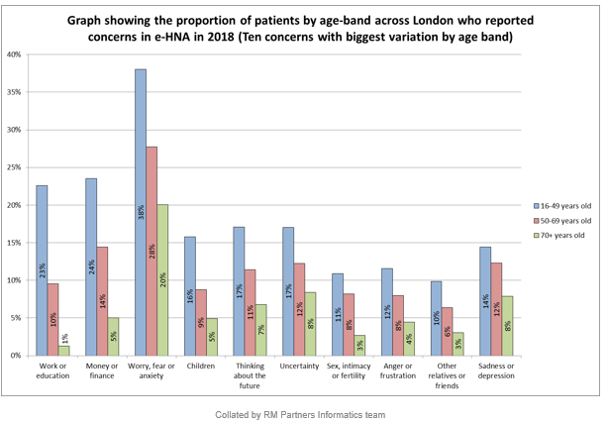Worry, fear or anxiety is the most reported concern across all age ranges. Interestingly, despite the wide range of psychosocial needs identified by the e-HNA, only 32.8 % of people received a care plan across all cancer types. This indicates that even when needs are assessed and identified, this does not always result in the necessary action and support being offered.
Psycho-oncology teams as indicated within NICE guidance3 need to be in place to deliver the Level 2 training supervision and support on an ongoing basis to ensure the quality of holistic needs assessments and to be available when more specialist psychological needs are identified and a person needs to be ‘stepped up’ for support.
E-HNA data can be broken down by provider Trust, STP and CCG via the Cancer Stats portal which is available here: https://cancerstats.ndrs.nhs.uk/user/login .

2.3. The economic impact of cancer and mental health difficulties
The impact of mental health difficulties on the individual, their family and loved ones, society, and the wider health and social care system is enormous and well documented. Research by the Kings Fund and the Centre for Mental Health suggests that approximately £1 in every £8 spent on long-term conditions (including cancer) is linked to poor mental health and wellbeing. This is particularly significant as 70% of people living with cancer are also living with at least one other long-term condition Similarly, international studies suggest that where a physical health concern coexists with a mental health problem, the costs of physical healthcare is increased by 45-75%.
It is estimated that a third of all cancer patients experience severe psychological distress and up to 70% will experience a less severe level of anxiety or depression. This means that up to 89% of cancer patients have unmet psychosocial needs, leading to poorer outcomes and quality of life. This is even more prevalent for those with low levels of social support and those from minority groups.
Impact of cancer and mental health on healthcare utilisation
Evidence shows that those living with cancer have greater levels of healthcare utilisation compared to populations of the same age and gender (e.g. a Nuffield Trust evaluation (2014) showed that 15 months after diagnosis, people with cancer had 60% more A&E attendances, 97% more emergency admissions and 50% more primary care contacts).
Those with cancer and experiencing psychological distress are even more likely to utilise additional healthcare services across the system. For example, studies by Mausbach and Irwin, Lo et al and Sambamoorthi et al found that relative to cancer patients without depression, those with depression:
- Were twice as likely to have an emergency or urgent care visit
- Incurred 76% more healthcare visits
- Were 81% more likely to be hospitalised
- Twice as likely to experience a 30-day hospital admission
- 25% more non-mental health primary care visits
- Incurred 14% higher inpatient expenditure

Depression has also been associated with greater length of hospital stays and psychosocial factors have been found to impact cancer surgery outcomes.

There are also wider socio-economic costs associated with cancer and mental health, particularly as cancer survivors are 37% more likely to be unemployed than people who have never had cancer. These additional costs outlined above are increasingly significant given the expected rise in the number of those receiving a cancer diagnosis.

Impact of psychosocial support for cancer patients
Evidence suggests that psychological therapy reduces physical healthcare costs by an average of 20% (meta-analysis of 91 studies). When data is available on cost of psychological treatment and physical healthcare, savings exceeds costs.
Cancer-specific studies show that adequate prevention, detection and treatment for psychological distress for cancer patients is effective in improving quality of life, and can result in significant cost reductions in overall cancer care, particularly when integrated within other cancer services. Several studies suggest that cancer patients who access psychosocial services in turn access other healthcare services less and better adhere to treatments and preventative behaviour, leading to better outcomes and quality of life. Furthermore, evidence also suggest that those receiving psychosocial support are more likely to return to work, also reducing the wider costs and impacts of cancer and its treatment.
Lending further support to the vital role of specialist psychological interventions was a Health Foundation report published in August, 2018 which highlighted that patients most able to manage a mental health condition, as well as their physical health conditions:
- experienced 49% fewer emergency admissions than those who were least able.
- had a length of stay in hospital 41% shorter compared to those least able
- 32 % fewer A & E attendances
- 18 % fewer GP appointments

2.4. Psychosocial care needs across the cancer pathway
Figure 7: Macmillan Cancer Support Times and Types of Need across the Cancer Pathway
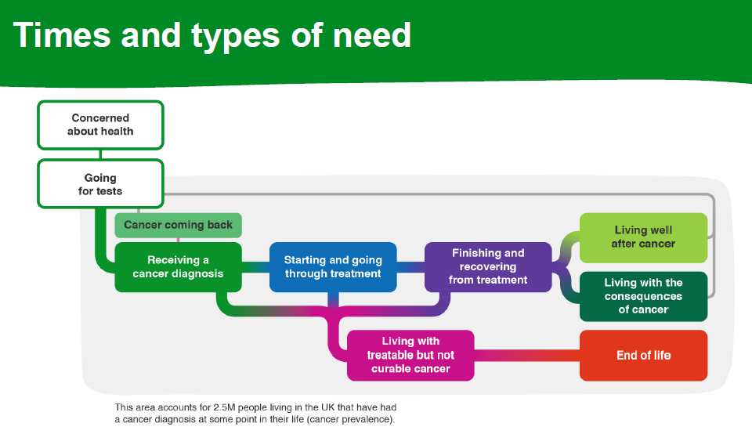
At numerous points along the cancer pathway outlined in Figure 7, psychosocial interventions are essential in ensuring that patients and their families receive the optimal outcomes. Recommendations outlined in this business case take a whole pathway approach ensuring that patients receive the right psychosocial care at the right time and in the right place.

Needs for those within first year of diagnosis
Modelling example, based on London prevalence data
- “In the year following diagnosis, around one in ten patients will experience symptoms such as anxiety and depression severe enough to warrant intervention by specialist psychological/psychiatric services”3 (Level 4 interventions)
- “15% of patients will experience mild to moderate distress at any one time within the first year after diagnosis and are likely to benefit from psychological techniques by trained health professionals or specific psychological interventions”3 (Level 3 interventions).
Figure 8: Number of cancer patients in London requiring specialist psychological support within 1 year of diagnosis (NCRAS-PHE/TCST partnership)
Delivery Units | Locality |  | CCG Code | CCG Name | 1 Yr Prevalence (Cases - 2017 Diagnosis) | 15% Requiring Level 3 Intervention | 10% Requiring Level 4 Intervention
STP Localities |  |  | North Central London |  | 4135 | 620 | 414
 |  |  | North East London |  | 5033 | 755 | 503
 |  |  | North West London |  | 5664 | 850 | 566
 |  |  | South East London |  | 5343 | 801 | 534
 |  |  | South West London |  | 4616 | 692 | 462
London Region |  |  |  |  | 24791 | 3719 | 2479
 |  | Limitation: this will not take into account those who have had a psychological event and have since died.

It should be noted that these are just two modelling examples of psychological need within one year of a cancer diagnosis. It does not take into account psychological needs at other points along a cancer pathway, the needs of families and carers or the ‘indirect’ work carried out such as Level 2 training for Clinical Nurse Specialists (CNSs) or Allied Health Professionals (AHPs).
Based on Figure 8, estimates of the number of patients in (name of local area CCG/STP) needing level 3 and 4 interventions within the first year of diagnosis is estimated to be (Number).

Needs for those living with and beyond cancer and impact on quality of life
The psychological impact of cancer needs to be recognised not only at diagnosis and during acute treatment, but for increasing numbers of people who are now living for many years with the consequences of cancer and its treatment. There is a recognition that for many people cancer should be viewed as a long-term condition, a vision which was developed by the Transforming Cancer Services Team for London (TCST) and endorsed by the London Cancer Commissioning Board in December 2015 and is supported in the NHS’s Long Term Plan with clear reference to cancer and the Universal Personalised Care comprehensive model.
A 2019 report by Macmillan Cancer Support and Public Health England’s National Cancer Registration and Analysis Service (NCRAS) estimates there are around 136,000 people in England who are living with treatable but not curable cancer. This means that the person is unlikely to be cured but can be treated to slow the progression of the cancer, prolong life and control symptoms, where services need to be designed around this group and their unique psychosocial needs. This report identified that many people do not feel that health or social care services adequately meet their long-term needs.
Some groups of cancer patients experience significantly more distress, especially those affected by lung, pancreatic, Hodgkin’s lymphoma, brain, head and neck, leukaemia and lymphoma cancers. Women, those with younger children, those with co-morbidities and those from more deprived backgrounds are also more likely to experience psychological difficulties.

It is also important to consider psychosocial provision for those with rarer cancers. About one in five people in the UK have a rare cancer of which there are 198 types. There can be extra challenges faced by those with rarer cancers as the cancer may take longer to diagnose, treatment may require travelling to a specialist centre or being seen at several hospitals and access to a Clinical Nurse Specialist with knowledge of the rare cancer may be problematic.

Improvements in diagnosis, medical treatments and survival means that the cancer landscape is changing, so the scope and specification of cancer psychosocial care will need to change accordingly.

A modelling example of need: Even 10 years after treatment 54% of cancer survivors still suffer from at least one significant psychological issue7= (insert number per CCG/STP).

Figure 9: Numbers of adults affected by at least one psychological issue up to 10 years after cancer treatment
 |  | Numbers of adults with at least one psychological issue
STP | North East London | 16,540
 | North Central London | 14,517
 | North West London | 20,087
 | South West London | 16,664
 | South East London | 18,396
Region | London | 86,205

Needs for those with advanced disease/ at the end of life
- After recurrence, prevalence of anxiety and depression rises to 50% and remains at this level through advanced illness.3
- Currently the provision of psychosocial support within palliative care teams is hugely variable across London, where access to Level 3 or 4 psychological specialists is often missing. This also the case for the recent service development of Enhanced Supportive Care Teams.This variation in provision must be addressed.
Needs for families and carers
- 67% of carers experience anxiety and 42% experience depression. Of these over three quarters do not receive any support
- More than 9 out of 10 carers report that caring has a negative impact on their mental health, including stress and depression, while 75 per cent of carers said it was hard to maintain social relationships.
- Currently the psychological needs of families and carers are not explicitly commissioned into the provision delivered by psycho-oncology services with the main focus being solely on the person diagnosed with cancer. Any psycho-oncology service commissioned must consider how to meet the needs of the person diagnosed with cancer as well as those significant to them (partners, parents and children). These may include treatments for specific psychological difficulties associated with caring such as relationship difficulties, anxiety, depression, bereavement and grief therapy.
- Nice guidance (CSG4)3 is clear that carers and families should have their needs assessed and addressed on a regular basis with available access to specialist psychological support and other services when required. Additionally, family members and carers must be able to access bereavement services irrespective of where a patient dies, whether at home, in hospital, hospice or care home.
Figure 10: Prevalence of anxiety (67 %) and depression (42%) in carers (based on prevalent cases diagnosed up to 2017-assuming one carer per cancer patient in first year after diagnosis)
 |  | Carers affected by Anxiety | Carers affected by Depression
STP | North East London | 2,723 | 1,144
 | North Central London | 2,236 | 939
 | North West London | 3,062 | 1,286
 | South West London | 2,494 | 1,048
 | South East London | 2,887 | 1,213
Region | London | 13,402 | 5,629

The caveats attached to these figures are that they are based on needs of just one carer/family member of one person diagnosed within the first year after cancer diagnosis. It does not include the psychological impact on more than one significant person or the psychological needs of people after the first year, at different points along the pathway. However, these figures are a starting point to illustrate the often-neglected psychosocial needs of carers/family members of those affected by cancer.
Needs for staff/health professionals:
- Supporting the psychological needs of staff working in cancer contexts is essential to ensure excellent patient care and clinical outcomes as well as ensuring staff retention, reducing sickness and ‘burnout’.
- Staff working in cancer contexts must have their psychological needs met. The annual cost of mental health needs of staff not being supported is between £33-42 billion pounds per year (sickness absence, less productivity, staff turnover)
- For cancer and wider healthcare staff to develop & sustain their psychological care skills, through teaching, training, consultation and collaboration
- To work together to shape cancer care pathways that are psychologically informed,
- To feel supported in order to deliver excellent patient-centred care.
- Developing the Level 2 skills of the Clinical Nurse Specialist (CNS) and Allied Health Professionals (AHP) workforce which requires training, education and ongoing support and supervision.
- Training and collaboration with Primary care teams, community services, including IAPT to enhance their understanding of working with the psychological impact of cancer and its treatment.

3. Implementing the London Integrated Cancer Psychosocial Care Pathway and the development of psycho-oncology services
The London Integrated Cancer Psychosocial Care Pathway and the development of psycho-oncology services (where gaps or limited provision is identified) is the solution for meeting the psychosocial needs identified across the pathway outlined in section 2.4.

3.1. Theoretical assumptions behind the proposed integrated pathway model for London
The London Integrated Pathway for Psychosocial Support (Figure 11) is based on an adjustment model for cancer (Brennan’s (2001) model, the ‘ARC’ model) ie that the majority of those affected by cancer find ways through their experience using their own inner resources, external resources (e,g supported self-management, third sector support, social prescribing, digital support) and support systems (family, friends, trusted professionals) to adjust to the experience of cancer and will not require specialist psychosocial interventions (levels 3 and 4) but universal support (see figure 2) or for some people enhanced support (level 2). This is an important key message so that adults affected by cancer are not assumed to have a mental health difficulty, for example, by virtue of showing distress or worry following a cancer diagnosis.
All psychosocial care within the proposed pathway should be provided within the framework of the 4 level model recommended by the NICE Supportive and Palliative Care Guidance 20043 (See Figure 2). This guidance has not been refreshed since 2004, but remains in effect and is a well-recognised framework, understood by service providers, the third sector and system leaders/commissioners.

3.2 The Integrated Pathway for Cancer Psychosocial Support: A solution for London
The model outlined in Figure 11 illustrates the proposed pathway for delivering excellent psychosocial support across acute, primary care and community contexts.
Figure 11: London Integrated Pathway for Cancer Psychosocial Support
This model is based on a core set of principles that has been the result of extensive engagement with stakeholders across London, including system leaders/commissioners, GPs, primary and secondary care providers, the third sector, and service users.
Key features/benefits of the pathway:
A) Preventing distress and promoting adjustment (Part of existing strategies/national priorities)
A key principle underpinning the whole pathway, across acute, primary care and community settings is what needs to happen within the existing system to prevent distress and promote adjustment.
Significant positive impact on patients, carers and families with the following simple steps:
- focusing on effective communication and good partnership working between all staff across the whole pathway (for example Holistic Needs Assessments producing helpful care plans and Treatment summaries (TS) being shared with patient and GP)
- patients, families and carers being communicated with compassionately by all staff
- high quality cancer care reviews (CCRs) taking place within primary care (see TCST 4 point model here)
- prompt efficient and reliable appointment systems and reporting processes in place across the whole pathway
- robust safety netting and follow-up in primary care
- early identification of who may need extra support (e.g by asking about current or past mental health issues, being aware of social isolation and socio-economic deprivation, recent or previous loss/bereavement, poor previous healthcare experiences)
- supporting a psychologically minded culture within primary and community care and across all cancer services emphasising the integration between physical health and psychological well-being.
- Supporting self-management across the pathway

B) There are three levels of support indicated in this pathway: universal, enhanced and specialist.
- Patients and their families may need different support at different times and may not proceed through universal, enhanced and specialist support in a linear or predictable fashion, so access to services must be flexible.
- All people affected by cancer will have access to universal support, a substantial proportion will require enhanced support episodically or throughout their cancer experience, and a smaller proportion will require specialist support at one or more timepoints. All components of the pathway must be coordinated and working in partnership to deliver excellent psychosocial support.

C) It is a ‘whole’, integrated pathway for cancer psychosocial care across acute, community and primary care.
- The psycho-oncology team will work with key professionals across the pathway delivering consultation and sharing expertise, education, training and supervision.
- Training and education will ensure that physical health and mental health are no longer regarded as separate, disconnected elements of healthcare.
- Ultimately this way of working will encourage a “psychologically minded culture”, which will improve patient outcomes and experience across acute, primary care and community settings.
D) Psycho-oncology teams, as the specialists in cancer and mental health, should take the lead to ensure a ‘whole system’/integrated approach to identifying and providing psychosocial support with clear and flexible referral pathways and processes, which are understood by professionals, patients, their carers and families.
- Within the pathway there is a clear role for both Psycho-oncology teams and IAPT services, which provide vital support at different points along the pathway (see appendix 1 service specification)
- Further details including activity to be delivered at the 4 levels outlined in the NICE guidance3 and the referral criteria between services can be found in the detailed service specification in Appendix 1.
Why implement the London Integrated Cancer Psychosocial Care Pathway and develop Psycho-oncology services?
A summary of the case for change:
- It has been a national priority for all STPs to establish ‘parity of esteem’ so there is the same level of attention paid to mental health as physical health within commissioning generally and now within cancer care.
- Pan-London mapping, carried out by the Transforming Cancer Services Team in November 2017, of cancer psychological services (available here) identified that there is considerable inequity and variation in cancer psychosocial support across London and in particular access to psycho-oncology teams.
- The NHS Long term planError! Bookmark not defined. identified, more NHS action needs to focus on “reducing health inequalities and addressing unwarranted variation in care”. Additionally, the Long-term plan emphasised how both cancer and mental health are strategic priorities for NHS England. The proposed integrated pathway model and underlying principles for cancer psychological care services aligns with the key themes of integration, more joined up/coordinated care, services being more proactive, boosting ‘out of hospital care’, carers getting greater recognition and support and a focus on “shared responsibility for health” and support being provided across the whole pathway to help people manage both their physical and mental well-being.
- Additionally, implementing the cancer psychosocial support pathway aligns with the quality of life agenda. It is an NHS England priority – measuring quality of life for people affected by cancer. Work is underway within the National Cancer programme to develop a ‘Quality of Life’ metric which will be measured on the National Cancer Dashboard. This will capture whether a patient has had their psychosocial care needs met allowing this vital component of patient experience to be routinely recorded in the national database and used to inform care delivery. The final tool is expected for rollout in 2019/20.
- The importance of the mental health component of many NICE physical health guidelines for cancer has been identified by the Royal College of Psychiatrists. Currently across a wide range of cancer types, NICE recommendations are not being met in relation to psychological support. NICE guidance recommends access to cancer specialist psychological services across numerous guidelines, including: Brain Tumours (NG Improving outcomes for people with brain and other CNS tumours CSG10 (2006) , Improving supportive and palliative care for adults with cancer (CSG4) (2004), Lung Cancer: diagnosis and management (CG121) (2011), Suspected Cancer: recognition and referral (NG12) (2017), Improving Outcomes in head and neck cancers (CSG6) (2004) (reviewed in 2015), Early and locally advanced breast cancer: diagnosis and management (NG101) (2018).
- Patient experience – the results of the National Cancer Patient Experience Survey 2018 (NCPES) demonstrates that although progress has been made in London across several domains, there remain many areas where further improvements are urgently needed.

3.3. Service specification
A detailed service specification describing the service to be developed is included in Appendix 1. This specification identifies the key features of the pathway as well as recommendations on how psycho-oncology teams will need to work and clear referral criteria to ensure the best outcomes for service users.

3.4. Benefits of a Psycho-oncology service
Figure 12: The benefits of commissioning a psycho-oncology service
Group | Benefits
For patients | Improved quality of care  Improved patient experience and quality of life  Reduced strain on carers/families  Improved clinical outcomes as patient receives specialist psychosocial interventions aimed at:  - Supporting patients with accessing tests  - Supporting patients with treatment adherence  - Supporting patients to engage in cancer rehabilitation and rehabilitation  - Supporting patients to manage their mental health  - Supporting those with Severe Mental Illness (SMI) to engage with services across the cancer pathway  Receiving interventions from psychological specialists with expertise in both psychological/mental health and cancer rather than generalists.  Patient choice and preference- patients want to see psychological specialists with expertise in both mental health and cancer.  Consultation, liaison and training of other staff across the pathway (CNSs, AHPs, GPs and practice nurses, MDT colleagues, IAPT workers) enhances psychologically informed cancer care and develops the skills of other professionals seen by the patient.
For Primary Care | Reduced GP attendances if patient has mental health needs better met.  Increased confidence of GPs to manage psychosocial difficulties associated with cancer  Skills development through stronger links with psycho-oncology teams, training and consultation.  Clearer pathway and knowledge of when to refer to IAPT services and when to refer to psycho-oncology teams, resulting in better clinical outcomes and improved patient experience.
For Providers | Psychological specialists embedded within cancer settings where people are diagnosed and treated delivering a range of NICE recommended interventions.  Skills development/training for Level 2 workforce (Clinical Nurse Specialists and Allied Health Professionals)  Skills development/training for medical colleagues and all staff working with adults affected by cancer.  Enhanced multi-disciplinary team working-using psychological approaches  Staff support (improving staff retention/recruitment, reducing sickness) e.g Schwartz rounds  Improved clinical outcomes  Improved patient experience  Impact on wider healthcare utilisation e.g fewer GP appointments, fewer emergency admissions, reduced lengths of hospital stays
For System leaders/ Commissioners | An effective integrated model where psycho-oncology teams share expertise, training and skills across the pathway  Improved quality of cancer psychosocial care for local population  Improved patient experience and outcomes  Reduced variation/inequality  Potential cost savings from reduced healthcare utilisation and quantifiable improvements in quality of life.

3.5. Impact of lack of Psycho-oncology services
- Given that screening uptake, engaging in tests and investigations, treatment adherence, rehabilitation and rehabilitation, patient experience and quality of life are all mediated by psychosocial variables, a lack of psycho-oncology services would negatively impact clinical outcomes across the whole cancer pathway.
- Those affected by cancer requiring specialist interventions to address their mental health needs will be at significant risk-Cancer patients have a 55% higher risk of suicide than those without cancer5.
- The mental health of people with cancer is not considered equitably with their physical health (‘parity of esteem’)
- NICE (2004) guidance and other guidance is not being implemented and an estimated XXX do not get the service that is clinically indicated.
- There is inequity in service provision across London so that a patient can only access Level 3 and Level 4 Cancer psychological care depending on where they are diagnosed or treated.
- % of patients in (CCG/STP) report significant psychological concerns in their Holistic Needs Assessment
- NICE recommended Level 2 training and supervision in psychological skills for Clinical nurse specialists (CNSs and AHPs) are failed, impacting on patient care and staff burnout, sickness levels and retention.
- Pre/rehabilitation cancer programmes lack the necessary psychological expertise in design and delivery.
- Significant aspects of personalised care planning cannot be delivered including staff training and support as well as clinical input
- Increased pressure on 62 day target as adults who have psychological obstacles to engage in treatment are not receiving the psychological interventions to enable them to engage in tests and treatment in clinically recommended time-scales.

4. Cost analysis

4.1. Financial impact

It is estimated that a level 3 or 4 professional with a full-time clinical focus can deal with around 120 cases per year. This is based on a comparison of activity data from psycho-oncology services across the UK.
Based on the estimated prevalence of patients (2017) requiring level 3 and 4 interventions within the first year of diagnosis only and carrying a caseload of 120 per year.
Figure 13: Workforce requirements solely based on delivering NICE recommended interventions within the first year of diagnosis
Delivery Units | Locality | CCG Code | CCG Name | 1 Yr Prevalence (Cases - 2017 Diagnosis) |  | 15% Requiring Level 3 Intervention |  | 10% Requiring Level 4 Intervention |  | Workforce requirement  Level 3 |  | Workforce requirement  Level 4
STP Localities |  | North Central London |  |  | 4135 |  | 620 |  | 414 |  | 5.1 (wte) |  | 3.4 (wte)
 |  | North East London |  |  | 5033 |  | 755 |  | 503 |  | 6.2 (wte) |  | 4.2 (wte)
 |  | North West London |  |  | 5664 |  | 850 |  | 566 |  | 7 (wte) |  | 4.7 (wte)
 |  | South East London |  |  | 5343 |  | 801 |  | 534 |  | 6.6 (wte) |  | 4.45 (wte)
 |  | South West London |  |  | 4616 |  | 692 |  | 462 |  | 5.7 (wte) |  | 3.85 (wte)

The above workforce calculation is only based on prevalence of cases needing level 3 and 4 interventions within the first year following diagnosis. It does not include:
- any other work of psycho-oncology teams at other points along the pathway (after a year, living with and beyond cancer/treatable but not curable, during recurrence, supporting cancer rehabilitation, end of life/palliative care, the 15 % of patients with advanced disease requiring level 3 or 4 interventions as identified in the NICE guidance3)
- work with families and carers
or the ‘indirect’ work delivered by psycho-oncology teams:
- regular, ongoing supervision, support, training and education of Level 2 staff (CNSs and AHPs)
- collaboration, consultation, liaison, training with Primary Care, Community services including IAPT
- Enhancing the psychological cancer care delivered by Level 1 staff
- Rapid case consultation with MDT oncology colleagues
- Staff support-reflective practice, Schwartz rounds
A recommendation would be of an extra 20% workforce capacity to deliver ‘indirect’ work across the pathway. This figure is based on how much indirect work is currently carried out by services and that their remit will be expanding to work more closely across primary care and IAPT services.
Potential cost savings:
- Reduced costs related to unnecessary healthcare utilisation due to timely intervention addressing underlying psychological/mental health issues and/or increasing ability to adhere to demanding treatments or recommendations e.g. reduced length of stay on wards, reduced A&E attendance, reduced DNAs.

In 2010 the cost of extended bed days due to preventable psychological problems in cancer patients at the Barts and the London NHS Trust was an estimated £366,000 per year. Although, it should be noted that this is data from just one provider rather than London wide, it demonstrates the potential to reduce pressure across acute providers from unnecessary hospital bed days.

- Reduced costs related to cancer service staff due to provision of appropriate supervision/support/training and referral pathways to support their patients e.g. reduced absenteeism/burnout/sickness absence in cancer staff, increased staff resilience, reduction in outsourcing of training requirements to external organisations.

- Reduced costs to society due to addressing psychological/mental health issues e.g. improved ability to work, reduction in reliance on state benefits, improvements in self-care and lifestyle.
There is an increasing body of evidence demonstrating the impact of psychological interventions on wider healthcare utilisation, but there is currently less evidence available for the cancer population. As a result these are described as potential cost savings. It may be useful for services to explore the appropriateness of using the Client Services Receipt Inventory (CSRI) to begin to evaluate impact on wider healthcare utilisation of interventions by psychological specialists and whether meaningful conclusions can be drawn for cancer populations.
Quantifying psychological health improvement
Consistent with much of health economics, and with NICE methodology, the Quality Adjusted Life Year (QALY) has been used as an appropriate metric for quantifying the health improvement associated with moving from a depressed/anxious health state to a non-depressed/anxious health state as a result of ‘recovery’.

A QALY score is defined on the interval [0,1], with 0 representing death and 1 representing perfect health. It is often estimated for particular health states and conditions using the EQ-5D tariff, which evaluates health on five dimensions, one of which is anxiety/depression (the other dimensions are: mobility, self-care, usual activities, pain/discomfort). The QALY gain from an intervention can then be estimated by comparing the average QALY score with
intervention against the average QALY score without intervention and multiplying the difference by the length of time over which the change of health state is assumed to occur. In reality,
moderate/severe sufferers will have higher health detriments than mild sufferers, and so will have higher QALY gains upon recovery.

Consistent with data from the original IAPT Impact Assessment document, QALY estimates are based on reports that a change from moderate depression or anxiety is associated with a QALY gain of 0.152 for those with good health across the other four dimensions, and a QALY gain of 0.071 for those with moderate health across the other four dimensions. As a result, the IAPT document recommends using an average of the two scores is taken, i.e. a gain of 0.11 QALYs for each year of recovery following successful treatment.

Given that the QALY is being considered within a cancer context with likely moderate to high levels of impact across the other four dimensions it is sensible to use the lower 0.07 figure as
an average. QALY gains can be monetarised and QALY gains have been given a threshold range by NICE of £20,000-30,000 for each QALY gained.

Therefore one reasonable calculation could be that:

We could assume that 50% of those receiving Level 3 and Level 4 interventions experience a significant improvement. This is multiplied through by the QALY improvement – assumed to be 0.07 or 0.11 – and then multiplied by the value of the QALY.

Example, based on the lowest estimated monetarised health gain: North Central London 414 + 620/2=517 X 0.07=36.19 QALYs X £20,000= £723,800
Example, based on the highest estimated monetarised health gain: North Central London 414 + 620/2=517 X 0.11=56.87 QALYs X £30,000= £1,706,100

Figure 14 demonstrates the potential monetarised health benefits of the psychological interventions delivered by cancer psychological specialists (levels 3 and 4) just within the first year after diagnosis.
Figure 14: Health gains using QALY calculations
 |  |  |  |  |  | Sensitivity analysis 0.07 at £20,000 per QALY |  |  |  |  | Mid-point (conservative) analysis 0.07 at £25,00 per QALY |  |  |  |  | Sensitivity analysis 0.11 at £30,000 per QALY
Delivery Units | Locality | CCG Code | CCG Name | 1 Yr Prevalence (Cases - 2017 Diagnosis) | 10% Requiring Level 4 Intervention |  | 15% Requiring Level 3 Intervnetion | Monetarised health gains | 1 Yr Prevalence (Cases - 2017 Diagnosis) | 10% Requiring Level 4 Intervention |  | 15% requiring level 3 intervention | Monetarised health gains | 1 Yr Prevalence (Cases - 2017 Diagnosis) | 10% Requiring Level 4 Intervention |  | 15% requiring level 3 intervnetion | Monetarised health gains
STP Localities |  | North Central London |  | 4135 | 414 |  | 620 | £723,800 | 4135 | 414 |  | 620 | £904,750 | 4135 | 414 |  | 620 | £1,706,100
 |  | North East London |  | 5033 | 503 |  | 755 | £880,600 | 5033 | 503 |  | 755 | £1,100,750 | 5033 | 503 |  | 755 | £2,075,700
 |  | North West London |  | 5664 | 566 |  | 850 | £991,200 | 5664 | 566 |  | 850 | £1,239,000 | 5664 | 566 |  | 850 | £2,336,400
 |  | South East London |  | 5343 | 534 |  | 801 | £934, 500 | 5343 | 534 |  | 801 | £1,168,125 | 5343 | 534 |  | 801 | £2,202,750
 |  | South West London |  | 4616 | 462 |  | 692 | £807,800 | 4616 | 462 |  | 692 | £1,009,750 | 4616 | 462 |  | 692 | £1,904,100

This data, using the QALY metric can usefully demonstrate the value and cost effectiveness of a
commissioned psycho-oncology service, by calculating the workforce costs and the potential QALY gains. Obviously, these calculations will vary depending on the configuration of teams. These calculations identified in Figure 14 do not consider the huge range of other interventions delivered by these clinicians and only focus on direct interventions delivered within the first year. But these calculations can indicate that the likely health benefits to the person outweigh the costs.

Services should consider scoping the merits of using this measure to demonstrate the value and potential cost-effectiveness of services.

Workforce calculations
The tool outlined in Figure 15 can be used by STPs/ICSs to consider what the potential demand for services is and what it means for service costs.
Figure 15: Recommended workforce algorithm for estimating minimum service requirement at Level 3 and 4 (Psycho-oncology teams) ,

 | Example number
New cancer diagnoses per annum | 1000
15 % require level 3 support | 15/100 X 1000= 150
10 % require level 4 support | 10/100 X1000=100
Number of patients with advanced active disease (AAD) | 750
15% of AAD require level 3 or 4 support | 15/100 X750=113
Total patients requiring direct input (excluding families/carers) | 113 + 150 + 100 =363
20 % Minimum number of carers/family requiring input (conservative estimate) | 20/100 X363= 72
120 new cases per year per 1.0 wte (NB variation between banding) 56 | 363 + 72= 435 /120= 3.6 (wte)
Add additional minimum of 20 % extra capacity required for ‘indirect’ work e.g level 2 supervision (e.g Clinical Nurse specialists), teaching/training/consultation with multi-disciplinary colleagues, cancer teaching for IAPT workers, liaison/partnership working with primary care staff | 3.6 (wte) + 20%= 4.3 (wte)
Staff cost | £ Xxxxx (depending on service configuration)
Assumed health gain (based on mid-point QALY calculation) | 363 (number of patients supported excluding carers/families) x 0.5 (proportion of people assumed to benefit) x0.07 (QALY gain) x £25,000 (QALY value) = £317,625

4.2. Option appraisal
The following options should be considered (see Figure 16)
Figure 16: Options appraisal
 | Advantages | Disadvantages
Option 1: Do nothing | No additional costs to CCGs/STP | - No psycho-oncology service provided at (xxx)-the benefits shown in Figure 11 will not be realised  - Significant clinical needs left unmet  - Breaching several NICE guidance documents recommendations  - Not meeting ‘parity of esteem’ for mental health and physical health  - No strategic leadership/supervision/training  - Negative impact on wider workforce-no consultation, supervision or training for CNSs/AHPs, oncology colleagues, primary care, IAPT services)  - Psychological obstacles that affect test/investigations, treatment adherence, rehabilitation are not addressed resulting in poorer clinical outcomes.
Option 2: Develop psycho-oncology service where each CCG funds their own service | - Psycho-oncology service at each Trust within a CCG ensuring equity of provision.  - Many of the benefits shown in Figure 12 will be realised. | - Services may work in isolation, meaning less integrated/ joined up working, potential for duplication across CCGs and widening inequalities, less efficiency  - Confusion for service users and providers, especially when many cancer centres relate to multiple CCGs, especially if services are provided differently in each CCG. Difficult to plan a coherent approach to psychological treatment.  - CCGs investing individually will mean certain cost pressures cannot be shared-as a whole this could increase costs across the STP
Option 3: Develop a comprehensive psycho-oncology service at STP or Integrated Care System (ICS) Level | - The benefits shown in Figure 12 will be realised  - Quantifiable assumed health benefits for each STP.  - Enhanced psychologically informed cancer care benefitting all those affected by cancer at every point along the pathway  - Larger service footprint covers more patients, carers and families  - Makes care provision and capacity consistent across the patch  - Larger services are more resilient, more efficient and more attractive for recruitment.  - Able to deliver the proposed model-London Integrated pathway for Cancer Psychosocial Support (Figure 11)  - More integrated approach, prevents duplication across CCGs, provides opportunities for joint/more efficient working between providers  - Potential for sharing various cost pressures across CCGs | - Larger project may require more set up costs and management capacity  - Set up phase for a larger service may take longer

4.3. Implementation
It is essential that the introduction of this service is adequately supported. The local requirements for this are anticipated to be:
Project management: Brief description
Project Administration: Brief description
Evaluation support: Brief description
Time-scale for introduction of service:
Planning: Duration
Recruitment: Duration
Anticipated launch: Duration
The proposal has the support of:
(List the boards/groups that have considered/approved this business case)

5. Risks and Issues
The potential risks and issues of this proposal are shown in Figure 17
Figure 17: Risks and issues
 | Risk | Probabiliity | Impact | Risk score | Mitigation
1 | Difficulty in recruiting specialist staff |  |  |  | Use clinical networks and psycho-oncology leads to optimise recruitment strategy
2 | Clinical engagement: as a new service psycho-oncology may not be understood and used appropriately |  |  |  | Incorporate into the model that the first 3 months are spent engaging with key stakeholders, building relationships and establishing clear referral pathways

6. Recommendations
We recommend that the London Integrated pathway for cancer psychosocial support is implemented and a comprehensive psycho-oncology service is developed at STP/ICS level (option 3) for xxx (insert local area). This recommendation is in line with the guidance and recommendations from Healthy London Partnership’s Transforming Cancer Services Team for London and the Cancer Commissioning Board for London.
System leaders/commissioners are asked to:
1. Adopt the proposed London Integrated Cancer Psychosocial Care Pathway
2. Localise the pathway by mapping current resources, supporting partnership working and identifying gaps at STP/ICS level.
3. Where there are no or very limited Psycho-oncology teams, allocate sufficient resource to ensure that a Psycho-oncology service is available to ensure that the outcomes indicated in the pathway are delivered.
It is clear from the case outlined above that implementing the proposed pathway model and the development of this psycho-oncology service will improve patient experience, quality of life and clinical outcomes. The proposed service has the potential to impact on wider healthcare utilisation and through QALY gains will also contribute monetary benefits.
This proposal has the support of:
(List the boards/groups that have considered/approved this business case)

References
Healthy London Partnership, The psychological impact of cancer: commissioning recommendations, pathway and service specification on psychosocial support for adults affected by cancer (May 2018). Available here: https://www.healthylondon.org/wp-content/uploads/2018/05/Psychological-support-for-people-affected-by-cancer-May-2018.pdf
2 Transforming Cancer Services Team and Public Health England Partnership, 2017 Cancer Prevalence Dashboard (2019). Available here: https://www.healthylondon.org/resource/2017-cancer-prevalence-dashboard/
3 National Institute for Health and Care Excellence, Guidance on Improving Supportive and Palliative Care for Adults with Cancer (2004). Available here: https://www.nice.org.uk/guidance/csg4/resources/improving-supportive-and-palliative-care-for-adults-with- cancer-pdf-773375005
4 Macmillan Cancer Support, Worried sick: the emotional impact of cancer (2006). Available here: https://www.macmillan.org.uk/documents/getinvolved/campaigns/campaigns/impact_of_cancer_english.pdf
5 Calati, R., Di Mattei, V. and Courtet, P, Risk of suicide mortality among cancer patients: A meta-analysis of observational studies. (2017) European Psychiatry, 41, pp.S290-S291. Available here: http://www.europsy.net/wp-content/uploads/2017/03/cancersuicide.pdf
6 Healthy London Partnership, Cancer Rehabilitation: a scoping report for London (2016). Available here: https://www.healthylondon.org/wp-content/uploads/2017/11/Cancer-rehabiliation-a-scoping-report-for-london.pdf
7 Macmillan Cancer Support, Worried sick: the emotional impact of cancer (2006). Available here: https://www.macmillan.org.uk/documents/getinvolved/campaigns/campaigns/impact_of_cancer_english.pdf
8 Layard, R & Clark, D.M, Thrive: The Power of Evidence-Based Psychological Therapies (2014)
9 Deeny, Thorlby, R, Steventon, Health Foundation, A Briefing: Reducing emergency admissions: unlocking the potential of people to better manage their long-term conditions (2018). Available here: https://www.health.org.uk/sites/default/files/Reducing-Emergency-Admissions-long-term-conditions-briefing.pdf
10 Transforming Cancer Services Team and Public Health England Partnership, 2017 Cancer Prevalence Dashboard (2019). Available here: https://www.healthylondon.org/resource/2017-cancer-prevalence-dashboard/
11 Healthy London Partnership, Guidance for reducing variation and improving outcomes in cancer rehabilitation (2019). Available here: https://www.healthylondon.org/resource/guidance-for-reducing-variation-and-improving-outcomes-in-cancer-rehabilitation/
12 Cancer Stats. Available here: https://cancerstats.ndrs.nhs.uk/user/login
NB. At the time of publication, the eHNA data provided via the Cancer Stats portal is limited. More detailed data outlined above is provided by the RM Partners Analytics team. For further details please contact: rmpartners.info@nhs.net
13 The Kings Fund and the Centre for Mental Health, Long-term conditions and mental health The cost of co-morbidities. Available here: https://www.centreformentalhealth.org.uk/sites/default/files/2018-09/Cost_of_Comorbidities.pdf
14 Ell K, Quon B, Quinn DI, et al. Improving treatment of depression among low-income patients with cancer: the design of the ADAPt-C study. Gen Hosp Psychiatry 2007;29(3):223–231.; Zabora J, BrintzenhofeSzoc K, Curbow B, Hooker C, Piantadosi S. The prevalence of psychological distress by cancer site. Psycho-Oncology 2001;10(1):19–28.
15 The Kings Fund, Long-term conditions and mental health: The cost of co-morbidities (2012). Available here: https://www.kingsfund.org.uk/sites/default/files/field/field_publication_file/long-term-conditions-mental-health-cost-comorbidities-naylor-feb12.pdf
16 Ell K, Quon B, Quinn DI, et al. Improving treatment of depression among low-income patients with cancer: the design of the ADAPt-C study, (2007) Gen Hosp Psychiatry;29(3):223–231; Zabora J, BrintzenhofeSzoc K, Curbow B, Hooker C, Piantadosi S, The prevalence of psychological distress by cancer site (2001) Psycho-Oncology;10(1):19–28
17 Harrison JD, Young JM, Price MA, Butow PN, Solomon MJ, What are the unmet supportive care needs of people with cancer? A systematic review (2009), Support Care Cancer;17:1117-28; Jansen F, van Uden-Kraan CF, van Zwieten V, Witte BI, Verdonckde Leeuw IM, Cancer survivors’ perceived need for supportive care and their attitude towards self-management and eHealth (2015), Support Care Cancer, 23:1679-88
18 Jacobsen PB, Jim HS, Psychosocial interventions for anxiety and depression in adult cancer patients: achievements and challenges (2008), CA Cancer J Clin 58(4):214–230; Fallowfiel L, Ratcliffe D, Jenkins V, Saul J, Psychiatric morbidity and its recognition by doctors in patients with cancer (2001), Br J Cancer, 84(8):1011–1015
19 Christopher Lo, Andrew Calzavara, Paul Kurdyak, Lisa Barbera, Frances Shepherd, Camilla Zimmermann, Malcolm J. Moore and Gary Rodin, Depression and use of health care services in patients with advanced cancer (2013), Canadian Family Physician, 59 (3) e168-e174
20 Nuffield Trust, Use of health and social care by people with cancer (2014). Available here: https://www.nuffieldtrust.org.uk/research/use-of-health-and-social-care-by-people-with-cancer
21 Luber MP, Meyers BS, Williams-Russo PG, et al, Depression and service utilization in elderly primary care patients (2001), Am J Geriatr Psychiatry, 9(2):169-176; Himelhoch S, Weller WE, Wu AW, Anderson GF, Cooper LA, Chronic medical illness, depression, and use of acute medical services among Medicare beneficiaries (2004), Med Care, 42(6):512‐521; Koenig HG, Differences in psychosocial and health correlates of major and minor depression in medically ill older adults (1997), J Am Geriatr Soc.;45(12):1487-1495; Christopher Lo, Andrew Calzavara, Paul Kurdyak, Lisa Barbera, Frances Shepherd, Camilla Zimmermann, Malcolm J. Moore and Gary Rodin, Depression and use of health care services in patients with advanced cancer (2013), Canadian Family Physician, 59 (3) e168-e174
22 Mausbach BT, Irwin SA, Depression and healthcare service utilization in patients with cancer (2017), Psychooncology. 26(8):1133-1139
23 Lo C, Calzavara A, Kurdyak P, et al, Depression and use of health care services in patients with advanced cancer (2013), Can Fam Physician, 59(3):e168‐e174.
24 Xiaoyun Pan, Usha Sambamoorthi, Health care expenditures associated with depression in adults with cancer (2015), J Community Support Oncol. 13(7): 240–247
25 Prina AM, Deeg D, Brayne C, Beekman A, Huisman M, The association between depressive symptoms and non-psychiatric hospitalisation in older adults (2012), PLoS One 7(4)
26 De Boer,A.G;Taskilla, T; Ojajarvi, A;Van Dijk, F.J & Verbeek, J.H, Cancer Survivors and Unemployment: a meta-analysis and meta-regression, (2009) JAMA 301, 753-762. Available here: https://www.ncbi.nlm.nih.gov/pubmed/19224752
27 Transforming Cancer Services Team and Public Health England Partnership, 2017 Cancer Prevalence Dashboard (2019). Available here: https://www.healthylondon.org/resource/2017-cancer-prevalence-dashboard/
28 Layard, R & Clark, D.M, Thrive: The Power of Evidence-Based Psychological Therapies (2014)
29 Linda E Carlson and Barry D Bultz, Benefits of psychosocial oncology care: Improved quality of life and medical cost offset (2003), Health Qual Life Outcomes, 1: 8.
30 Brent T. Mausbach, Philip Yeung, Taylor Bos, Scott A. Irwin, Health care costs of depression in patients diagnosed with cancer (2018), Psycho-Oncology, 27(7), 1735-1741(7); Linda E. Carlson, Barry D. Bultz, Efficacy and medical cost offset of psychosocial interventions in cancer care: Making the case for economic analyses (2004), Psychooncology, 13(12):837-49; Chambers SK, Hyde MK, Smith DP, et al, New challenges in psycho-oncology research III: a systematic review of psychological interventions for prostate cancer survivors and their partners: clinical and research implications (2017), Psychooncology. 26(7):873-913. 6; Faller H, Schuler M, Richard M, Heckl U, Weis J, Kuffner R, Effects of psycho-oncologic interventions on emotional distress and quality of life in adult patients with cancer: systematic review and meta-analysis (2013), J Clin Oncol Off J Am Soc Clin Oncol. 31(6): 782-793; ParahooK, McDonough S, McCaughan E, et al, Psychosocial interventions for men with prostate cancer: a Cochrane systematic review (2015), BJU Int, 116(2):174-183
31 Dieng, Anne E. Cust, Nadine A. Kasparian, Graham J. Mann, Rachael L. Morton, Economic evaluations of psychosocial interventions in cancer: a systematic review (2016), Psycho-Oncology, 25(S3), 104. [297]; A. Duarte,a,⁎ J. Walker,b S. Walker,a G. Richardson,a C. Holm Hansen,c P. Martin,d G. Murray,e M. Sculpher,a and M. Sharpeb, Cost-effectiveness of integrated collaborative care for comorbid major depression in patients with cancer (2015), J Psychosom Res, 79(6): 465–470
32 Mbathio Dieng Anne E. Cust Nadine A. Kasparian Graham J. Mann Rachael L. Morton, Economic evaluations of psychosocial interventions in cancer: a systematic review (2016), Psychooncology 25(12), 1380-1392
33 Verdonck-de Leeuw IM, van Bleek WJ, Leemans CR, de Bree R, Employment and return to work in head and neck cancer survivors (2010), Oral Oncol. 46:56-60; Tevaarwerk AJ, Lee JW, Sesto ME, Buhr KA, Cleeland CS, Manola J, et al, Employment outcomes among survivors of common cancers: The Symptom Outcomes and Practice Patterns (SOAPP) study (2013), J Cancer Surviv, 7:191-202.
34 Deeny, Thorlby, R, Steventon, Health Foundation, A Briefing: Reducing emergency admissions:unlocking the potential of people to better manage their long-term conditions (2018). Available here: https://www.health.org.uk/sites/default/files/Reducing-Emergency-Admissions-long-term-conditions-briefing.pdf
35 Transforming Cancer Services Team and Public Health England Partnership, 2017 Cancer Prevalence Dashboard (2019). Available here: https://www.healthylondon.org/resource/2017-cancer-prevalence-dashboard/
36 Healthy London Partnership, Cancer as a long term condition: A review of Cancer Care Reviews and a proposed model for London (2015). Available here: https://www.myhealth.london.nhs.uk/system/files/Cancer%20Care%20Review.pdf
37 NHS England, The NHS Long Term Plan (January 2019). Available here: https://www.longtermplan.nhs.uk/wp-content/uploads/2019/01/nhs-long-term-plan.pdf
38 NHS England, Comprehensive Personalised Care Model: All age, whole population approach to Personalised Care (2019). Available here: https://www.england.nhs.uk/wp-content/uploads/2019/02/comprehensive-model-of-personalised-care.pdf
39 Macmillan Cancer Support, NCRAS, Treatable but not curable cancer (2019). Available here: https://www.macmillan.org.uk/_images/tbcn-research-summary_tcm9-355791.PDF
40 Macmillan Cancer Support, Worried sick: The emotional impact of cancer (2006). Available here: https://www.macmillan.org.uk/documents/getinvolved/campaigns/campaigns/impact_of_cancer_english.pdf
41 Macmillan Cancer Support, What is rare cancer: Macmillan Cancer Support (2017). Available here: https://www.macmillan.org.uk/information-and-support/audience/rare-cancers/what-is-rare-cancer.html
42 NHS England, Enhanced Supportive Care-Integrating supportive care in oncology (2016).
Available here: https://www.england.nhs.uk/wp-content/uploads/2019/02/comprehensive-model-of-personalised-care.pdf
43 Macmillan Cancer Support, Worried sick: The emotional impact of cancer (2006). Available here: https://www.macmillan.org.uk/documents/getinvolved/campaigns/campaigns/impact_of_cancer_english.pdf
44 The Stevenson/Farmer independent review of mental health and employers, October 2017
45 Brennan, J., (2001).Adjustment to cancer—coping or personal transition?.Psycho-oncology, 10(1), pp.1-18. Available here: https://pdfs.semanticscholar.org/f049/60a5025562e5b2b49b0896de1f84e9f1443e.pdf
46 Le Boutiller, C, Archer, S, Barry, C, King, A, Mansfield, L & Urch, C, Conceptual framework for living with and beyond cancer: A systematic review and narrative synthesis. Psycho-oncology, 2019;1-12
47 HM Government, No health without mental health: a cross-government outcomes strategy (2011). Available here: https://assets.publishing.service.gov.uk/government/uploads/system/uploads/attachment_data/file/138253/dh_124058.pdf
48 The Independent Mental Health Taskforce to the NHS in England, The Five Year Forward View for Mental Health (2016). Available here: https://www.england.nhs.uk/wp-content/uploads/2016/02/Mental-Health-Taskforce-FYFV-final.pdf
49 More information on the Quality of Life Metric is available here: https://www.england.nhs.uk/cancer/living/
50 NICE, Guidance on Cancer Services: Improving Outcomes for People with Brain and Other CNS Tumours (2006). Available here: https://www.nice.org.uk/guidance/csg10/resources/improving-outcomes-for-people-with-brain-and-other-central-nervous-system-tumours-update-27841361437
51 NICE, Improving supportive and palliative care for adults with cancer (2004). Available here: https://www.nice.org.uk/guidance/csg4
52 NICE, Lung cancer: diagnosis and management (2019). Available here: https://www.nice.org.uk/guidance/ng122
53 NICE, Suspected cancer: recognition and referral (2017). Available here: https://www.nice.org.uk/guidance/ng12
54 NICE, Improving outcomes in head and neck cancers. Available here: https://www.nice.org.uk/guidance/csg6
55 NICE, Early and locally advanced breast cancer: diagnosis and management (2004). Available here: https://www.nice.org.uk/guidance/ng101
56 The British Psychological Society/DCP, Demonstrating Quality and Outcomes in Psycho-oncology (March 2015)
57 Personal Social Services Research Unit (2020), Client Services Receipt Inventory. Available here: https://www.pssru.ac.uk/csri/client-service-receipt-inventory/
58 Impact assessment of the expansion of talking therapies services as set out in the Mental Health Strategy (2011)
59 NICE, Methods for the estimation of the NICE cost effectiveness threshold (2013).
60 London Cancer Alliance, Developing mental health and psychological support services for adults (2014)
61 Macmillan Cancer Support, Developing Adult Professional Psychological Services for Oncology (2015)

Appendix A: Service Specification
Please note that this is a recommended service specification for Psycho-oncology services. There is expected to be some local variation requiring local determination and agreement.

SCHEDULE 2 – THE SERVICES

Service Specification

Service Specification No.
Service | Psycho-oncology service for adults affected by cancer, their carers and families
Commissioner Lead | NHS xxxCCG/STP
Provider Lead | Acute Trust/Community/Primary Care
Period | Add
Date of Review | Add
Version | Version 1 February 2020

1. Population Needs

National/local context and evidence base
Psychological impact of cancer
Cancer and its treatments can have a significant psychological impact on the person diagnosed and those close to them. The majority of people use a variety of resources to cope including their own inner emotional resources and external support systems, for example family, friends, peer support, online forums or third sector organisations.

But for some people where there may be additional social and psychological adversity, these resources may be insufficient to manage the personal impact of cancer and distress, dysfunction and poor health self-management may follow having a significant impact on the person’s quality of life and on the lives of their families and carers.

- In the year following diagnosis, around 10% of patients will experience symptoms of anxiety and depression severe enough to warrant intervention by specialist psychological/psychiatric services. Such difficulties can also be seen in 10-15% of patients with advanced disease
- 58% of people diagnosed feel their emotional needs are not looked after as much as their physical needs
- Cancer patients have a 55% higher risk of suicide than those without cancer
- 240,000 experience mental health difficulties including moderate to severe anxiety, depression and post-traumatic stress disorder
- Even 10 years after treatment 54% of cancer survivors still suffer from at least one significant psychological issue
- 67% of carers experience anxiety and 42% experience depression. Of these over three quarters do not receive any support

Improvements in diagnosis, medical treatments and survival means that the cancer landscape is changing, so the scope and specification of cancer psychosocial care will need to change accordingly.

Prevalence

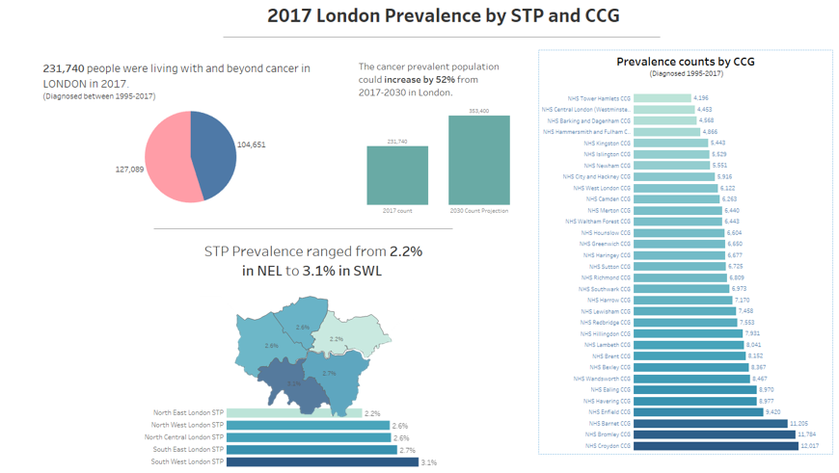

National Context
Every two minutes someone in England will be told they have cancer. Half of people born since 1960 will be diagnosed with cancer in their lifetime. But now more than half of people receiving a cancer diagnosis will live ten years or more. An ageing population combined with increased survival rates means that the number of people diagnosed and living with cancer will continue to grow rapidly, even with improvements in prevention. There are currently approximately 2.5 million people living with cancer in the UK, and this is projected to increase to 5.3 million by 2040.
There is a recognition that for many people cancer should be viewed as a long-term condition, with increasing numbers of people surviving and living with the consequences of cancer and its treatment.

Macmillan Cancer Support have produced a number of valuable documents detailing the impact of cancer and its treatment, how this continues to be a neglected area and addressing the mental health, physical health and psychosocial consequences. Worried sick: the emotional impact of cancer (2006), Cured-but at what cost (2013), Throwing light on the consequences of cancer and its treatment (2013), Rich Picture Series (2015), Am I meant to be OK Now? (2017).

Cancer and mental health are strategic priorities for NHS England. Following the launch of the National Cancer Survivorship Initiative (NCSI) in 2007, the 2010 NCSI vision and Living with and beyond cancer: taking action to improve outcomes (2013), NHS Five Year Forward View , Improving Outcomes for Cancer Strategyand most recently the NHS Long Term Plan, there is now recognition that how well people live, their quality of life, is as important as how long they live. One of the biggest challenges both nationally and in London is ensuring that improving psychological support for people affected by cancer is given the same attention as support for the physical health difficulties associated with cancer.

As part of the NHS cancer dashboard, a new ‘quality of life metric’ is currently being developed. This will provide, for the first time, an indication of how well people are living after cancer treatment and not just how long they are alive. Five cancer alliances have pilot sites, including North Central & East London Cancer Alliance (Barts Health, Royal Free London and UCLH). The pilot and evaluation period ran from September 2017 until 2019. Once the quality of life metric is rolled out in June 2020, psychological and emotional well-being will have to be prioritised and for the first time regarded as central to maintaining quality of life with parity to physical health outcomes.

Alignment with the NHS Long term plan and Personalised care agenda
The proposed integrated pathway model and underlying principles for cancer psychological care services aligns with the key themes in the recently published NHS Long Term Plan. These include:
- Emphasis on more joined up/coordinated care
- Emphasis on services being more proactive
- Importance of service redesign and reducing pressure on the wider healthcare system eg emergency hospital services
- Boosting ‘out of hospital care’
- Carers getting greater recognition and support
- Focus on “shared responsibility for health” –support being provided across the whole pathway to help people manage both their physical and mental well-being.
- More NHS action needs to focus on “reducing health inequalities and addressing unwarranted variation in care”.
- “Quality of life metric” to be introduced from 2020, “to track and respond to the long-term impact of cancer”
- Integrated care systems (ICSs) to be established everywhere by 2021 to improve population health, demonstrating “triple integration” between:
- Primary and specialist care
- Physical and mental health services
- Health and social care
- By 2021 every person with cancer should have access to personalised care, including a needs assessment, care plan and health and well-being information and support.

London Context
In 2015, the Transforming Cancer Services Team for London and London Strategic Clinical Networks jointly published a guidance document entitled ‘Psychological support for people living with cancer’ ‘Commissioning guidance for cancer care in London’.

In May 2018, the Transforming Cancer Services Team (TCST) in partnership with Macmillan Cancer Support published a report, ‘The psychological impact of cancer: commissioning recommendations, pathway and service specifications on psychosocial support for adults affected by cancer’ (available on the HLP website: https://www.healthylondon.org/resource/psychological-cancer-support/ ). The recommendations in this report were endorsed by the Cancer Commissioning Board in February 2018. This report was refreshed in 2020 and is available here: https://www.healthylondon.org/resource/psychosocial-support/).
Ensuring that the personalised care agenda and specifically psychosocial support needs retains a high profile within London at a time when early diagnosis and cancer waiting times are being prioritised will be essential to ensure improved quality of life for all Londoners affected by cancer.

Management of psychological difficulties in the context of cancer
The NICE guidance document Improving supportive and palliative care for adults with cancer (2004)⁷, remains in effect and is clear in outlining recommendations specific to patient and carer involvement, how cancer psychological services should be arranged, as well as palliative care, rehabilitation services, services for families and carers and workforce development.

The main points include:
- Individuals have different needs at different points in time and services should be responsive to those needs
- Families and carers need support during the patient’s life and in bereavement
- All patients and carers should undergo systematic psychological assessment at key points along the pathway (such as around the time of diagnosis, as treatment ends, at recurrence, end of life) and have access to appropriate psychological support.
- Those experiencing particular distress should be referred to professionals with “specialist expertise”
- Psychological needs of staff caring for patients and carers should be adequately met
- All staff providing psychological care should be adequately trained and receive ongoing supervision.

Psycho-oncology services
Psycho-oncology services are typically teams of cancer specialists, with expertise in the area of psychological and mental health care for people affected by cancer, their carers and families (such as cancer counsellors, Clinical Psychologists, Psychiatrists, psychotherapists, Art therapists etc). Most psycho-oncology services are hospital based but not all.

The scope of these services includes:
- direct clinical care for patients, families and carers
- addressing psychological issues that can inhibit access to investigations and treatments
- contributing psychological evidence and insights to all multi-disciplinary teams
- providing training and supervision for CNS and AHP colleagues in level 2 skills to fulfil core peer review requirements.
- training and supporting staff to deliver aspects of the recovery package (e.g HNAs) and directly contributing to designing and running other aspects e.g HWBEs.
- Taking the lead in developing collaborative and effective working relationships with 3rd sector and community services (e.g IAPT, community palliative care teams, GPs and practice nurses, district nurses, and cancer rehabilitation teams) to ensure optimal post-acute psychosocial support
- Providing rapid access to consultation and advice on complex cases (e.g people with mental health history, poor adherence to treatment, complex treatment decision-making)
- Offering highly specialist clinical care for inpatients during medical admission, and outpatients at any point along the pathway

A refreshed mapping exercise by the Transforming Cancer Services Team in London published in February 2020 (available here: https://www.healthylondon.org/resource/psychosocial-support/) showed that:
- The commissioning of Psycho-oncology services is varied and complex. How services are commissioned is not clear for every service.
- Despite some excellent services in London there are still some geographical areas that have no or limited psycho-oncology provision.
- Providers describe increasing demands on their services and some referral decisions are influenced by perceptions of waiting time and expertise in cancer (e.g referring to IAPT services) or concern about the higher thresholds for acceptance of referrals in Community mental health teams

Although Integrated Improving Access to Psychological Therapies (IAPT) services are developing their role in working with long-term conditions (cancer has now been coded as a long term condition), the central focus remains on reduction in anxiety and depression in those with long-term conditions. Other cancer-related psychosocial distress and difficulties, for example, adjustment disorder, fear of recurrence, role and identity change, sexual dysfunction or body image distress are not within the main focus of IAPT services. Additionally, IAPT services do not provide the range of ‘indirect’ work outlined above.

The most common LTCs that are currently seen in integrated IAPT services are:
- –Diabetes
- –Chronic obstructive pulmonary disease (COPD)
- –Cardiovascular disease (CHD)
- –Musculoskeletal problems, Chronic pain

Psycho-oncology teams should take the lead in sharing their clinical expertise, providing training and consultation to all professionals working with people affected by cancer, their families and carers across the whole pathway including acute, primary care and community settings.

2. Outcomes

2.1 NHS Outcomes Framework Domains & Indicators
Domain 1 | Preventing people from dying prematurely | YES
Domain 2 | Enhancing quality of life for people with long-term conditions | YES
Domain 3 | Helping people to recover from episodes of ill-health or following injury | YES
Domain 4 | Ensuring people have a positive experience of care | YES
Domain 5 | Treating and caring for people in safe environment and protecting them from avoidable harm | YES

2.2 Expected outcomes

It is intended the following outcomes will be achieved via commissioning of a psycho-oncology service that provides expertise across the pathway.

- Improve the emotional well-being of people affected by cancer their families and carers by reducing distress, improving functional activity and quality of life
- Improve psychological skills and understanding of the whole workforce
- Improved patient experience – monitored through National Cancer Patient Experience Surveys (NCPES)
- Improve survival outcomes for patients through psychological interventions increasing uptake of screening, testing and treatments
- Address the psychological obstacles that may impact on cancer waiting time standards

3. Scope

3.1 Key aims and objectives of service

Aim
The Psycho-oncology service should be multi-disciplinary offering clinical assessment, formulation, multi-modal treatment and monitoring as well as specialist consultation, training, supervision, service and pathway development. The service to patients, carers and both cancer healthcare professionals and non-speciaist staff should be flexible, accessible, proactive and responsive to psychosocial needs at any point along the pathway from diagnosis, through treatment, living with and beyond cancer and end of life care.

Historical barriers and obstacles need to be overcome to provide integrated care, within acute settings and across primary and secondary care, bridging acute, primary care and community.

The main objectives of the service are:

To work, as cancer specialists, with the full range of psychological problems associated with cancer, including:
- Adjustment difficulties
- Anxiety and phobias
- Depression
- Decision-making difficulties: indecision related to cancer treatment choices
- Fear of recurrence
- Problems with personal relationships
- Psychosexual and body image difficulties
- Psychological issues inhibiting access to cancer investigations and treatment
- Alcohol and drug-related difficulties
- Cognitive impairment (e.g due to radiotherapy to CNS)
- Personality Disorder
- Deliberate self-harm
- Psychotic illness
- Organic brain syndromes (e.g delirium)
- Carer and family support, including bereavement work

To provide on-going clinical supervision of the psychological work of CNS, AHP colleagues within the acute hospital setting and colleagues within Primary Care and Community services where appropriate.

To improve patient’s ability to self-manage and access other sources of support

To provide consultation, liaison, education, training and in-reach to support to the primary care workforce in supporting people living with and beyond cancer.

3.2 Service description/Care pathway

3.2.1 Staffing
Staffing levels need to be negotiated locally but need to incorporate both the specialist psychological support workforce (levels 3 and 4) and the level 2 workforce such as AHPs, and CNS. Services should have a suitable skill mix for the setting and type of service.

The business case attached outlines an algorithm that can be used to establish the minimum workforce provision required to operate a psycho-oncology service. This algorithm in Figure 1:

Figure 1: algorithm to establish the minimum
workforce provision
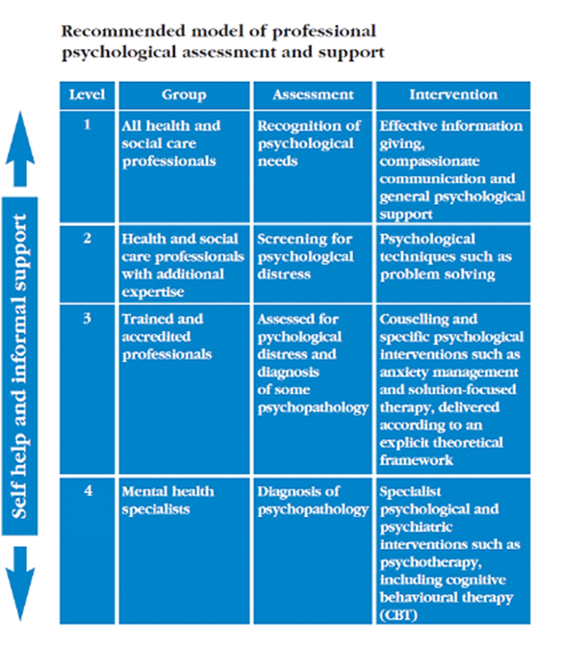
Algorithm example
New cancer diagnoses per annum

15 % require level 3 support

10 % require level 4 support

Number of patients with advanced active disease (AAD)

15% of AAD require level 3 or 4 support

Total patients requiring direct input (excluding families/carers)

20 % Minimum number of carers/family requiring input (conservative estimate)

120 new cases per year per 1.0 wte (NB variation between banding)

Add additional minimum of 20 % extra capacity required for ‘indirect’ work e.g level 2 supervision (e.g Clinical Nurse specialists), teaching/training/consultation with multi-disciplinary colleagues, cancer teaching for IAPT workers, liaison/partnership working with primary care staff

Figure 2: Four Levels of Psychological Assessment and
Support (NICE 2004)

All care within the pathway should be provided within the framework of the 4 level model recommended by the NICE Supportive and Palliative Care Guidance 2004. Although this guidance has not been refreshed since 2004, it is still in effect and remains a well-recognised framework, understood by service providers, the third sector and system leaders/commissioners.

It is recommended that this framework remains and has been useful for developing psycho-oncology services and cancer psychological care, however some notes of caution must be offered. The most important considerations for services must be the needs of the local population and the skills mix required to deliver the range of therapeutic offers from each service as well as the leadership skills required.

Additionally, it is acknowledged that for some people, the level 3 and 4 distinction is perceived as hierarchical, suggesting a two-tier system of provision with Level 4 being superior to Level 3. This is not what is intended so although the distinction is made between these two levels no judgement is made about the levels, it is purely a reflection of the most common current make up of teams and what is considered to be the key components of psycho-oncology services.

Minimum acceptable level of staff requirements for the functioning of any psycho-oncology service is that there should be a Consultant Clinical Psychologist (Band 8c), essential for leadership, service development, strategic work, high level consultation, training and education as well as holding a complex caseload. Band 8a clinical psychologists will do the majority of the clinical work, both direct with adults affected by cancer and their families and ‘indirect’ work e.g supervision/training for level 2 CNS/AHP workforce, rapid case consultation. Band 4/5 Assistant Psychologists play a vital in supporting the work of the team by carrying out audit and service evaluation, measuring outcomes, recording and capturing data to ensure high quality service provision and improvement.

Members of the Psycho-oncology service can come from a variety of backgrounds including: Clinical Psychologists, Counselling Psychologists, Specialist Liaison Psychiatrist, Oncology psychiatrists Psychosexual therapist, Neuropsychologist, Cancer counsellors, psychotherapists, Art therapists and administrators. Patients may require a variety of interventions so can then be seen by the most appropriate clinician. Access to social work support is also important to ensure people have their social care needs met which also impacts on mental health.

The overall benefits of implementing this model in relation to people affected by cancer has included:
- Reductions in psychological distress
- Improvements in overall quality of life and other functional outcomes
- Improvements in concordance with cancer treatments

Prevalence data for London will be able to assist in this workforce planning for each STP/ICS.
Workforce calculations must include provision for both ‘direct’ and the range of ‘indirect’ activities delivered by Psycho-oncology teams such as:
- Level 2 training for CNS and AHP colleagues
- ongoing supervision to Level 2 workers
- consultation to enhance the psychological elements of Personalised Care Interventions e.g input into Health and Well-being support activities
- training on conducting Holistic Needs Assessments
- offering specialist advice on complex cases within multi-disciplinary team meetings
- offering specialist advice, supervision, skills training and consultation to multi-disciplinary colleagues across the whole pathway, including primary care and community settings when needed.
- providing Level 1 training (e.g Sage and Thyme training)
- providing reflective practice groups, multi-disciplinary support and education groups
- providing joint clinics and staff support such as Schwartz rounds.

Please note this is not an exhaustive list of ‘indirect’ activities nor will every service provide these activities.

Activity levels
Level of activity needs to be clearly defined and seen as not just about the direct clinical caseload. For example a Band 7 Clinical Psychologist 1.0 (wte) will likely hold a larger caseload than a Consultant Clinical Psychologist 1.0 (wte) who is responsible for service development, clinical governance, senior management, quality improvement, patient engagement, consultation with clinical colleagues, supervision and training and has therefore has fewer clinical cases.

Comparison of activity data from services across the UK yielded an average of 120 new cases per year for a Level 3/4 professional56 but this does not take into account any ‘indirect’ work. The London Integrated pathway for cancer psychosocial support emphasises an enhanced role for psycho-oncology teams in relation to offering consultation, education and training across the pathway for staff within Primary Care and those in community settings such as IAPT services. Activity levels and workforce capacity must consider the broader role for psycho-oncology teams within this pathway model.

3.2.2 Clinical Space
All Psycho-oncology services need dedicated clinical space. Privacy is essential with good sound-proofing of rooms where possible.

Rooms need to be able to accommodate not only direct interventions with one patient/carer, but also to support couple, family work, groups, supervision, staff consultation and multi-disciplinary team meetings. Medical rooms with examination equipment and medical supplies are not appropriate for facilitating a relaxed context for therapeutic interventions and should be avoided.

Rooms should have sufficient IT resources to access and display relevant patient records, case notes, web-based material, and phone/video conferencing (e.g Skype).

Consideration also needs to be given to providing domiciliary visits when appropriate.

3.2.3 Multi-disciplinary team (MDT) working
Excellent working relationships are required to ensure the MDT works effectively and efficiently. A well-coordinated and managed MDT ensures that:
- Referrals are responded to swiftly, appropriately and efficiently within a weekly team meeting
- Rapid access to the appropriate clinician is secured
- The person/people referred are communicated with quickly and compassionately
- Partnership working and collaborative care is encouraged and facilitated between professionals within an acute service and between acute, community and primary care services when needed.
- The patient remains at the centre of all MDT discussions and is offered as much choice as possible in terms of where and when they are seen.

There should be representation from the psycho-oncology team at oncology MDT meetings.

3.2.4 Education and Training

The NICE (2004)¹guidance document and the National Cancer Peer Review clearly detail the education and training requirements needed to operate at the NICE levels 1-4.

- Level 1 - All staff across acute, primary and community care should receive mandatory ‘Sage and Thyme’ training which guides all healthcare professionals on how to listen and respond to patients who are distressed and has been viewed as essential to improve care and patient experience.
- Level 2 – Clinical Nurse Specialists/Allied Health Professionals-additional training on the National Advanced Communications Skills Training Course and further level 2 training “relevant to cancer patients and their carers which covers basic psychological screening, psychological assessment and basic psychological intervention skills”. After training there is a requirement for Level 2 professionals to attend regular supervision sessions for the psychological support work they undertake. Supervisors need to be at Level 3 or 4.
- Level 3 - a counsellor, accredited by the British Association for Counselling and Psychotherapy, an NHS psychotherapist accredited by the United Kingdom Council for Psychotherapy, a registered mental health nurse with a diploma in counselling, a social worker with additional university accredited diploma in counselling or psychotherapy. The assumption is that basic qualifications in these disciplines would exempt a practitioner from level 2 training.
- Level 4 - a Consultant psychiatrist, a Consultant liaison psychiatrist, a Clinical or Counselling psychologist. All the above professions at Level 4 should have completed an induction that meets the British Psychosocial Oncology Society (BPOS) and SIGOPAC (DCP Faculty for Oncology and Palliative Care) requirements.

3.2.5 Service evaluation and audit
All services have a responsibility for on-going evaluation and audit and should have a plan for doing so. Results should be used to improve services. Services should be supported to test out new initiatives. Health equity assessments should be regularly conducted to ensure that the services are meeting the needs of the widest range of Londoners.

3.2.6 Interventions which should be available
Interventions should be carried out following an assessment of clinical need and the competency level of the practitioner and their skill set.

Within a Psycho-oncology MDT, ‘direct’ interventions should include the following:
- Addressing psychological issues, enabling a patient to make decisions about engaging in testing and treatment and managing any obstacles to engaging with a medical team.
- Cognitive-behavioural therapy
- Third wave cognitive-behavioural therapies (e.g Acceptance and Commitment therapy)
- Systemic interventions
- Couple/Family Therapy
- Bereavement support
- Psychosexual therapy
- Neuropsychological assessment and Interventions
- Cancer counselling
- Brief focused psychotherapy
- Mindfulness
- Assessment and management of suicidality, co-morbid alcohol and drug problems, personality disorder, deliberate self-harm, psychotic illness, organic brain syndromes, complex co-morbidity.

‘Indirect’ interventions should include:
- Delivering Level 2 training and ongoing supervision to Level 2 workers
- Consultation to enhance the psychological elements of the Recovery package e.g input into Health and Well-being events, training on conducting Holistic Needs Assessments
- Offering specialist advice, supervision, skills training and consultation with multi-disciplinary colleagues within cancer multi-disciplinary team meetings and across primary and community settings when needed
- Providing Level 1 training (e.g Sage and Thyme training)
- Providing reflective practice groups, multi-disciplinary support and education groups
- Providing joint clinics
- Providing staff support such as Schwartz rounds.

Please note that this is neither an exhaustive nor prescriptive list of activities. Local needs for both patients and staff need to be assessed to determine what interventions are prioritised by services.

3.2.7 London Integrated Pathway for Cancer Psychosocial support

Figure 3: London Integrated Pathway for Cancer Psychosocial Support

There are a range of interventions that are beneficial and not just delivered by one single professional group. The term Psychosocial Support Pathway captures the importance of considering a broader range of determinants of emotional well-being.

Key features of the model:
- There are three levels of support indicated in this pathway, universal, enhanced and specialist. Patients and their families may need different support at different times and may not proceed through universal, enhanced and specialist support in a linear or predictable fashion, so access to services must be flexible.
- A key principle underpinning the whole pathway, across acute, primary care and community settings is what needs to happen within the existing system to prevent distress and promote adjustment.
- It is a ‘whole’, integrated pathway for cancer psychosocial care across acute, community and primary care. The psycho-oncology team will work with key professionals across the pathway delivering consultation and sharing expertise, education, training and supervision. Training and education will ensure that physical health and mental health are no longer regarded as separate, disconnected elements of healthcare. Ultimately this way of working will encourage a “psychologically minded culture”, which will improve patient outcomes and experience across acute, primary care and community settings.
- Psycho-oncology teams, as the specialists in cancer and mental health, should take the lead to ensure a ‘whole system’ approach to identifying and providing psychosocial support with clear and flexible referral pathways and processes, which are understood by professionals, patients, their carers and families. Within the pathway there is a clear role for both Psycho-oncology teams and IAPT services, which provide vital support at different points along the pathway

Figure 4: Activity at each level of the pathway (NICE, 2004)3.

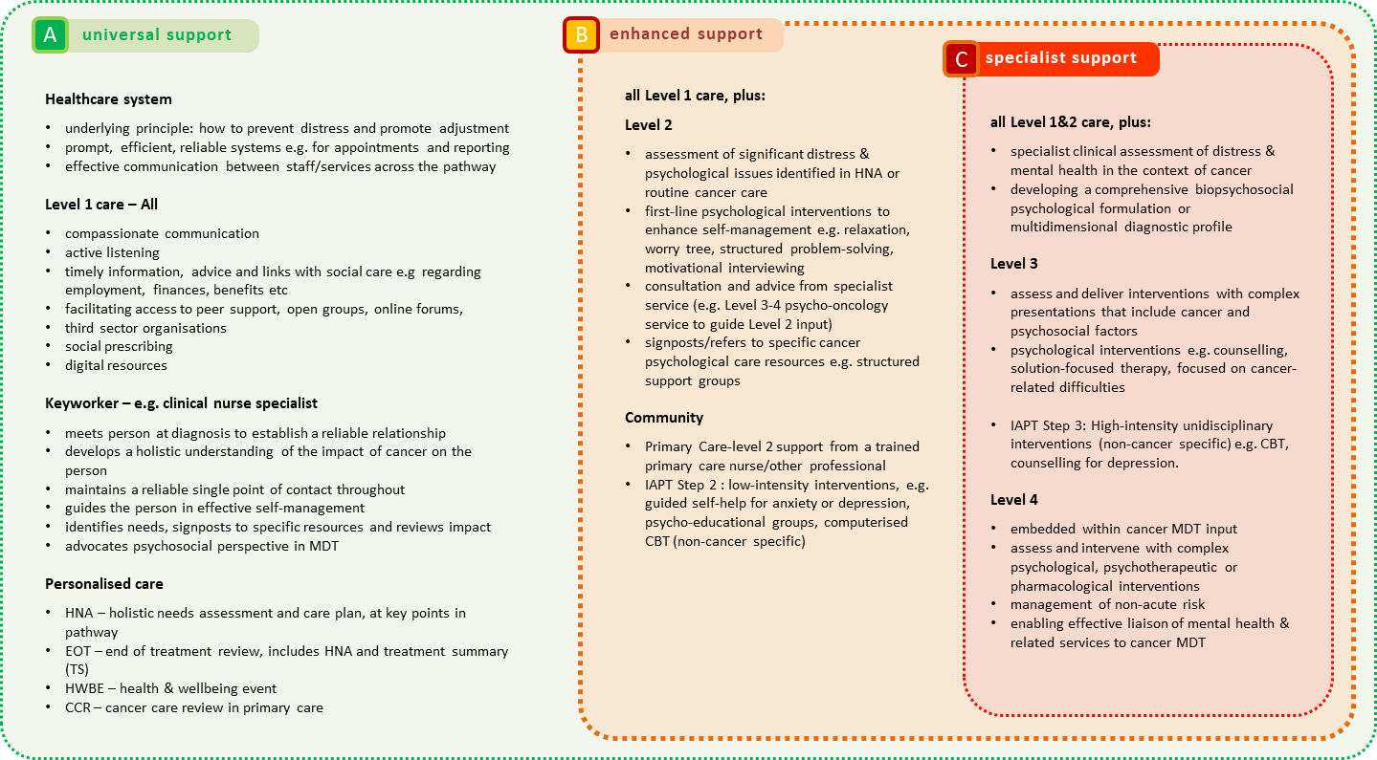

A full outline of practitioner levels of activity is below:
Level 1 Role - All staff working with people affected by cancer, their families and carers
Psychosocial care activity needs to include:
- Recognition of psychological need
- Look for indications of distress, low mood, worry. All professionals need to be proactive, asking “how are you feeling in yourself?”/”what impact is…having on your life?”
- Active listening - asking and listening can be an intervention in itself
- How is the patient coping? Are they accessing support? Are their difficulties interfering with their life and accessing treatment?
- Provide general emotional support
- Signpost to support that patient finds relevant-discuss with them
- Communicate with compassion
- Ensure all professionals are communicating effectively with each other across the pathway.
- Discuss with a CNS/Level 2 worker
- Contact Psycho-oncology service for advice/consultation

Level 2 Role Clinical Nurse Specialists/Allied Health Professionals/Primary Care Key worker role– requires specific training and regular supervision (e.g by Level 3/4 practitioners)
Psychosocial care activity includes:
- meet the person at diagnosis – to build a reliable relationship
- explore and address the person’s information preferences
- include and involve family and carers
- track person’s adjustment throughout the pathway
- guide and coordinate care, including support
- contribute psychosocial perspective to MDT decisions
- signpost to internal and third-sector resources, e.g. welfare advice
- undertake holistic needs assessment (HNA) at key transitions
- offer first-line psychological support (Level 2)
- consult with, work jointly with and refer to Level 3/4 psycho-oncology services
- link and coordinate care with external services (e.g. learning disability)

Level 3 includes psychotherapists, family therapists, counsellors, mental health therapists accredited in a particular modality (e.g CBT accreditation by British Association for Behavioural and Cognitive Psychotherapies (BABCP), social workers and mental health nurses with an accredited psychotherapeutic training.) Completed specialist training in cancer care.

- assess and deliver interventions with complex presentations that include psychosocial factors
- provide triaging with complex presentations that include psychosocial factors
- contribute to service developments aimed at delivering the biopsychosocial care delivered by the organisation
- provide supervision, consultation and training relating to psychosocial factors
- provide training placements to trainees in their professional discipline to develop the future workforce

Level 4 includes clinical psychologists, consultant liaison psychiatrists, counselling psychologists who have completed a substantive mental health training, are accredited to deliver interventions across a range of modalities, able to use formal methods to adapt, evaluate and deliver interventions. Knowledge through training and experience of other mental health services. Completed specialist training (e.g in role-teaching, supervision and formal courses) with specific reference to cancer care.

- assess and intervene with complex presentations that include a combination of physical, social and psychological variables
- able to make differential diagnosis/construct biopsychosocial formulations
- lead the triaging process
- provide supervision/consultation/training relating to severe and enduring mental health issues especially in the context of risk
- lead service developments aimed at enhancing the biopsychosocial care delivered by the organisation
- lead psycho-oncology teams/services
- liaise with and work in combination with other services and agencies ( e.g IAPT, community mental health teams, primary care)
- provide training placements to trainees in their professional discipline to develop the future work force.

A range of professionals should be available within a Psycho-oncology service to include Clinical/Counselling Psychologist, access to Liaison Psychiatry, Psychosexual therapists and Neuropsychologists. These will comprise both level 3 and level 4 professionals.

Psycho-oncology teams are usually embedded within cancer pathways and led by Level 4 professionals such as Consultant Clinical Psychologists. These teams:
- Work with inpatients and outpatients
- Provide a vital role in supporting patients to access cancer investigations, treatments and care thus improving patient outcomes.
- Provide support for patients, families and carers
- Work with full range and severity of difficulties associated with cancer including(but not limited to): anxiety, depression, deliberate self-harm, alcohol and drug-related issues, mild cognitive impairment, helping people with adjustment issues, decision-making, body image difficulties, problems with personal relationships and relationships with professionals
- Offer a range of interventions including:
  - Cognitive-behavioural therapy
  - Brief focused psychotherapy
  - Mindfulness
  - Grief/Existential Therapy
  - Couple/Family therapy
  - Systemic interventions
  - Cancer counselling
  - Consultancy to survivorship events
  - Assessment and management of: suicidality and risk, co-morbid alcohol and drug-related problems, personality disorders, deliberate self-harm, psychotic illness, organic brain syndromes, complex co-morbidity
- Provide consultation and expert advice on cancer and psychological issues to MDT teams and other professionals across the pathway
- Provide training, consultation and supervision for Level 2 workers (e.g CNS)
- Provide specialist functions such as Neuropsychological assessment, psycho-sexual interventions

Figure 5: Referral criteria across the pathway within the acute/hospital context
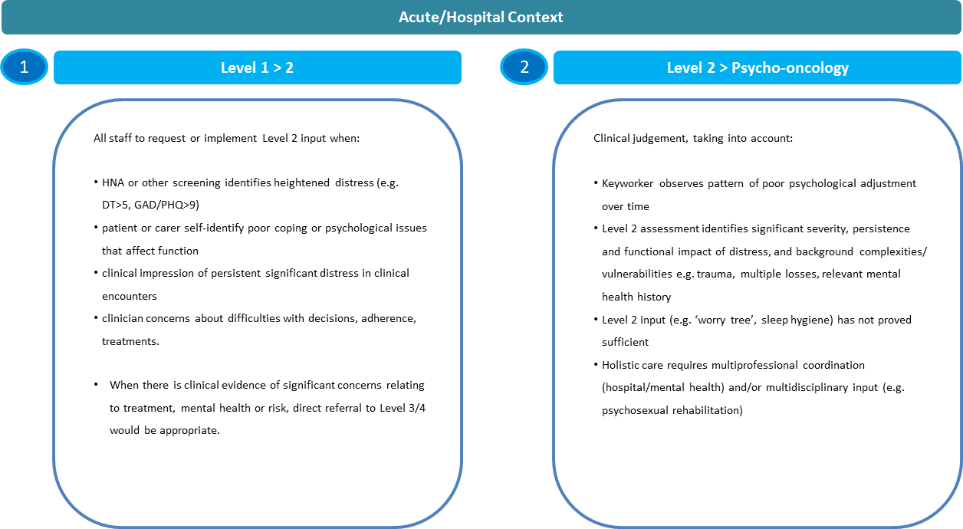

Figure 6: Referral criteria for Primary Care/Community context

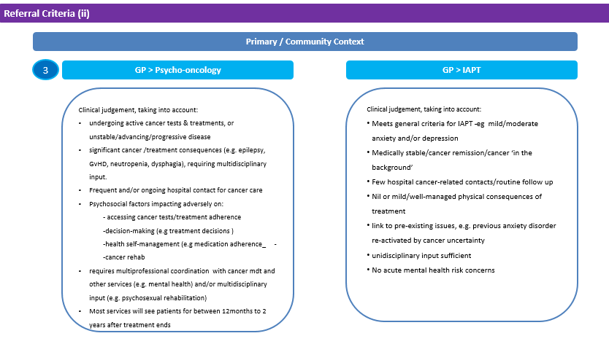

A key area to be considered in commissioning psycho-oncology service provision is the service cut offs that most teams have historically used predominantly for capacity reasons rather than clinical reasons or based on research evidence. Most services currently will see patients for a maximum of up to 2 years after treatment ends. However, we know from patients themselves that they report significant psychological difficluties which are often related to cancer and its treatment 5 years, 7 years or more than ten years after their treatment ends and there is increasing recognition of the ‘treatable but not curable’ cohort and the importance of meeting their psychosocial needs. IAPT does not always meet the requirements as they are a generalist service treating anxiety and depression and are not cancer psychological specialists. Currently this group of patients fall through a gap and are not having their needs met and this must change by psycho-oncology services having the workforce capcity to support this cohort of patients.

Figure 7: Expanded role of psycho-oncology teams across the pathway.

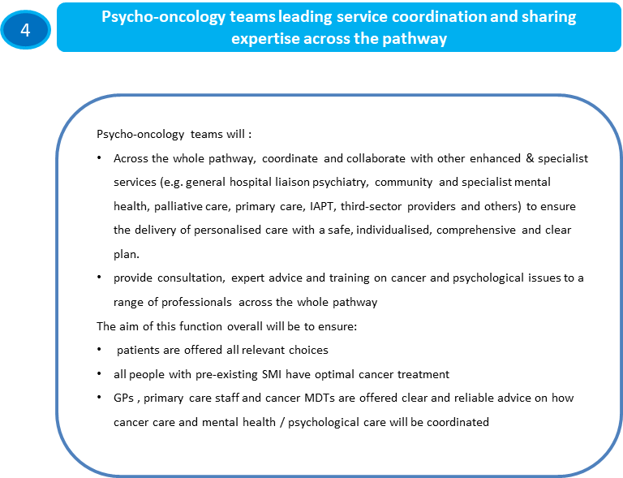

3.2. 1 Role of Primary Care teams/Primary Care Networks
Primary care teams should be able to access specialist cancer expertise from Psycho-oncology teams easily. Primary care teams should be involved in localising the pathway and developing links with local psycho-oncology teams. Support and training should be delivered to primary care staff to enhance the psychological care and emotional support they offer to patients. Primary care professionals should be able to easily communicate with a psycho-oncology team to discuss complex cases seen within primary care or to discuss where might be an appropriate referral.

Additionally, it is recommended that the primary care provider implements London’s 4 point Model for managing cancer as a long term condition as a way of identifying the psychosocial needs of people affected by cancer.
A personalised care consultation covering cancer (such as a cancer care review or a long term conditions review) should be co-produced between the Primary Care Clinician (GP, Practice Nurse or allied health professional) and the patient. For example, the patient may wish to bring a list of current issues. The consultation should enable a broad range of topics to be identified covering psycho-social needs, physical health needs, needs of carers and support patients towards self-management. It is recognized that not all issues will be covered in one ten-minute consultation, and so patients are encouraged to identify those that are of most concern, at the moment. These consultations provide an opportunity within primary care to identify psycho-social support needs at a number of points along the pathway. Currently the quality and provision of Cancer Care Reviews across London is variable. But this is an important vehicle to identify need and support patients in a more proactive and coordinated way within primary care.

3.2.2 Collaborating with Integrated Improving Access to Psychological Therapies (IAPT) services.

IAPT Integrated services started to treat people with long-term conditions in January 2017. The main focus of interventions remains “to treat the patient’s anxiety or depression in the context of their long term condition”.

The TCST has had a multi-disciplinary working group focused on the referral pathway including referral criteria across Primary care, IAPT, Psycho-oncology services and Psychiatry with consensus from service providers that this is a sensible approach.

- Integrated IAPT services within their respective CCGs and STP areas need to identify what the existing and established pathway in place looks like for cancer. This will avoid any duplication in work and enables better pathway partnership working.
- In relation to Integrated IAPT services and their work with people affected by cancer, it is recommended that education, training and consultation with cancer specialists such as psycho-oncologists would need to be integral to service development to ensure the best outcomes for people affected by cancer.
- Integrated IAPT services are adapting their direct interventions for people with LTCs but generally it is not within their remit nor are they financially incentivised to carry out ‘indirect’ work which is delivered by Psycho-oncology services.
- Good practice going forward is that psycho-oncology services and IAPT services will need to adopt the referral criteria outlined in figure 6 and collaborate to localise the pathway according to resources available.
- IAPT services play an important role in treating anxiety and depression in the context of a long term condition, when the patient is no longer in active treatment and cancer is very much in the background.

3.3 Costing of Services

As a mimimum psycho-oncology workforce: 8c Consultant Clinical Psychologist (1.0 wte), 8a Clinical Psychologist (1.0 wte), Band 4 Assistant Psychologist (1.0 wte), the costs are £197,490 (plus on costs). This also excludes administrative support. This basic configuration, as a starting point, is consistent with many existing services within London.
However each STP/Integrated Care System should consider their own local demographic data to agree on the most appropriate skills mix to meet the needs of their cancer population. Calculations will need to consider the local population needs, the skills mix needed and the expanded ‘indirect’ role for psycho-oncology teams as outlined in this pathway.

In developing services access to psychiatry should be considered for both inpatients and outpatients as there is currently inequity of access to psychiatry for cancer patients within services across London resulting in unwarranted variations in care (See Mapping report 2020).

3.4 Population covered, location and timing of services

The Psycho-oncology service is available across the psychosocial pathway. Most psycho-oncology services are hospital based, as cancer specialists linking in with acute oncology teams. However, services should be developed in line with the integrated care and care closer to home agendas to ensure the best outcomes for patients. For example, a psycho-oncology clinic may be delivered in a community setting, covering one or more Primary Care Networks.

3.5 Acceptance and exclusion criteria

Eligibility criteria

3.6 Referral process and waiting times
Patients should be able to access Psycho-oncology services via referrals from healthcare professionals including GPs, Consultants, Clinical Nurse Specialists and AHPs. Consideration may also be given to self-referral.

Recommended waiting times are:
- Rapid response to Inpatient referrals-within 48 hours (Monday-Friday)
- Outpatient referrals should have an initial assessment within 14 days.
- Outpatient referrals should have wait times to treatment of no more than 4 weeks

The Psycho-oncology team should take the lead on communicating and partnership working across the pathway and triaging referrals for those affected by cancer. If a patient is seen as inappropriate for the Psycho-oncology service, they should still be involved in facilitating a swift referral elsewhere. Primary care professionals should not be expected to make complex clinical decisions about psychological care and referral routes. Localising the pathway will ensure clarity on referral pathways based on knowledge of local resources. Establishing local working groups to embed the pathway are advised (e.g including IAPT, Primary Care, Psycho-oncology).

3.7 Partnership working with other services/providers
Key partnerships and relationships include the following:
Primary care teams
Palliative Care Teams
IAPT services
Community health services
Community Mental Health Teams
Local authority
Local hospitals
Local hospices
The Third sector
Cancer rehabilitation services
Psychiatry

It is recommended that to ensure the effective implementation of the pathway that local steering groups are developed with representation across the pathway including service users, primary care, IAPT, psycho-oncology and psychiatry to ensure closer collaboration and effective working.

3.8 System leadership, co-ordination and accountability
Effective implementation of an integrated model of care will require some resource to lead and co-ordinate the process. Alliance/STP footprints often include two or more cancer centres in addition to multiple providers of community/DGH based psychological care. There needs to be single named psycho-oncology lead with specific time in their job plan, who can report directly into the local STP/alliance or ICS board.

4. Applicable Service Standards

The service will be delivered according to best practice and in line with the relevant local and national guidance

4.1 Applicable national standards

- NICE guidance on Improving Supportive and Palliative Care for Adults with Cancer (2004)1
- Psychological Support Measures for Cancer (NCAT 2008). Whilst Psycho-oncology services still await national guidance to replace the 2008 peer review measures, services continue to apply these principles as examples of best practice and as quality indicators.

4.2 Applicable local standards
As referred to in this document and as developed by providers to ensure that there is an operational level for self-certified protocols.

5. Applicable quality requirements and CQUIN goals

5.1 Applicable Quality requirements and CQUIN goals

5.1.1 Outcome measures:
Core domains of quality and outcomes of psycho-oncology services have been identified in the British Psychological Society/Division of Clinical Psychology (BPS/DCP) document Demonstrating Quality and Outcomes in Psycho-Oncology:
- Is this service safe?
- Is this service equitable, while also focused on those most in need?
- Is this service timely and responsive?
- Is this service respectful, collaborative and patient-centred?
- Is this service offering effective interventions?
- Is this service contributing to efficient multi-disciplinary care?

Outcome measures should be used to evaluate the effectiveness of direct interventions. There is a wide selection of quantitative self-report measures in use.

It is important that a patient is not overwhelmed by assessment measures to the detriment of the clinical relationship, so administration of measures should be kept to an agreed minimum. Following a survey of outcome measures used by Psycho-onology services in London (December 2018-January 2019). The most commonly used measures could usefully include the following:
- Global Assessment of Function (GAF) (pre-and post-intervention for inpatients)
- Functional Assessment of Cancer Therapy-General (FACT-G) (pre and post treatment for outpatients)
- GHQ-12 (General Health Questionnaire)
- HADS (Hospital Anxiety and Depression Scale)
- PHQ-9 or PHQ-8 (pre and post treatment for outpatients) when working with depression
- GAD-7 (pre and post treatment for outpatients) when working with anxiety
- National Quality of Life metric (in development and due for national implementation in 2020). The two instruments being piloted are the EORTC QLQ-C30 which is a cancer specific quality of life measure and the EQ-5D which is a generic quality of life measure).

There are additional measures that are used across London and the clinician’s therapeutic orientation is also likely to dictate what measures are used within clinical practice.

Psycho-oncology services offer specialist advice, supervision, skills training and consultation with multi-disciplinary colleagues. Delivering Level 2 training and ongoing supervision to Level 2 workers. Services may also be providing Level 1 training (e.g Sage and Thyme training), reflective practice groups, multi-disciplinary support and education groups, joint clinics and staff support such as Schwartz rounds. This ‘indirect’ work must also be captured to ensure comparisons can be made on service standards and value of Psycho-oncology services across London.

Data captured to include:
- Numbers receiving Level 2 training (CNS and other professionals) and report outcomes of Level 2 training
- Numbers receiving cancer specific training within IAPT services, delivered by psycho-oncology teams and outcome

Services should explore the use of health care utilization metrics using the Client Service Receipt Inventory (CSRI) (available here:) to evaluate the impact of their service on for example:
- Emergency inpatient admissions
- A & E attendance
- GP consultations
.
A patient satisfaction questionnaire should be used across all services. This could be the NHS Friends and Family Test (FFT) and whatever will replace this measure and in addition a tailored more psychologically relevant satisfaction measure could be used for service improvement purposes.

5.1.2 Key performance indicators
These are used in addition to outcome measures to evaluate the performance of a service. A survey was conducted in December 2018-January 2019 of KPIs being used by psycho-oncology services across London. There is currently significant variation between services. A Pan-London approach to KPIs is needed in order to benchmark services and obtain meaningful data for comparison across services.

A useful framework for KPIs, used by some services, is to group KPIs under the 6 domains identified in the Demonstrating Quality and Outcomes in Psycho-oncology56 document: Safe, Equitable, Timely and Responsive, Effective, Efficient, Patient-Centred and to then have KPIs within these domains.
Key areas to be measured include (please note this is not an exhaustive list):

Domain | Example KPIs
Safe | 100% new patients seen for initial consultation have care plans agreed at team meeting and risk discussed.
 | All clinical staff are HCPC registered
 | All clinical staff receive clinical supervision in line with professional guidance
 | Clear procedures for risk governance
 | Clinical activity levels are within locally agreed range
Equitable | Patient data across all domains as defined in the NHS equalities framework is captured and reported regularly. This should align with the Minimum Data Set recommended within recent TCST Cancer Rehabilitation guidance documentError! Bookmark not defined.
 | Data is analysed and reported regularly
 | Data from referrals is compared to cancer centre data and local demographics
 | Regular audits are carried out to assess access to services and potential unmet need and a plan is made to address inequity when identified.
Timely and Responsive | Service meeting in-patient response targets (>90% seen within 2 working days)
 | Service meeting out-patient response targets (>90% offered initial out-patient assessment within 14 days)
 | Outpatients should have wait times to treatment of no more than 4 weeks
 | Service meeting Consultation request response targets (>90% within 1 working day)
 | Service monitors and reports DNA rates
 | Service monitors waiting times to first booked appointment
Effective | All cancer CNSs trained to Level 2
 | Monthly level 2 supervision provided for all CNSs
 | Minimum of 1 hour clinical supervision by a level 3 or level 4 practitioner per month.
 | Ensuring compliance >70% of CNSs attending at least 9 supervision groups per year.
 | Outcome measures administered and evaluated to ensure interventions are effective
Efficient | Clinical activity including direct patient work, level 2 supervision and other ‘indirect’ work (e.g teaching of oncology colleagues-drs/AHPs, teaching IAPT workers, consultation and liaison with primary care etc) is collected on a regular basis and included in annual report
 | Prompt review of incoming referrals and communication with referrers
Patient-centred | Patient satisfaction data routinely collected
 | Feedback from patients and carers used regularly to improve service
 | Patients routinely offered choice of appointment time, site and clinician (as far as possible)

5.3 Data collection
This is important in order to benchmark services across London. Ensuring that meaningful data is collected to address health equality in service provision is also extremely important. This should align with the Minimum Data Set recommended within recent TCST Cancer Rehabilitation guidance document and the TCST Cancer Inequalities toolkit available here. TCST/PHE Prevalence dashboard should be used in conjunction with service demographics to identify groups who may not be accessing local services.

References
National Institute for Health and Care Excellence (2004) Guidance on Improving Supportive and Palliative Care for Adults with Cancer https://www.nice.org.uk/guidance/csg4/resources/improving-supportive-and-palliative-care-for-adults-with-cancer-pdf-773375005
2 Macmillan Cancer Support (2006) Worried sick: the emotional impact of cancer https://www.macmillan.org.uk/documents/getinvolved/campaigns/campaigns/impact_of_cancer_english.pdf
3 Calati, R., Di Mattei, V. and Courtet, P.,(2017) Risk of suicide mortality among cancer patients: A meta-analysis of observational studies. European Psychiatry, 41, pp.S290-S291. http://www.europsy.net/wp-content/uploads/2017/03/cancersuicide.pdf
4 Transforming Cancer Services Team for London (2016) Cancer Rehabilitation: a scoping report for London https://www.healthylondon.org/wp-content/uploads/2017/11/Cancer-rehabiliation-a-scoping-report-for-london.pdf
5 Macmillan Cancer Support (2006) Worried sick: the emotional impact of cancer https://www.macmillan.org.uk/documents/getinvolved/campaigns/campaigns/impact_of_cancer_english.pdf
6 Independent Cancer Taskforce (2015) Achieving World-Class Outcomes A Strategy for England 2015-2020 https://www.cancerresearchuk.org/sites/default/files/achieving_world-class_cancer_outcomes_-_a_strategy_for_england_2015-2020.pdf
7 Macmillan Cancer Support (2015) The burden of cancer and other long-term conditions https://www.macmillan.org.uk/documents/press/cancerandotherlong-termconditions.pdf
8 Macmillan Cancer Support (2019) Cancer statistics: people living with cancer https://www.macmillan.org.uk/_images/cancer-statistics-factsheet_tcm9-260514.pdf
9 Macmillan Cancer Support (2006) Worried sick: the emotional impact of cancer https://www.macmillan.org.uk/documents/getinvolved/campaigns/campaigns/impact_of_cancer_english.pdf
10 Macmillan Cancer Support (2013) Cured-but at what cost? https://www.macmillan.org.uk/_images/cured-but-at-what-cost-report_tcm9-295213.pdf
11 Macmillan Cancer Support (2013) Throwing light on the consequences of cancer and its treatment https://www.macmillan.org.uk/documents/aboutus/research/researchandevaluationreports/throwinglightontheconsequencesofcanceranditstreatment.pdf
12 Macmillan Cancer Support (2015) Rich Picture Series http://be.macmillan.org.uk/Downloads/CancerInformation/RichPicture/MAC150691114RPPeoplelivingwithCancer-Interactive.pdf
13 Macmillan Cancer Support (2017) Am I meant to be OK Now? https://www.macmillan.org.uk/assets/lwbc-report-2017.pdf
14 National Cancer Survivorship Initiative (2007) (archived) http://webarchive.nationalarchives.gov.uk/20100809103735/http://www.improvement.nhs.uk/cancer/Default.aspx?alias=www.improvement.nhs.uk/cancer/survivorship
15 National Cancer Survivorship Vision (2010) (archived)http://webarchive.nationalarchives.gov.uk/20100809113601/http://www.improvement.nhs.uk/cancer/LinkClick.aspx?fileticket=4apVUSvGcow%3d&tabid=214
16 National Cancer Survivorship Initiative (2013) Living with and beyond cancer: Taking action to improve outcomes https://www.gov.uk/government/uploads/system/uploads/attachment_data/file/181054/9333-TSO-2900664-NCSI_Report_FINAL.pdf
17 NHS England (2014) Five Year Forward View https://www.england.nhs.uk/wp-content/uploads/2014/10/5yfv-web.pdf
18 Department of Health (2011) Improving Outcomes: A Strategy for Cancer https://assets.publishing.service.gov.uk/government/uploads/system/uploads/attachment_data/file/213785/dh_123394.pdf
19 NHS England (2019) Long Term Plan https://www.longtermplan.nhs.uk/publication/nhs-long-term-plan/
20 The psychological impact of cancer: commissioning recommendations, pathway and service specification on psychosocial support for adults affected by cancer, Transforming Cancer Services Team (May 2018)
21 Quality Health (2017) National Cancer Patient Experience Surveys https://www.quality-health.co.uk/surveys/national-cancer-patient-experience-survey
22 Transforming Cancer Services Team for London (2015) Cancer as a long term condition: A review of Cancer Care Reviews and a proposed model for London https://www.healthylondon.org/wp-content/uploads/2017/12/Four-point-model-for-holistic-cancer-care-reviews-cancer-as-a-long-term-condition.pdf
23 Healthy London Partnership (2020), Pan-London Psycho-oncology Mapping Report. Available here: https://www.healthylondon.org/psychosocial-support/
24 National Cancer Peer Review Programme, Manual for Cancer Services 2008: Psychological Support Measures (NCAT 2008)
25 The British Psychological Society (2015) Demonstrating Quality and Outcomes in Psycho-oncology, https://www1.bps.org.uk/system/files/Public%20files/cat-1704.pdf
26 Healthy London Partnership (2019) Guidance for reducing variation and improving outcomes in cancer rehabilitation https://www.healthylondon.org/resource/guidance-for-reducing-variation-and-improving-outcomes-in-cancer-rehabilitation/
27 Public Health England and Transforming Cancer Services Team Partnership (2019) 2017 Cancer Prevalence Dashboard https://www.healthylondon.org/resource/2017-cancer-prevalence-dashboard/

Healthy London Partnership, The psychological impact of cancer: commissioning recommendations, pathway and service specification on psychosocial support for adults affected by cancer (May 2018). Available here: https://www.healthylondon.org/wp-content/uploads/2018/05/Psychological-support-for-people-affected-by-cancer-May-2018.pdf
Transforming Cancer Services Team and Public Health England Partnership, 2017 Cancer Prevalence Dashboard (2019). Available here: https://www.healthylondon.org/resource/2017-cancer-prevalence-dashboard/
National Institute for Health and Care Excellence, Guidance on Improving Supportive and Palliative Care for Adults with Cancer (2004). Available here: https://www.nice.org.uk/guidance/csg4/resources/improving-supportive-and-palliative-care-for-adults-with- cancer-pdf-773375005
Macmillan Cancer Support, Worried sick: the emotional impact of cancer (2006). Available here: https://www.macmillan.org.uk/documents/getinvolved/campaigns/campaigns/impact_of_cancer_english.pdf
Calati, R., Di Mattei, V. and Courtet, P, Risk of suicide mortality among cancer patients: A meta-analysis of observational studies. (2017) European Psychiatry, 41, pp.S290-S291. Available here: http://www.europsy.net/wp-content/uploads/2017/03/cancersuicide.pdf
Healthy London Partnership, Cancer Rehabilitation: a scoping report for London (2016). Available here: https://www.healthylondon.org/wp-content/uploads/2017/11/Cancer-rehabiliation-a-scoping-report-for-london.pdf
Macmillan Cancer Support, Worried sick: the emotional impact of cancer (2006). Available here: https://www.macmillan.org.uk/documents/getinvolved/campaigns/campaigns/impact_of_cancer_english.pdf
Layard, R & Clark, D.M, Thrive: The Power of Evidence-Based Psychological Therapies (2014)
Deeny, Thorlby, R, Steventon, Health Foundation, A Briefing: Reducing emergency admissions: unlocking the potential of people to better manage their long-term conditions (2018). Available here: https://www.health.org.uk/sites/default/files/Reducing-Emergency-Admissions-long-term-conditions-briefing.pdf
Transforming Cancer Services Team and Public Health England Partnership, 2017 Cancer Prevalence Dashboard (2019). Available here: https://www.healthylondon.org/resource/2017-cancer-prevalence-dashboard/
Healthy London Partnership, Guidance for reducing variation and improving outcomes in cancer rehabilitation (2019). Available here: https://www.healthylondon.org/resource/guidance-for-reducing-variation-and-improving-outcomes-in-cancer-rehabilitation/
NB. At the time of publication, the eHNA data provided via the Cancer Stats portal is limited. More detailed data outlined above is provided by the RM Partners Analytics team. For further details please contact: rmpartners.info@nhs.net
The Kings Fund and the Centre for Mental Health, Long-term conditions and mental health The cost of co-morbidities. Available here: https://www.centreformentalhealth.org.uk/sites/default/files/2018-09/Cost_of_Comorbidities.pdf
Ell K, Quon B, Quinn DI, et al. Improving treatment of depression among low-income patients with cancer: the design of the ADAPt-C study. Gen Hosp Psychiatry 2007;29(3):223–231.; Zabora J, BrintzenhofeSzoc K, Curbow B, Hooker C, Piantadosi S. The prevalence of psychological distress by cancer site. Psycho-Oncology 2001;10(1):19–28.
The Kings Fund, Long-term conditions and mental health: The cost of co-morbidities (2012). Available here: https://www.kingsfund.org.uk/sites/default/files/field/field_publication_file/long-term-conditions-mental-health-cost-comorbidities-naylor-feb12.pdf
Ell K, Quon B, Quinn DI, et al. Improving treatment of depression among low-income patients with cancer: the design of the ADAPt-C study, (2007) Gen Hosp Psychiatry;29(3):223–231; Zabora J, BrintzenhofeSzoc K, Curbow B, Hooker C, Piantadosi S, The prevalence of psychological distress by cancer site (2001) Psycho-Oncology;10(1):19–28.
Harrison JD, Young JM, Price MA, Butow PN, Solomon MJ, What are the unmet supportive care needs of people with cancer? A systematic review (2009), Support Care Cancer;17:1117-28; Jansen F, van Uden-Kraan CF, van Zwieten V, Witte BI, Verdonckde Leeuw IM, Cancer survivors’ perceived need for supportive care and their attitude towards self-management and eHealth (2015), Support Care Cancer, 23:1679-88
Jacobsen PB, Jim HS, Psychosocial interventions for anxiety and depression in adult cancer patients: achievements and challenges (2008), CA Cancer J Clin 58(4):214–230; Fallowfiel L, Ratcliffe D, Jenkins V, Saul J, Psychiatric morbidity and its recognition by doctors in patients with cancer (2001), Br J Cancer, 84(8):1011–1015.
Christopher Lo, Andrew Calzavara, Paul Kurdyak, Lisa Barbera, Frances Shepherd, Camilla Zimmermann, Malcolm J. Moore and Gary Rodin, Depression and use of health care services in patients with advanced cancer (2013), Canadian Family Physician, 59 (3) e168-e174
Nuffield Trust, Use of health and social care by people with cancer (2014). Available here: https://www.nuffieldtrust.org.uk/research/use-of-health-and-social-care-by-people-with-cancer
Luber MP, Meyers BS, Williams-Russo PG, et al, Depression and service utilization in elderly primary care patients (2001), Am J Geriatr Psychiatry, 9(2):169-176; Himelhoch S, Weller WE, Wu AW, Anderson GF, Cooper LA, Chronic medical illness, depression, and use of acute medical services among Medicare beneficiaries (2004), Med Care, 42(6):512‐521; Koenig HG, Differences in psychosocial and health correlates of major and minor depression in medically ill older adults (1997), J Am Geriatr Soc.;45(12):1487-1495; Christopher Lo, Andrew Calzavara, Paul Kurdyak, Lisa Barbera, Frances Shepherd, Camilla Zimmermann, Malcolm J. Moore and Gary Rodin, Depression and use of health care services in patients with advanced cancer (2013), Canadian Family Physician, 59 (3) e168-e174
Mausbach BT, Irwin SA, Depression and healthcare service utilization in patients with cancer (2017), Psychooncology. 26(8):1133-1139
Lo C, Calzavara A, Kurdyak P, et al, Depression and use of health care services in patients with advanced cancer (2013), Can Fam Physician, 59(3):e168‐e174.
Xiaoyun Pan, Usha Sambamoorthi, Health care expenditures associated with depression in adults with cancer (2015), J Community Support Oncol. 13(7): 240–247.
Prina AM, Deeg D, Brayne C, Beekman A, Huisman M, The association between depressive symptoms and non-psychiatric hospitalisation in older adults (2012), PLoS One 7(4):
De Boer,A.G;Taskilla, T; Ojajarvi, A;Van Dijk, F.J & Verbeek, J.H, Cancer Survivors and Unemployment: a meta-analysis and meta-regression, (2009) JAMA 301, 753-762. Available here: https://www.ncbi.nlm.nih.gov/pubmed/19224752
Transforming Cancer Services Team and Public Health England Partnership, 2017 Cancer Prevalence Dashboard (2019). Available here: https://www.healthylondon.org/resource/2017-cancer-prevalence-dashboard/
Layard, R & Clark, D.M, Thrive: The Power of Evidence-Based Psychological Therapies (2014)
Linda E Carlson and Barry D Bultz, Benefits of psychosocial oncology care: Improved quality of life and medical cost offset (2003), Health Qual Life Outcomes, 1: 8.
Brent T. Mausbach, Philip Yeung, Taylor Bos, Scott A. Irwin, Health care costs of depression in patients diagnosed with cancer (2018), Psycho-Oncology, 27(7), 1735-1741(7); Linda E. Carlson, Barry D. Bultz, Efficacy and medical cost offset of psychosocial interventions in cancer care: Making the case for economic analyses (2004), Psychooncology, 13(12):837-49; Chambers SK, Hyde MK, Smith DP, et al, New challenges in psycho-oncology research III: a systematic review of psychological interventions for prostate cancer survivors and their partners: clinical and research implications (2017), Psychooncology. 26(7):873-913. 6; Faller H, Schuler M, Richard M, Heckl U, Weis J, Kuffner R, Effects of psycho-oncologic interventions on emotional distress and quality of life in adult patients with cancer: systematic review and meta-analysis (2013), J Clin Oncol Off J Am Soc Clin Oncol. 31(6): 782-793; ParahooK, McDonough S, McCaughan E, et al, Psychosocial interventions for men with prostate cancer: a Cochrane systematic review (2015), BJU Int, 116(2):174-183
Dieng, Anne E. Cust, Nadine A. Kasparian, Graham J. Mann, Rachael L. Morton, Economic evaluations of psychosocial interventions in cancer: a systematic review (2016), Psycho-Oncology, 25(S3), 104. [297]; A. Duarte,a,⁎ J. Walker,b S. Walker,a G. Richardson,a C. Holm Hansen,c P. Martin,d G. Murray,e M. Sculpher,a and M. Sharpeb, Cost-effectiveness of integrated collaborative care for comorbid major depression in patients with cancer (2015), J Psychosom Res, 79(6): 465–470.
Mbathio Dieng Anne E. Cust Nadine A. Kasparian Graham J. Mann Rachael L. Morton, Economic evaluations of psychosocial interventions in cancer: a systematic review (2016), Psychooncology 25(12), 1380-1392
Verdonck-de Leeuw IM, van Bleek WJ, Leemans CR, de Bree R, Employment and return to work in head and neck cancer survivors (2010), Oral Oncol. 46:56-60; Tevaarwerk AJ, Lee JW, Sesto ME, Buhr KA, Cleeland CS, Manola J, et al, Employment outcomes among survivors of common cancers: The Symptom Outcomes and Practice Patterns (SOAPP) study (2013), J Cancer Surviv, 7:191-202.
Deeny, Thorlby, R, Steventon, Health Foundation, A Briefing: Reducing emergency admissions:unlocking the potential of people to better manage their long-term conditions (2018). Available here: https://www.health.org.uk/sites/default/files/Reducing-Emergency-Admissions-long-term-conditions-briefing.pdf
Transforming Cancer Services Team and Public Health England Partnership, 2017 Cancer Prevalence Dashboard (2019). Available here: https://www.healthylondon.org/resource/2017-cancer-prevalence-dashboard/
Healthy London Partnership, Cancer as a long term condition: A review of Cancer Care Reviews and a proposed model for London (2015). Available here: https://www.myhealth.london.nhs.uk/system/files/Cancer%20Care%20Review.pdf
NHS England, The NHS Long Term Plan (January 2019). Available here: https://www.longtermplan.nhs.uk/wp-content/uploads/2019/01/nhs-long-term-plan.pdf
NHS England, Comprehensive Personalised Care Model: All age, whole population approach to Personalised Care (2019). Available here: https://www.england.nhs.uk/wp-content/uploads/2019/02/comprehensive-model-of-personalised-care.pdf
Macmillan Cancer Support, NCRAS, Treatable but not curable cancer (2019). Available here: https://www.macmillan.org.uk/_images/tbcn-research-summary_tcm9-355791.PDF
Macmillan Cancer Support, Worried sick: The emotional impact of cancer (2006). Available here: https://www.macmillan.org.uk/documents/getinvolved/campaigns/campaigns/impact_of_cancer_english.pdf
Macmillan Cancer Support, What is rare cancer: Macmillan Cancer Support (2017). Available here: https://www.macmillan.org.uk/information-and-support/audience/rare-cancers/what-is-rare-cancer.html
NHS England, Enhanced Supportive Care-Integrating supportive care in oncology (2016).
Available here: https://www.england.nhs.uk/wp-content/uploads/2019/02/comprehensive-model-of-personalised-care.pdf Macmillan Cancer Support, Worried sick: The emotional impact of cancer (2006). Available here: https://www.macmillan.org.uk/documents/getinvolved/campaigns/campaigns/impact_of_cancer_english.pdf
The Stevenson/Farmer independent review of mental health and employers, October 2017
Brennan, J., (2001).Adjustment to cancer—coping or personal transition?.Psycho-oncology, 10(1), pp.1-18. Available here: https://pdfs.semanticscholar.org/f049/60a5025562e5b2b49b0896de1f84e9f1443e.pdf
Le Boutiller, C, Archer, S, Barry, C, King, A, Mansfield, L & Urch, C, Conceptual framework for living with and beyond cancer: A systematic review and narrative synthesis. Psycho-oncology, 2019;1-12
HM Government, No health without mental health: a cross-government outcomes strategy (2011). Available here: https://assets.publishing.service.gov.uk/government/uploads/system/uploads/attachment_data/file/138253/dh_124058.pdf
The Independent Mental Health Taskforce to the NHS in England, The Five Year Forward View for Mental Health (2016). Available here: https://www.england.nhs.uk/wp-content/uploads/2016/02/Mental-Health-Taskforce-FYFV-final.pdf
More information on the Quality of Life Metric is available here: https://www.england.nhs.uk/cancer/living/
NICE, Guidance on Cancer Services: Improving Outcomes for People with Brain and Other CNS Tumours (2006). Available here: https://www.nice.org.uk/guidance/csg10/resources/improving-outcomes-for-people-with-brain-and-other-central-nervous-system-tumours-update-27841361437
NICE, Improving supportive and palliative care for adults with cancer (2004). Available here: https://www.nice.org.uk/guidance/csg4
NICE, Lung cancer: diagnosis and management (2019). Available here: https://www.nice.org.uk/guidance/ng122
NICE, Suspected cancer: recognition and referral (2017). Available here: https://www.nice.org.uk/guidance/ng12
NICE, Improving outcomes in head and neck cancers. Available here: https://www.nice.org.uk/guidance/csg6
NICE, Early and locally advanced breast cancer: diagnosis and management (2004). Available here: https://www.nice.org.uk/guidance/ng101
The British Psychological Society/DCP, Demonstrating Quality and Outcomes in Psycho-oncology (March 2015)
Personal Social Services Research Unit (2020), Client Services Receipt Inventory. Available here: https://www.pssru.ac.uk/csri/client-service-receipt-inventory/
Impact assessment of the expansion of talking therapies services as set out in the Mental Health Strategy (2011)
NICE, Methods for the estimation of the NICE cost effectiveness threshold (2013).
London Cancer Alliance, Developing mental health and psychological support services for adults (2014).
Macmillan Cancer Support, Developing Adult Professional Psychological Services for Oncology (2015).
National Institute for Health and Care Excellence (2004) Guidance on Improving Supportive and Palliative Care for Adults with Cancer https://www.nice.org.uk/guidance/csg4/resources/improving-supportive-and-palliative-care-for-adults-with-cancer-pdf-773375005
Macmillan Cancer Support (2006) Worried sick: the emotional impact of cancer https://www.macmillan.org.uk/documents/getinvolved/campaigns/campaigns/impact_of_cancer_english.pdf
Calati, R., Di Mattei, V. and Courtet, P.,(2017) Risk of suicide mortality among cancer patients: A meta-analysis of observational studies. European Psychiatry, 41, pp.S290-S291. http://www.europsy.net/wp-content/uploads/2017/03/cancersuicide.pdf
Transforming Cancer Services Team for London (2016) Cancer Rehabilitation: a scoping report for London https://www.healthylondon.org/wp-content/uploads/2017/11/Cancer-rehabiliation-a-scoping-report-for-london.pdf
Macmillan Cancer Support (2006) Worried sick: the emotional impact of cancer https://www.macmillan.org.uk/documents/getinvolved/campaigns/campaigns/impact_of_cancer_english.pdf
Independent Cancer Taskforce (2015) Achieving World-Class Outcomes A Strategy for England 2015-2020 https://www.cancerresearchuk.org/sites/default/files/achieving_world-class_cancer_outcomes_-_a_strategy_for_england_2015-2020.pdf
Macmillan Cancer Support (2015) The burden of cancer and other long-term conditions https://www.macmillan.org.uk/documents/press/cancerandotherlong-termconditions.pdf
Macmillan Cancer Support (2019) Cancer statistics: people living with cancer https://www.macmillan.org.uk/_images/cancer-statistics-factsheet_tcm9-260514.pdf
Macmillan Cancer Support (2006) Worried sick: the emotional impact of cancer https://www.macmillan.org.uk/documents/getinvolved/campaigns/campaigns/impact_of_cancer_english.pdf
Macmillan Cancer Support (2013) Cured-but at what cost? https://www.macmillan.org.uk/_images/cured-but-at-what-cost-report_tcm9-295213.pdf
Macmillan Cancer Support (2013) Throwing light on the consequences of cancer and its treatment https://www.macmillan.org.uk/documents/aboutus/research/researchandevaluationreports/throwinglightontheconsequencesofcanceranditstreatment.pdf
Macmillan Cancer Support (2015) Rich Picture Series http://be.macmillan.org.uk/Downloads/CancerInformation/RichPicture/MAC150691114RPPeoplelivingwithCancer-Interactive.pdf
Macmillan Cancer Support (2017) Am I meant to be OK Now? https://www.macmillan.org.uk/assets/lwbc-report-2017.pdf
National Cancer Survivorship Initiative (2007) (archived) http://webarchive.nationalarchives.gov.uk/20100809103735/http://www.improvement.nhs.uk/cancer/Default.aspx?alias=www.improvement.nhs.uk/cancer/survivorship
National Cancer Survivorship Vision (2010) (archived)http://webarchive.nationalarchives.gov.uk/20100809113601/http://www.improvement.nhs.uk/cancer/LinkClick.aspx?fileticket=4apVUSvGcow%3d&tabid=214
National Cancer Survivorship Initiative (2013) Living with and beyond cancer: Taking action to improve outcomes https://www.gov.uk/government/uploads/system/uploads/attachment_data/file/181054/9333-TSO-2900664-NCSI_Report_FINAL.pdf
NHS England (2014) Five Year Forward View https://www.england.nhs.uk/wp-content/uploads/2014/10/5yfv-web.pdf
Department of Health (2011) Improveing Outcomes: A Strategy for Cancer https://assets.publishing.service.gov.uk/government/uploads/system/uploads/attachment_data/file/213785/dh_123394.pdf
NHS England (2019) Long Term Plan https://www.longtermplan.nhs.uk/publication/nhs-long-term-plan/
The psychological impact of cancer: commissioning recommendations, pathway and service specification on psychosocial support for adults affected by cancer, Transforming Cancer Services Team (May 2018)
Quality Health (2017) National Cancer Patient Experience Surveys https://www.quality-health.co.uk/surveys/national-cancer-patient-experience-survey
Transforming Cancer Services Team for London (2015) Cancer as a long term condition: A review of Cancer Care Reviews and a proposed model for London https://www.healthylondon.org/wp-content/uploads/2017/12/Four-point-model-for-holistic-cancer-care-reviews-cancer-as-a-long-term-condition.pdf
Healthy London Partnership (2020), Pan-London Psycho-oncology Mapping Report. Available here: https://www.healthylondon.org/psychosocial-support/
National Cancer Peer Review Programme, Manual for Cancer Services 2008: Psychological Support Measures (NCAT 2008)
The British Psychological Society (2015) Demonstrating Quality and Outcomes in Psycho-oncology, https://www1.bps.org.uk/system/files/Public%20files/cat-1704.pdf
Healthy London Partnership (2019) Guidance for reducing variation and improving outcomes in cancer rehabilitation https://www.healthylondon.org/resource/guidance-for-reducing-variation-and-improving-outcomes-in-cancer-rehabilitation/
Public Health England and Transforming Cancer Services Team Partnership (2019) 2017 Cancer Prevalence Dashboard https://www.healthylondon.org/resource/2017-cancer-prevalence-dashboard/

